Brennan Cheatwood
CSD440 – Assignment 10.2
5/24/26
Github.com/brengeware/csd-440

Landing page:
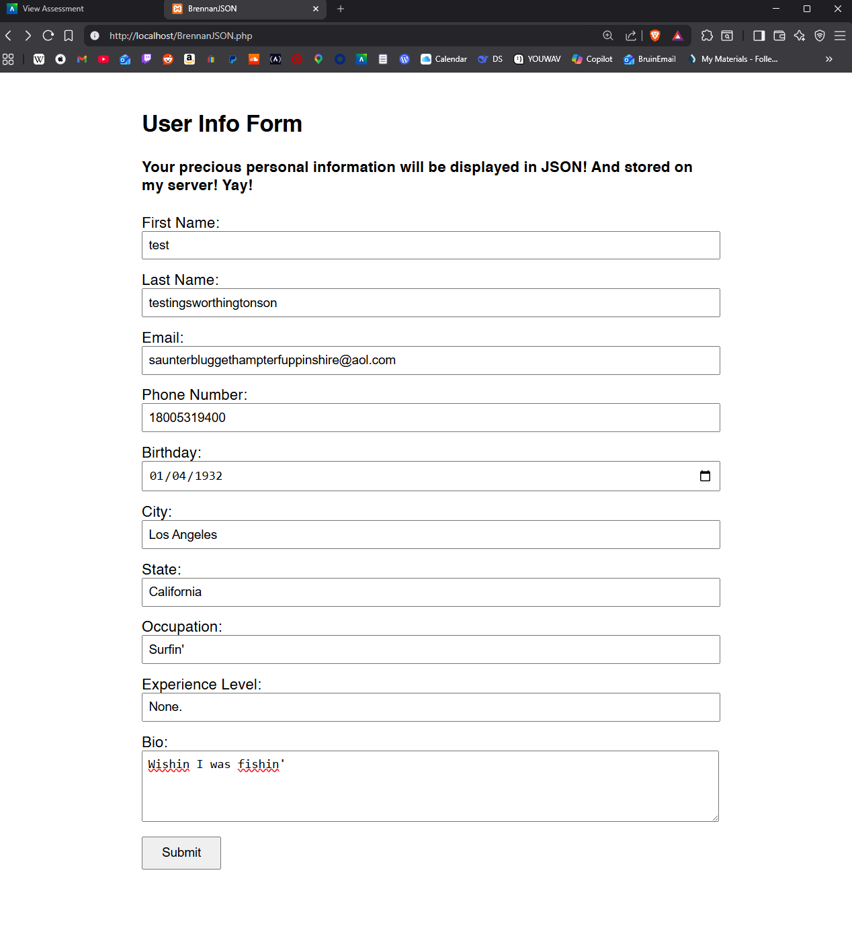
Output in JSON:
