Project: Moffat Bay Lodge
Course: CSD460: Capstone in Software Development
Description: Test plans for Attractions page
Date: 2026/11/08
To complete the test case plan, fill out the information for Project, Course, Description and Date in the header below.

TABLE OF CONTENTS
Access Attractions page from direct link 2
Access Attractions page from direct link 2

For each test, the developer should: provide a test description, a test objective, the developer name and date tested. For each step, fill out the actions to be taken and describe the expected results, and indicate yes or no for each step depending upon the result. The peer tester should provide their name, date tested, indicate yes or no for each step depending upon the result, and a screenshot (thumbnail) of the result.

Test 1 | Access Attractions page from direct link
 | Test Objective: Verifies the attractions page can be reached directly through a URL | Developer: Daniel Preller  Date tested: 2026/11/08 | Peer tester: Brennan Cheatwood  Date tested: <2026/11/08>
Step | Action | Expected results: | Developer pass/fail | Tester pass/fail  + Screenshot
1 | Go to Attractions page (<user-specific localhost URL>/MoffatBay/attractions.jsp) | Attractions page loads | yes | <yes
2 | Confirm Attractions page and content is present | Page content loads (Three single images, one 3-image bar, one 4-image bar) | yes | <yes
Comments | Comments should be substantive; this means there should be at least 2-3 well-structured sentences with constructive feedback.

Test 2 | Access Attractions page from direct link
 | Test Objective: Verifies the attractions page can be reached from the navigation bar | Developer: Daniel Preller  Date tested: 2026/11/08 | Peer tester: Brennan Cheatwood  Date tested: <2026/11/08>
Step | Action | Expected results: | Developer pass/fail | Tester pass/fail
1 | Go to home page (<user-specific localhost URL>/MoffatBay/index.jsp) | Home page loads | yes | <yes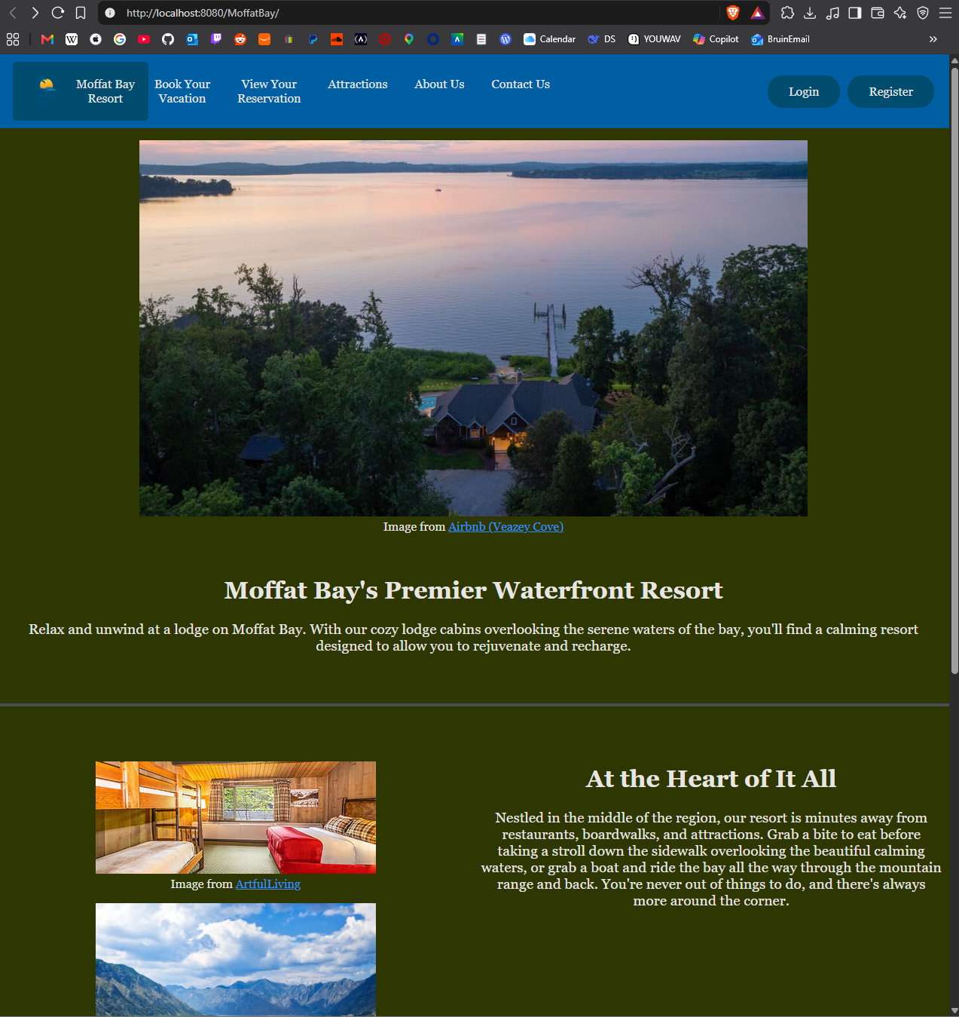
2 | Click “Attractions” | Attractions page loads | yes | <yes
3 | Confirm Attractions page content is present | Page content loads (Three single images, one 3-image bar, one 4-image bar) | yes | <yes
Comments | Comments should be substantive; this means there should be at least 2-3 well-structured sentences with constructive feedback.

