Project: Moffat Bay Lodge
Course: CSD-460 Capstone
Description: Test Cases for Reservation Page
Date: 2026/10/18

To complete the test case plan, fill out the information for Project, Course, Description and Date in the header below.
TABLE OF CONTENTS
RESERVATION PAGE LOCKOUT 2
RESERVATION PAGE VIEW 3
MAKE A RESERVATION 5
FORCED DATE AND GUEST SELECTION 6

For each test, the developer should: provide a test description, a test objective, the developer name and date tested. For each step, fill out the actions to be taken and describe the expected results, and indicate yes or no for each step depending upon the result. The peer tester should provide their name, date tested, indicate yes or no for each step depending upon the result, and a screenshot (thumbnail) of the result.

Test 1 | RESERVATION PAGE LOCKOUT
 | Test Objective: Ensure that the user could not see the room selection page without logging in | Developer: Anthony Nguyen  Date tested: 2026/10/18 | Peer tester: Daniel Preller  Date tested: 2026/10/18
Step | Action | Expected results: | Developer pass/fail | Tester pass/fail  + Screenshot
1 | Open the Home Page | Home page is displayed | yes | yes  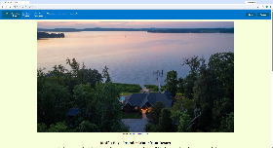
2 | Click “Book Your Vacation” in the navigation bar | The Login page is displayed instead | yes | yes  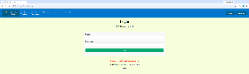
3 | View the bottom of the Login page | There should be a red message prompting the user to login | yes | yes
4 | Enter information:  Email: Freddy@Fred.net  Password: Fred1234 | The information appears in the form.  The password can only be seen as dots. | yes | yes  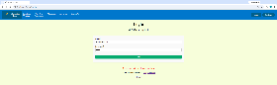
5 | Click Login | The entire reservation.jsp can now be viewed | yes | yes  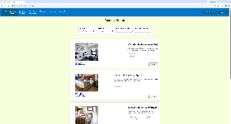
6 | Inspect the buttons on the top right of the page | Instead of “Login” and “Register”, the buttons should now read “Welcome, *firstname*” and “Logout” | yes | yes
7 | Click Logout | The home page loads | yes | yes
Comments | Users are cleanly taken through the process of logging in and being redirected to the reservation page. The message instructing the users to login to view reservations makes it clear that being taken to the login page is intentional, and the redirect back to the reservation page significantly smooths the process.

Test 2 | RESERVATION PAGE VIEW
 | Test Objective: Verify that the reservation page loads and all elements are loaded properly | Developer: Anthony Nguyen  Date tested: 2026/10/18 | Peer tester: Daniel Preller  Date tested: 2026/10/18
Step | Action | Expected results: | Developer pass/fail | Tester pass/fail  + Screenshot
1 | Open the home page | Home page opens | yes | yes  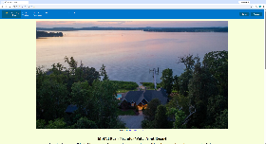
2 | Click “Book Your Vacation” in the navigation bar | The Login page is displayed instead | yes | yes  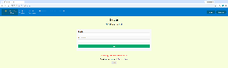
3 | Enter information:  Email: Freddy@Fred.net  Password: Fred1234 | The information appears in the form.  The password can only be seen as dots. | yes | yes  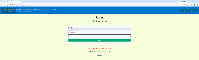
4 | Click Login | The entire reservation.jsp can now be viewed | yes | yes  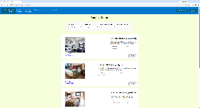
5 | Inspect the top of the page:  Check-In: Input date 10/30/2026  Check-Out: Input date 11/18/2026  How Many Rooms? Input 4  How many Guests? Input 10 | Each box of the form should populate  10/30/2026  11/18/2026  4  10 | yes | yes  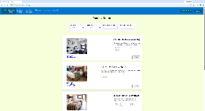
6 | Change the dates:  Check-In: click the button on the right of the box to change the date to 10/20/2026  Check-In: click the button on the right of the box to change the date to 12/20/2026 | The Check-In date should show 10/20/2026  The Check-Out date should show 12/20/2026 | yes | yes  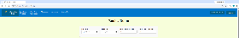
7 | Change the numbers:  Hover to the right of the “How Many Rooms?” field and hold the up arrow  Hover to the right of the “How Many Guests?” field and hold the up arrow | Both the “How Many Rooms?” and “How Many Rooms?” fields should show 99 | yes | yes  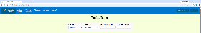
8 | Inspect the four rooms of the page | Each section should have:  an image with working caption links  A Select button  The room type and price  Room description | yes | yes
9 | Inspect the bottom of the page | Above the footer, there should be a message telling the user how to make a reservation | yes | yes  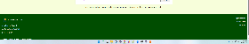
10 | Click Logout | The Home page | yes | yes  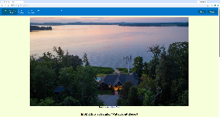
Comments | The process of viewing the available rooms is smooth while still preventing users who are not logged in from viewing the page. Room information could be placed on another page so users can learn the pricing and other information without having to create an account. Giving the date fields default dates could be useful for ease of access, but not doing so (the current method) is preferred because it prevents mistakes.

Test 3 | MAKE A RESERVATION
 | Test Objective: Ensure that users can make a reservation | Developer: Anthony Nguyen  Date tested: 2026/10/18 | Peer tester: Daniel Preller  Date tested: 2026/10/18
Step | Action | Expected results: | Developer pass/fail | Tester pass/fail  + Screenshot
1 | Click “Book Your Vacation” in the navigation bar | The Login page is displayed instead | yes | yes  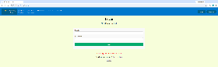
2 | Enter information:  Email: Freddy@Fred.net  Password: Fred1234 | The information appears in the form.  The password can only be seen as dots. | yes | yes  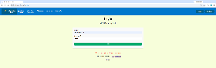
3 | Click Login | The entire reservation.jsp can now be viewed | yes | yes
4 | Fill in the top of the page:  Check-In: Input date 10/30/2026  Check-Out: Input date 11/18/2026  How Many Rooms? Input 4  How many Guests? Input 10 | Each box of the form should populate  10/30/2026  11/18/2026  4  10 | yes | yes  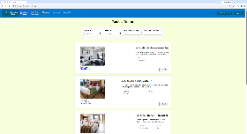
5 | Scroll to the section “2 Queen Beds ($150/night)” | The section should show “2 Queen Beds ($150/night)” | yes | yes
6 | Click Select | The Confirmation page is displayed. | yes | yes  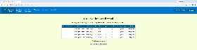
7 | Inspect Confirmation page | A table should be shown:  One row per room (4 rooms, 4 rows)  Columns: room type, price, guests, and subtotals  Below the table is the final total | yes | yes
8 | Click Logout | Home page opens | yes | yes
Comments | The reservation process allows users to smoothly create a reservation. The confirmation screen could benefit from the ability to cancel the reservation before confirming it so that users can make changes or decide against the reservation.

Test 4 | FORCED DATE AND GUEST SELECTION
 | Test Objective: Ensure that the user cannot move to the Confirmation page without filling the form first | Developer: Anthony Nguyen  Date tested: 2026/10/18 | Peer tester: Daniel Preller  Date tested: 2026/10/18
Step | Action | Expected results: | Developer pass/fail | Tester pass/fail  + Screenshot
1 | Click “Book Your Vacation” in the navigation bar | The Login page is displayed | yes | yes  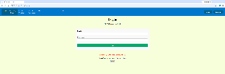
2 | Enter information:  Email: Freddy@Fred.net  Password: Fred1234 | The information appears in the form.  The password can only be seen as dots. | yes | yes  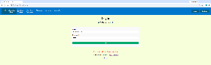
3 | Click Login | The entire reservation.jsp can now be viewed | yes | yes  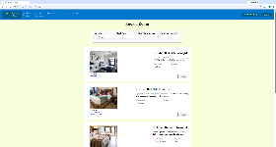
4 | Immediately click the Select button of the section for “2 Double Beds ($120/night)” | A message under the Check-In date: “Please fill out this field” | yes | yes  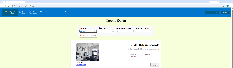
5 | Fill out the Check-In: Input date 10/30/2026  Click the Select button of the section for “2 Double Beds ($120/night)” | A message under the Check-Out date: “Please fill out this field” | yes | yes  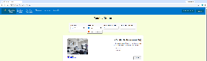
6 | Fill out the Check-Out: Input date 11/18/2026  Click the Select button of the section for “2 Double Beds ($120/night)” | A message under How many Rooms?: “Please fill out this field” | yes | yes  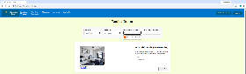
7 | Fill out the How Many Rooms? Input 4  Click the Select button of the section for “2 Double Beds ($120/night)” | A message under How many Guests?: “Please fill out this field” | yes | yes  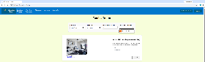
8 | Fill out the How many Guests? Input 10  Click the Select button of the section for “2 Double Beds ($120/night)” | The Confirmation page is displayed. | yes | yes  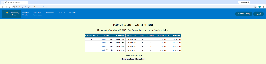
Comments | The page successfully prevents users from creating a reservation with missing fields. If the form is submitted with missing fields (such as by changing the required attribute with browser developer tools), further error messages successfully prevent invalid reservations.

