

**Motto:**

It’s Database Time!

**Members:**

Brennan Harrison (Lead)

Huong Le

Brian Pueschel

Mike Sangrene

PowerShell Rangers | 16 April 2019 | ISM 4212 | Dr. Hyman

**Youth Soccer League Database Design Document**

**Version History**

|  |  |
| --- | --- |
| **Version** | **Description** |
| 1.0 | First released draft |
| 2.0 | Summary of changes:   1. Additional Requirements, Entities, Relations. 2. Updated ERD 3. Updated EERD 4. Youth Soccer League Relational Schema 5. Youth Soccer League Data Dictionary Header 6. Youth Soccer League Data Dictionary |
| 3.0 | Summary of changes:   1. Updated ERD    1. Corrected optionality connecting Referees to Matches.    2. Corrected optionality connecting Teams to Matches.    3. Corrected optionality connecting Teams to Sponsors. 2. Updated EERD 3. Updated Youth Soccer League Data Dictionary    1. Dropped all Phone Number column unique constraints.    2. Dropped all Phone Number column check constraints.    3. Dropped all Date column check constraints.    4. Converted all Phone Number Column datatypes to varchar (18).    5. Converted all Primary Key and Foreign Key datatypes to int.    6. Converted Zip column datatype to varchar (12).    7. Modified all Foreign Key columns to allow nulls.    8. Modified all Phone Number columns to allow nulls.    9. Modified Minute, Goal and Penalty columns to allow nulls.    10. Removed the identity seed and increment for all Primary Keys in associate tables. 4. Table Views 5. SPROCS |
| 4.0 | Summary of changes:   1. Updated ERD    1. Added Ratio field as intersection data. 2. Updated EERD    1. Added Ratio field to Player Analysis table. 3. Updated Youth Soccer League Data Dictionary    1. Modified all Season columns to allow nulls.    2. Added Ratio calculated column to Player Analysis table. 4. Updated Average Goals for Players by First Name SPROC    1. Created a parameter and set the First Name field to the parameter. 5. Updated Field Vendor Number SPROC    1. Created a parameter and set the City field to the parameter. 6. Table View Reports 7. User-Acceptance Test Queries |

**Purpose**

This document was prepared by the PowerShell Rangers to design a conceptual data model that logically illustrates the connections between the major objects of interest to the youth soccer league.

**Narrative**

The soccer league has many teams containing players and a team captain. Teams and players may or may not compete in matches. The goals, minutes played and penalties for each participating player in a match are documented. Referees may or may not serve in matches and mentor other referees. The position of each referee in each match is documented. Matches are played at one field and a field may or may not host any matches. Each field contains multiple vendors and a vendor is stationed only at one field. A sponsor may or may not sponsor teams and fields. The season of a team’s and field’s sponsorship is also documented.

**Requirements (Actors and Roles)**

TEAM – A team may compete other teams in matches but is designated a team captain.

PLAYER – A player may participate in matches.

MATCH – A match is played on a field.

REFEREE – A referee may be mentored by another referee. Referees may serve in matches.

FIELD – Each field is serviced by vendors.

SPONSOR – A sponsor may sponsor fields and teams.

**Entities Identified**

TEAM

PLAYER

MATCH

REFEREE

FIELD

VENDOR

SPONSOR

**Entities with Nested Attributes**

TEAM

Team ID

Team Name

MATCH

Match ID

Date

PLAYER

Player ID

First Name

Last Name

Phone Number

Date of Birth

SPONSOR

Sponsor ID

Sponsor Name

VENDOR

Vendor ID

Vendor Name

Phone Number

Type

REFEREE

Referee ID

First Name

Last Name

Phone Number

FIELD

Field ID

Field Name

Street

City

State

Zip

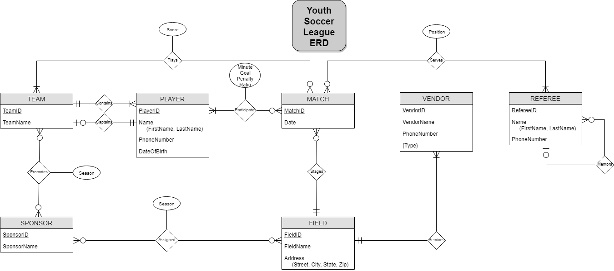

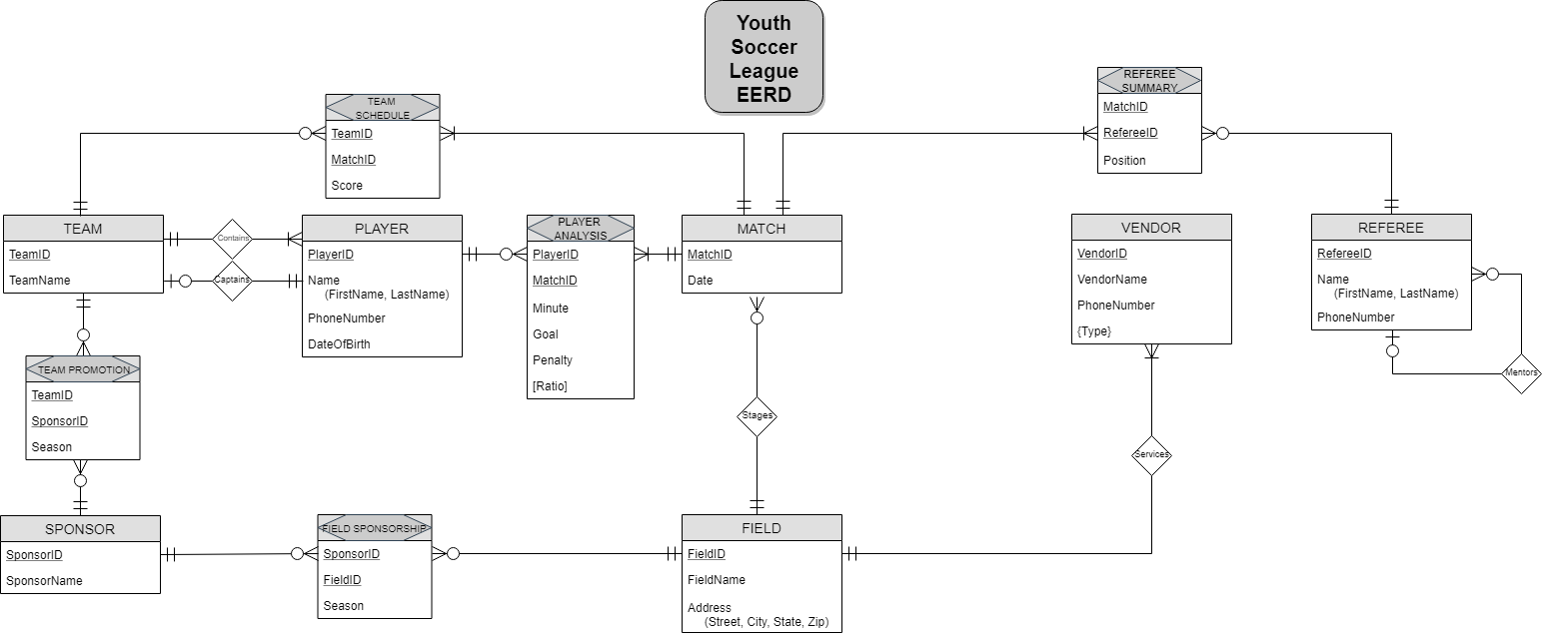

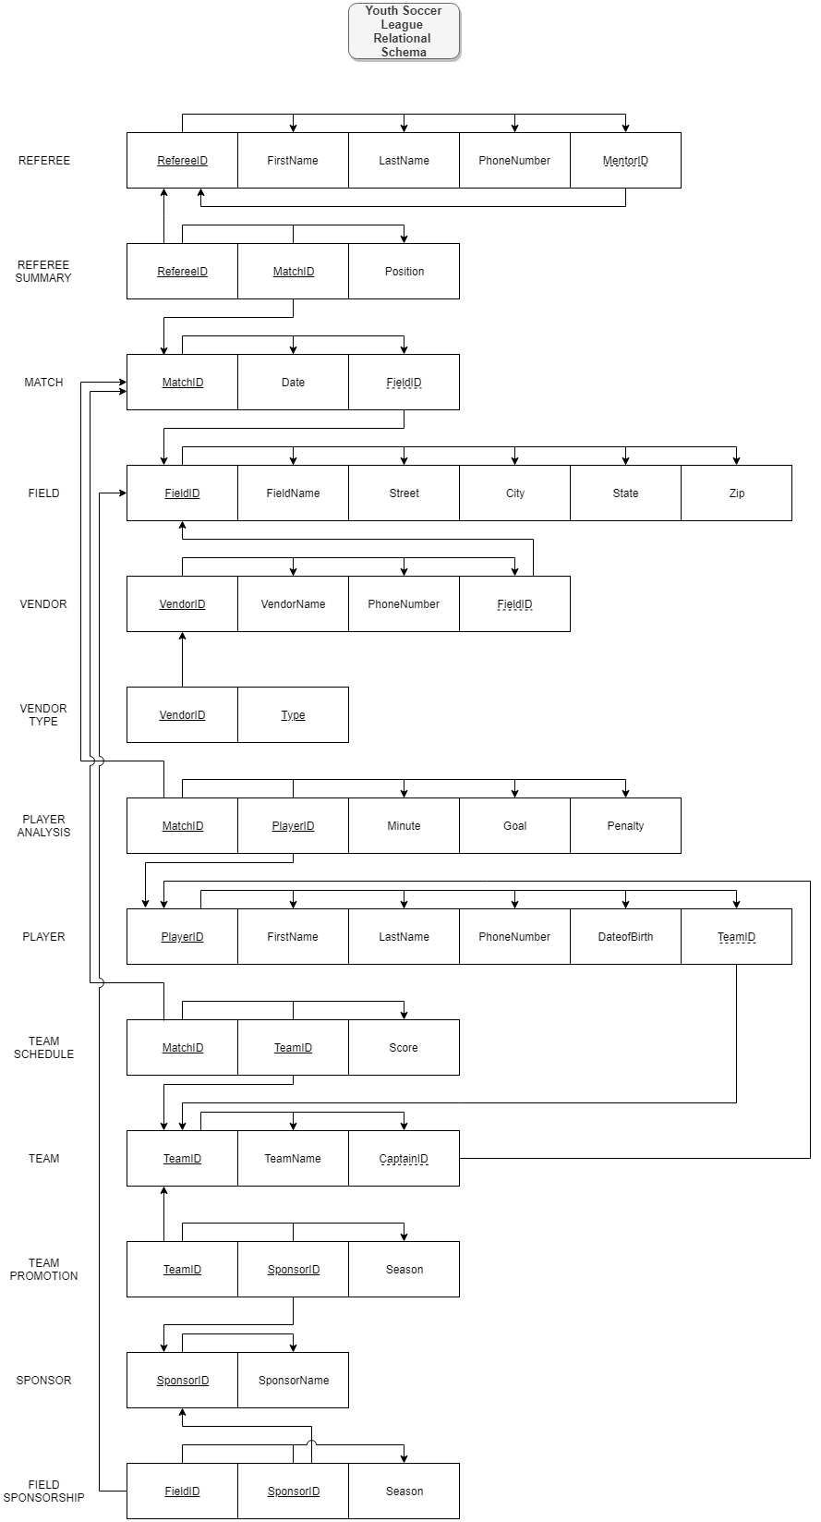

**Data Dictionary Summary Header**

**Youth Soccer League Database Tables and Attributes**

Referee (RefereeID, FirstName, LastName, PhoneNumber, MentorID)

RefereeSummary (RefereeID, MatchID, Position)

Match (MatchID, Date, FieldID)

Field (FieldID, FieldName, Street, City, State, Zip)

Vendor (VendorID, VendorName, PhoneNumber, FieldID)

VendorType (VendorID, Type)

PlayerAnalysis (PlayerID, MatchID, Minute, Goal, Penalty, Ratio)

Player (PlayerID, FirstName, LastName, PhoneNumber, DateOfBirth, TeamID)

TeamSchedule (TeamID, MatchID, Score)

Team (TeamID, TeamName, CaptainID)

TeamPromotion (TeamID, SponsorID, Season)

Sponsor (SponsorID, SponsorName)

FieldSponsorship (SponsorID, FieldID, Season)

YOUTH SOCCER LEAGUE – DATA DICTIONARY

**(Microsoft SQL Server Notation)**

Table: **Referee**

|  |  |  |  |  |  |  |  |  |  |
| --- | --- | --- | --- | --- | --- | --- | --- | --- | --- |
| **Column Name** | **Description** | **Data Type** | **Size** | **Identity** | **Unique** | **Default** | **Check** | **Allow Nulls** | **Index** |
| RefereeID | **PK;** Unique sequential referee ID number | int |  | Y |  |  |  |  | Y |
| FirstName | Referee first name | varchar | 15 |  |  |  |  |  |  |
| LastName | Referee last name | varchar | 20 |  |  |  |  |  |  |
| PhoneNumber | Referee phone number | varchar | 18 |  |  |  |  | Y |  |
| MentorID | Recursive **FK**; synonym to RefereeID; referee’s mentor | int |  |  |  |  |  | Y |  |

Table: **RefereeSummary**

|  |  |  |  |  |  |  |  |  |  |
| --- | --- | --- | --- | --- | --- | --- | --- | --- | --- |
| **Column Name** | **Description** | **Data Type** | **Size** | **Identity** | **Unique** | **Default** | **Check** | **Allow Nulls** | **Index** |
| RefereeID | **CPK;** **FK** to Referee table | int |  |  |  |  |  |  | Y |
| MatchID | **CPK; FK** to Match table | int |  |  |  |  |  |  | Y |
| Position | The position of the referee | char | 1 |  |  |  | ([Position] = (‘H’)  OR  [Position] = (‘L’)) |  |  |

Table: **Match**

|  |  |  |  |  |  |  |  |  |  |
| --- | --- | --- | --- | --- | --- | --- | --- | --- | --- |
| **Column Name** | **Description** | **Data Type** | **Size** | **Identity** | **Unique** | **Default** | **Check** | **Allow Nulls** | **Index** |
| MatchID | **PK**; Unique sequential match ID number | int |  | Y |  |  |  |  | Y |
| Date | Date the match is played | date |  |  |  |  |  |  |  |
| FieldID | **FK** to Field table; field that match is played on | int |  |  |  |  |  | Y |  |

Table: **Field**

|  |  |  |  |  |  |  |  |  |  |
| --- | --- | --- | --- | --- | --- | --- | --- | --- | --- |
| **Column Name** | **Description** | **Data Type** | **Size** | **Identity** | **Unique** | **Default** | **Check** | **Allow Nulls** | **Index** |
| FieldID | **PK**; Unique sequential field ID number | int |  | Y |  |  |  |  | Y |
| FieldName | Name of the field | varchar | 15 |  |  |  |  |  |  |
| Street | Street of the field | varchar | 20 |  |  |  |  |  |  |
| City | City of the field | varchar | 15 |  |  |  |  |  |  |
| State | State of the field | char | 2 |  |  |  | LIKE ‘[A-Z][A-Z]’ |  |  |
| Zip | Zip code of the field | varchar | 10 |  |  |  |  |  |  |

Table: **Vendor**

|  |  |  |  |  |  |  |  |  |  |
| --- | --- | --- | --- | --- | --- | --- | --- | --- | --- |
| **Column Name** | **Description** | **Data Type** | **Size** | **Identity** | **Unique** | **Default** | **Check** | **Allow Nulls** | **Index** |
| VendorID | **PK**; Unique sequential vendor ID number | int |  | Y |  |  |  |  | Y |
| VendorName | Name of the vendor | varchar | 20 |  |  |  |  |  |  |
| PhoneNumber | Phone number of vendor | varchar | 18 |  |  |  |  | Y |  |
| FieldID | **FK** to Field table; field that vendor services | int |  |  |  |  |  | Y |  |

Table: **VendorType**

|  |  |  |  |  |  |  |  |  |  |
| --- | --- | --- | --- | --- | --- | --- | --- | --- | --- |
| **Column Name** | **Description** | **Data Type** | **Size** | **Identity** | **Unique** | **Default** | **Check** | **Allow Nulls** | **Index** |
| VendorID | **CPK; FK** to Vendor table | int |  |  |  |  |  |  | Y |
| Type | **CPK;** Vendor type | varchar | 30 |  |  |  |  |  |  |

Table: **PlayerAnalysis**

|  |  |  |  |  |  |  |  |  |  |
| --- | --- | --- | --- | --- | --- | --- | --- | --- | --- |
| **Column Name** | **Description** | **Data Type** | **Size** | **Identity** | **Unique** | **Default** | **Check** | **Allow Nulls** | **Index** |
| PlayerID | **CPK; FK** to Player table | int |  |  |  |  |  |  | Y |
| MatchID | **CPK; FK** to Match table | int |  |  |  |  |  |  | Y |
| Minute | Number of minutes played per match per player | tinyint |  |  |  |  |  | Y |  |
| Goal | Number of goals scored per match per player | tinyint |  |  |  |  |  | Y |  |
| Penalty | Number of penalties received per match per player | tinyint |  |  |  |  |  | Y |  |
| Ratio | Number of minutes played divided by the total time for a match | decimal | (6,2) |  |  |  |  | Y |  |

Table: **Player**

|  |  |  |  |  |  |  |  |  |  |
| --- | --- | --- | --- | --- | --- | --- | --- | --- | --- |
| **Column Name** | **Description** | **Data Type** | **Size** | **Identity** | **Unique** | **Default** | **Check** | **Allow Nulls** | **Index** |
| PlayerID | **PK**; Unique sequential player ID number | int |  | Y |  |  |  |  | Y |
| FirstName | First name of player | varchar | 15 |  |  |  |  |  |  |
| LastName | Last name of player | varchar | 20 |  |  |  |  |  |  |
| PhoneNumber | Phone number of player | varchar | 18 |  |  |  |  |  |  |
| DateOfBirth | Date of birth of player | date |  |  |  |  |  |  |  |
| TeamID | **FK** to Team table; team that player is on | int |  |  |  |  |  | Y |  |

Table: **TeamSchedule**

|  |  |  |  |  |  |  |  |  |  |
| --- | --- | --- | --- | --- | --- | --- | --- | --- | --- |
| **Column Name** | **Description** | **Data Type** | **Size** | **Identity** | **Unique** | **Default** | **Check** | **Allow Nulls** | **Index** |
| TeamID | **CPK; FK** to Team table | int |  |  |  |  |  |  | Y |
| MatchID | **CPK; FK** to Match table | int |  |  |  |  |  |  | Y |
| Score | Score per match of each team | tinyint |  |  |  |  |  |  |  |

Table: **Team**

|  |  |  |  |  |  |  |  |  |  |
| --- | --- | --- | --- | --- | --- | --- | --- | --- | --- |
| **Column Name** | **Description** | **Data Type** | **Size** | **Identity** | **Unique** | **Default** | **Check** | **Allow Nulls** | **Index** |
| TeamID | **PK**; Unique sequential team ID number | int |  | Y |  |  |  |  | Y |
| TeamName | Name of team | varchar | 15 |  |  |  |  |  |  |
| CaptainID | **FK** to Player table; synonym for PlayerID; captain of a team | int |  |  |  |  |  | Y |  |

Table: **TeamPromotion**

|  |  |  |  |  |  |  |  |  |  |
| --- | --- | --- | --- | --- | --- | --- | --- | --- | --- |
| **Column Name** | **Description** | **Data Type** | **Size** | **Identity** | **Unique** | **Default** | **Check** | **Allow Nulls** | **Index** |
| TeamID | **CPK**; **FK** to Team table | int |  |  |  |  |  |  | Y |
| SponsorID | **CPK**; **FK** to Sponsor table | int |  |  |  |  |  |  | Y |
| Season | Season of team sponsorship | varchar | 8 |  |  |  |  | Y |  |

Table: **Sponsor**

|  |  |  |  |  |  |  |  |  |  |
| --- | --- | --- | --- | --- | --- | --- | --- | --- | --- |
| **Column Name** | **Description** | **Data Type** | **Size** | **Identity** | **Unique** | **Default** | **Check** | **Allow Nulls** | **Index** |
| SponsorID | **PK**; Unique sequential sponsor ID number | int |  | Y |  |  |  |  | Y |
| SponsorName | Name of sponsor promoting a team | varchar | 17 |  |  |  |  |  |  |

Table: **FieldSponsorship**

|  |  |  |  |  |  |  |  |  |  |
| --- | --- | --- | --- | --- | --- | --- | --- | --- | --- |
| **Column Name** | **Description** | **Data Type** | **Size** | **Identity** | **Unique** | **Default** | **Check** | **Allow Nulls** | **Index** |
| SponsorID | **CPK**; **FK** to Sponsor table | int |  |  |  |  |  |  | Y |
| FieldID | **CPK**; **FK** to Field table | int |  |  |  |  |  |  | Y |
| Season | Season of field sponsorship | varchar | 8 |  |  |  |  | Y |  |

**Player Metrics Table View**

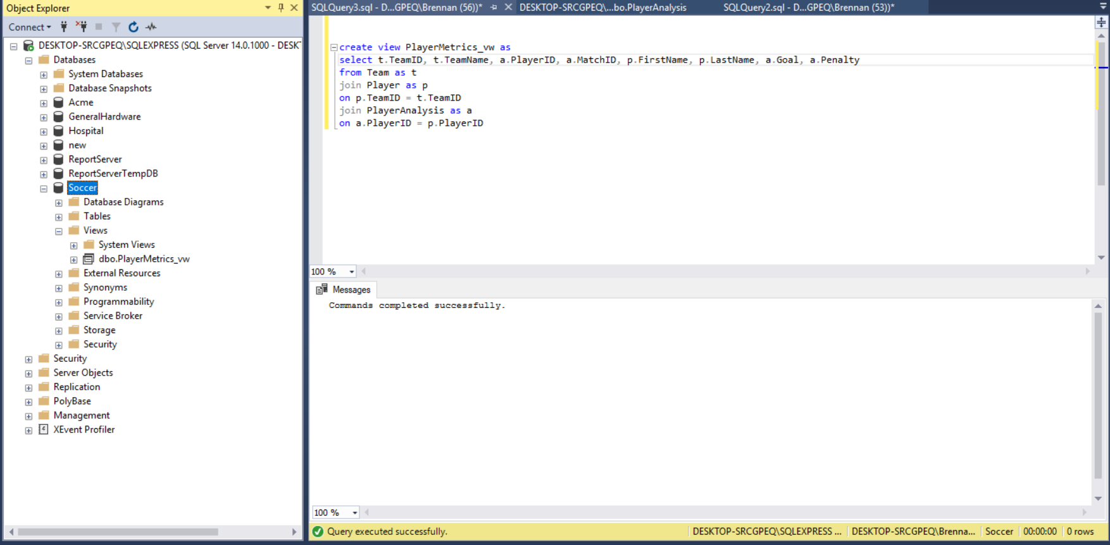

**Player Metrics Table View Description**

The Player Metrics Table View joins the Team, Player and Player Analysis tables into one pre-prepped select statement. Each table is given an alias to make it easier for readers to see which tables the columns are being extracted from. The columns inserted in the join view are Team ID, Team Name, Player ID, Match ID, First Name, Last Name, Goal and Penalty. This table view was created to generate more narrow searches with the selected columns using stored procedures.

**Vendor Inquiry Table View**

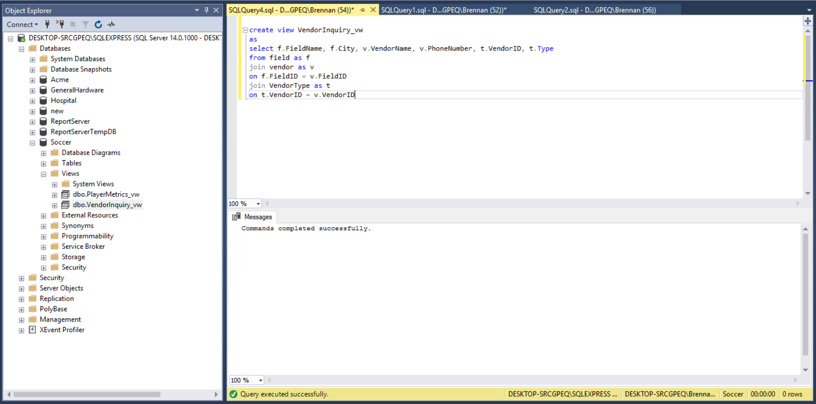

**Vendor Inquiry Table View Description**

The Vendor Inquiry table view joins the Field, Vendor and Vendor Type tables on their primary and foreign key connections. Each table is given an alias for reader comprehension. The columns that are matched in this table view are Field Name, City, Vendor Name, Phone Number, Vendor ID, and Type. The PowerShell Rangers chose these columns to answer questions concerning the number of vendors on fields in different cities, as well as the number of distinct vendor types through stored procedures.

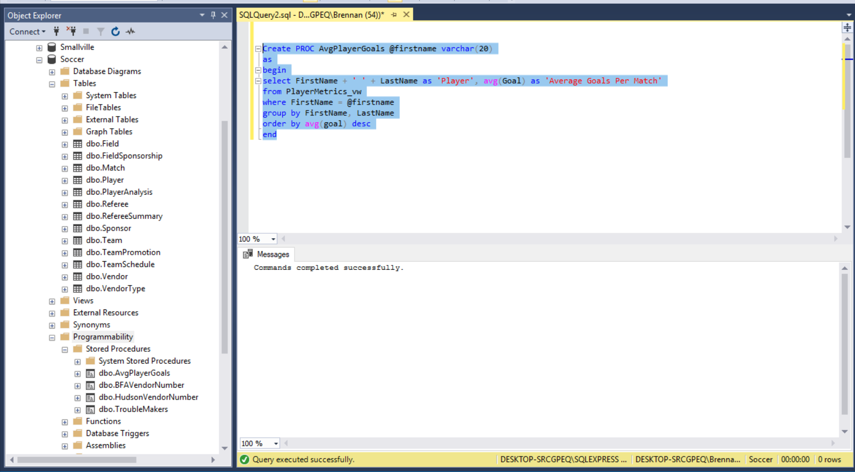**Average Goals for Players by First Name SPROC**

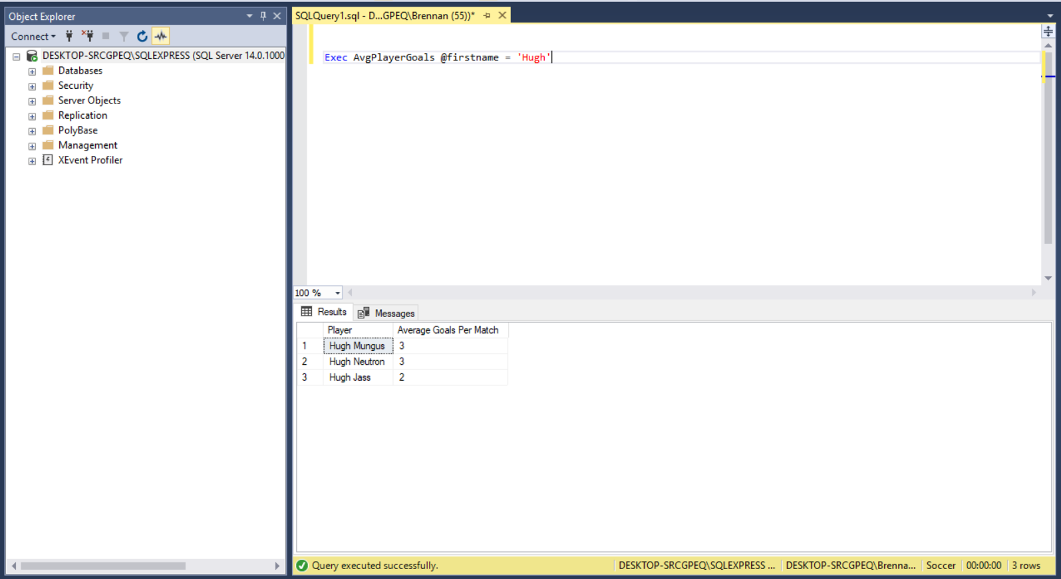

**Average Goals for Players by First Name SPROC Description**

The SPROC named AvgPlayerGoals was created using the Player Metrics table view and is searching for the average number of goals scored by all players by a specific first name. Therefore, the stored procedure combines the first and last name fields into one column and uses the avg aggregate function for goals. Each column also uses a header for their output. The where clause sets the defined parameter to the first name field. Since an aggregator was used, a group by clause was inserted to group the result set by the first and last name columns. The SPROC was finally sorted by the average number of goals per player in descending order.

**Troublemakers SPROC**

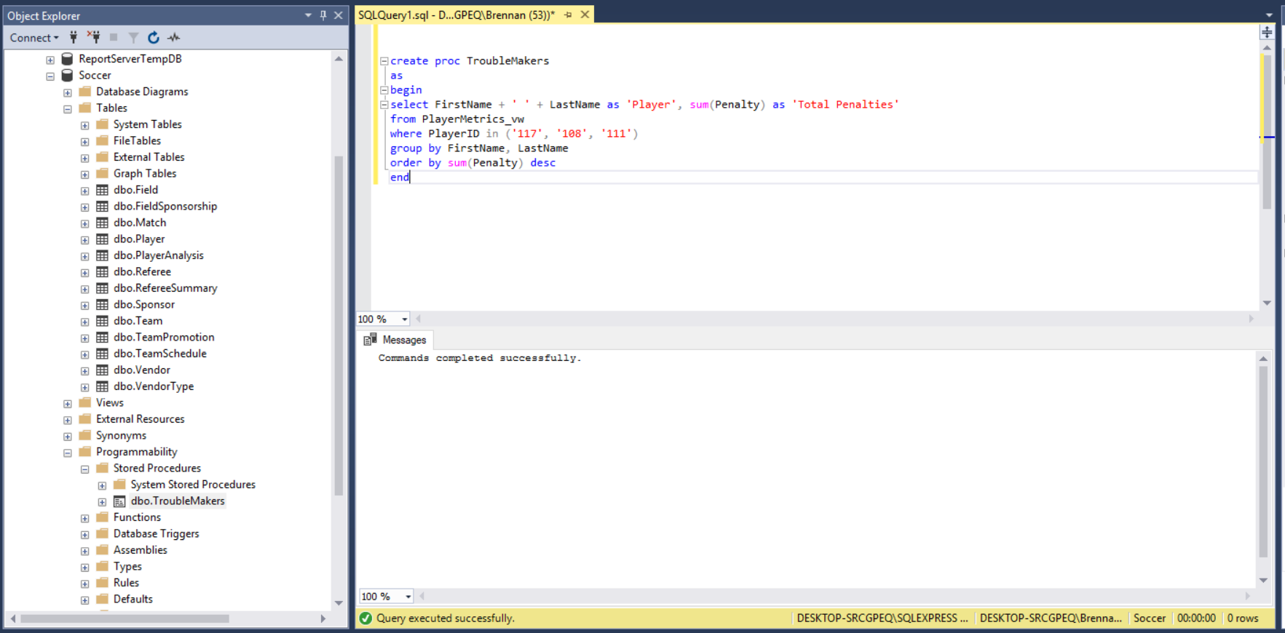

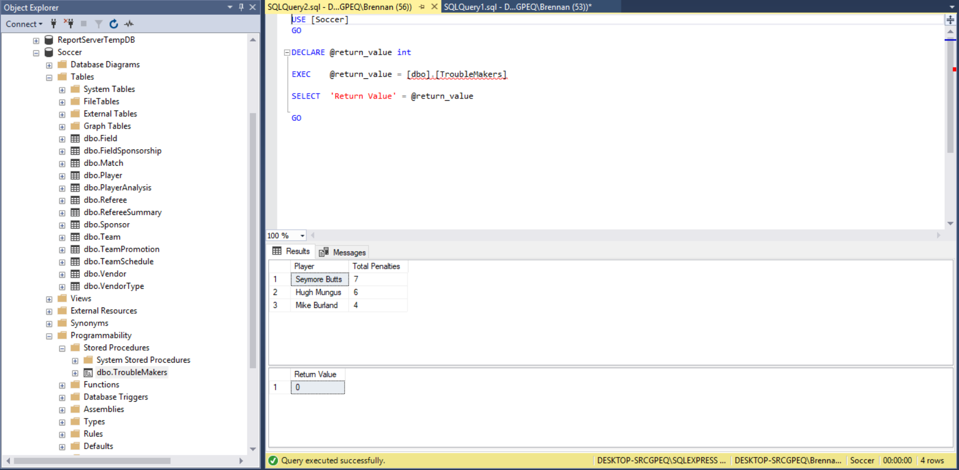

**Troublemakers SPROC Description**

The SPROC named Troublemakers was created using the Player Metrics table view and is searching for the total number of penalties for all players with 117, 108 and 111 as their ID. The stored procedure combines the first and last name fields into one column and uses the sum aggregate function for the penalty column. Each also uses a header for their output. The where clause forces the SPROC to only search for records that contain 117, 108 and 111 for its ID field and uses the IN operator rather than multiple ORs. Since an aggregator was used, a group by clause was inserted to group the result set by the first and last name columns. The SPROC was finally sorted by the total number of penalties per player in descending order.

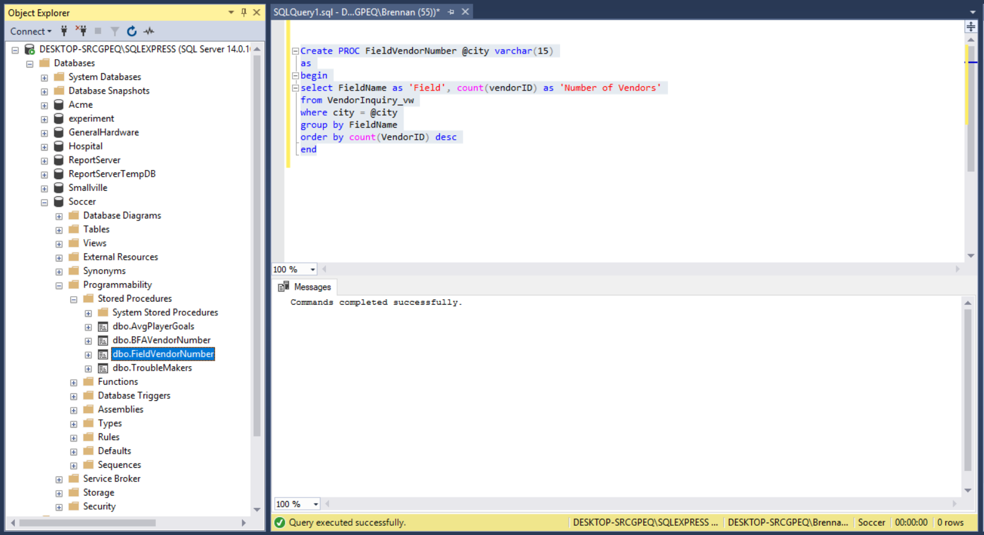**Field Vendor Number SPROC**

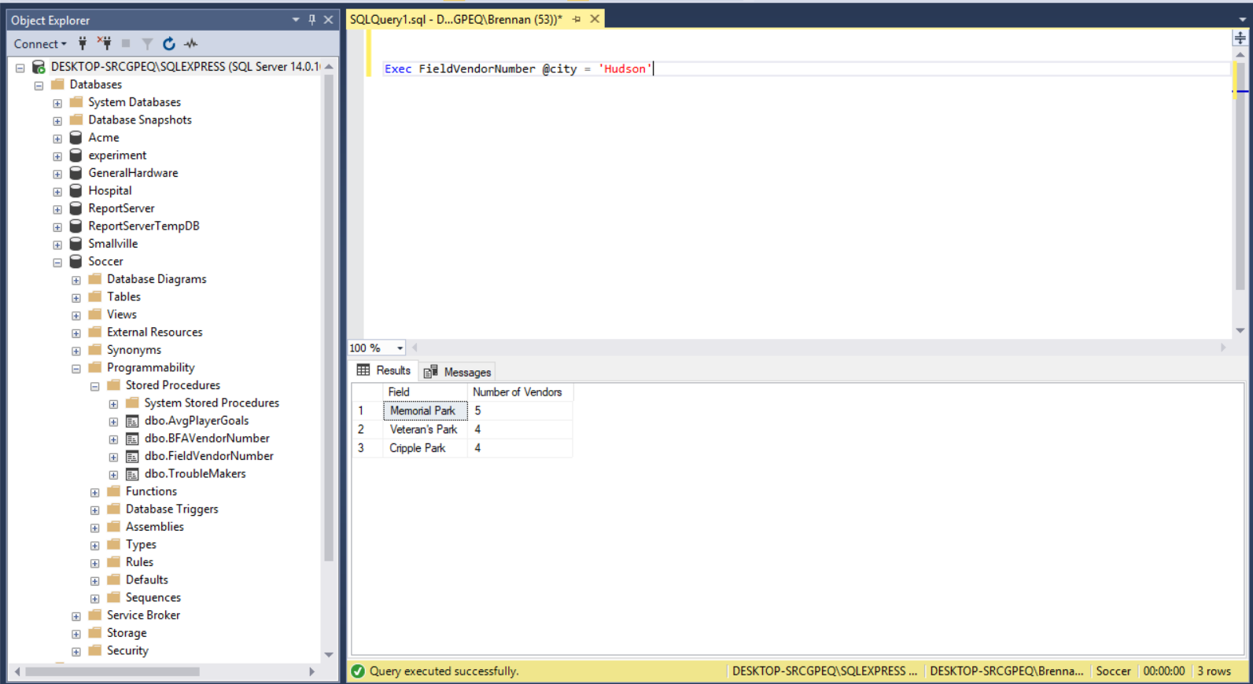

**Field Vendor Number SPROC Description**

The Field Vendor Number SPROC was created using the Vendor Inquiry table view and is counting the number of vendors assigned to fields located in distinct cities. The two selected columns are FieldName and a count of all vendor IDs using a header for both. A where clause was inserted to set the defined parameter to the city field. Because an aggregator was used, a group by clause was used for FieldName. The SPROC was finally sorted in descending order by the count of Vendor IDs.

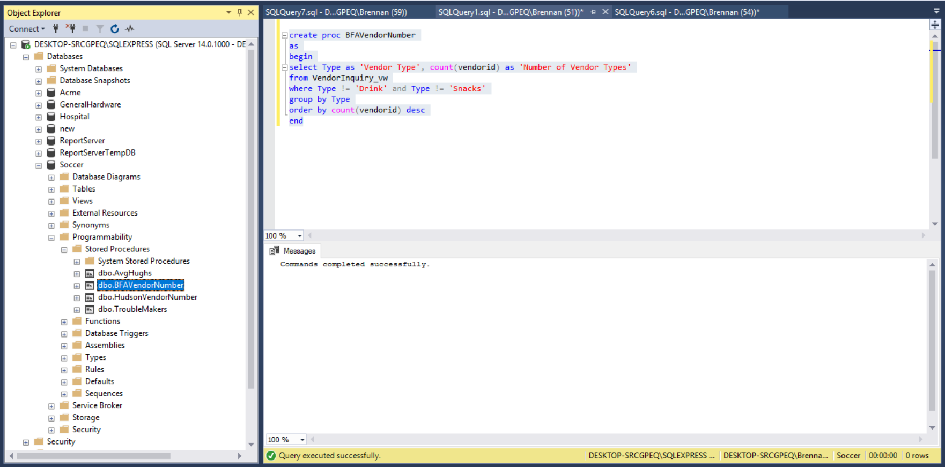**BFA Vendor Number SPROC**

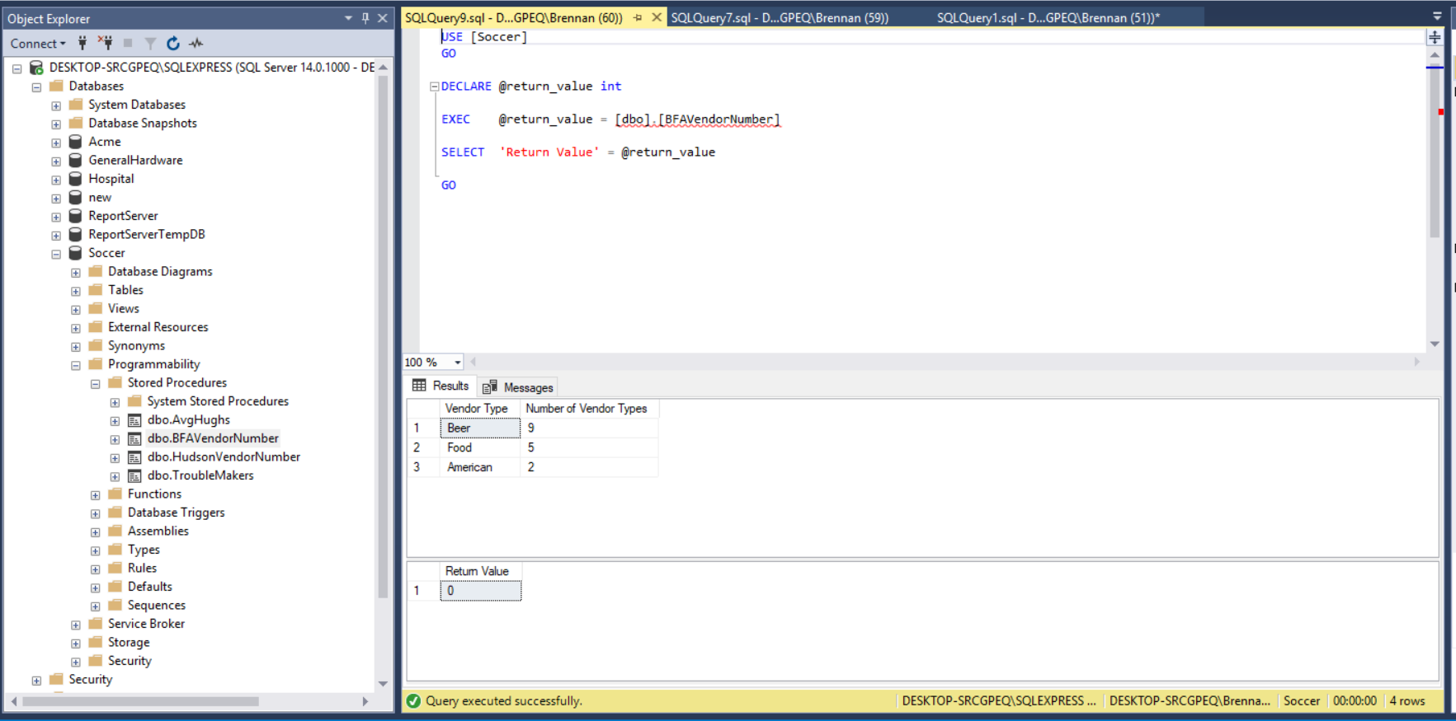

**BFA Vendor Number SPROC Description**

The BFA Vendor Number SPROC was created using the Vendor Inquiry table view and is counting the number of vendor types that do not sell drinks and snacks. The two selected columns are Type and a count of all vendor IDs using a header for both. A where clause was inserted to limit the result set to only search for records that do not have drink and snacks for its type. Because an aggregator was used, a group by clause was used for Type. The SPROC was finally sorted in descending order by the count of Vendor IDs.

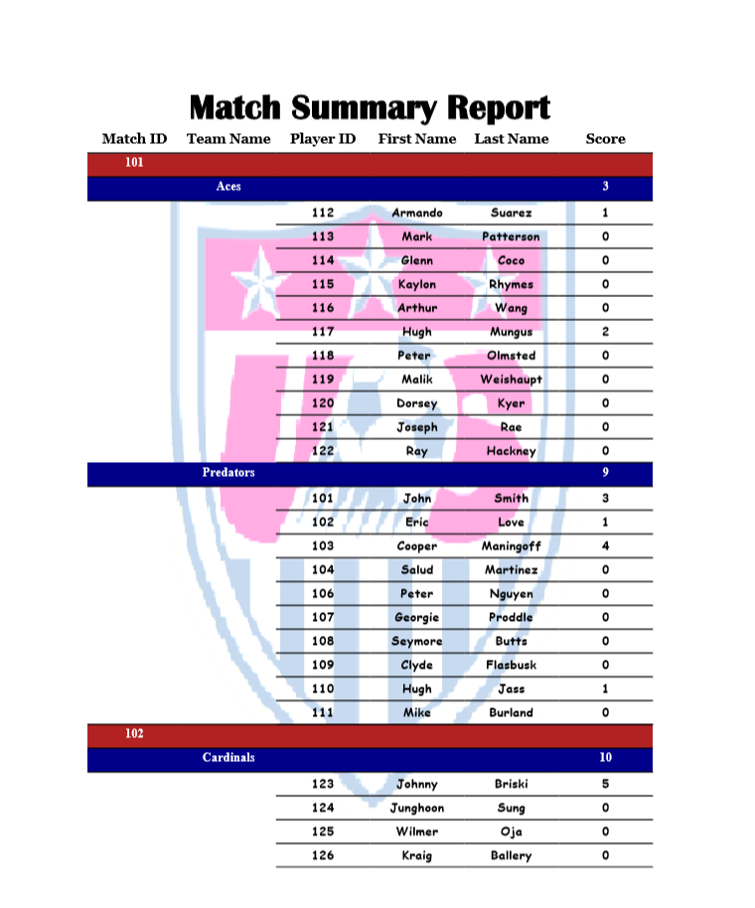**Player Metrics Table View Report**

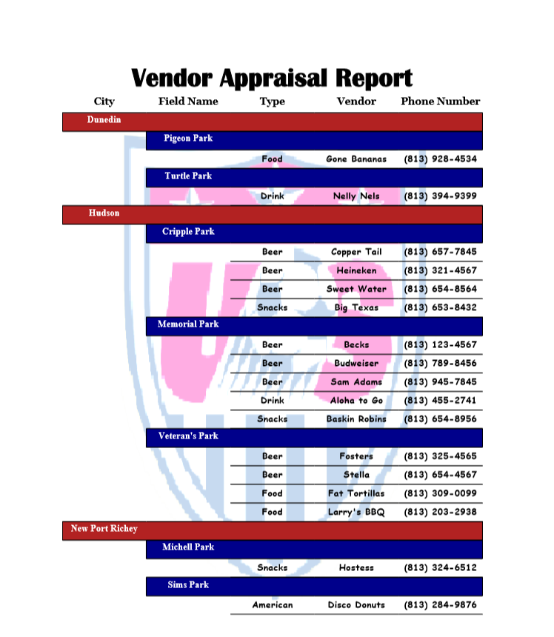**Vendor Inquiry Table View Report**

**User Acceptance Test Queries**

What is the time played and percentage of the match played for players who participated in two-hour long matches, sorted by the highest time?

--ratio is a calculated column

select a.[Minute] as 'Time Played', cast(convert(decimal(4,2),([ratio]/7200) * (100)) as varchar) + '%'

as 'Percentage of Match Played',

concat(p.[FirstName], ' ', p.[LastName]) as 'Player',

a.[MatchID] as 'Match'

from [PlayerAnalysis] a

join [player] p

on p.[PlayerID] = a.[PlayerID]

where a.[Ratio] is not null

order by 'Time Played' desc

How many sponsorships occurred during each season for all teams?

select count([sponsorid]) as 'Sponsorships', isnull(convert(varchar(18),[Season]),'No Sponsorships') as 'Season', [teamname] as 'Team'

from [TeamPromotion] p

right join [team] t

on t.[TeamID] = p.[TeamID]

group by [season], [TeamName]

What are the average goals scored for all teams starting from the highest average?

select avg([score]) as 'Average Goals Scored per Match',

[TeamID] as 'Team ID'

from [TeamSchedule]

group by [TeamID]

order by avg([score]) desc