STUFFY BOOS
Marketing Plan
Brennan Seely | Digital Marketing Coordinator, Klopp Richards | November 2026
1. Brand Overview
"When fears come out at night, the Stuffy Boos make it right"
Stuffy Boos is a kids entertainment brand built around a squad of goofy, loveable stuffed animal like characters who live in a cozy floating world called the Pillow Patch. It's their home base, their headquarters, and kind of a silly little paradise up in the clouds.
The squad is constantly looking for fears or trouble all around. The fears could be things that keep a child awake at night or something silly that scares them. When they spot a silly fear, they speak to it, resolve the issue, and yell ‘BOO!’ to scare the fear away. It’s meant to be a silly and playful way of helping children overcome fears or other emotions.
The toy connection is what makes it really work. When a kid gets a Stuffy Boo, they're not just getting a stuffed animal. They're adopting one of the characters who is literally up there in the Pillow Patch watching over them every night. That's the hook for parents and kids both. It's a show that makes the toy actually mean something.
Think of Paw Patrol with a bedtime routine. Same reliable team, same collectible characters, same kind of energy, but built around something every parent needs help with.
2. Characters
Lead Duo
- Peek: the sharp-eyed explorer. Always got her binoculars out, always first to spot the problem. She’s Quick, smart, and energetic.
- 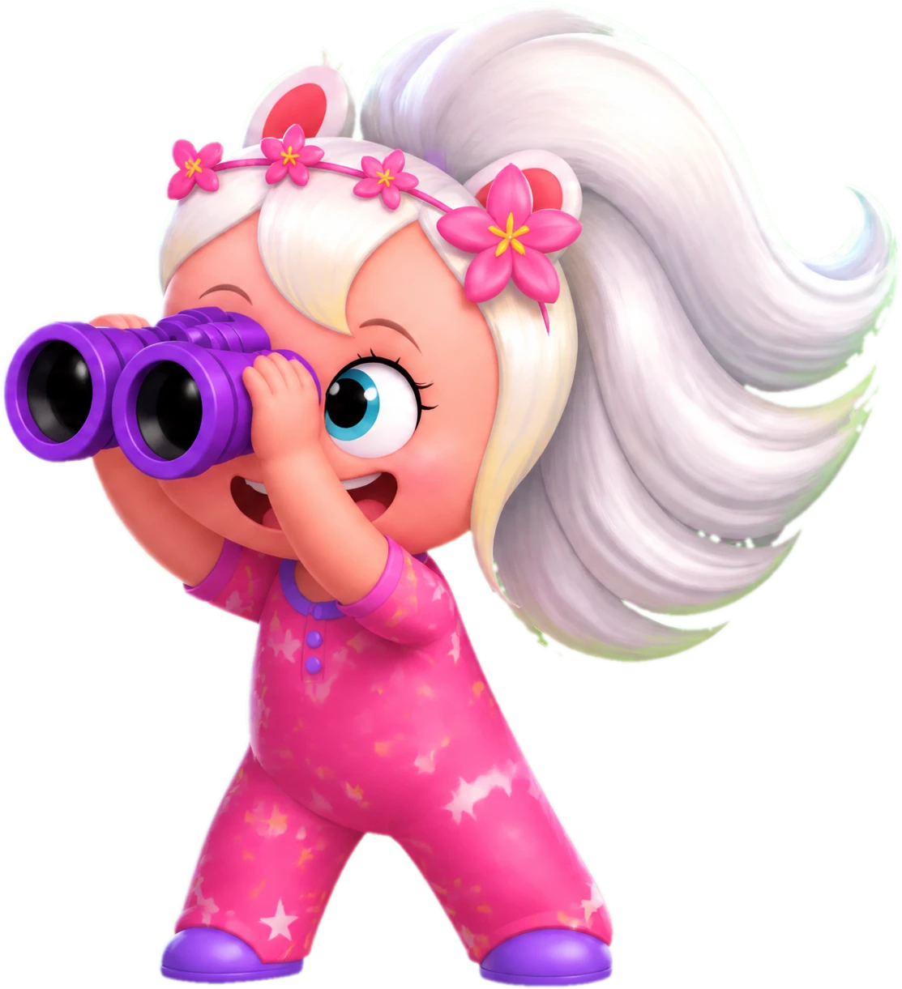
- Boo Boo: the original Stuffy Boo. He’s calm, dependable, and a legend around the Pillow Patch.
- 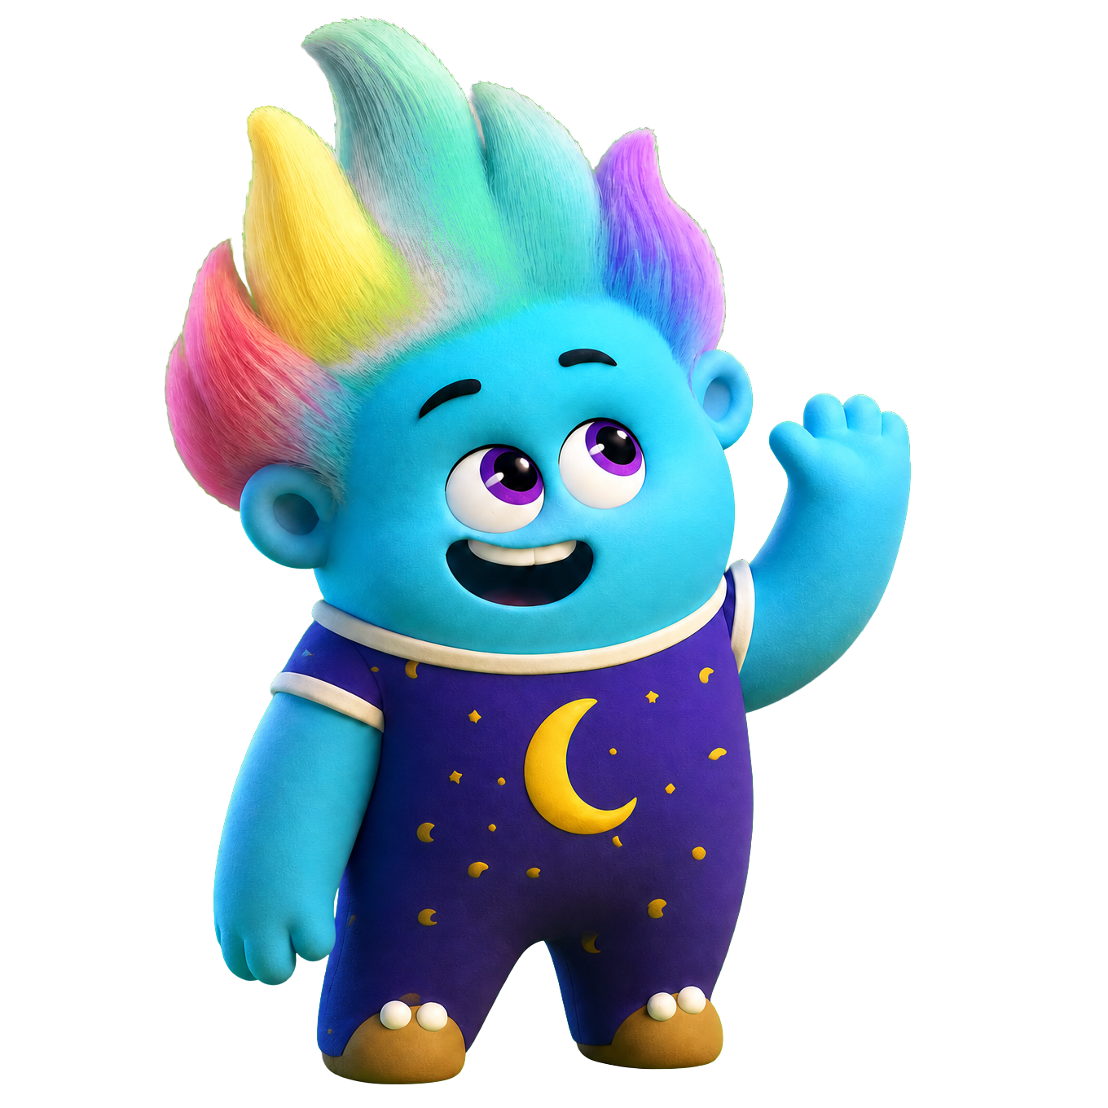

The Boos
- Snacky Boo: fully obsessed with snacks at all times. Eats a lot of snacks. He is goofy, crazy, and always thinking of food.
- 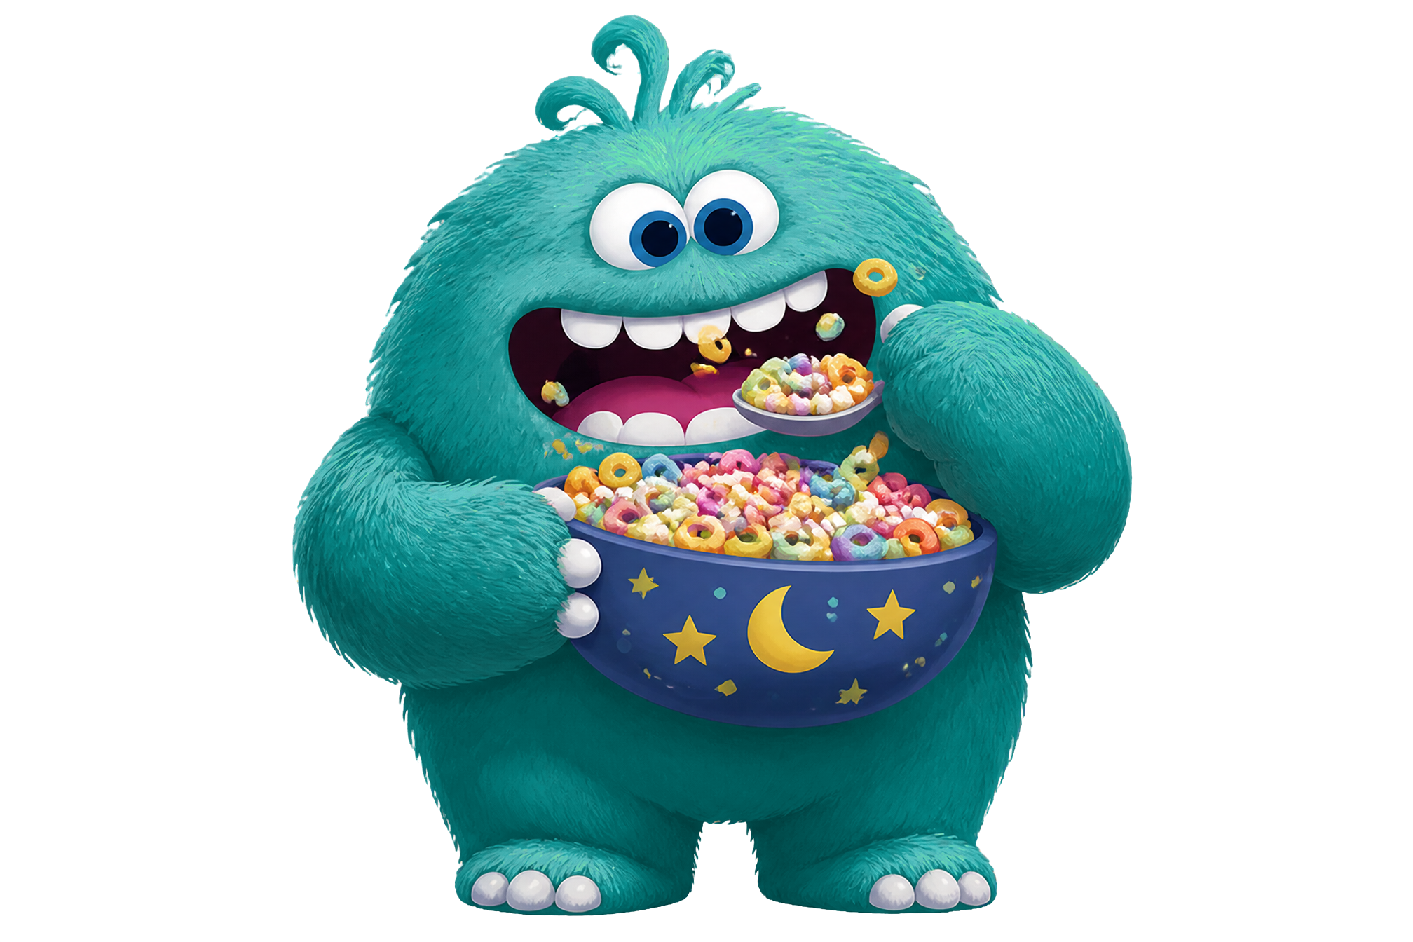
- Jammy Boo: jumps incredibly high, delivers the cosiest pyjamas in the Pillow Patch. She is energetic, crazy, and silly.
- 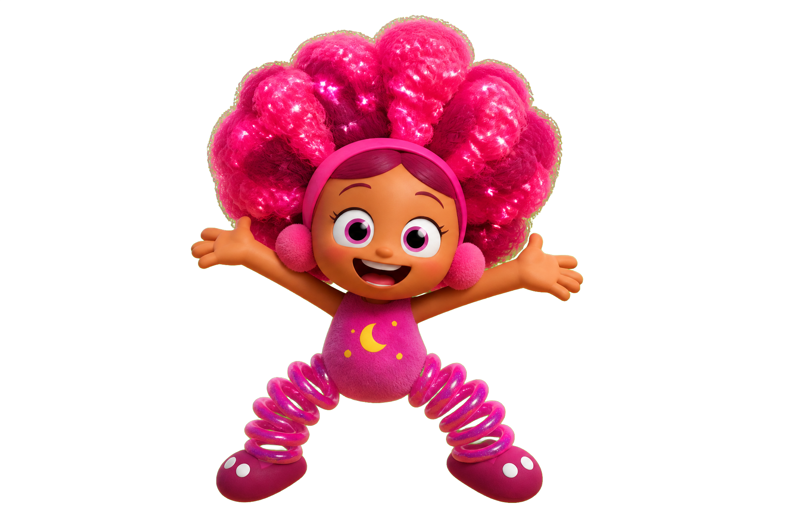
- Blanky Boo: always shows up with the warmest blanket you've ever seen. He is kind, cute, shy/quiet, and always cozy.
- 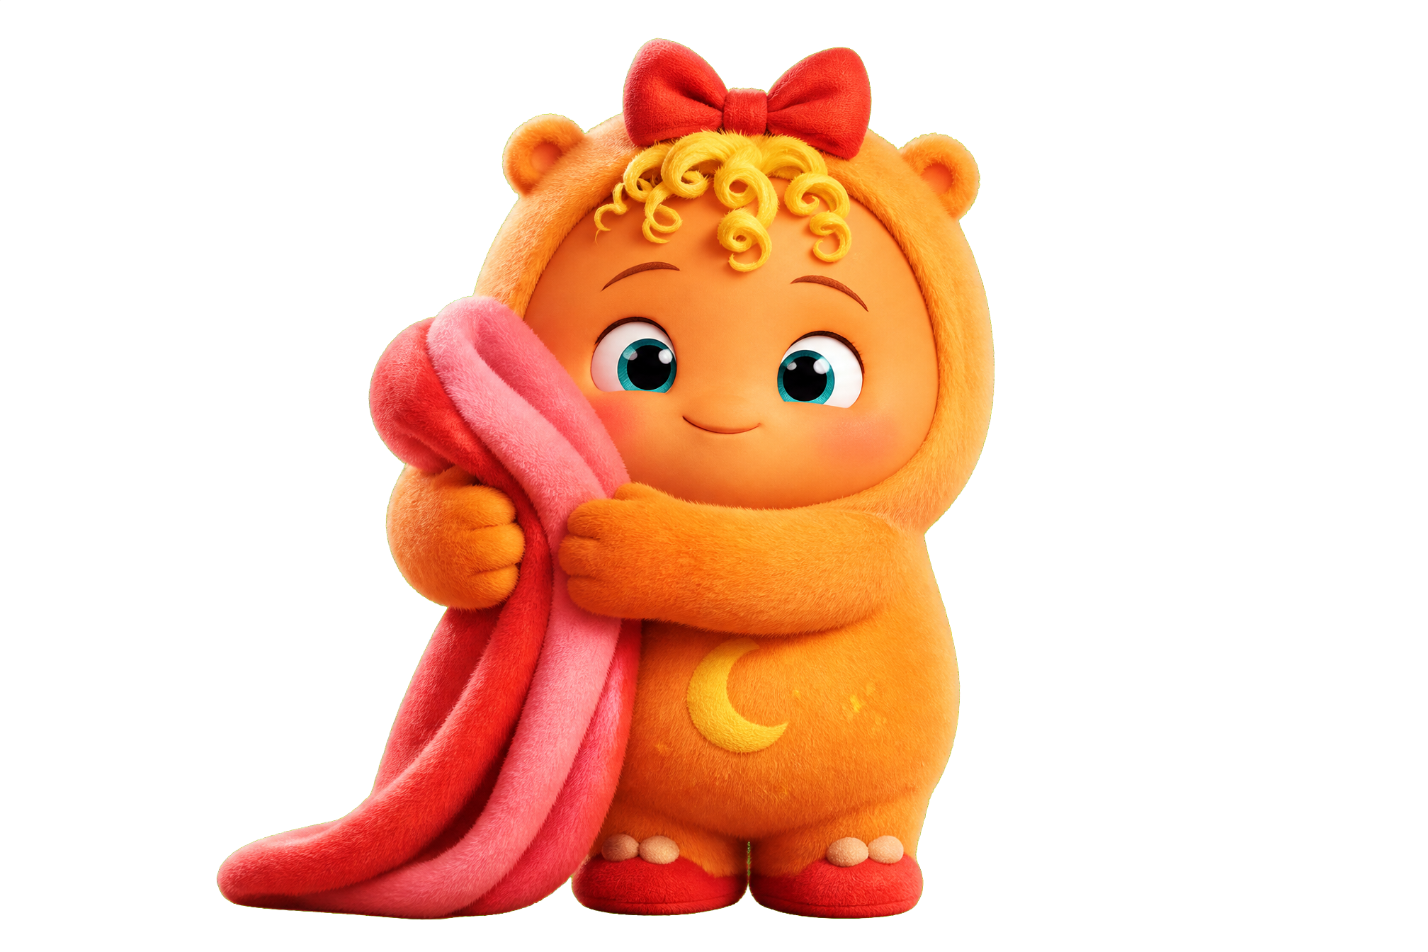
- Dreamy Boo: the storyteller of the group. Tells bedtime stories good enough to put any worked up child to sleep. Handles whatever an overactive imagination throws at them. He is calm, smart, kind, caring.
- 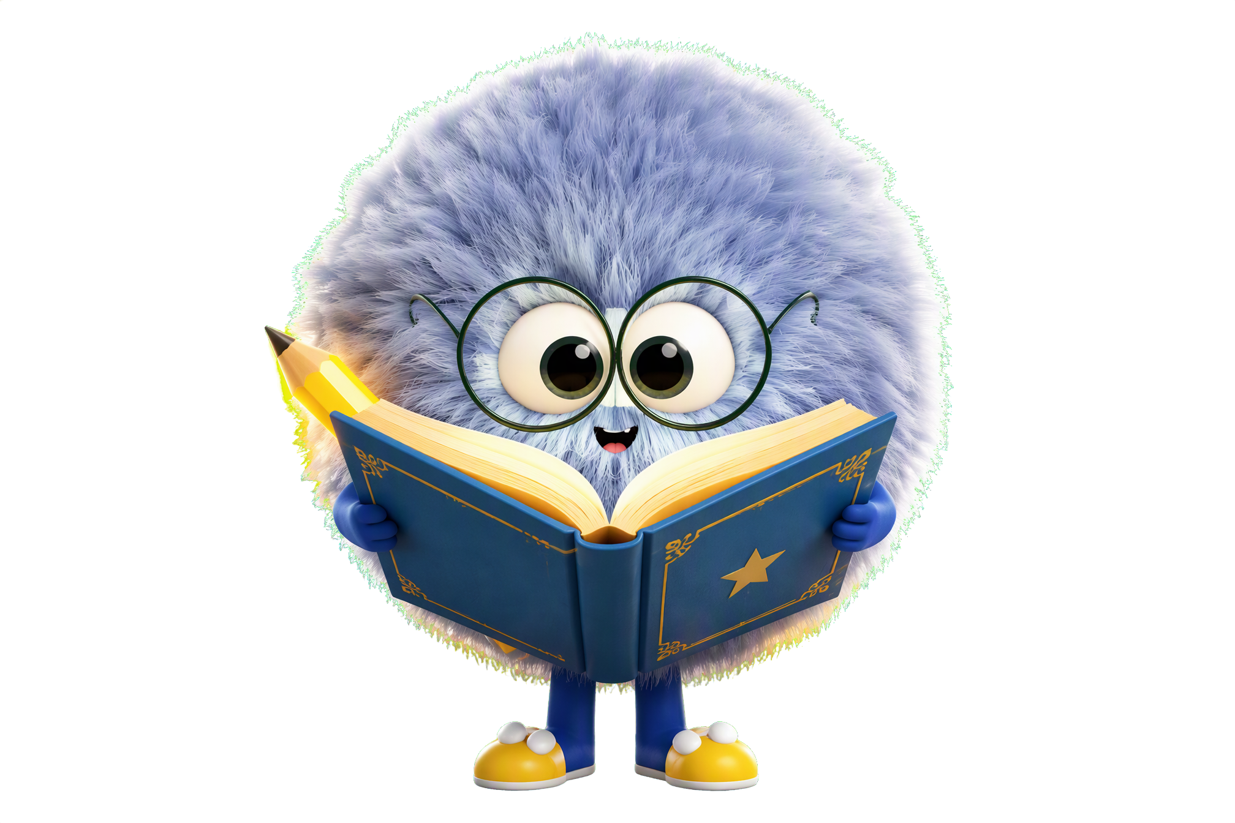
- Nighty Boo: glows in the dark. First pick for anything involving shadows or dark corners. Very proud of the glow. She’s energetic, quick, clever.
- 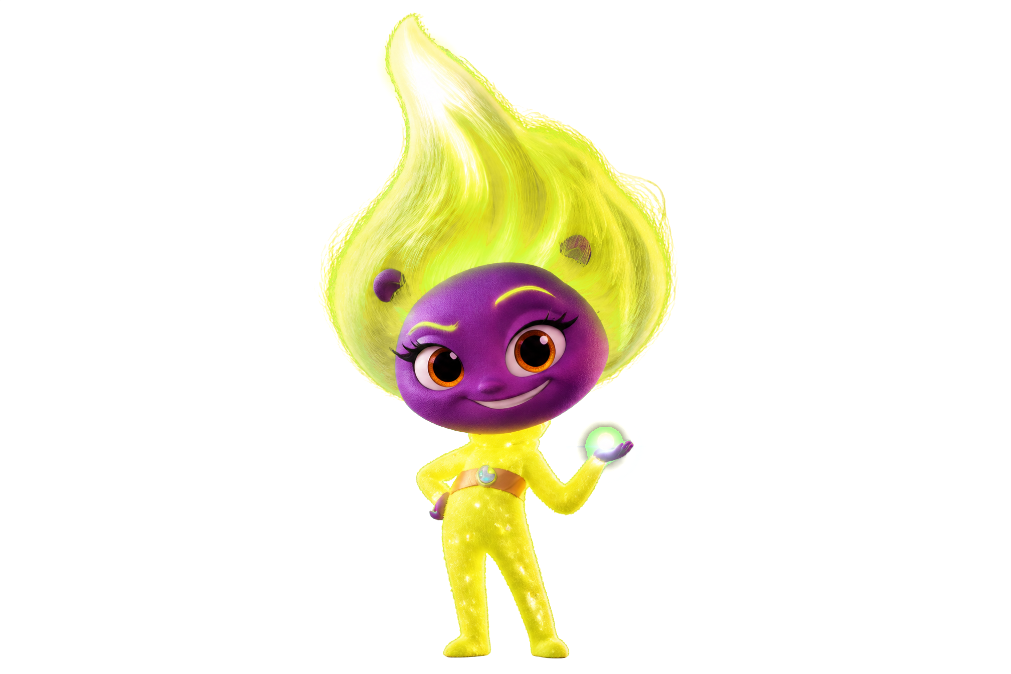

All seven Boos share the same art style and world, with different colours, accessories, and abilities. Same formula as Paw Patrol: one team, every character is collectible, every toy has a reason to exist.

3. Episode Format
Every episode follows the exact same structure on purpose. Kids that age love knowing what's coming, and the repetition is a big part of what makes it stick.
- Peek (or another squad member) spots a fear through the telescope or binoculars, something bothering a sleeping kid
- They call it in with the squad catchphrase, same line every single episode, every time. This is the moment kids start saying it along with the show.
- Everyone races back to Pillow Patch HQ with lights and sirens blaring
- The squad deals with it in a silly way, it gets resolved, and the kid goes back to sleeping safe and sound

Episodes run about 1 to 2 minutes. Short enough for TikTok and YouTube Shorts which is where the first audience is coming from anyway. Everything stays in the Pillow Patch, there's no back and forth to earth. Each of the first episodes will be introducing a new character until they’re all introduced.
Target audience: ages 2 to 6.
4. Marketing Strategies
Strategy 1: Owned Social Content
Build the Stuffy Boos audience before there's a product to sell. Treat the brand's social accounts like a mini-show and post consistently. Character introductions, Pillow Patch world reveals, silly fear-of-the-week content, all of it.
The goal is to have parents and kids already attached to Peek and the Boo’s by the time there's something to buy. Launch day should have a waiting audience instead of starting from zero.
- Platforms: TikTok (primary), Instagram Reels, YouTube Shorts
- Content: character introductions, episode teasers, Pillow Patch world-building, fear polls, behind-the-scenes clips
- Cadence: 3x per week minimum to start
- Cost: free to start but need animators to make videos
Strategy 2: Parent Micro-Influencer Outreach
Partner with parenting accounts on TikTok and Instagram in the 10K to 100K follower range. These are real parents posting about toddlers, bedtime, and kids entertainment, not celebrities. Micro-influencers in this range get significantly higher engagement for a fraction of the cost.
Offer founding family status: first access to the brand, exclusive content to share, free products, and a small payment to promote stuffy boos. It's the most cost effective reach available at this stage.
- Target: parents of kids aged 2 to 6, focus on bedtime, toddler emotions, and sleep
- Approach: personal DM, lead with the brand story before making any ask
- Cost: roughly $200 to $500 in product gifting and payment
Bigger Accounts: General Parenting
- Big Little Feelings (@biglittlefeelings): 4.2M Instagram followers, toddler emotions and bedtime content, direct fit for the brand
- Dr. Becky Kennedy (@drbeckyatgoodinside): 3.5M Instagram followers, parenting psychology and emotional coaching
- TheDadLab (@thedadlab): 2M+ across YouTube and Instagram, family activities and hands-on content
- The Considerate Mama (@theconsideratemama): 1.4M TikTok followers, parenting coach with a toddler focus
- Toddler Talk (@toddlertalkofficial): active TikTok community for toddler parents

Note: accounts at 1M+ followers charge $2,000 to $10,000 per post. For a lower budget, focus on the micro tier (10K to 200K): roughly $100 to $500 per post with better engagement.
Recommended Smaller Accounts: Mom Toy Review on TikTok
These accounts review toys from a parent perspective which is a direct match for a Stuffy Boos launch. All are in the micro or nano range, meaning lower cost and higher engagement.
- @lynnfinitelife: 66K followers, mom toy and lifestyle content
- @gracefulmommy: 170K followers, parenting and toy reviews
- @jessakatan: 65K followers, mom toy review content
- @workingmama40: 177K followers, working mom, parenting and toy content
- @pineconesandpacifiers: 16K followers, nano-influencer with high engagement, toy and baby content
Strategy 3: Email Waitlist
Run a "be the first to adopt a Stuffy Boo" campaign through the website. Parents sign up and get a message back as if their child has been matched with a specific character. Builds emotional investment before anything is available to buy.
- Tool: Mailchimp, free up to 500 contacts and $13 per month up to 5,000
- Hook: short 3-question quiz asking which Stuffy Boo will adopt your child
- Follow-up: welcome email from their matched Boo
- Cost: free to start

5. Animation: Fiverr Options
For producing 1 to 2 minute animated episodes, here are four Fiverr animators worth reaching out to. Prices are in CAD before service fees.
Option 1: lowbudgetanim
- Style: rigged 2D character with painted background, works well for TikTok and YouTube Shorts
- Basic: CA$66.44, 1 character, 25 seconds, 4-day delivery, 1 revision
- Standard: CA$287.89, 1 character, 55 seconds, 7-day delivery, 1 revision
- Premium: CA$583.16, 2 characters, 75 seconds, 14-day delivery, 1 revision
- fiverr.com/lowbudgetanim
Option 2: Sanii Art (saniaakbar8786)
- Style: 2D and 3D character animation in Full HD, best value for runtime per dollar
- Basic: CA$73.82, 1 character, 30 seconds, 1-day delivery, 8 revisions
- Standard: CA$118.11, 3 characters, 60 seconds, 3-day delivery, unlimited revisions
- Premium: CA$221.45, 4 characters, 120 seconds, 4-day delivery, unlimited revisions
- fiverr.com/saniaakbar8786
Option 3: victor_d0
- Style: 2D cartoon and anime character animation
- Premium: CA$332.18, check profile for Basic and Standard package details
- fiverr.com/victor_d0
Option 4: Nahua (aime_lorenzo)
- Style: cut-out animation with production-ready rigs, best option for ongoing episodic work
- Basic: CA$664.36, 1 character, 60 seconds, 4-day delivery, 1 revision
- Standard: CA$944.86, 2 characters, 60 seconds, 7-day delivery, 2 revisions
- Premium: CA$1,300, 4 characters, 60 seconds, 14-day delivery, 3 revisions
- Hourly rate: CA$46.73 per hour, good for ongoing episode production
- fiverr.com/aime_lorenzo

When reaching out: send a short description of the Stuffy Boos concept, 2 to 3 character reference images, the length needed, and the number of characters. Ask for a custom quote on a full pilot episode.

6. Budget Allocation:
- Domain and hosting: stuffyboos.com is 18$ for 1 year (GoDaddy.com)
- Pilot episode animation: $500 to $2,000 for one 90-second episode from a Fiverr animator
- Micro-influencer outreach: $500 to $1,500 for 1 to 3 sponsored posts from targeted parenting accounts
- Email marketing: $0 to $50, Mailchimp free tier covers first 500 contacts
- Reserve: remaining funds held for extra animation rounds or anything unexpected that comes up

Priority order: get the website live and email signup connected first (zero cost), claim social handles, then put the remaining budget toward one strong pilot episode.

