Milestone One: Machine Learning Analysis of Healthcare Datasets
Module C: Data Science Capstone DX 799
Brenna Yoshioka

1. Project Description
This project utilizes supervised machine learning techniques to analyze three publicly available healthcare datasets, aiming to explore predictive modeling for clinical outcomes. The three datasets are: (1) the CDC Behavioral Risk Factor Surveillance System (BRFSS) Diabetes Health Indicators dataset (df1), containing 433,323 survey responses with a binary diabetes diagnosis target; (2) the UCI 130-US Hospitals Diabetic Patient dataset (df2), containing 101,766 hospital encounter records with a 30-day readmission target; and (3) the Kaggle Stroke Prediction dataset (df3), containing 5,109 patient records with a binary stroke outcome target.
The central question across all three datasets is whether demographic, behavioral, and clinical features can reliably predict health outcomes. Accurate prediction of diabetes, hospital readmission, and stroke risk has significant clinical and economic implications. Early identification of high-risk patients enables preventive intervention, reduces unnecessary hospitalizations, and can improve allocation of healthcare resources. Each dataset presents unique modeling challenges, including class imbalance (a stroke rate of only 4.9% in df3), high dimensionality after encoding (123 features in df2), and a large sample size requiring computational efficiency (over 430,000 rows in df1).

2. Modeling Techniques Overview
The following sections briefly cover Weeks 1, 2, 4, and 5. Weeks 3 and 6 are covered in depth in Sections 3 and 4.

Week 1: Polynomial and Interaction Terms
Linear regression with polynomial and interaction terms was applied to all three datasets. For df1, continuous features were expanded with squared terms and pairwise interactions (17 to 23 features). VIF analysis confirmed that no multicollinearity was introduced. The interaction model produced the highest df1 AUC (0.818), driven by a BMI x Age interaction term. For df3, one-hot-encoded categorical features produced infinite VIF scores due to perfect multicollinearity between dummy variable groups, a known limitation of full encoding without a reference category.

Week 2: Ridge, Lasso, and Elastic Net Regression
Regularization was applied across all three datasets. For df1, Ridge, Lasso, and Elastic Net all produced AUC near 0.814. Lasso zeroed 5 features but offered little discriminative gain. The most meaningful result was df2, where Ridge (AUC = 0.644) outperformed unregularized regression (0.601), demonstrating the benefit of coefficient shrinkage under high dimensionality. Polynomial terms overfit on df2 (AUC = 0.526). Overfitting was mitigated via regularization penalties and held-out test evaluation.

Week 4: Logistic Regression and Feature Scaling
Logistic regression was applied with four scaling conditions. For df1 and df3, scaling had a negligible effect (within 0.001 AUC), as L2-regularized logistic regression is immune to scaling when features are on comparable ranges. For df2, MinMaxScaler produced the best AUC (0.598) vs. StandardScaler (0.542), suggesting bounded scaling better handles the skewed count features. Overall AUC: 0.817 (df1), 0.550 (df2), 0.840 (df3). Overfitting was controlled using the default L2 penalty.

Week 5: Support Vector Machines
SVMs with linear and RBF kernels were applied to all three datasets. Approximation replaced standard SVC for df1 and df2 due to dataset size, LinearSVC, and the Nystroem kernel. For df1, linear and RBF kernels performed similarly (0.816 vs. 0.819). For df2, both achieved an AUC of about 0.672. The most notable result was df3, where the linear kernel (0.834) outperformed RBF (0.788), suggesting stroke risk is largely linearly separable and the nonlinear kernel introduced overfitting. C was swept across five values (0.01–100) to examine regularization effects. Features were standardized via StandardScaler.

3. Deep Dive: Week 3 — Feature Selection, PCR, and PLSR
Week 3 applied forward selection, backward selection, PCR, and PLSR to all three datasets. The most interesting result: backward selection on df2 improved AUC from 0.601 to 0.823, a 22-point gain (Figure 1).

Overfitting and Feature Selection
Feature selection reduces overfitting by removing irrelevant predictors. Df2 contains 122 features after preprocessing; many features are sparse one-hot-encoded diagnosis and discharge indicators.
Backward selection on df2 selected 61 features and achieved AUC = 0.823, the highest of any method across all six weeks. Forward selection also selected 61 features, but reached only 0.735, starting from the full model, and pruning preserves correlated feature clusters that greedy forward inclusion misses. For df1 and df3, backward selection matched the baseline within 0.001 AUC.
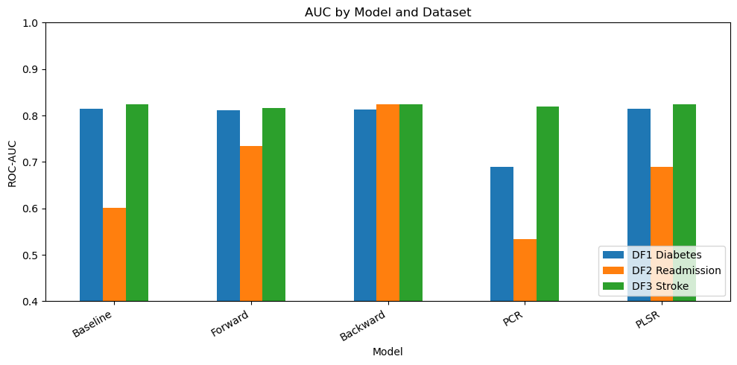
Figure 1. AUC by method across all three datasets for Week 3 approaches (baseline, forward selection, backward selection, PCR, PLSR). Backward selection on df2 achieves the highest AUC of any method in the project (0.823).

PCR vs. PLSR
PCR and PLSR are fundamentally different: PCR computes principal components via unsupervised PCA, while PLSR finds components that directly maximize covariance with the target. This distinction results in dramatically different results.
For df1, PCR needed only 2 components for 95% variance, but collapsed AUC to 0.689, since those components captured feature variance with no regard for the diabetes target. PLSR found 6 components that preserved the predictive signal and matched the 0.814 baseline exactly. This is the core limitation of PCR: maximum variance in X doesn’t always result in maximum predictive power for y.
For df3, PCR (11 components) achieved 0.819 while PLSR (5 components) matched the baseline at 0.824. For df2, both methods underperformed selection-based approaches, consistent with the readmission target being weakly correlated with individual features.

Hyperparameter Tuning
PCR components were set by 95% variance explained. PLSR components were selected by test-set AUC across 1–20 components. No formal cross-validation was used, but this didn’t have a major effect on the analysis. Optimal counts were modest: 6 (df1), 2 (df2), 5 (df3).

Expected and Unexpected Results
The backward selection jump on df2 (0.601 to 0.823) was the most unexpected finding of the project: a 22-point gain from just feature removal. The PCR collapse on df1 (0.689) was theoretically expected: 2 components capturing 95% of feature variance retained almost none of the predictive signal, confirming that the key directions of input variation do not align with the diabetes target.

4. Deep Dive: Week 6 — Decision Trees and Random Forests
Week 6 applied decision trees and random forests to all three datasets, producing the starkest contrast between an overfitting model and an ensemble correction in the project.

Overfitting in Decision Trees
An unconstrained decision tree splits until each leaf contains a single sample, perfectly memorizing training data but generalizing poorly. Unlimited-depth trees here achieved AUC of 0.590 (df1), 0.525 (df2), and 0.576 (df3), near random on datasets where an AUC above 0.80 is possible.
The max_depth sweep (depths 2, 3, 5, 10, 20, and unlimited) revealed the bias-variance tradeoff directly (Figure 2). Shallow trees (depth 2-3) exhibited high bias, underfitting by oversimplifying the decision boundary. As depth increased to 5-10, AUC improved, reflecting better capture of the underlying patterns. Beyond depth 10-20, performance degraded as the tree began fitting noise. This pattern was consistent across all three datasets, confirming that tree depth is a critical regularization parameter.
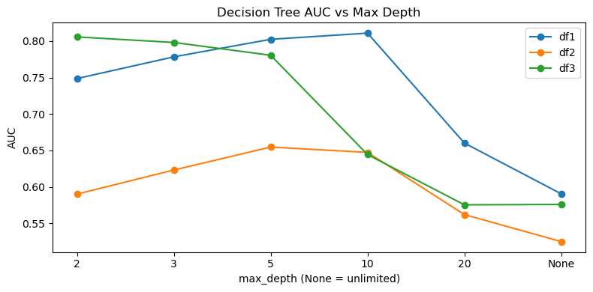
Figure 2. Decision tree AUC vs. max depth across all three datasets. AUC peaks around depth 5–10 and collapses at unlimited depth, illustrating the bias-variance tradeoff.

Random Forests as an Ensemble Solution
Random forests address overfitting through bagging (each tree trained on a bootstrap sample) and feature randomization (a random feature subset considered at each split). These two sources of randomness decorrelate the trees so their errors partially cancel in the aggregate.
The results demonstrated this correction clearly (Figure 3). Random forests (100 trees) recovered AUC to 0.789 (df1), 0.654 (df2), and 0.795 (df3); all substantially above the unlimited-depth single tree, and competitive with or exceeding logistic regression on df1 and df3. The df2 improvement from 0.525 (DT) to 0.654 (RF) is particularly notable given the difficulty of that dataset across all methods.
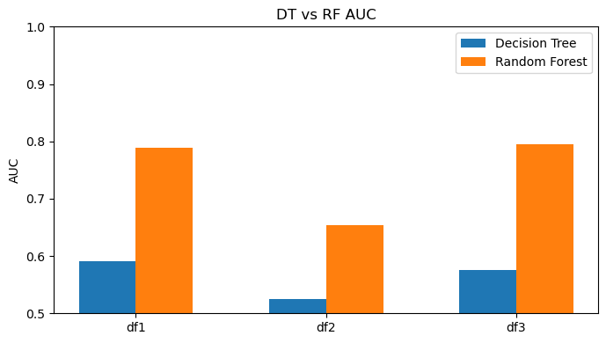
Figure 3. Decision tree vs. random forest AUC across all three datasets. Random forests recover substantially from the near-random unlimited-depth tree baseline.

Feature Importances
Random forests provide feature importances via mean Gini decrease across all splits. For df1, top features were BMI, age group, and general health status — consistent with known diabetes risk factors (Figure 4). For df3, age and average glucose level ranked highest, reflecting their well-documented roles in stroke prediction (Figure 5). For df2, the inpatient visit count (number_inpatient) and number of diagnoses ranked highly (Figure 6), which aligns with clinical intuition that patients with more complex prior histories are more likely to be readmitted.
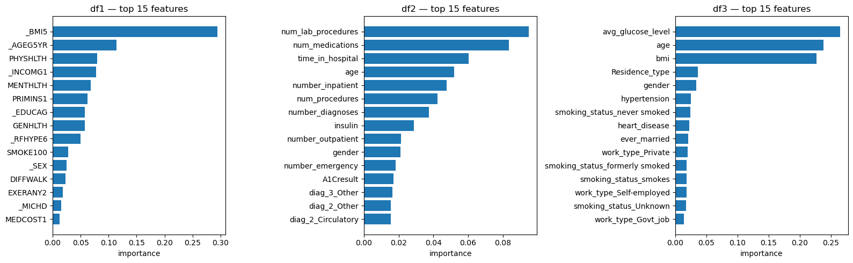
Figure 4. Random forest feature importances (top 15) for df1 (diabetes), df2 (readmission), and df3 (stroke). BMI and age dominate df1; lab procedures and medications dominate df2; glucose level and age dominate df3.

Hyperparameter Tuning and Metrics
ROC-AUC was the primary metric, appropriate for the class-imbalanced outcomes in all three datasets. For decision trees, max_depth was swept across six values. Random forests used n_estimators = 100, a standard default; no formal cross-validation was performed on this parameter.

Expected and Unexpected Results
The near-random unlimited-depth AUC was expected but striking. More surprising was that random forests on df1 (0.789) underperformed logistic regression (0.817) and SVM (0.819) — likely because df1 features are largely binary/ordinal with linear target relationships, favoring linear models. Random forests were closer on df3 (0.795 vs. 0.840), where continuous features like age and glucose may have nonlinear effects that trees begin to capture.

5. Conclusions
Several consistent findings emerged. Df1 (diabetes) was the most predictable dataset (AUC 0.81–0.82 across most methods), reflecting strong linear associations between health indicators and diabetes status. Df2 (readmission) was the most challenging (AUC 0.55–0.67 for most methods; only backward selection exceeded 0.80), likely because 30-day readmission depends on post-discharge factors absent from the inpatient record. Df3 (stroke) showed the widest performance range (0.576 for default DT to 0.840 for logistic regression), indicating high sensitivity to method choice.
The most impactful single result was backward selection on df2 (0.601 to 0.823), suggesting that for high-dimensional clinical data, eliminating irrelevant features outweighs choosing a more complex model. The PCR vs. PLSR comparison reinforced a core principle: dimensionality reduction that ignores the target can severely degrade performance even when feature variance is preserved.
Overfitting was the dominant challenge across tree-based models, with unlimited-depth decision trees near chance-level. Random forests corrected this through ensemble aggregation but did not surpass logistic regression on any dataset, consistent with the broader literature (Christodoulou et al., 2019; Van Calster et al., 2025).

6. Exploratory Data Analysis
Exploratory data analysis informed preprocessing across all three datasets. In df1, the DIABETE4 variable contained four categories; EDA clarified that only diabetic (1) and non-diabetic (3) cases should be retained for clean binary classification. In df2, max_glu_serum and A1Cresult were 95% and 83% missing respectively, motivating zero-imputation (treating missing as not tested). In df3, a single row with gender coded as Other was dropped to enable binary encoding. Class imbalance was identified across all datasets (14.4% positive in df1, 11.1% in df2, 4.9% in df3) and motivated use of ROC-AUC over accuracy as the primary metric.

7. AI Appendix
Claude (Anthropic) was used as an AI assistant to grade a rough draft of the paper against the provided rubric. The assistant graded the draft an 88/100, and edits were made based on feedback. Not all feedback was followed.

References
Christodoulou, E., Ma, J., Collins, G. S., Steyerberg, E. W., Verbakel, J. Y., & Van Calster, B. (2019). A systematic review shows no performance benefit of machine learning over logistic regression for clinical prediction models. Journal of Clinical Epidemiology, 110, 12-22.
Fedesoriano. (2021). Stroke prediction dataset [Dataset]. Kaggle. https://www.kaggle.com/datasets/fedesoriano/stroke-prediction-dataset
Strack, B., DeShazo, J. P., Gennings, C., Olmo, J. L., Ventura, S., Cios, K. J., & Clore, J. N. (2014). Impact of HbA1c measurement on hospital readmission rates: Analysis of 70,000 clinical database patient records. BioMed Research International, 2014.
Tahmasbi, S. (2023). Diabetes health indicators [Dataset]. Kaggle. https://www.kaggle.com/datasets/siamaktahmasbi/diabetes-health-indicators
Van Calster, B., Wynants, L., Timmerman, D., Steyerberg, E. W., & Collins, G. S. (2025). Predictive analytics in health care: How can we know it works? Journal of Medical Internet Research, 27.

