**Purpose:** The purpose of this tool is to measure the temperature of things that require you to break the outer surface using a sharp object.

**Application:** There could be many applications of this product, from culinary kitchens to labs that require the temperature measurements of liquids.

**How it works:** Based on our perspective, it’s easy to see there is a thermistor connected by two conductive wires to a PCB. Given this, it’s safe to assume that the thermistor is reporting resistance to the PCB which is computing its resistance into a temperature value. It’s powered by a battery in the back and controlled by the several push buttons on the screen cover

**What We See:** From the exploded view we can see the thermometer is controlled by a main PCB that acts like a “motherboard” We can also see how the battery fits into the casing as well as the rubber casket used to keep the PCB safe from various chemicals that may try to creep in. A screen also connects to this PCB which fits into a outer casing with a clear plastic hole to allow the user to see the screen but also keep it sealed in the casing.

**Disassembly:**

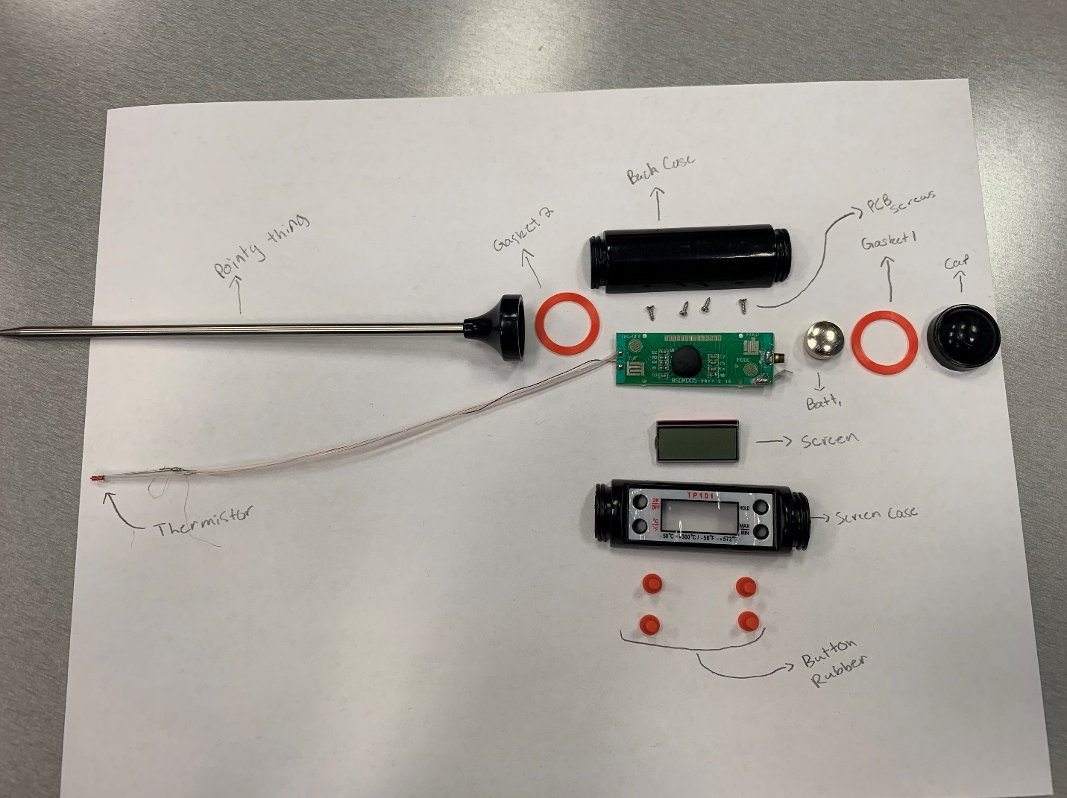

**Reassembly:**

My team was able to completely reassembly the thermometer to a working state.

**Parts List:**

Back/Front Case: Used to protect the PCB from external forces

Rubber Gaskets: Helps seal off the casing and is aesthetic

Cap: Protects the battery

Metal Probe: Used to get the temperature of a specific object or liquid

Thermistor Circuit: Facilitates the calculation of temperature based on total resistance

Battery: Powers the entire system

Buttons: Helps control the circuit

**Redesign:**

The system is pretty well put together, but I am not the biggest fan of the rubber buttons on the front. These were very poorly made and could be easily broken leaving a specific button unusable. I think they should be replaced by plastic or maybe even aluminum metals.