

|  |  |
| --- | --- |
| Student Name: Brennen Green | Date: 10/08/2019 |
| Course: EGR102-001 |  |

Assignment – Food Line Monitor

Description:

Schematic

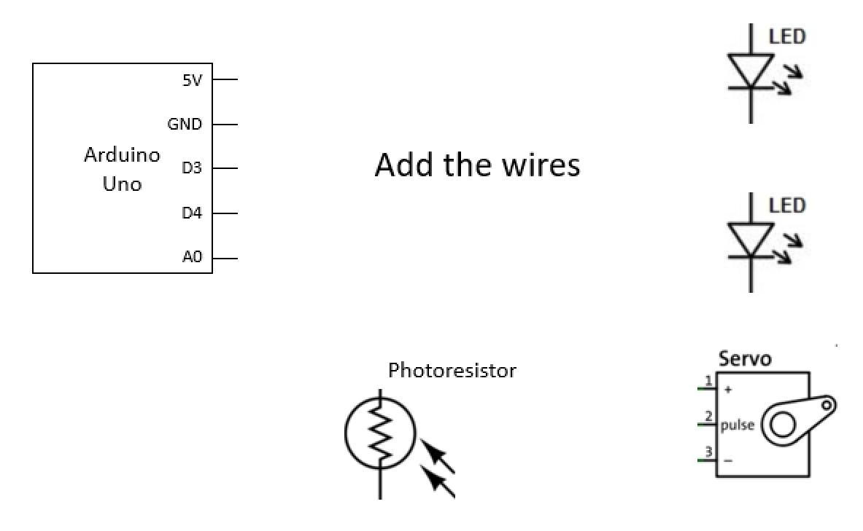

Image of Circuit

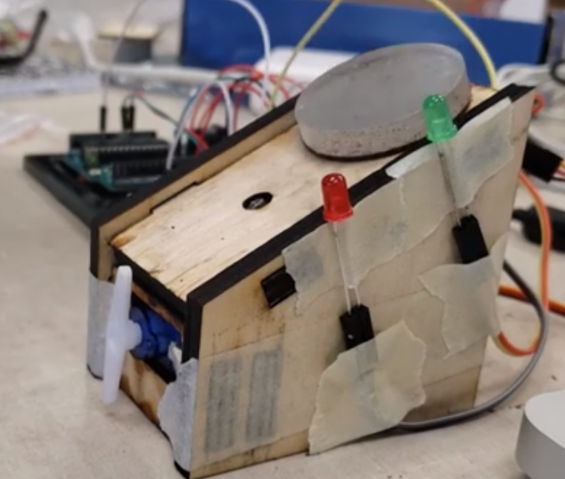

Insert an image of your circuit