WK4: In-class Exercise

Use wk1-tempConvert & wk3-mpg.js as references for this exercise. The HTML (wk4-temp.html) for the following is provided. You have to write the JavaScript to make it work.

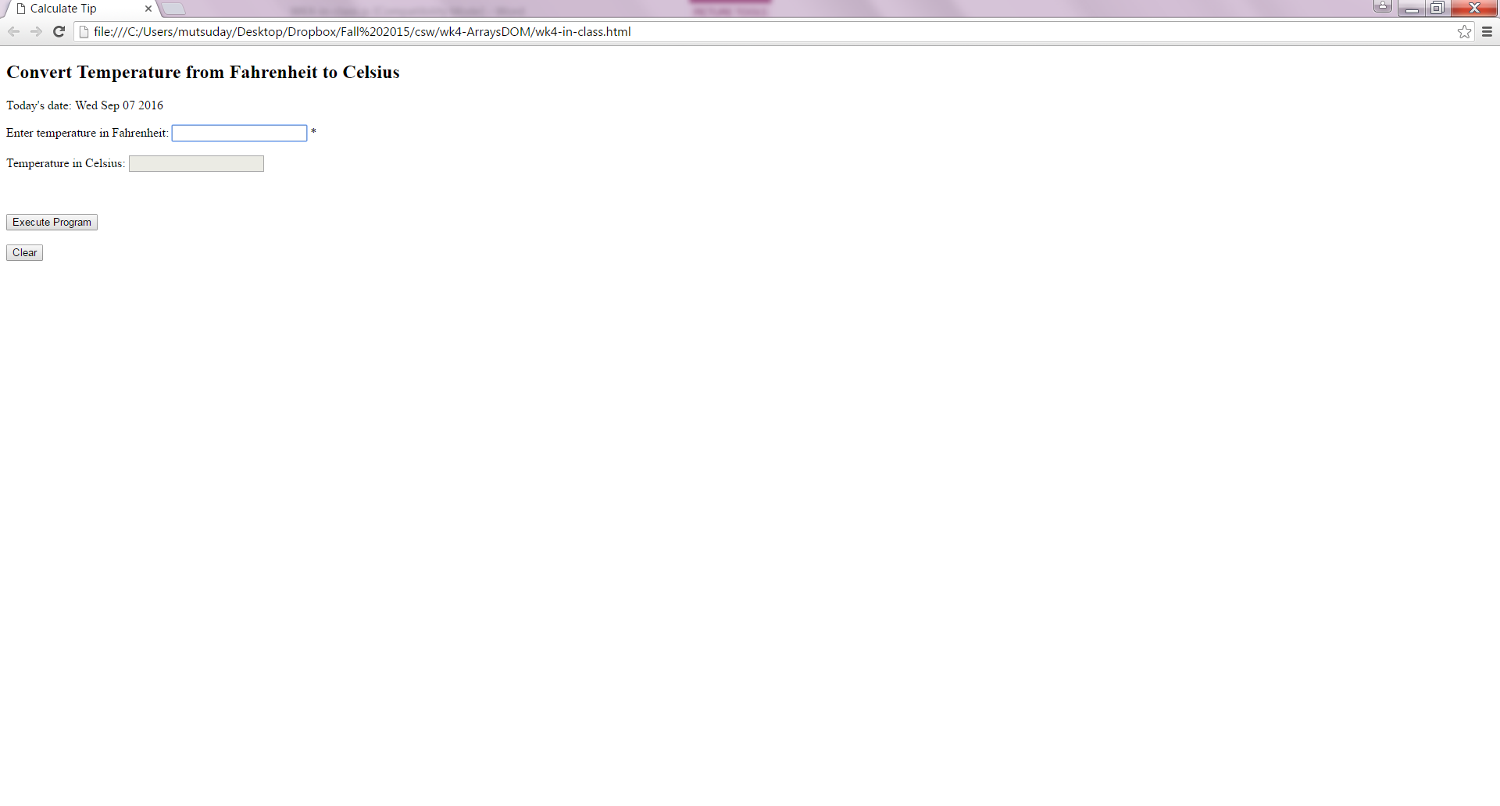

Print an error message in place of the \* when letters are entered. Negative numbers are ok. Use the span tag to do this.

Use the clear button which on click clears all the textboxes and span texts.

Use the console.log function to trace the execution of the program.

Challenge: When the textbox is in focus (Event: focus, Event Handler: onfocus), change the background color of the textbox. When the textbox is out of focus (Event: blur, EventHandler: onblur), change the background color of the textbox back to white.

Here’s how you can change background color of a TextBox with id “textBoxID”:

$("textBoxID").style.backgroundColor = "yellow";

where $ is the function that returns an element object.