Brennon Fultz

DAD 220

RMA Data Analysis Report

SQL Queries and Resultant Output:

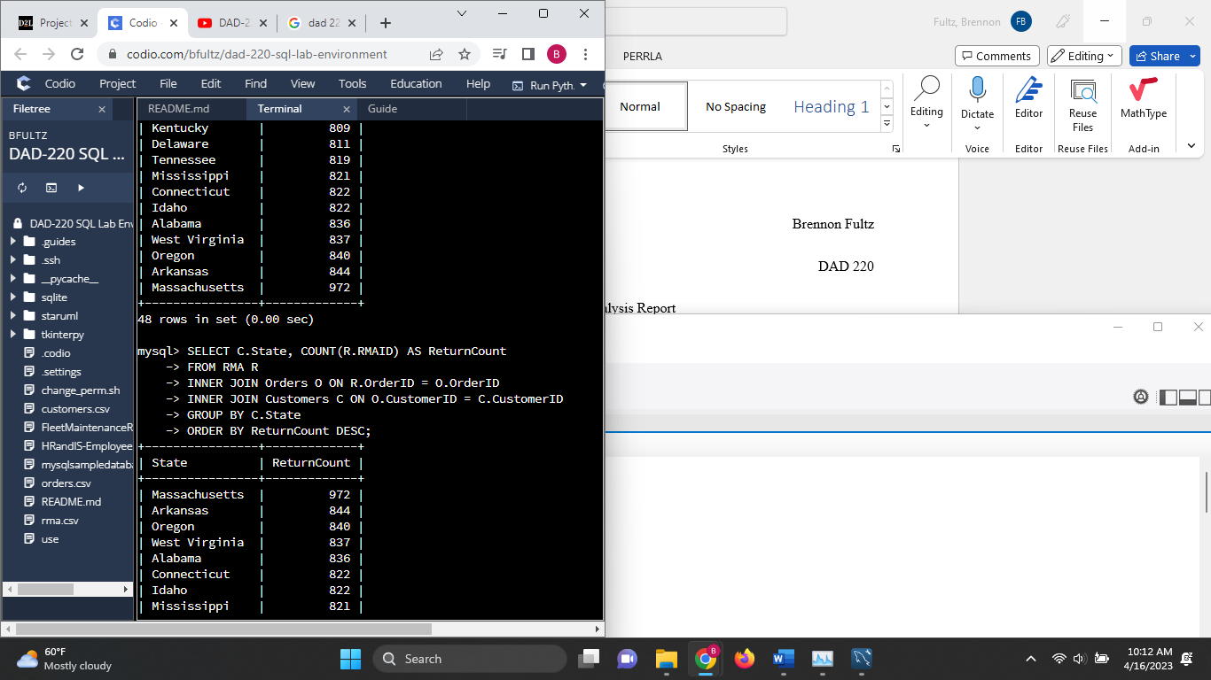

COMMAND: SELECT C.State, COUNT(R.RMAID) AS ReturnCount

FROM RMA R

INNER JOIN Orders O ON R.OrderID = O.OrderID

INNER JOIN Customers C ON O.CustomerID = C.CustomerID

GROUP BY C.State

ORDER BY ReturnCount DESC;

This query produces the number of returns by state, in descending order.

COMMAND: SELECT O.SKU, COUNT(R.RMAID) AS NumReturns,

(COUNT(R.RMAID)/(SELECT COUNT(\*) FROM RMA)\*100.0) AS ReturnPercent

FROM Orders O

LEFT JOIN RMA R ON O.OrderID = R.OrderID

GROUP BY O.SKU

ORDER BY ReturnPercent DESC;

This query produces the percent of total returns for each product type.

Analysis

The data in the Quantigration database revealed that the company has the most returns in the state of Massachusetts, with a total of 972 returns in that state. This was followed by Arkansas with 844 returns, Oregon with 840 returns, and West Virginia with 837 returns. This was an expected result relative to the sales figures in these states. Regarding the products most frequently returned, BAS-48-1 C accounted for 22 percent of returns, followed by ENT-48-40F with 16 percent of returns. ENT-48-10F, BAS-08-1 C, and ENT-24-10F also represented 11 percent of returns each.

This data set would imply that location has little impact on returns compared to the products themselves. The information gathered here could be used to direct efforts to improve certain products that have higher return rates. The trends indicated in this data set could be further investigated by comparing the number of returns in each state to the number of orders to produce a rate of return statistic that may be more useful than just the number of returns per state. The same could be done with the data on which products were returned by comparing the total sales for each SKU with the total returns for each SKU. As for the data requested in this report, it has also been organized in chart form below.