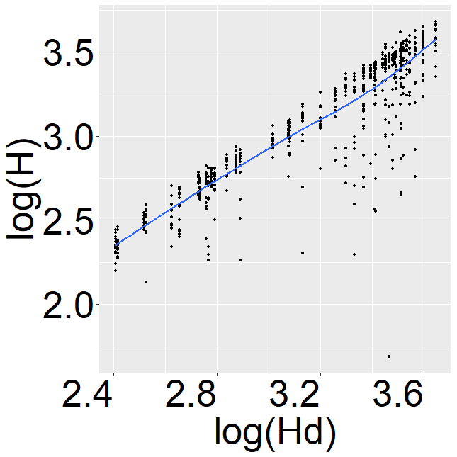  (a) | 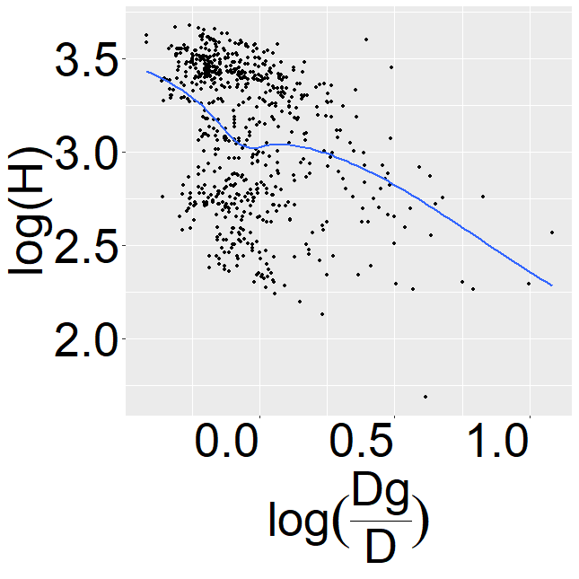  (b) | 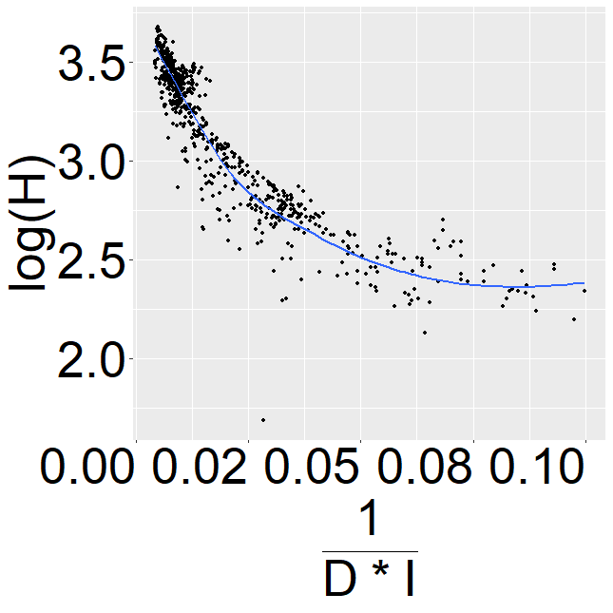  (c)
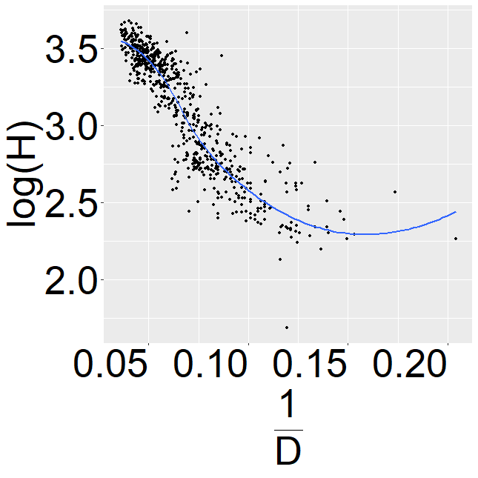  (d) | 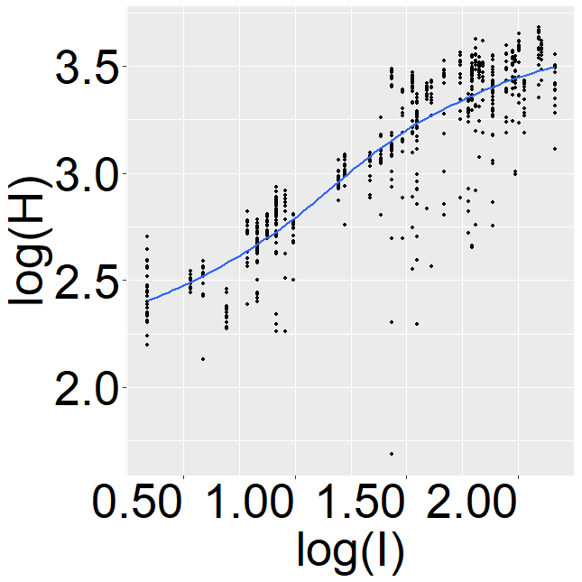  (e) | 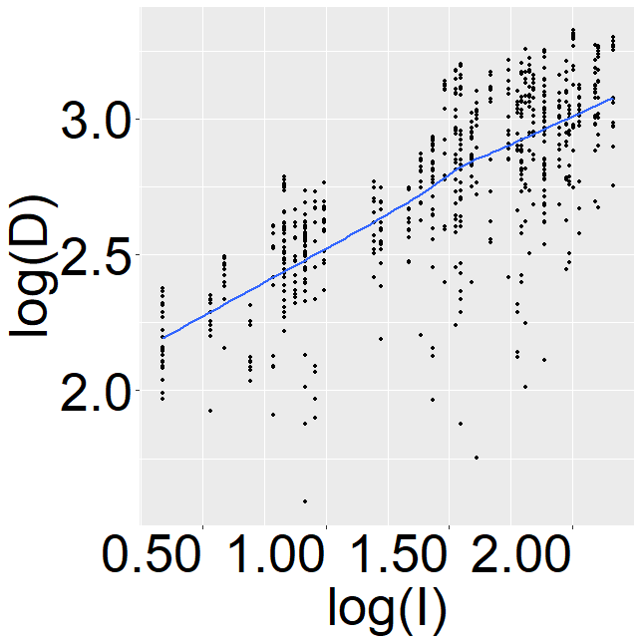  (f)
Fig. 1. Comparative scatterplots displaying the relationships between $log(H)$ as a function of: (a) $log\left(Hd\right)$, (b) $log\left(\frac{Dg}{D}\right)$, (c) $\frac{1}{D*I}$, (d) $\frac{1}{D}$ (e) $log\left(I\right).$ and $log(D)$ as a function of: (f) $log\left(I\right).$

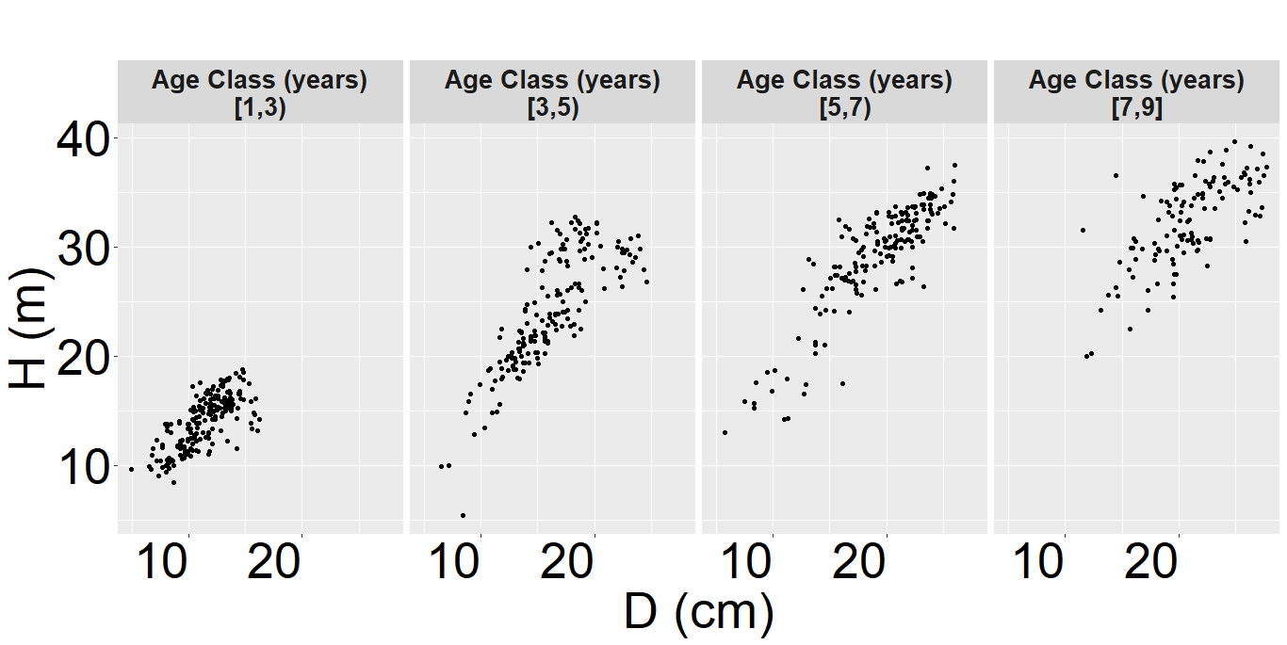
Fig. 2. Total height (H) (m) as a function of diameter ($D$) (cm) grouped by Age Classes.

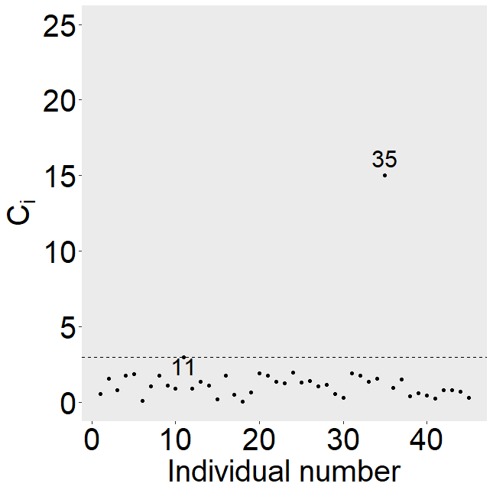
Fig. 3. Index plot of total local influences $C_{i}$ of the individuals per stand of the Forestry data set.

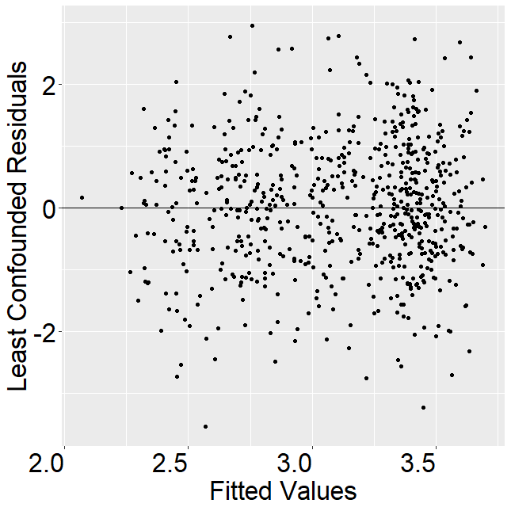  (a) | 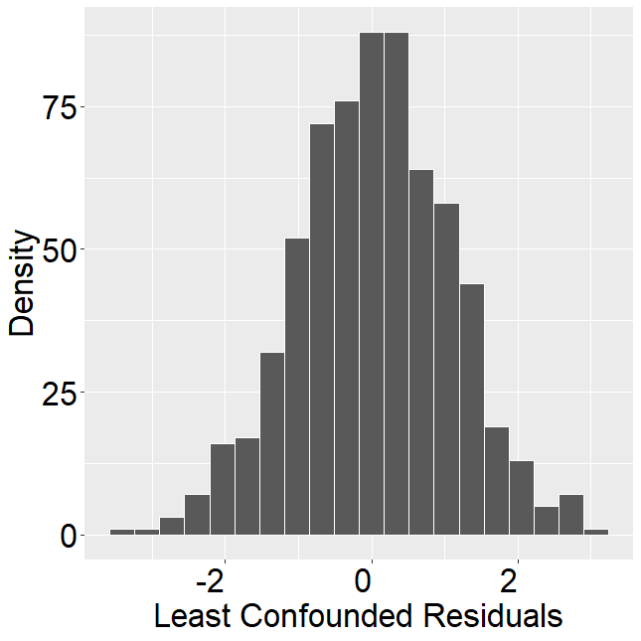  (b) | 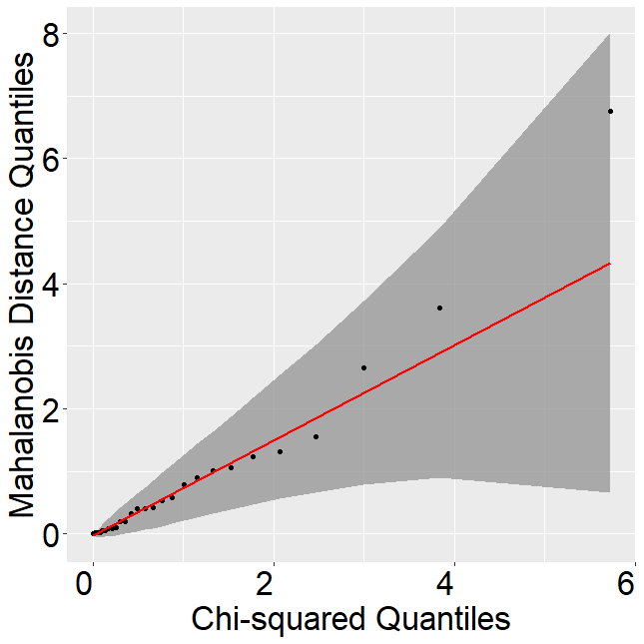  (c)
Fig. 4. (a) Dispersion plot for the least confounded residuals vs. fitted values. (b) Histogram of the least confounded residuals. (c) Quantiles of $χ^{2}$ vs. Mahalanobis quantile distance.

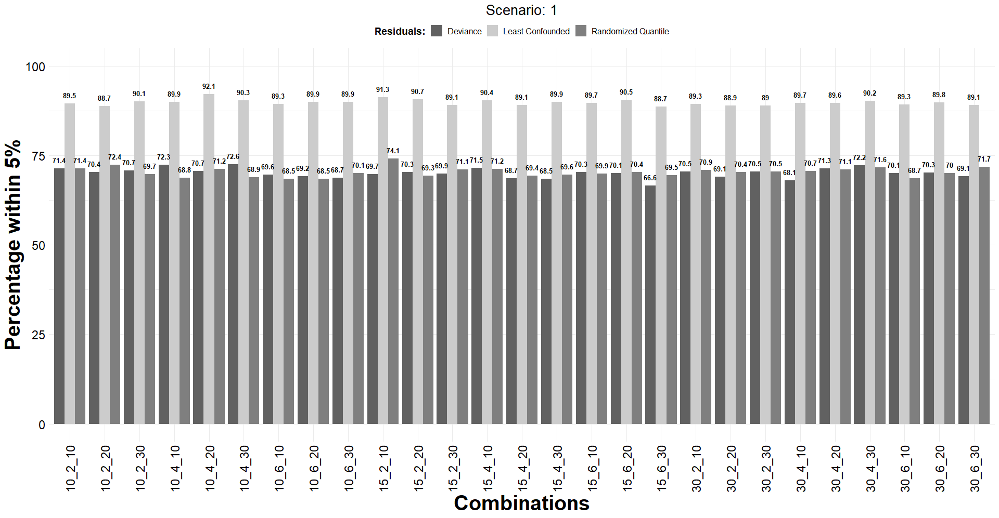
Fig 5. Percentage of residuals within the 5% threshold across fixed factor combinations in Scenario 1.

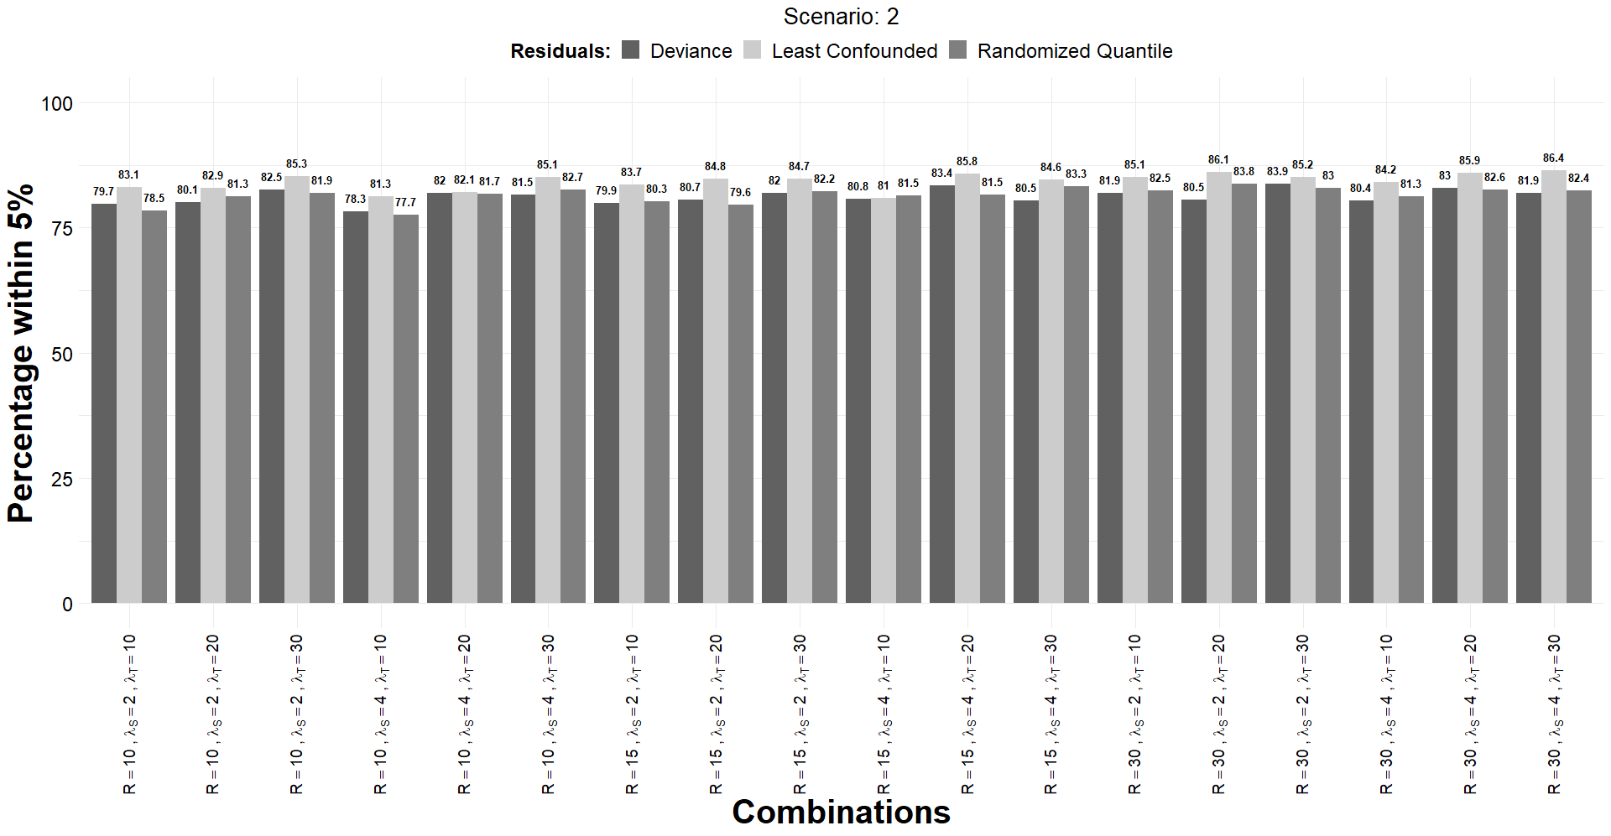
Fig 6. Percentage of residuals within the 5% threshold across non-fixed factor combinations in Scenario 2.

