

**National College of Ireland**

**Higher Diploma in Science in Computing**

**Introduction to Databases**

**2023**

**CA Report**

**Authors**

**Gustavo Brentano**

**Rafael Fortunato**

**Student ID**

**x23159049**

**x23121513**

**E-mail**

**x23159049@student.ncirl.ie**

**x23121513@student.ncirl.ie**

**INTRODUCTION**

NCI Cars is a website developed for the NCI Web Design faculty project, with the aim of demonstrating the skills acquired throughout the course.

The idea is to create a simple, responsive, intuitive and beautiful website so that users can access it dynamically and objectively while browsing the website.

**RESEARCH**

To develop our website, we used the knowledge acquired in the college classroom, as well as some knowledge platforms for this purpose, such as:

W3schools - The platform has several sources to help you learn the jQuery library.

Khan Academy - Educational website, very useful with content related to HTML and JavaScript.

Mimo - Excellent application, with useful content for learning HTML.

Curso em Video - Educational channel, also present on YouTube, with materials and video classes on programming in HTML, JavaScript and CSS.

After reading and studying content relevant to the project, we decided to start implementing it in practice and building our website.

**PROJECT DETAILS**

Before we start coding our website, we create a wireframe of it in order to position our final project objective.

The final draft was defined through consultations carried out via the internet itself, observing some websites similar to the project theme, which is an online store for car sales (dealership). Some initial ideas were discussed and remodelled until the final decision for the website was made, thus adopting the winning idea and coding of the website began.

It was decided that the website must be responsive, stable, elegant and simple, so that the user does not run the risk of getting lost while browsing the website.

Among the tools selected for website development, coding using the languages HTML, CSS, JavaScript and JQuery was chosen.

**DEVELOPMENT PROCESS**

The development of the website was a bit arduous, as we believed we already had the necessary knowledge to apply the content studied and prepared in practice. However, with rereading previous classes and the help of some additional studies, we were able to develop our final project.

To do this, we observed some websites on the internet to get a basic idea of how we would develop our website. After some ideas, we designed the wireframes and, through them, started the HTML coding of our website, adding CSS styling resources to it. Follow the wireframes developed below.

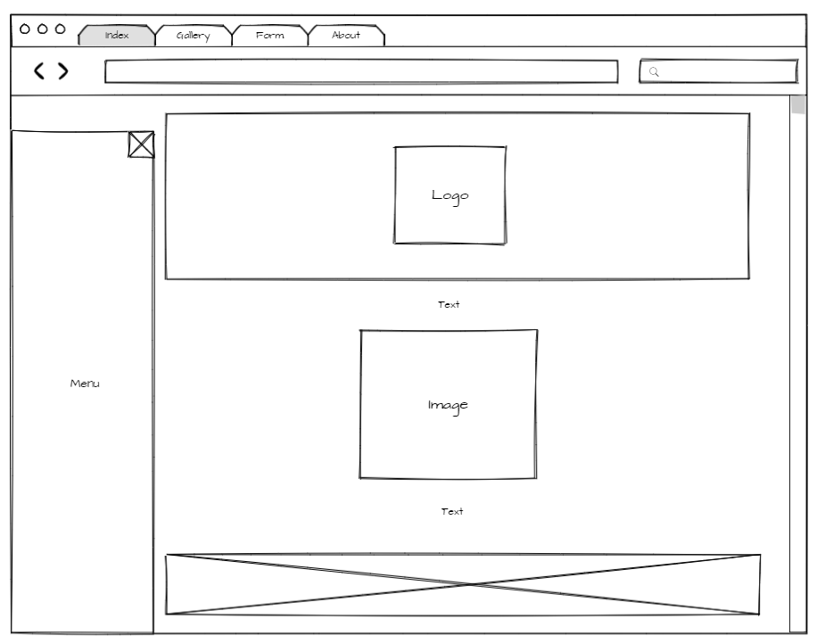

Figure 1 - Index wireframe

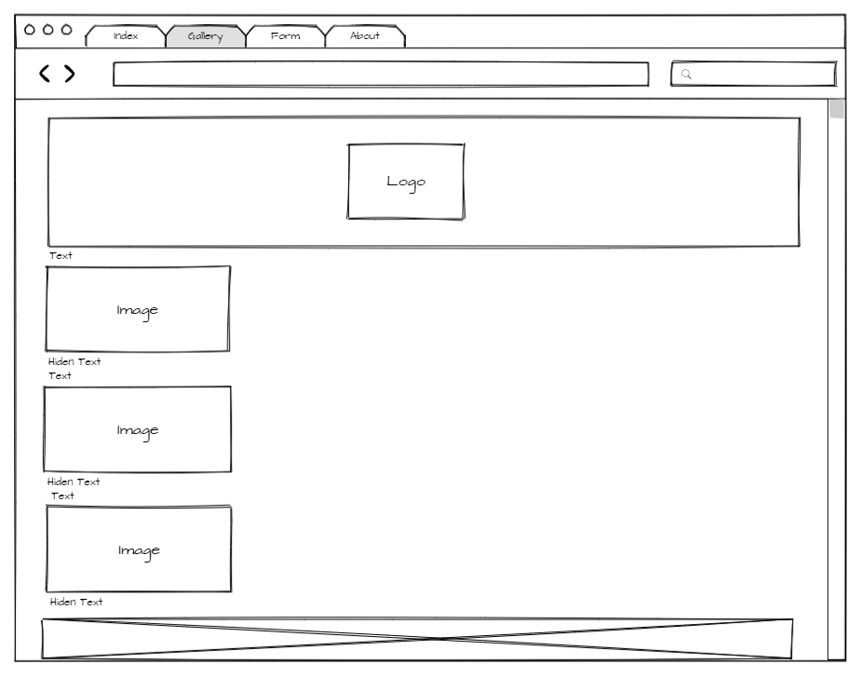

Figure 2 - Gallery wireframe

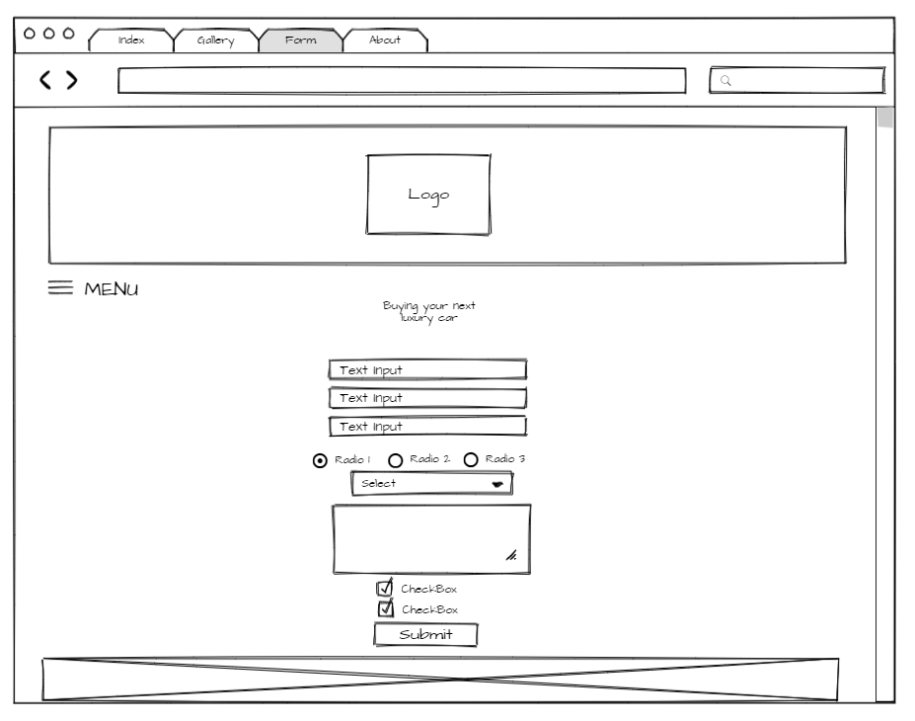

Figure 3 - Form wireframe

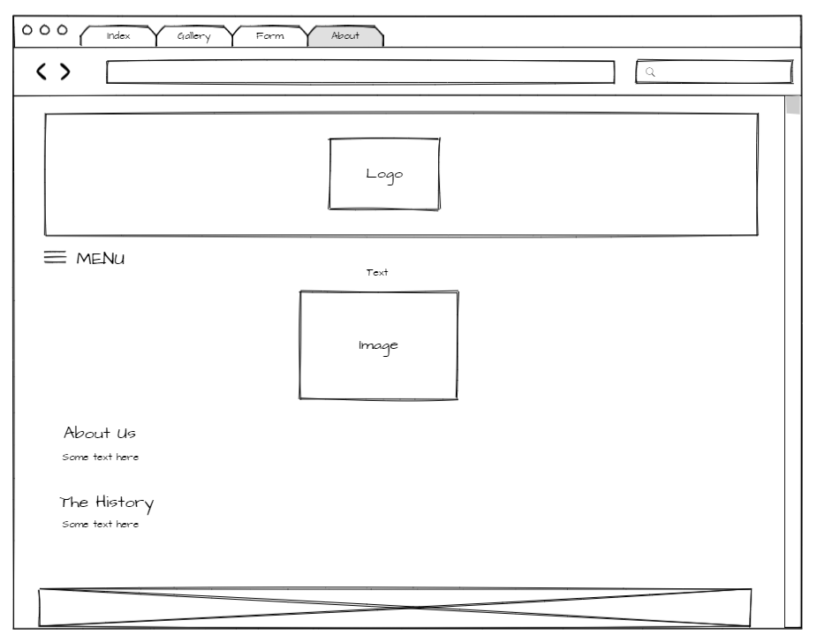

Figure 4 - About us wireframe

After developing the HTML and CSS, we began implementing JavaScript, in order to carry out the site's interactions with the user. The codes were checked and verified for their readability and possible errors. Afterwards, its SEO was checked and, after the website was completed, it was deployed, making it available on the internet.

Throughout the project, improvements and corrections were implemented until the end of the project.

**VALIDATION**

After coding our website, it was validated and some errors were found, which were later corrected. After the final check of the project, no critical or non-responsive errors were found that could compromise the site's performance during use. We use the official validator used in the classroom, which can be found at https://validator.w3.org/.

Some of the errors found include the closing of some tags, indentation and small syntax errors, arising from the coding carried out by the project authors.

Some alerts are still displayed when validating the site on the platform mentioned above, but they do not affect the use or performance of the site, which was also tested in different browsers (such as Chrome, Edge, Mozilla and Opera).

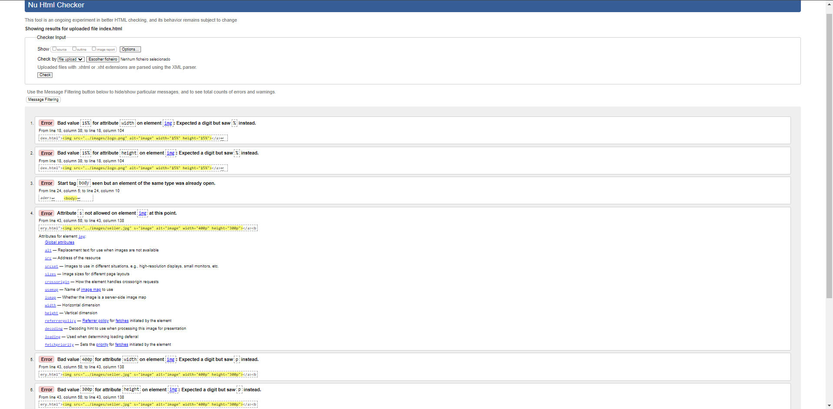

Figure 5 – Index

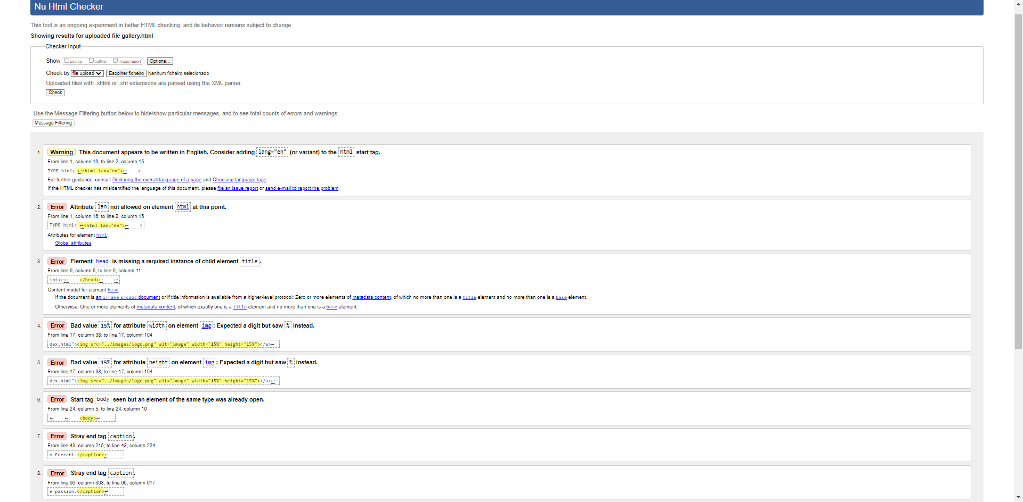

Figure 6 – Gallery

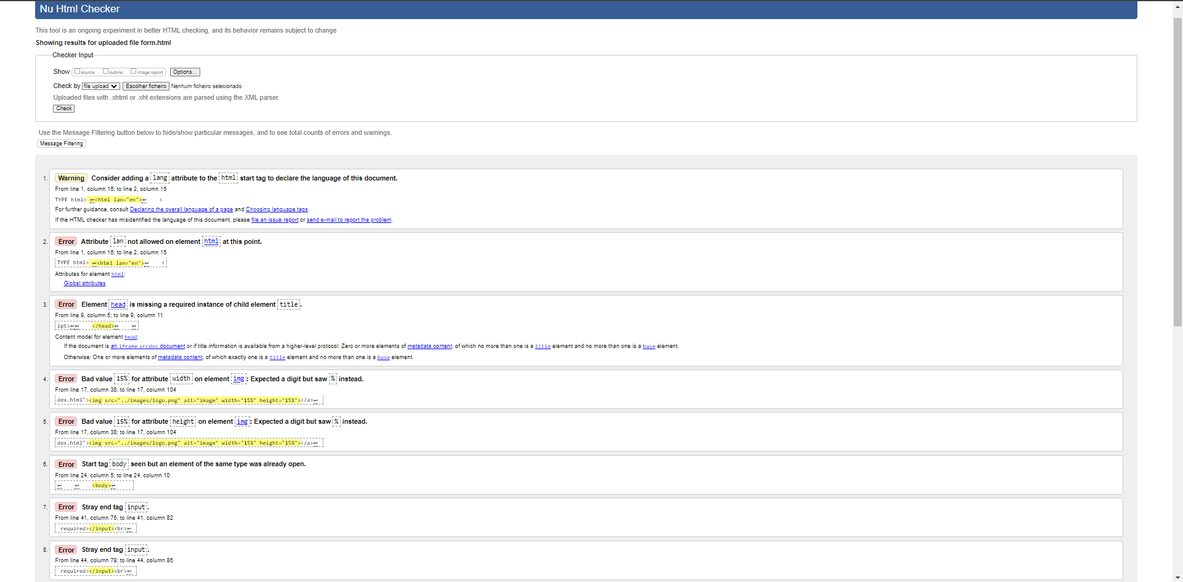

Figure 7 – Contact Form

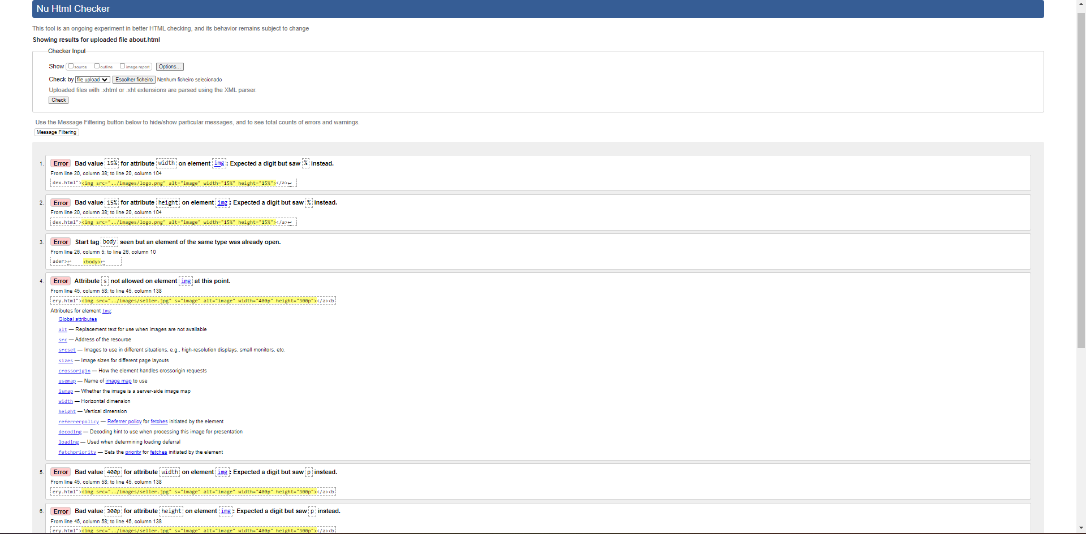

Figure 8 - About Us

**DEPLOYMENT**

Our website was deployed on Infinity Free.

[ COLOQUE AQUI A IMAGEM DO DEPLOYMENT ]

**TEAMWORK**

After the group formed to develop this project decided, we discussed our skills, defined tasks for each member, defined meetings and goals to be achieved for creating the website. After completing each of the website's stages, progress was checked as a team and discussions were held on identifying possible errors, enhancements and enhancements to our website.

Student 1 was assigned the task of coding, implementing resources and testing 3 of the pages developed as a team. For student 2, the task of planning and mapping the layout of the website pages, designing the wireframes, validating the pages, as well as developing one of the pages and monitoring the development and progress with student 1, providing support with suggestions, tips and brainstorming.

As it was a college team effort, some challenges were encountered throughout the project's trajectory. Among them, the scarcity of time available for meetings, as we had to divide our time with daily tasks, work, among others. Despite this, we were able to dedicate ourselves to the project and complete it with the needs imposed by the project.

**CONCLUSION**

Carrying out this project turned out well for the team. Every task required time, knowledge and dedication, and the most challenging part was recovering the content that we did not have solid to complete some resources necessary for the website, correction and improvements, time and correction. From the organization, planning, execution and final stages of the website, everything went well, with no disagreements within the team, just the mutual and joint work of the members, aiming to obtain the best quality and the best results at the end of the development of this website. The development of this project was extremely important, as it could contribute to the practical application of the content acquired in the classroom, as well as studies acquired from other sources.

## 

**REFERENCES**

W3 Schools. (2023). *jQuery Tutorial*. [online] Available at: https://www.w3schools.com/jquery/default.asp [Accessed 2023].

Khan Academy. (2023). *Intro to HTML/CSS: Making webpages*. [online] Available at: https://css- https://www.khanacademy.org/computing/computer-programming/html-css-js/ [Accessed 2023].

Khan Academy. (2023). *HTML/JS: Making webpages interactive| CSS-Tricks*. [online] Available at: https://css- https://www.khanacademy.org/computing/computer-programming/html-css-js/ [Accessed 2023].

Khan Academy. (2023). *HTML/JS: Making webpages interactive with jQuery*. [online] Available at: https://www.khanacademy.org/computing/computer-programming/html-js-jquery/ [Accessed 2023].

Mimo. (2023). *Intro to Web Development - Create webpages using HTML and CSS*. [online] Available at: https://mimo.org/web/219/section/0 [Accessed 2023].

Curso em Video. (2023). *HTML5*. [online]

Available at: https://www.cursoemvideo.com/curso/html5/ [Accessed 2023].

Curso em Video. (2023). *Javascript*. [online]

Available at: https://www.cursoemvideo.com/curso/javascript/ [Accessed 2023].

Curso em Video. (2023). *HTML5 and CSS3 course*. [online]

Available at: https://www.cursoemvideo.com/curso/html5-css3-modulo1/ [Accessed 2023].

Curso em Video. (2023). *Practical SEO Course*. [online]

Available at: https://www.cursoemvideo.com/curso/curso-pratico-de-seo-modulo-01/ [Accessed 2023].

Google Search Central. (2023). *Explore Google Search documentation to improve your site's SEO*. [online]

Available at: https://developers.google.com/search/docs/ [Accessed 2023].