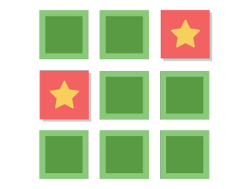 Press - Memory Game - 49.213389, 16.614778

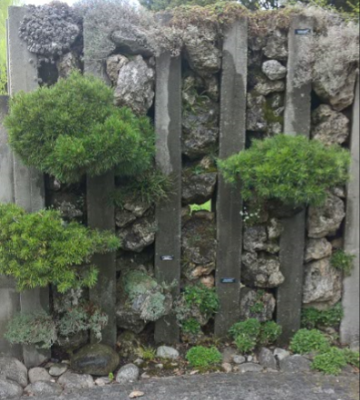 Shuffle - 49.212306, 16.614694 stone, rock, bush,.. search the word - beacon

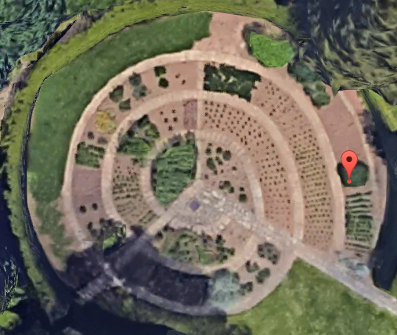 Beacon - 49.212556, 16.614333   
How many sand particles are there?

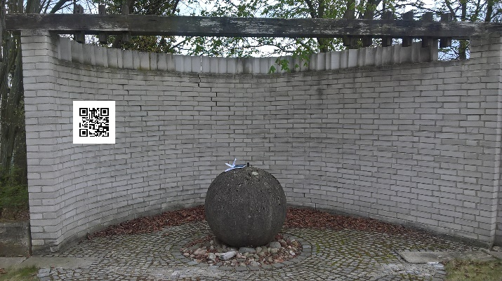 49.214222, 16.611667 – QR

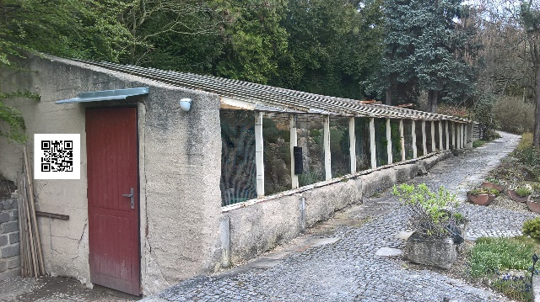 49.214722, 16.611528  
What is the material of ..

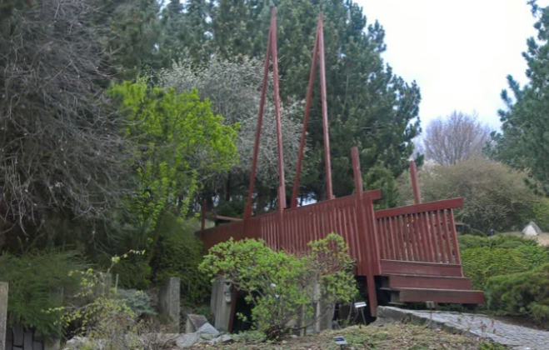 49.215583, 16.612861

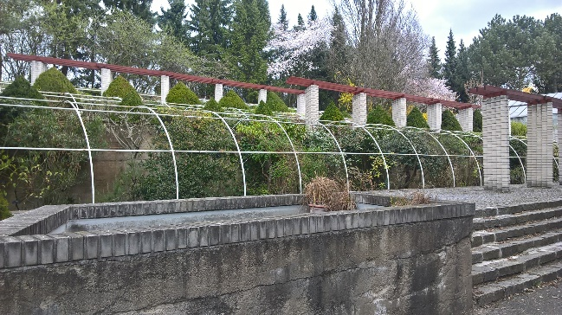 49.215806, 16.613889