# All Things Open 2020

**All Things Containers Workshop**

**Setup Instructions**

Version 1.5 by Brent Laster

09/30/20

**Setup – Installing the VM image**

**Purpose:** In this workshop, we will be using a virtual machine (VM). This VM has all of the software and lab setups on it that we need to use for the class.This section guides you through getting the VM up and running.

1. You will need to supply your own laptop for this workshop. Ensure that you have a fairly modern system with at least 8 gig of memory and 25 gig of free disk space to use in the workshop.
2. Install VirtualBox on it (from [www.virtualbox.org](http://www.virtualbox.org)) and ensure you can start the application without problems.
3. Download a copy of the VM (ato-ws2.ova file) from the location given (or the day of the actual workshop, copy it onto a location on your laptop from one of the USB drives being passed around).

If you download it, the following are checksums you can use to verify the download worked correctly:

MD5 Checksum: d403825663a59e935547160c2cfb96fd  
SHA-1 Checksum: b7b919f3d0fca99ea130bef33d62196cfb465420  
SHA-256 Checksum: 2b249fa5fd2f297efd0d2cf70fd2f7a422d2c24f5892dcbe4175141fd4575b74

1. Via the start menu or on your desktop, open up the VirtualBox application.

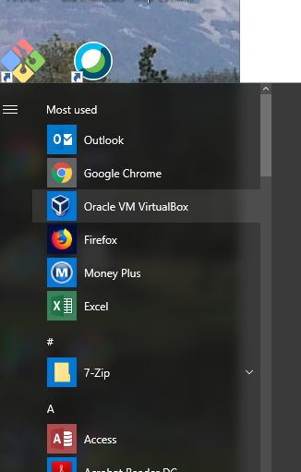 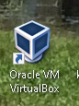

1. Once VirtualBox comes up, click on the **File** option in the menu bar, and select **Import Appliance…**

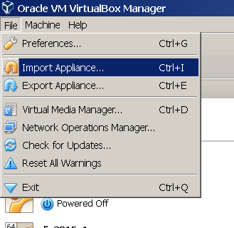

1. In the dialog box that comes up, enter the location of the **ato-ws2.ova** image that you downloaded or that you copied from one of the USB drives.

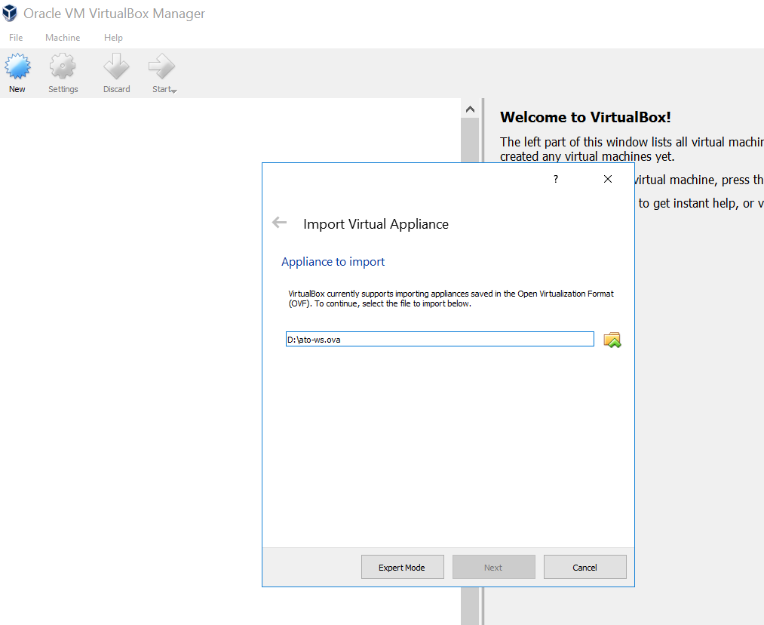

1. On the next screen, click the box to reinitialize the MAC addresses. You can just accept the rest of the **Appliance Settings** and then click the **Import** button.

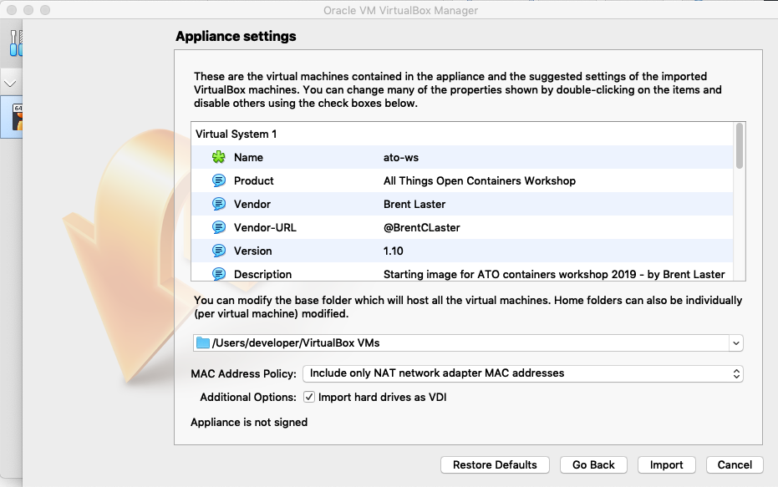

1. You will get a pop-up box for the “license” info. Just click the **Agree** button. Your system will then start processing the import. This may take a while.

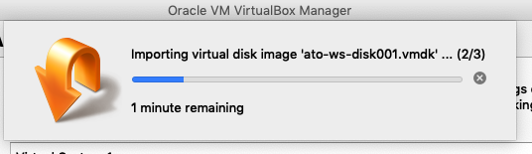

1. After the import is finished, you should have a VM listed in VirtualBox named **ato-ws.**

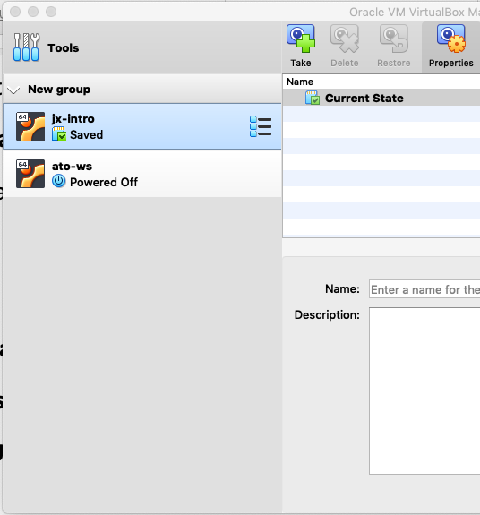

1. **(OPTIONAL)** At this point, depending on the settings of your physical system, you can adjust the amount of memory for the image if you need/want. You can do this by clicking on **Settings** in the menu bar, then **System** in the pop-up box for the settings. Then you can adjust the amount of memory for the virtual machine with the slider.

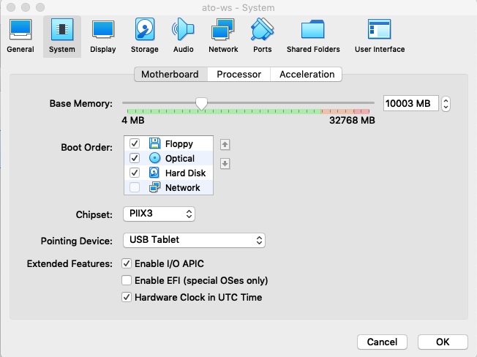

1. At this point, you can start up the virtual image by right-clicking on the image name and then selecting **Normal Start.**

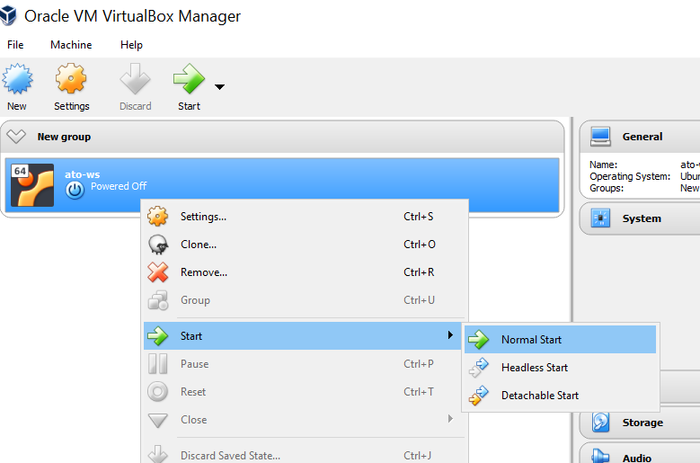

1. You may receive an error about network adapters here similar to the one below.

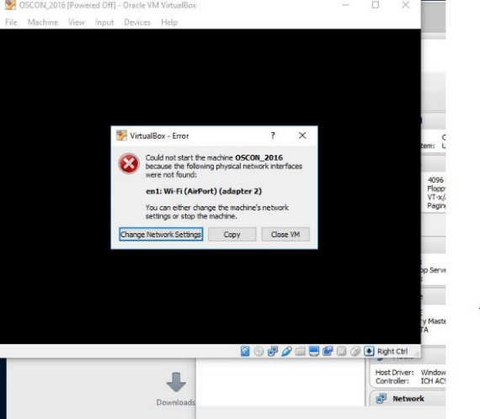

If so, just click on the option given to “Change Network Settings”. Then click on “Ok” in the network settings. ( After the system starts, you can also enable enable “**Auto Ethernet**” in the networking menu (click on double arrors in upper-right corner) but that is probably not necessary).

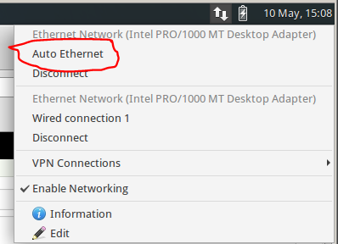

1. If you get a warning dialog that pops up like the one below, it is due to a missing shared directory. (You can see that if you click the Details – not required.) This is not important for using the VM and you can just click OK to proceed and ignore the warning.

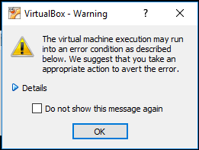

1. It may take several minutes for the desktop to appear. If, after several minutes, you don’t see the desktop, try switching to full screen mode (Host key + F) or access the menu item for it through the View menu. On most systems, the Host key here will be the right Ctrl key. (Note: Windows 10 seems to have issues if you try to switch to scaled mode. If on a Windows 10 system, you may want to avoid that setting. If you do go into scaled mode and the screen seems to disappear, try using the Host key + F to switch out. Or the menu may still be accessible, although hidden, at the very top of the screen.)
2. After starting up the VM, you should see the desktop of the VM.

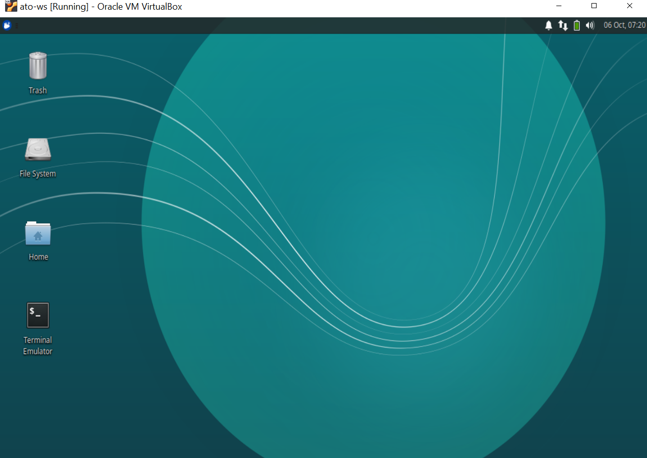

1. If you are on Windows and get a Windows firewall dialog, you can click both boxes and tell Windows to “Allow access”.
2. If you are given an option to upgrade ubuntu, just decline that.
3. If you have messages at the top of the screen about “Auto capture keyboard” and “mouse pointer integration” you can just click the x on the far right of the messages to dismiss those.
4. Verify that you have internet connectivity from the VM. Open up a terminal session from the VM’s desktop and type something like “ping google.com” to make sure you get a response.
5. Login is diyuser3, diyuser3 if you need it.
6. You are now ready to proceed with the workshop labs. A location for the labs document will be shared separately.

**OPTIONAL**

1. Optionally, if you are not in the Eastern time zone - you can change the system to have the correct date/time. To do this:

a. Click on the mouse icon in the upper left corner of the screen.

b. In the drop down menu, select “Settings” on the right-hand side.

c. In the left-hand side, select “Time and Date”.

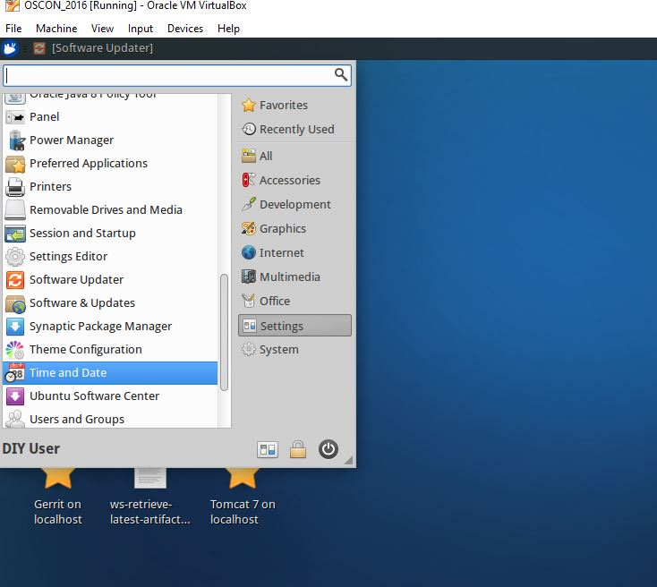

d. The Time and Date Settings dialog will pop up. In order to change this, you need to click on the “Unlock” button on the bottom and then authenticate to unlock it. The password to use here is “diyuser2”.

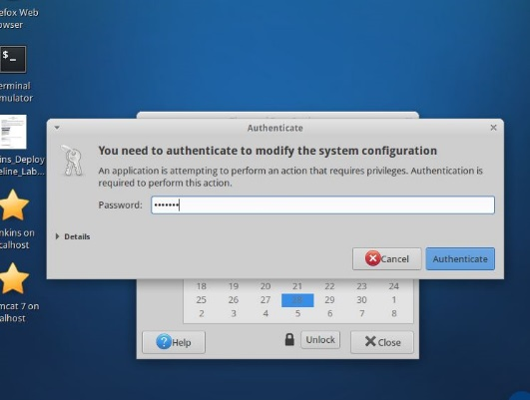

e. Click on the “Time zone” selection at the top and then find a city that is in the timezone where you are (probably prefixed by America/ if you’re in the US). Select it and close the “Time zone” choosing dialog.

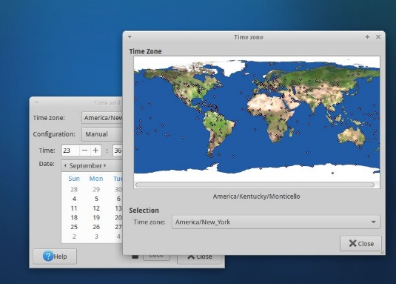

f. Back on the main “Time and Date” settings dialog, the time should have changed to reflect the timezone you selected.

g. Select the Lock button to lock the settings again and then the close button.16. To persist the date/time changes, you just need to logout and log back in. To log out select the mouse icon again in the upper left corner, then click on the “Power” button.

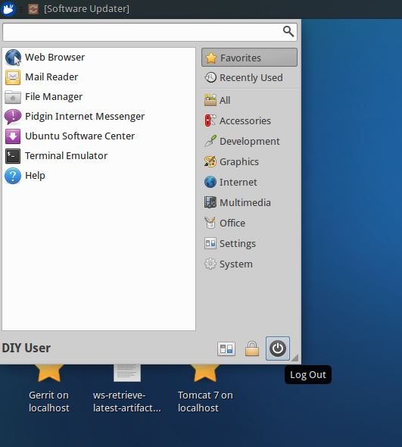

1. After logging out, you can log back in with user=diyuser3 and password=diyuser3. Confirm that your date and time are set as expected.