VirtualBox Troubleshooting (v3)

# This document is intended to help diagnose the most common type of problems that you may run into when trying to use VirtualBox on your system. (MAC-specific items are at the end.) This document was originally started by John Anderson and has been added to over time. It may or may not assist in helping you (hopefully it will) but no guarantee is made or implied.

Errors generally fall into a couple of categories. Consider all before spending a lot of time on one solution.

1. **Virtualization is not enabled on the machine.**

# If you receive errors similar to these:

 VMMR0_DO_NEM_INIT_VM failed: VERR_NEM_MISSING_KERNEL_API_2 (VERR_NEM_MISSING_KERNEL_API_2).

VT-x is not available (VERR_VMX_NO_VMX).

|  |  |
| --- | --- |
| Result Code: | E_FAIL (0x80004005) |
| Component: | ConsoleWrap |
| Interface: | IConsole {872da645-4a9b-1727-bee2-5585105b9eed} |
|  |  |

## Check your Bios

1. Confirm that VT-x or VT-d are enabled.

# Confirm that Intel Virtualization is enabled, if you see the option.

Another approach may be to uninstall VirtualBox, remove any residual files, and reinstall, as suggested at <https://stackoverflow.com/questions/61344675/virtual-box-vt-x-is-not-available-verr-vmx-no-vmx-hyper-v-and-core-isolation>

1. **Conflict with Hyper-V and/or Docker for Windows**

If you are running with Docker for Windows or Hyper-V enabled, those compete with VirtualBox for the virtualization capabilities. To run VirtualBox on a system where those are installed, you will need to temporarily disable them.

This can be done via the configuration in Windows 10 through changing the Windows features via the Control Panel or by typing in “Windows features” in the search box. See figure below.

## Configure Windows 10

These settings work for me:

Note that disabling Hyper-V and Virtual Machine platform will break Docker.

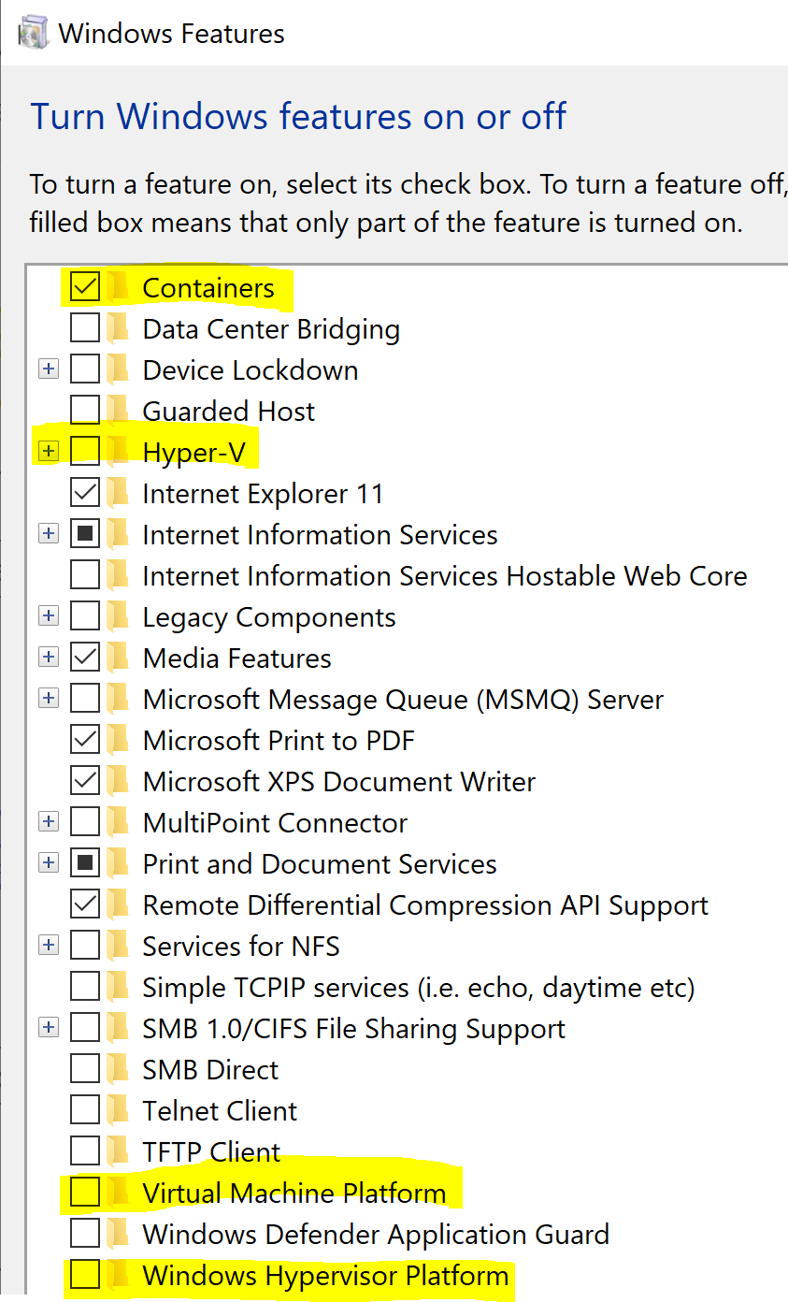

You may also be able to disable Hyper-V via Powershell if you are comfortable with that via the command “bcdedit /set hypervisorlaunchtype off” and rebooting.

## **Other issues**

If the above does not fix the problem, you may need to uninstall VirtualBox, remove any leftover files and restart the system. And, for good measure, get a fresh copy of the ova file.

## Reinstall Virtual Box

1. Uninstall Virtual Box

It is listed in programs as Oracle VirtualBox

It is normally installed in folder C:\Program Files\Oracle\VirtualBox

1. Delete extra folders after uninstalling

* C:\Users\[username]\.VirtualBox
* C:\Users\[username]\VirtualBox VMs

1. You may also want to delete the .ova file that you imported, in case it could be corrupt.
2. Reboot
3. Reinstall VirtualBox and try to attach the image file, and start it.

## If it still fails after trying the above steps:

1. Go back into your bios
2. Disable the virtualization settings then re-enable them. Then save your settings and exit.
3. **Other issues when running the image** 
   1. **kubectl can’t connect to the server**

The symptom here is that when you run kubectl you get a message like:

*The connection to the server 10.0.2.15:8443 was refused - did you specify the right host or port?*

This typically means that minikube (the single node Kubernetes cluster) has stopped working and needs to be started again. The command to do that is

*sudo minikube start --vm-driver=none*

You would type this in a terminal window on the VM.

If you need to stop minikube at some point, the command is:

*sudo minikube stop*

* 1. **The system can’t complete some operation that requires access to the network.**

You may have lost connectivity to the network in the VM. You can verify this by typing something like

*ping google.com*

in a terminal window of the VM and seeing if you get a response or a timeout. If you get a timeout, you will need to reestablish connectivity. This can be done in a couple of ways, but the simplest may be to click on the up/down arrow icon in the bar near the top right of the VM window and click “Enable Networking” or “Wired connection 1” or “Auto Ethernet” to get things working again.

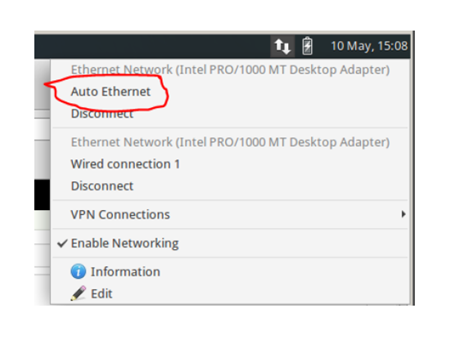

**MAC-specific issues**

MACs can have their own issues with VirtualBox. If you’re able to import and startup the virtual machine, then please see the preceding items in this doc. But if you can’t get that far, here are some things to try based on commonly reported problems and what others have found that works. If nothing in here works, try googling the exact error message that you’re getting.

* Try going into the Settings for the VM, going to the Audio tab, and disabling/unchecking Enable Audio.
* Check under System Preferences, Privacy and Security to make sure there's not something there that is trying to monitor or restrict Virtual Box.
* Go into the System settings for the VM, and scale back the amount of RAM the system is trying to grab.
* It may sound cliche, but uninstall VB and reinstall just in case there are any problems with the installation.
* Try downloading the ova file again to make sure it got fully downloaded.

Hopefully, one or more of these things may help.