4. Solution
The solution to our problem has three fundamental parts: the website which is modified by the genetic algorithm, the experiments used to determine the fitness function and assess the GA-generated site, and the GA itself.

4.1. Website Design v. 5
The website that we used in this project was designed to work smoothly with the genetic algorithm and the experiment. The genetic algorithm must be able to understand a description of the structure of the website so that the genetic algorithm can alter that structure. For the experiment to be successful, the website must provide the experimental subjects with a clean interface, which they need in order to produce consistent, reliable data. These requirements dictate some aspects of the design of the website.

4.1.1. Representing a Website
The genetic algorithm must be able to manipulate the representation of the website. A website can be multiple pages. To make the representation easier, the website was designed so that its structure could be represented as an array. It is much easier for the instructions in the genetic algorithm to manipulate an array than the HTML code that is used to represent the website on the Internet. Therefore, one of the goals of this project is to find an array that captures the relevant information of the website in a form that the genetic algorithm can understand.
Each member of the array is called a content unit. A content unit represents an amount of web content roughly equivalent to a paragraph. The term “roughly equivalent” is used because there are often headers, links, or buttons associated with each paragraph, and these are absorbed into the content unit to make things easier. Consider the simple website in Fig. 4.1 as an example.
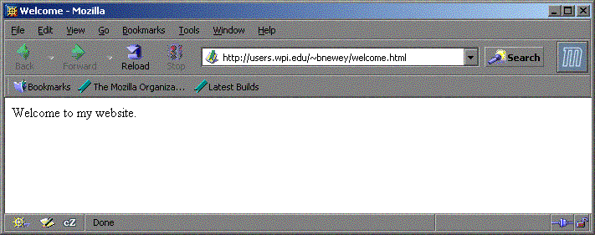
Figure 4.1: A Simple Website
There is one content unit on this website, and it contains the string “Welcome to my website.” The entirety of a website can be represented by an array with a length equal to the number of content units. In this case, the length is one. Figure 4.2 shows a pictorial representation of this array. Note that in many computer science applications, arrays are zero indexed. This means that the first member of the array has an index of zero, the second member an index of one, and so on.
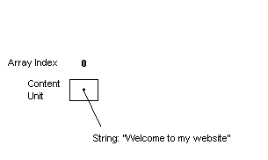
Figure 4.2: Representing a Simple Webpage
Adding another content unit to a website increases its complexity (See fig. 4.3). There must be multiple content units in the array, and there must be some way to distinguish the order of the content units.
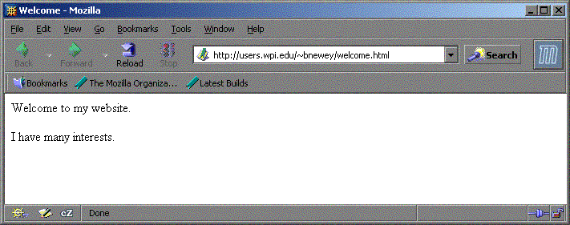
Figure 4.3: Adding a Content Unit
There are now two content units in the array. A second variable is added to each, representing its “priority” on the webpage. The smaller the priority, the closer the content unit is to the top of the page.
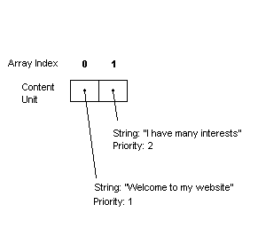
Figure 5-4: Representing the New Webpage
Priorities control how content units are positioned on the page relative to each other. Any content unit with a certain priority will always appear below any units with a lower priority, and above all units with a higher priority. For example, if there are three content units which have priorities of 3, 1, and 9, the website would contain the content unit with priority 1 first, the content unit with priority 3 second, and the content unit with priority 9 third.
When the GA acts on this array, no content information is modified, because all resulting websites must contain the same content. If content information were to be exchanged through crossover or changed through mutation, the websites would no longer have identical content. The information presented by each member of the population of websites must be the same. The GA is changing the presentation of this information, not the information itself. The priority attribute does not relay any content information. Because of this independence from content, the GA can alter the priority to produce different ordering results without changing the content.
Consider the following array (Fig. 4.5), which produces the following web site (Fig. 4.6).
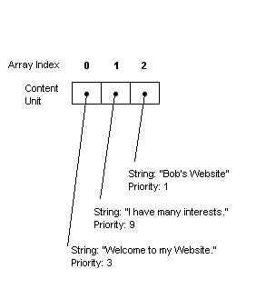
Figure 4.5: Three Content Units
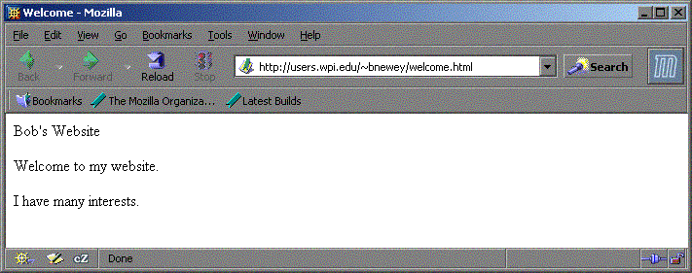
Figure 4.6: Website for Figure 4.5
Let us now consider that an arbitrary number of mutations or crossovers have been performed to achieve new priority results, as shown in Figure 4.7 and 4.8
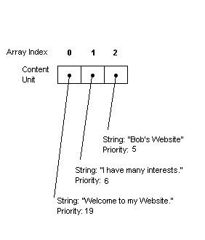
Figure 4.7: Changing the Priority
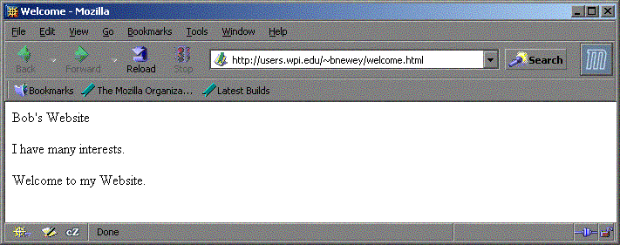
Figure 4.8: Website for Figure 4.7
This demonstrates that priority can be arbitrarily changed to produce new presentations without modifying the data.

4.1.2. Using Websites to Construct a Hierarchy
The above examples are not hierarchies. To include the hierarchical structure of an actual website in the algorithm, a limitation is imposed that all pages of a website can only link to a page lower in the hierarchy. This forms a tree, and the graph of this tree contains no cycles (i.e., there is only one path to each page in the tree). This limitation allows us to easily represent the site in a fashion acceptable to the Genetic Algorithm.
The GA performs linking implicitly by binding multiple content units to a page. Consider the array shown in Fig 4.9. In this representation, the longer vertical dividing lines represent the ends of pages. The positions of these lines are included in the GA data structure in a way that will be described later.

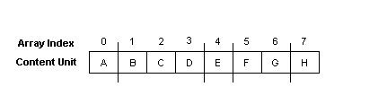
Figure 4.9: Representing Pages
In this example, content unit A is bound to the first page, content units B-D are bound to the second page, E to the third page, etc. To create the hierarchy from this setup, we perform the following algorithm. First, determine the index page, represented by the first group of content units before the first line. In this case, it is just “A”:

Figure 4.10: Step One in Constructing the Hierarchy
This represents a site containing a single page with a single content unit. The next group of content units represents page 2 of the hierarchy. These are content units B, C, and D, located between the first and second divisions in Figure 4.9, above. When added, the site looks like Fig 4.11.
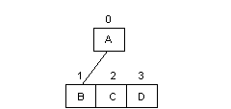
Figure 4.11: Step Two in Constructing the Hierarchy
The second page contains three content units. Each content unit may contain only one link. If it is at the bottom of the hierarchy, it has no links. Because there are three more content units to add in this example (as represented in Figure 4.9), this means that the tree will now contain three more branches. Content unit B will point to the next page. According to Figure 4.9, that page contains only content unit E.
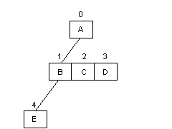
Figure 4.12: Step Three in Constructing the Hierarchy
The algorithm continues to perform these operations in a breadth-first manner until the entire hierarchy is constructed. Hence, it will add the next link to content unit C, the link after that to content unit D, and the link after that to content unit E. The results of the algorithm are shown in Fig 4.13.
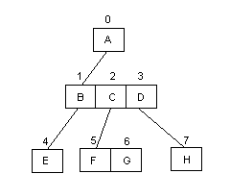
Figure 4.13: Completing the Hierarchy
To add additional pages to the hierarchy, the algorithm would continue to function in a breadth-first manner, adding a page first to content unit E, then to content units F, G, and H, respectively. This results in the hierarchy always being represented as a complete tree.
To represent the divisions in Figure 4.9, the algorithm uses “flag-based separation”. Flag-based separation is a concept that incorporates binary flags into the array. These flags are placed on the array values that have a page break directly following them. In this example, the flags would be placed in content units A, D, E, and G. The final content unit is always assumed to have a flag, because it will always appear at the end of a page.
Many of the website representation issues addressed here are necessary for the genetic algorithm to function properly. By using an array data structure with a clear division of pages we can represent an entire hierarchical website using a single data structure. The website representation discussed above was designed with these goals in mind.

4.2. Experiment Design
In this section, we will explain the design of each of the three experiments. We will also explain how we collected our data.

4.2.1. Experiment #1 v. 3
The first experiment allowed us to determine the effect of page length on how long it took for users to find a specific link. This was accomplished by giving users the task of finding the correct link for a given subject. Word count (of the experimental page) was the independent variable.

Figure 4.14: Introduction to Experiment 1
The users were first presented with an introduction page (Figure 4.14, above). The purpose of this page was to prepare the user to take the experiment. The users were told to imagine that they were searching for information about Mozart while reading the example page. Each user needed to click the link most appropriate to their search in order to complete the example task successfully (Figure 4.15).
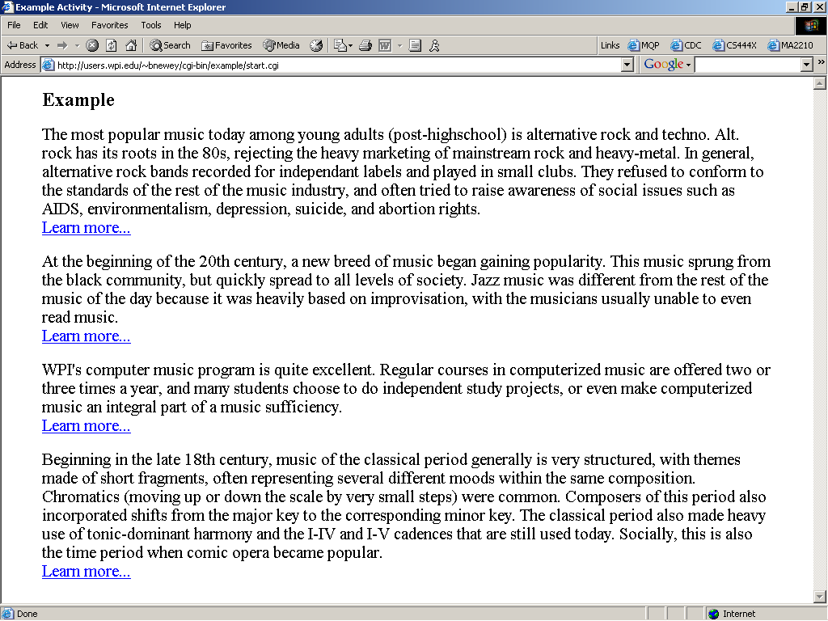
Figure 4.15: Example task for Experiment 1
Once a user completed the example, they were presented with one of five pages, each of different length. Each page contained similar information on five computer technologies (Figure 4.16, below). The users were asked to look for information on “online form technology”. These pages were presented in the same format as the example page, i.e. paragraphs followed by links. The topics, as well as the order they were presented, were the same on each of the five pages. Each page also contained the same proportion of information for each topic (i.e., each topic took up 20% of each page, regardless of the page’s total length). The amount of information provided for the topics was the only difference between the five pages. By varying the amount of information for the topics, we were able to test the effect of different page lengths on the time it took the user to find the correct link.

Figure 4.16: Experiment 1
Once the user clicked on a link, the experiment terminated. This occurred whether or not the user selected the correct link. We ran the experiment in this manner to avoid a possible side effect of correctness on reading time.
We recorded the time it took the user to click on a link, the length of the web page, and whether or not they selected the correct link. By conducting this experiment we found a relationship between the length of a web page (measured by word count) and the amount of time it takes a user to find a desired link.

4.2.2. Experiment #2 v. 3
The second experiment allowed us to obtain data on how the users traversed a human generated website. For this experiment, we designed a website that contained information on unusual sports.

Figure 4.17: Introduction to Experiments 2 & 3
As with the previous experiment, users were first given an example task (see Figures 4.17 and 4.18). For this task, links were not functional, and were only placed there to familiarize the users with the format of the experiment. Next to each paragraph was a button titled “This is my topic”, which the user clicked when they thought they had found their target topic.
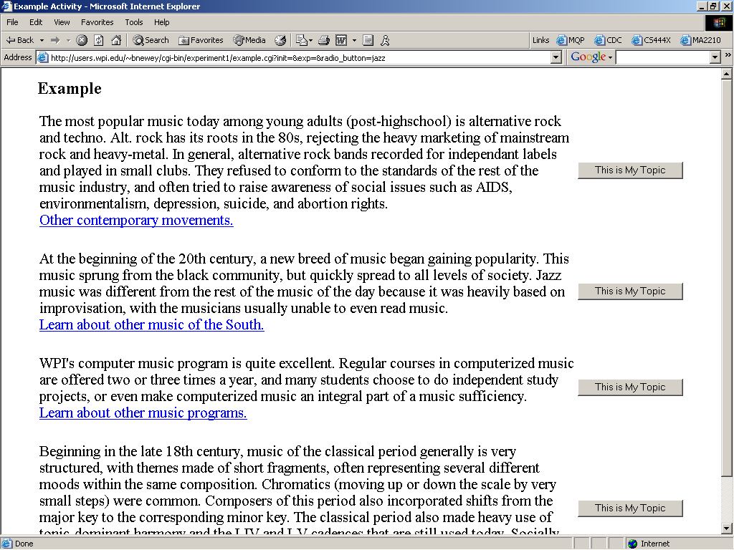
Figure 4.18: Example task for Experiments 2 & 3
Once the example task was successfully completed, each user was asked to select an unusual sport (Figure 4.19). This selection dictated their target topic for the experiment. By allowing this selection, we were able to obtain a frequency distribution of the number of times each sport was searched for.

Figure 4.19: Selecting a target topic
Once a target had been selected, each user navigated through the website (structure shown in Figure 4.20, below) until they believed they found the relevant information about their target. They indicated this by clicking the button next to the relevant paragraph. If the users clicked on the wrong button, they were presented with a page indicating this, and were asked to try again. Once the user selected the correct button, they were presented with a page indicating success.
The frequency distribution and the path followed to get to the target information were used in the GA’s fitness function.
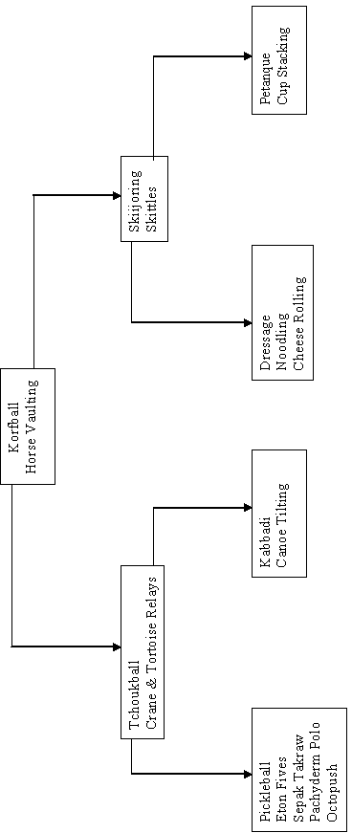
Figure 4.20: Site Structure, Experiment 2

4.2.3. Experiment #3 v. 3
The third experiment allowed us to obtain data on how the users traversed the website modified by the GA (see Appendix H for structure). The website contained exactly the same information as the human generated website in the second experiment. The structure of the website changed, as well as the location of content units within the site. We collected time data in this experiment to compare with the times from experiment 2.

4.2.4. Data collection v. 3
The subjects of our experiment were WPI Computer Science (CS) students. The rationale for using only CS students was to have a more homogenous population, therefore resulting in the experimental subjects having relatively similar levels of computer experience. They were solicited from two undergraduate classes, CS2005 and CS3041.

4.2.4. Data Storage
[To come]

4.3. Genetic Algorithm - NEW
We designed a genetic algorithm to adapt the website. In this section, we will discuss some of the details of its design.

4.3.1. Data Structure
The algorithm used a population of websites to simulate evolution. The website structure is the one described in section 4.1. The population is an array of pointers to the websites. Each website contains an array of content units in a fixed order. Each website also has settable values for fitness and ordering. Each content unit contains the content string (or a marker indicating the content), the word count for that content, a settable priority marker and page-end marker (as well as a number of internal variables used to determine page positioning and linking). The population of sites was designed in this manner to make crossover between websites possible.

4.3.2. Generations
Our genetic algorithm ran several times, 500 generations each time. We used standard generational replacement: selections from the parent generation produced a new, “child” generation. When the child generation was full, it became the new parent generation. Each generation had a population size of 30 sites.
When each generation was completed, the algorithm calculated fitness values for all the sites in the child population. The program recorded the best, worst, and average fitness values for each generation, and also recorded the representation of the site with the best fitness in each generation.

4.3.3. Fitness Function
As shown previously in Figure 4.19, we allowed subjects in our experiments to select which content to search for. Once they made a selection, their task was to find this target. When calculating the fitness of a particular site, we first calculated fitness for each task. The fitness value for a site is the sum of the task fitnesses for that site.
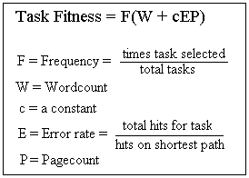
Figure 4.21: Fitness function
To calculate task fitness, we looked at four factors (Figure 4.21). Frequency is the percentage of subjects that chose the given task. Frequency was a weighting factor: tasks that were never chosen were not included in the fitness of a site, and tasks that had been chosen frequently weighed heavily in the results. Wordcount and pagecount estimate the time it would take a subject to read through all the material in the path to the given task. Wordcount was calculated by finding the content unit that linked to the target, then totaling its length and the length of any content before it on the page. Then the process was repeated with the content unit that linked to that page. In the example in Figure 4.22, the wordcount would be the sum of the lengths of all the units in red.
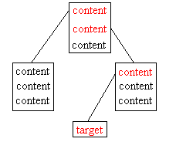
Figure 4.22: Path to target content
Pagecount is simply a count of the number of links required to get from the first page to the page with the target content. In Figure 4.22, the pagecount is 2. We realized that our experiments needed to incorporate error rate. Error rate is a crude measure of how likely a subject is to click on the wrong links in their quest for the target. In each task, error rate is a constant, calculated from the results of Experiment 2. We assume errors would be similar on a new site, so pagecount (the shortest path) is multiplied by error to yield a more likely path length for the task. This new path length is multiplied by a constant to give it an effect on the fitness function comparable to wordcount.
The fitness values obtained from the function above should be proportional to the time it takes a subject to find their goal content on a site. Since we are seeking to minimize this time, sites with lower fitness values are more desirable. Once fitness values have been calculated for a whole generation, the population is ordered, based on their fitness values. The lowest (best) fitness gets the highest order value (30 in our algorithm).

4.3.4. Reproduction
Once an order has been assigned to the members of the current population, the algorithm is ready to start the next generation. Parents are chosen in a weighted technique, based on their ordering. For example, the site with order number 30 is 30 times as likely to be chosen as the worst site of that generation, with order number 1. This technique is called linear normalization. As discussed in Section 2, this technique ensures greater diversity in selection of parents both at the beginning and end of a run. At the beginning of a run, linear normalization can decrease the perception of differences between the site with the top fitness and the next-best site. At the end of a run, linear normalization increases the perception of differences between otherwise close competitors.
Our site representation (discussed in Section 4.1.1.) was explicitly designed to allow mutation of attributes and crossover between sites. If a site was picked for mutation, two types of attributes could be affected. A page break flag could be flipped (turned on if it was off, turned off if it was on). A priority value could be mutated using “real number creep” to add or subtract a small random value from the priority. Standard one-point crossover was used. As seen in Figure 4.23, this crossover transfers many properties of the parent sites to their offspring.
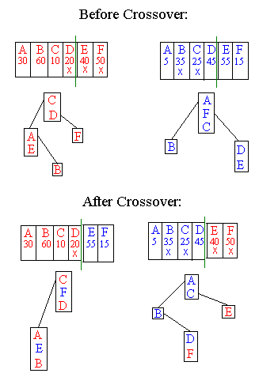
Figure 4.23: Website crossover

