X. Website Design v. 5
The website that we used in this project was designed to work smoothly with the genetic algorithm and the experiment. The genetic algorithm must be able to understand the structure of the website so that the genetic algorithm can manipulate that structure. For the experiment to be successful, the website must provide the experimental subjects with the tools they need in order to produce consistent, reliable data. These requirements dictate some aspects of the design of the website.

X.1. Representing a Website
The genetic algorithm must be able to manipulate the website. To make this easier, the website was designed so that its structure could be represented as an array. It is much easier for the instructions in the genetic algorithm to manipulate an array than the HTML code that is used to represent the website on the Internet. Therefore, one of the website design goals of this project is to find an array that captures the relevant information of the website in a form that the genetic algorithm can understand.
Each member of the array is called a content unit. A content unit represents an amount of web content roughly equivalent to a paragraph. The term “roughly equivalent” is used because there are often headers, links, or buttons associated with each paragraph, and these are absorbed into the content unit to make things easier. Consider the simple web page in Fig. X.1 as an example.
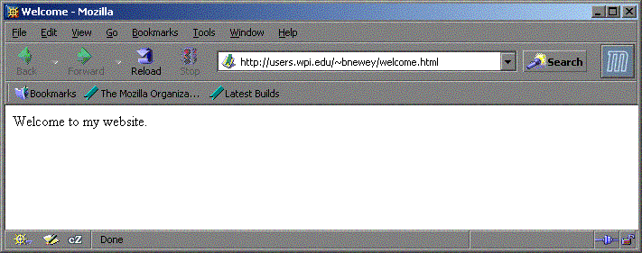
Figure X.1: A Simple Website
There is one content unit on this website, and it contains the string “Welcome to my website.” The entirety of a website can be represented by an array with a length equal to the number of content units. In this case, the length is one. Figure X.2 shows a pictorial representation of this array. Note that in many computer science applications, arrays are zero indexed. This means that the first member of the array has an index of zero, the second member an index of one, and so on.
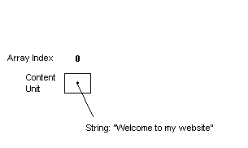
Figure X.2: Representing a Simple Webpage
Adding another content unit to a website increases its complexity (See fig. X.3). There must be multiple content units in the array, and there must be some way to distinguish the order of the content units.
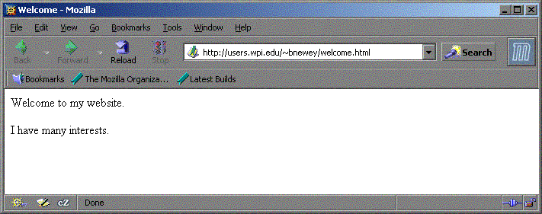
Figure X.3: Adding a Content Unit
There are now two content units in the array. A second variable is added to each, representing its “priority” on the webpage. The smaller the priority, the closer the content unit is to the top of the page.
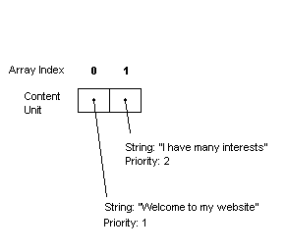
Figure 5-4: Representing the New Webpage
Priorities control how content units are positioned on the page relative to each other. Any content unit with a certain priority will always appear below any units with a lower priority, and above all units with a higher priority. For example, if there are three content units which have priorities of 3, 1, and 9, the website would contain the content unit with priority 1 first, the content unit with priority 3 second, and the content unit with priority 9 third.
When the GA acts on this array, no content information is modified, because all resulting websites must contain the same content. If content information is exchanged through crossover or changed through mutation, the websites no longer have identical content. The information presented by each member of the population must be the same. The GA is changing the presentation of this information, not the information itself. The priority attribute does not relay any content information. Because of this independence from content, the GA can alter the priority to produce different ordering results without changing the content.
Consider the following array (Fig. X.5), which produces the following web site (Fig. X.6).
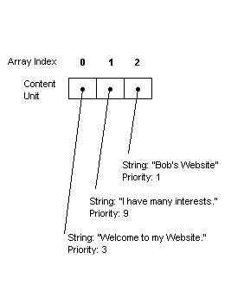
Figure X.5: Three Content Units
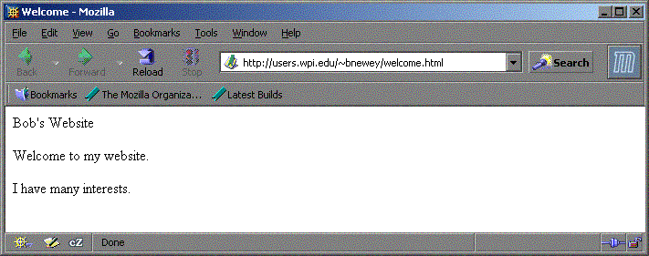
Figure X.6: Website for Figure 5-5
Let us now consider that an arbitrary number of mutations or crossovers have been performed to achieve new priority results, as shown in Figure X.7 and X.8
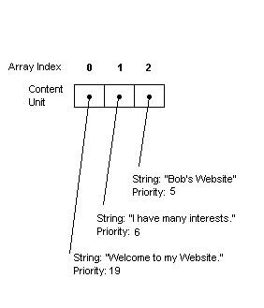
Figure X-7: Changing the Priority
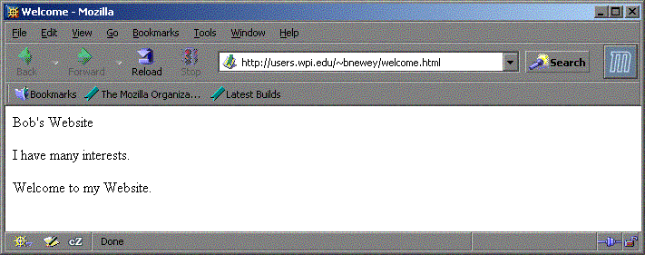
Figure X-8: Website for Figure X-7
This demonstrates that priority can be arbitrarily changed to produce new presentations without modifying the data.

X.2. Using Websites to Construct a Hierarchy
The above examples are not hierarchies. To include the hierarchical structure of an actual website in the algorithm, a limitation is imposed that all pages of a website can only link to a page lower in the hierarchy. This forms a tree, and the graph of this tree contains no cycles (i.e., there is only one path to each page in the tree). This limitation allows us to easily represent the site in a fashion acceptable to the Genetic Algorithm.
The GA performs linking implicitly by binding multiple content units to a page. Consider the array shown in Fig X.9. In this representation, the dividing lines represent the ends of pages. The positions of the lines are included in the GA data structure in a way that will be described later.
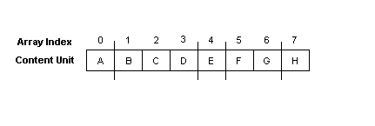
Figure X.9: Representing Pages
In this example, content unit A is bound to the first page, content units B-D are bound to the second page, E to the third page, etc. To create the hierarchy from this setup, we perform the following algorithm. First, determine the index page, represented by the first group of content units before the first line. In this case, it is just “A”:

Figure X.10: Step One in Constructing the Hierarchy
This represents a site containing a single page with a single content unit. The next group of content units represents page 2 of the hierarchy. These are content units B, C, and D, located between the first and second divisions in Figure X.9, above. When added, the site looks like Fig X.11.
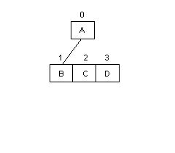
Figure X.11: Step Two in Constructing the Hierarchy
The second page contains three content units. Each content unit contains one link, unless it is at the bottom of the hierarchy. Because there are three more content units to add in this example (as represented in Figure X.9), this means that the tree will now contain three more branches. Content unit B will point to the next page. According to Figure X.9, that page contains only content unit E.
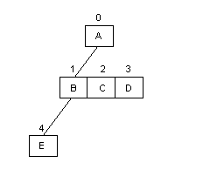
Figure X.12: Step Three in Constructing the Hierarchy
The algorithm continues to perform these operations in a breadth-first manner until the entire hierarchy is constructed. Hence, it will add the next link to content unit C, the link after that to content unit D, and the link after that to content unit E. The results of the algorithm are shown in Fig X.13.
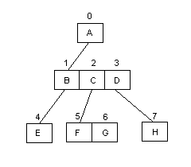
Figure X.13: Completing the Hierarchy
To add additional pages to the hierarchy, the algorithm would continue to function in a breadth-first manner, adding a page first to content unit E, then to content units F, G, and H, respectively. This results in the hierarchy always being represented as a complete tree.
To represent the divisions in Figure X.9, the algorithm uses “flag-based separation”. Flag-based separation is a concept that incorporates binary flags into the array. These flags are placed on the array values that have a page break directly following them. In this example, the flags would be placed in content units A, D, E, and G. The final content unit is always assumed to have a flag, because it will always appear at the end of a page.
Many of the website representation problems addressed here are necessary for the genetic algorithm to function properly. By combining the usage of the array data structure with a clear division of pages we can also represent an entire hierarchical website using a single data structure. The website representation discussed above was designed with these goals in mind.

