4.2. Experiment Design
In this section, we will explain the design of each of the three experiments. For each of these experiments, the physical collection of our data was done by perl scripts. The scripts logged the user access times, as well as the paths they took when traversing the websites. We implemented the scripts such that when a user clicked the back button on their web browser, it would not effect the collected data.

4.2.1. Experiment #1 v. 3
The first experiment allowed us to determine the effect of page length on how long it took for users to find a specific link. This was accomplished by giving users the task of finding the correct link for a given subject. Word count (of the experimental page) was the independent variable.
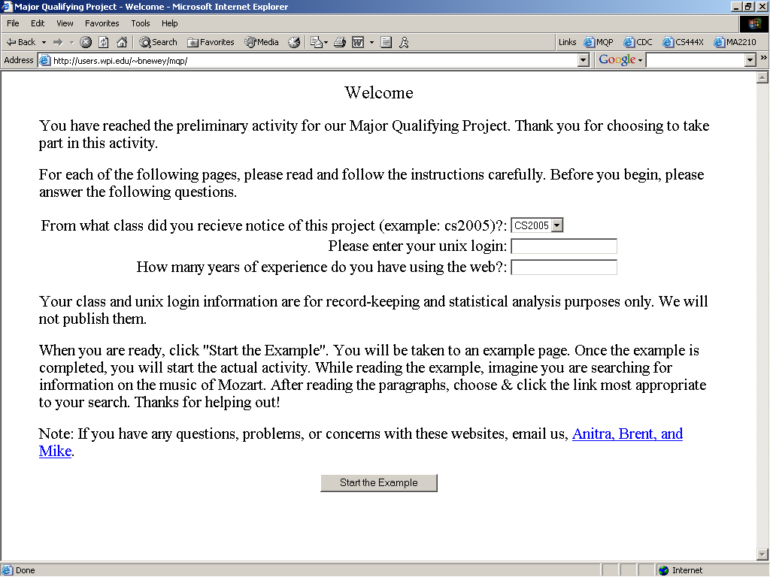
Figure 4.14: Introduction to Experiment 1
The users were first presented with an introduction page (Figure 4.14, above). The purpose of this page was to prepare the user to take the experiment. The users were told to imagine that they were searching for information about Mozart while reading the example page. Each user needed to click the link most appropriate to their search in order to complete the example task successfully (Figure 4.15).
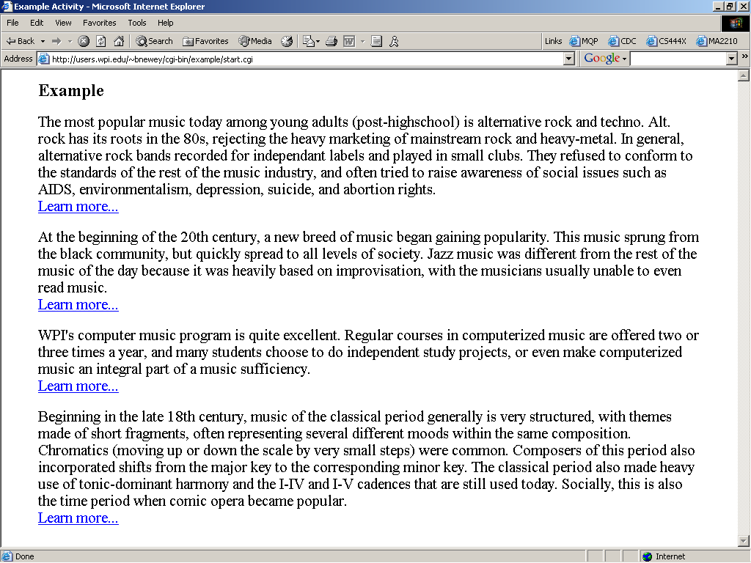
Figure 4.15: Example task for Experiment 1
Once a user completed the training example, they were presented with one of five pages, each of different length. Each page contained similar information about five computer technologies (Figure 4.16, below). The users were asked to look for information on “online form technology”. These pages were presented in the same format as the example page, i.e. paragraphs followed by links. The topics, as well as the order they were presented, were the same on each of the five pages. Each page also contained the same proportion of information for each topic (i.e., each topic took up 20% of each web page, regardless of the page’s total length). The amount of information provided for the topics was the only difference between the five pages. By varying the amount of information for the topics, we were able to test the effect of different page lengths on the time it took the user to find the correct link.
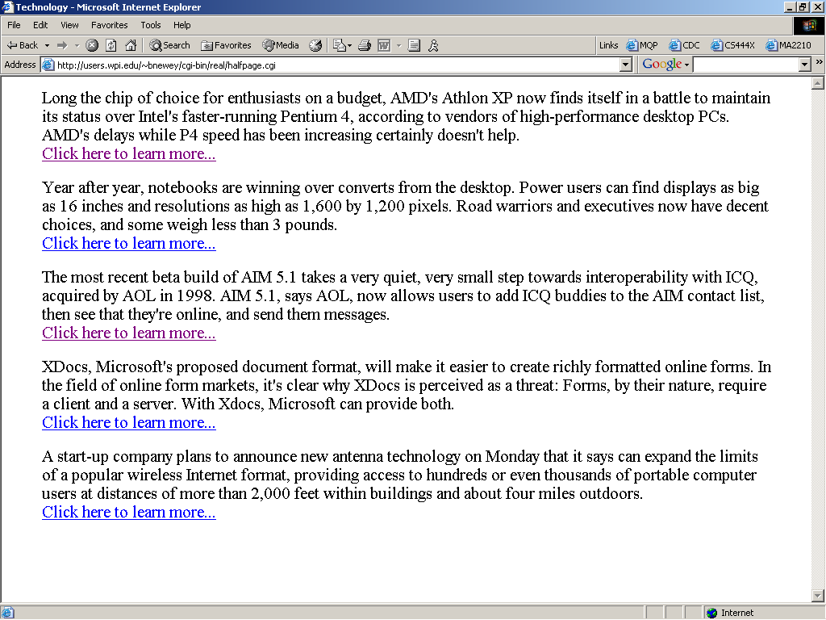
Figure 4.16: Experiment 1
Once the user clicked on a link, the experiment terminated. This occurred whether or not the user selected the correct link. We ran the experiment in this manner to avoid a possible side effect of correctness on reading time.
We recorded the time from when the user started the actual activity to the time when the user to clicked on a link, the length of the web page, and whether or not they selected the correct link. By conducting this experiment we found a relationship, which we used in our fitness function, between the length of a web page (measured by word count) and the amount of time it takes a user to find a desired link.

4.2.2. Experiment #2 v. 3
The second experiment allowed us to obtain data on how the users traversed a human generated website. For this experiment, we designed a website that contained information on unusual sports.
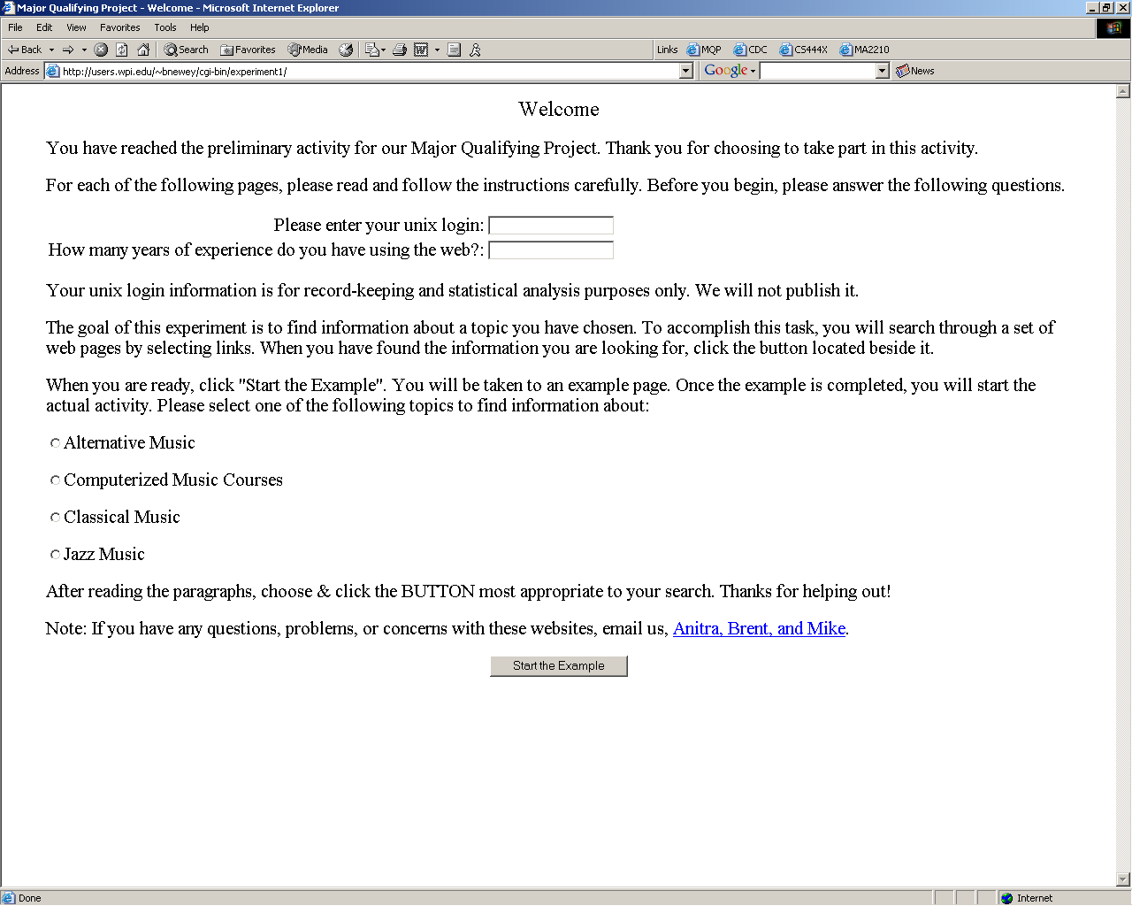
Figure 4.17: Introduction to Experiments 2 & 3
As with the previous experiment, users were first given an example task (see Figures 4.17 and 4.18). For this task, links were not functional, and were only placed there to familiarize the users with the format of the experiment. Next to each paragraph was a button titled “This is my topic”, which the user clicked when they thought they had found their target topic.
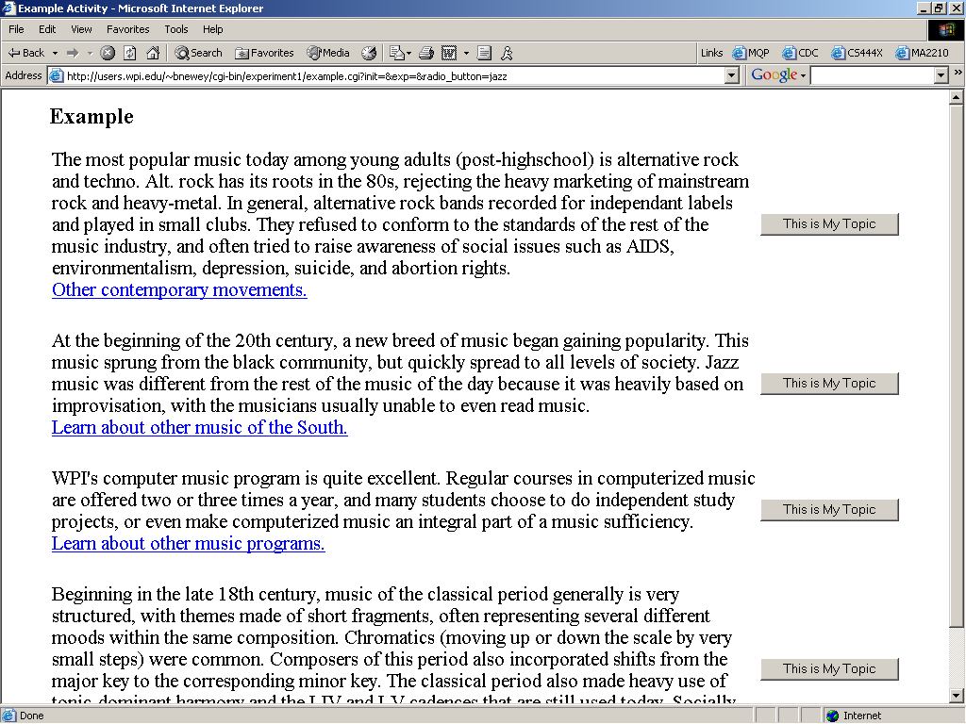
Figure 4.18: Example task for Experiments 2 & 3
Once the example task was successfully completed, each user was asked to select an unusual sport (Figure 4.19). This selection dictated their target topic for the experiment. By allowing this selection, we were able to obtain a frequency distribution of the number of times each sport was searched for.
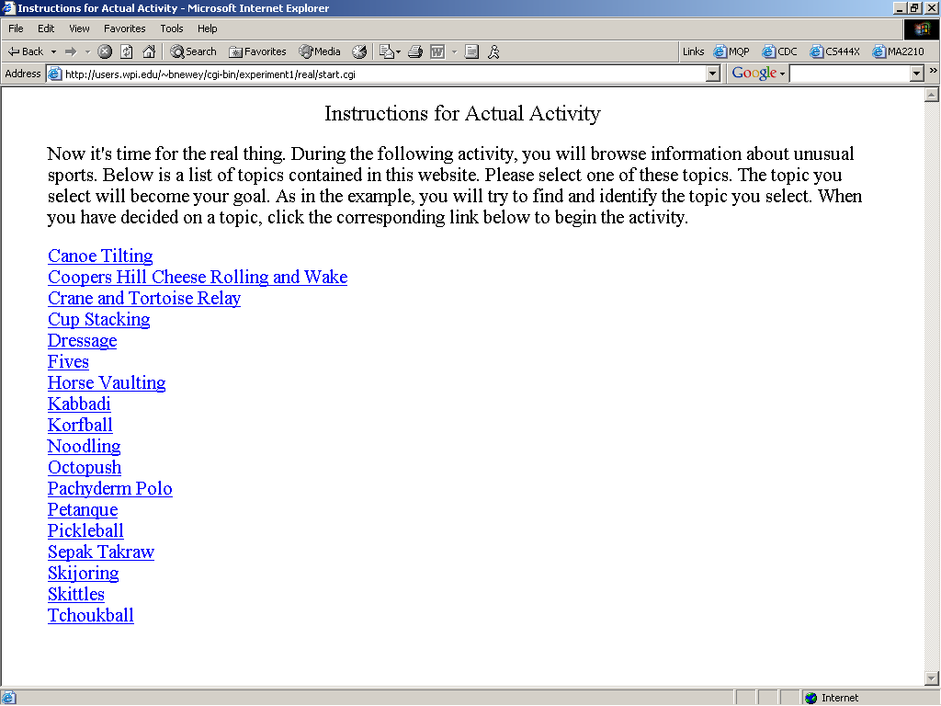
Figure 4.19: Selecting a target topic
Once a target had been selected, each user navigated through the website (structure shown in Figure 4.20, below) until they believed they found the relevant information about their target. They indicated this by clicking the button next to the relevant paragraph. If the users clicked on the wrong button, they were presented with a page indicating this, and were asked to try again. Once the user selected the correct button, they were presented with a page indicating success.
The frequency distribution and the path followed to get to the target information were used in the GA’s fitness function.
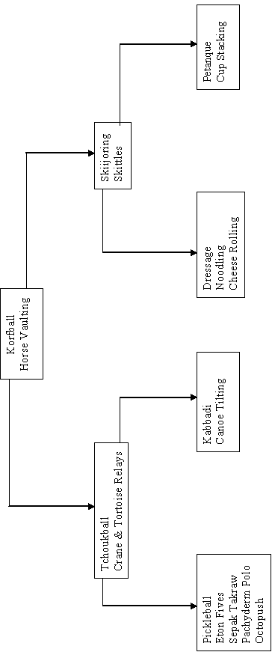
Figure 4.20: Site Structure, Experiment 2

4.2.3. Experiment #3 v. 3
The third experiment allowed us to obtain data on how the users traversed the website modified by the GA (see Appendix H for structure). The website contained exactly the same information as the human generated website in the second experiment. The structure of the website changed, as well as the location of content units within the site. We collected time data in this experiment to compare with the times from experiment 2.
(originally wrote):
Intro
Adaptive Websites background
Experiment Design
Conclusion
Appendices A,B,C

Found some of the info for all experiments

Wrote generator.h and mutator.h

