Appendix A: Sports Site (Experiment 2)
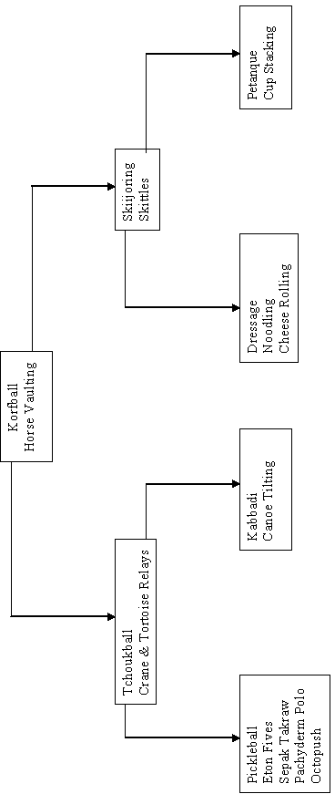

Appendix B: Sports Site (Experiment 3)
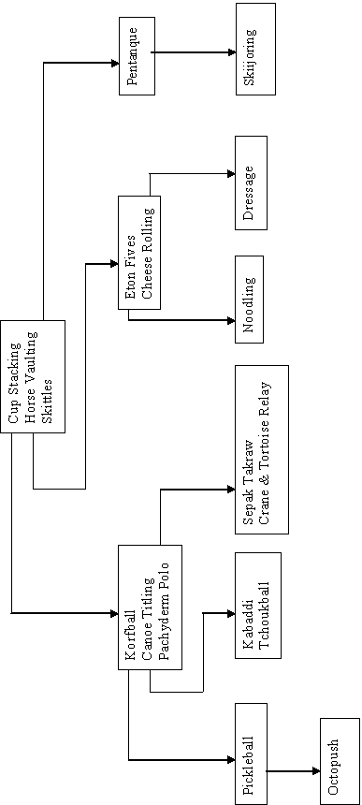

Appendix C: Animals Site (Experiment 3, unused)
Mantella
Amazon River Dolphin
Darwin's Frog
Dwarf Mongoose
Tasmanian Devil

Pacific Giant Salamander
Xenosaur
Amazon River Dolphin TARGET
Mammals

Darwin's Frog TARGET

Tasmanian Devil
TARGET
Komodo Dragon TARGET
Bushmaster TARGET
Komodo Dragon

Xenosaur TARGET

Dwarf Mongoose TARGET
Pacific Giant Salamander TARGET

Amphibans
Bushmaster
Mantella TARGET
Reptiles

