2. Problem Definition

This project hinges on the comparison of two fundamental methods for producing web media. The first, and most common, is simple human generation: a person or group of people designs, implements, and maintains a page or group of pages using a set of knowledge and “designer’s intuition”. By doing this, they hope to produce an optimal site. In the case of many professional sites, research is also done to determine the effects of certain aspects of the website on user performance. Additionally, the site will be tested and “tweaked” before and/or after its publication.
This method is essentially a “design first, test later” program, in which a website is generated, analyzed, evaluated, and modified based on findings. An alternative method attempts to reverse these processes by predicting the outcome of tests before they are actually performed and eliminating less desirable options using an algorithm. While this technique is much less common, it may have several applications worth exploring.
This project attempts to utilize the second method: it generates a site by standard means, and then modifies this site using a Genetic Algorithm. When this is done, we can compare the performance of a group of users on both the original and modified sites. We can then use this information to determine the usefulness and feasibility of a Genetic Algorithm for the application of adapting a website.
This task is accomplished in accordance with certain criteria. For starters, the general user of the website to be adapted must be modelled. This model is later used to calculate fitness in the genetic algorithm. The model must show a relationship between certain factors in a member of the population and its corresponding fitness.
There must be a website to adapt, and it must begin as a human-generated website. Performance measurements must be gathered for use with the fitness function and as a means for comparison with the final product, generated by the Genetic Algorithm.
The algorithm used must function effectively as a Genetic Algorithm. It must generate a population, assign each member of the population a fitness value, select the most fit individuals for breeding, perform mutation and crossover to provide diversity, and iterate the latter three steps enough times to produce a significant increase in fitness. Finally, it must select a single individual to replace the human-generated website.
Once these tasks have been accomplished, the project will be evaluated. Its success is dependent on the existence of improvement in the metric tested. In the case of this project, that is the average time it takes for a user to complete a random task on the site. It must meet this goal without causing an unacceptable loss of comfort with the website.

4. Solution
A solution to the problem of adapting a website using a Genetic Algorithm must inevitably include an explanation of parts of the Genetic Algorithm. It must also list the experiments necessary to gather the appropriate. However, the true purpose of this section is to illustrate the relationships between the experiments, dependent parts of the Genetic Algorithm (fitness function), and the final evaluation.
The fitness function used in this project receives two variables to calculate a total time to accomplish a task for each set of user behavior. The task that the Genetic Algorithm attempts to define a time for is the same task that the user attempted to accomplished in the initial experiment. The user behavior data consists of the list of links clicked for the user to achieve his or her goal. This list allows the fitness function to determine the path length associated with user behavior for any site generated by the Genetic Algorithm and the length of the pages that he or she would traverse, and thus calculate an aggregate time for the entire site for each user. It then averages these times to achieve a fitness rating for that site.
The first variable, path length, is used to calculate which pages are visited in the simulated environment of the Genetic Algorithm as it attempts to accomplish the task of a user based on his or her information. The data contained in this variable will be transformed by the fitness function into a list of pages that must be visited to accomplish the task. Once this is done, each page is given a value for the amount of time a user would spend on that page based on the word count (a measure of the length of the page) before the link clicked to arrive at the subsequent page. This relationship was calculated using data from the pre-experiment.

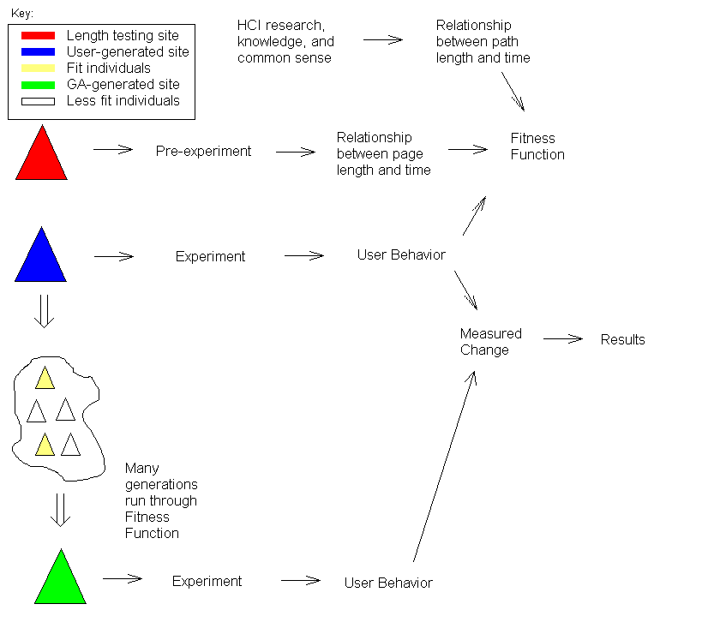
Figure 5: Overall design.

The solution opted for is illustrated in Figure 5. Each arrow in the diagram can be interpreted as “yields”. That is to say, for example, that an experiment yields user behavior, or a measured change yields results. Note that in this diagram, the fitness function has three requirements: the users’ behavior from the experiment and the two variables relating path or page length and time.
Once the experiment is run on the initial human-generated page, the user behaviors gathered therein are used in the genetic algorithm, represented by the arrow to the right of the “cloud” of generated sites in the lower left of Figure 5.
Finally, there is a statistical comparison between the final site (green triangle) generated by the algorithm and the initial human-generated site (the blue triangle), to determine the success of the experiment. This comparison factors in to a final evaluation of the project, and must measure the change using a variety of tools (stratified plots, means, medians, etc.). The final evaluation will also take into account the comfort levels of the users. It must determine is there is a drop in user satisfaction, and decide whether it is acceptable in light of an improved user behavior (if such exists).
To construct a solution for the problem of adapting a website, several approaches were considered. Each of these solutions involved the use of a genetic algorithm, but differed in: metrics collected, number and type experiments run, fitness function, or minor concerns.
The first component of the solution considered above is the fitness function. This aspect of the genetic algorithm is the one that is perhaps the most time consuming to design and implement. The fitness function must be able to simulate a type of behavior (natural evolution) and transform a data object (website hierarchy) into a single number that summarizes that object’s “fitness” in relation to the criteria set. Because of this, we determined that some experimental data would be required for this function to operate accurately.
A unique, and admittedly complex, solution would be to assign a value to each attribute of the website description, and use a set of pre-experiments to allow the function to “learn” the weights these attributes should have. This approach was rejected for a number of reasons, chiefly because of complexity and time constraints, but also because we were no longer limiting ourselves to the application of one artificial intelligence tool to solve the problem. That is, we were combining the tools of machine learning and Genetic Algorithm. Hence, it would be unclear as to the effect of a single tool.

5. Design
Throughout this experiment, the fundamental piece of data that is being manipulated and ultimately improved is referred to as a site. While there are a lot of different ways to manipulate a site, this project will limit the alterations to produce changes in two metrics (discussed above). Once the attributes to be changed are chosen, the representation of a site can be done using a simplified data structure. In this instance, the decision was made to use three data structures of increasing inclusiveness and magnitude, as illustrated in Figure 6.

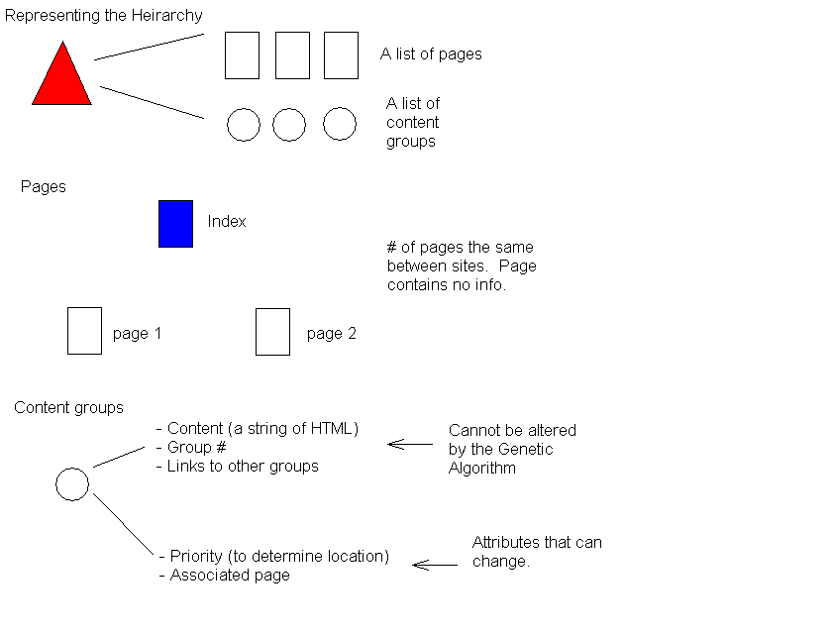

Figure 6: Data representation.
The basic data structure in this representation is a “Content Group”. There are two types of information that are stored here: mutable and immutable. Information is immutable for reasons of continuity. The content within one of these groups cannot be changed because it would not make sense. “Group #” and “Links to other groups” are important pieces of information that allow content groups to reference each other via links and form a hierarchy. Important information within the mutable category is anything that will yield a change in page length (the primary metric).
The page object contains no real data. In point of fact, the important information contained here is simply the number of pages within the hierarchy. Content objects store page associations, the important information for constructing pages, and link information, for building the hierarchy. Together, these two sets form the hierarchy object, the largest data structure and a representation of the entire site.
The experiments are performed using an informational page with navigation links within the text. The page offers a type of information that is of some interest to a large amount of WPI students (Academic information, football scores, book reviews, etc.). For the purposes of the experiment, the initial site has a hierarchical structure of three levels. However, the structuring of data allows for realization of any number of hierarchical levels, and the genetic algorithm provides alternative structures.
The user base for this experiment is WPI students with a computer science background, most easily obtained through professors of B-term classes. The users are divided into two groups, a control group and an experimental group. Users are classified by levels of web experience to provide a structured form of data for the fitness function.
All server side activities are conducted using Perl scripts. Since this mostly consists of recording links, this information is output to a file and given as such to the genetic algorithm.
Mutation is accomplished though what is known as "real number creep". The process is simple: choose some attributes at random and move them in a set positive or negative direction. Representation is inherently ordered, which means that similar attributes will be close together on the number scale (Color, for example: lighter colors are higher numbers, darker colors are lower numbers).

Another form of information that can be gathered is user feedback. In the case of this experiment, it is most desirable to reduce the intrusiveness of the gathering techniques, and so we opted for a simple rating system. We ask two fundamental questions to which they reply positively or negatively. These questions are "Is the layout of the page helpful in accomplishing your task?", and "Does the layout provide a comfortable navigating experience?" This goes in Experimental Design.

