3.5. Genetic Algorithms
Genetic algorithms are used to simulate evolution in a computerized environment. Natural evolution has long been recognized as a superb adaptive mechanism. Genetic algorithms are robust, able to solve many types of problems, but are also relatively efficient.

3.5.1. Why Genetic Algorithms?
Genetic algorithms are one of many optimization methods. So why use a genetic algorithm when there are so many other ways to optimize? Many optimization methods have gaps in their effectiveness, which a genetic algorithm may be able to fill. For example, most traditional methods work best on continuous functions, and might not work at all if the data points were not connected. Most are work poorly in functions with multiple peaks, often finding only a local optimum instead of the best value.
Goldberg [1989] lists several reasons why genetic algorithms work differently from traditional optimization methods. First, genetic algorithms use a representation of the parameters, not the actual parameter set. Second, they search from a population of points, as opposed to a traditional algorithm, which would search from a single point. This is especially important in multiple-peak functions, as the algorithm can be climbing many hills at once. Third, instead of trying to determine the single best answer, genetic algorithms are based on probability. So while the chances of finding the absolute best answer are the same or lower than what they would be in traditional algorithms, it is much more likely that the genetic algorithm will find a solution that is very close to the optimum. Last, but most important for their robustness, is the fact that genetic algorithms only use the information given to them by the previous solutions. They do not need any auxiliary knowledge (example – derivatives of a continuous function) to find a solution. Goldberg [1989] calls the previous solutions “payoff information”, that is, the payoff from the previous attempt. Traditional algorithms always need additional information (unless they are just a random walk); instead of working from previous solutions, they try to determine which solutions are likely to be good before trying them.

3.5.2. How genetic algorithms work
Genetic algorithms are easiest to understand when applied to a black-box problem. The box has a number of switches which can be toggled on or off. The output from the box depends on which switches are toggled, but we don’t know which combination will give the best result. We can represent each switch with a digit – 1 if the switch is on, and 0 if it is off. So a complete representation of the switches is a string of ones and zeros. To use a genetic algorithm to solve this problem, we first generate a few possible combinations for the switches by flipping a coin and recording the result, until we end up with several strings of ones and zeros that represent possible solutions to the black box problem. (We later refer to these strings as chromosomes.)
The genetic algorithm will use only two basic operations on these strings to find an answer: copying the strings and swapping partial strings. First, we evaluate each string and give it a fitness value, which Goldberg [1989] urges us to think of “as some measure of profit, utility, or goodness that we want to maximize.” We then copy over strings according to their fitness values; strings with a higher fitness have a greater probability of contributing one or more offspring to the next generation – an artificial version of Darwin's “survival of the fittest”. Each string copy is entered into a “mating pool” [Goldberg 1989]. The members of the pool are selected for mating at random. Each pair then undergoes crossover (Figure 1): a position is chosen on the pair of strings and all the characters in the string after that position are copied over to the other string instead. There is also a small chance that one of the offspring produced may mutate, which would change a single value at random within the string.
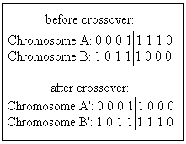
Figure 1: Basic crossover.
So, in short, there are four main parts to a genetic algorithm: evaluation (or fitness), reproduction, crossover, and mutation. The basic steps in a genetic algorithm are shown in Figure 2.
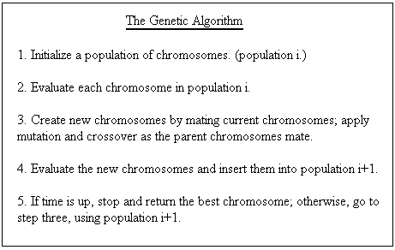
Figure 2: Genetic algorithm. Adapted from Davis [1991].

3.5.3. Reproduction
Genetic algorithms are intrinsically parallel [Davis 1991]. They work on many possible solutions at once. Reproduction, which maintains the population of possible solutions, makes this parallelism possible.
The simplest method for choosing parents is often called “roulette wheel selection” [Davis 1991; Goldberg 1989], because it can be thought of as assigning a slice of a wheel to each chromosome, with the size of the slice corresponding to the chromosome’s fitness. If the fitness values for the whole population are summed, we may then calculate each chromosome’s fitness in proportion to the whole. This proportion is the probability that the chromosome will be selected for reproduction.
There are two replacement techniques that can be used in reproduction: generational and steady-state. Replacement refers to what population new children are inserted into. Generational replacement replaces a whole generation with the children it produces. Steady-state replacement [Davis 1991] produces one or two children at a time, and inserts them into the current population. Noisy functions, in which the same chromosome may return a different value each time it is evaluated, are better served by generational reproduction. Steady-state reproduction can be used to reduce or eliminate the chances of having duplicate chromosomes in a population. It can also allow a higher rate of mutation and crossover, without the fear of losing many good chromosomes.
Another method to prevent loss of good chromosomes is elitism. The concept of elitism makes generational replacement more like steady-state: the best individual from the generation is copied over to the next generation. Some approaches extend this concept by encouraging duplicates of good chromosomes in the population in order to increase the chance of these chromosomes being involved in crossover.

3.5.4. Crossover, Mutation, Schemata
Crossover and mutation are the two major operations used in reproduction. [Goldberg 1989; Davis 1991] Crossover in its simplest form, known as one-point crossover, has been described above. Two-point crossover is similar (Figure 3), but sets both starting and ending points for the exchange of genetic material.
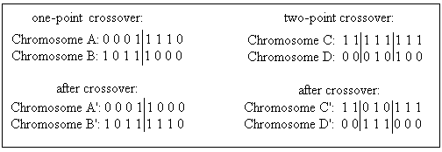
Figure 3: One-point and two-point crossover.
The methods for two-point crossover can be extended for longer chromosomes, but they begin to lose their effectiveness. When diversity in the population is greatly desired, a third type of crossover, called uniform crossover (Figure 4), is used. In uniform crossover, bits from the parents are randomly divided between the children. This is done by means of a template. The problem with uniform crossover is that it can easily destroy valuable schemata (defined below).
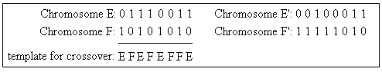
Figure 4: Uniform crossover.
Mutation is the other important operation used in genetic algorithms. A unary operation, it changes the value of a single bit within one chromosome. Mutation is used to introduce diversity into a population, finding solutions that would not be possible if only crossover were used. Crossover, on the other hand, can spread favorable mutations quickly, and allows the mutations to be combined (extremely unlikely without crossover).
Schemata are important to understanding how genetic algorithms work. A schema is essentially a template of a chromosome. In a binary representation, the template has three possible values for each position: 1, 0, or “don't care” (represented in Figure 5 by the # symbol). It is the strings of 1s and 0s that make up the schema and provide a basis for comparison of genes. The Schema Theorem states that a schema which occurs in chromosomes with above-average fitness will tend to occur more frequently in the next generation. This is especially true with shorter schemata, as they are less likely to be broken by crossover.
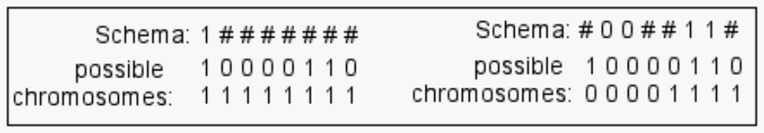
Figure 5: Simple schemata & binary chromosomes that fulfil them.

3.5.5. Fitness
The last important part of any genetic algorithm is its fitness function. This function is based on an evaluation function. The evaluation function determines how well the chromosome performs in its domain. This evaluation is highly dependent on the problem that the genetic algorithm is trying to solve. The individuals that have the highest evaluation (the answers closest to what is desired) are given the highest fitness. The individuals with the highest fitness are more likely to be chosen to reproduce for the next generation. According to Davis [1991], there are three popular techniques for computing fitness.
The first technique is very simple: the evaluation of the chromosome is its fitness. In this technique, the numerical value given to the chromosome by the evaluation function is simply copied to the fitness. While uncomplicated, this method has its disadvantages. At the beginning of a run, when there have not been many generations, a “super-individual” (one that is much better than the average) can quickly wipe out all its competitors, even if it is not very close to being optimal. When the algorithm has been slowly converging on an optimal solution, individuals in the late generations will be “close competitors” in fitness, and the best of the group will not stand out. This technique must also be modified if it is possible for an individual to have a negative evaluation, because fitness must be positive.
The second technique is called “windowing.” In this technique, the minimum evaluation within the population is found. Each chromosome is then assigned a fitness value equal to the amount it exceeds this minimum.
The third technique is linear normalization, which orders the chromosomes by their evaluation. The best evaluation gets the highest fitness value (equal to the size of the population) and the worst evaluation gets the lowest fitness value (usually one or zero).
Both of these later techniques compute fitness by a relative scale of the current population, so they are less likely to be affected by the “super-individual” or “close competitor” scenarios that can happen at the beginning or end of the algorithm.
Davis [1991] asserts that the concept of “fitness” (in this application, we’ll refer to it as preference) can also be applied to the operations performed on the chromosomes. At the beginning of a run, crossover is most effective at finding good solutions. However, at the end of a run, when all the individuals are relatively close, mutation is the better operator. By assigning the operators a preference value that increases or decreases over time, the algorithm can perform more efficiently. This also allows the operators to work independently of each other; a chromosome may be mutated without using crossover first.

3.5.6. Other Representations
So far, we've only discussed genetic algorithms that use a binary representation for the chromosomes. However, genetic algorithms can be used with other representations as well. In fact, this is desirable if it helps understandability of the problem [Davis 1991]. For a problem where steps must be ordered, each chromosome in the algorithm is a permutation of the list of steps. With this representation, crossover is similar to the uniform crossover described earlier, but incorporates the idea that order matters. Mutation rearranges the steps within a sub-list of the entire chromosome. Among other applications, order-based representations are an important part of genetic programming [Koza 1999].
If a real number representation is used for the chromosomes, the operators are again modified. A simple crossover for real numbers is to average the two parents. A value within the chromosome may be mutated either by replacing it with a randomly selected real number, or by shifting the value up or down a small, random amount.
If some information contained in an individual cannot be changed, or is dependent on other individuals, a more structured representation must be used. For this case, Koza [1999] describes a form of structure-preserving crossover, which restricts which parts of an individual can be changed.

3.5.7. Generations and population size
Population size is important to consider when designing a genetic algorithm. Usually, the algorithm is constrained to a certain number of evaluations, so a smaller population will be able to have more generations, and a larger population must have fewer generations. A rule of thumb is that a larger population will work more slowly (needing more generations), but achieve a better eventual answer than a smaller population [Davis 1991]. This has been tested to some degree [Goldberg 1989], but cannot be proven to always hold true, due to the random nature of genetic algorithms.
The examples Goldberg [1989] and Davis [1991] use generally have a population size of 100, because it is an easy number to deal with. The real world applications they mention use population sizes around 30, because they cannot afford the slower nature of the larger populations. Other constraints can apply to the selection of population size, as well. Oliver et. al. [2002] use a population size of only 12, because their design requires the whole population to be displayed simultaneously on a monitor.
The number of generations also varies depending on the application and resources. The general rule is to run as many generations as time allows, because increased generations should result in a better solution. Since their algorithm was based on human decisions instead of a programmed fitness function, the users in the experiments of Oliver et al. [2002] were able to indicate when an acceptable solution had been found, ending the algorithm.

7. GA design/implementation:
The genetic algorithm is a crucial part of our project. Earlier in our design, we described the website encoding on a high level. From that encoding, we can distill an array, keeping only the necessary information for the algorithm to work. Each position in the array represents a content group, and contains the unchangeable information (group number, length, and links) used to identify and evaluate the group, and the information which can be changed by the genetic algorithm (priority, page number, and appearance?). An array as a whole represents an entire website hierarchy.
Taking our cue from the real-world applications mentioned in Goldberg [1989] and Davis [1991], the population consists of about 30 such arrays. We plan to run 100-200 generations.
In each generation, we use a linear fitness technique, where the best array gets a fitness of 30, and the worst has a fitness of 1. Arrays will be chosen for reproduction with roulette-wheel selection. (See 3.5.3. for more information.)
Our structured representation allows for fairly simple crossover. We cross two entire sites (arrays). The crossover point may occur anywhere within the array, however, it may not occur between the unchangeable data in a particular position of the array (group number, length, and links). The offspring of crossover have a .01 chance of mutation. If an array is chosen to mutate, the position is chosen randomly, and real number creep between -1 and 1 is applied.
When a generation has finished, the offspring population becomes the parent population for the next generation.
Our design, much like that of Davis [1991], easily accommodates a modular approach. The evaluation module, which contains everything needed to evaluate a website and give it a fitness value, has been described above. The population module controls generational replacement and parent selection. The reproduction module contains the code needed to commit crossover and mutation.

