6. Experiment Design v. 1
In this section, we will explain the design of each of the three experiments. We will also explain how we collected our data.

6.1. Data collection v. 3
The subjects of our experiment were WPI Computer Science (CS) students. The rationale for using only CS students was to have a more homogenous population, therefore resulting in the experimental subjects having relatively similar levels of computer experience. They were solicited though the faculty of two undergraduate classes, CS2005 and CS3041.

6.1.1. Experiment #1 v. 3
The first experiment allowed us to determine the effect of page length on how long it took for users to find a specific link. This was accomplished by giving users a task of finding the correct link on webpages of differing lengths to learn more about a given subject.
The users were first presented with an introduction page (see appendix 1). The purpose of this page was to prepare the user to take the experiment. The users were first told that they will take an example experiment before performing the actual experiment. They were told to imagine that they were searching for information about Mozart while reading the example page and to click the link most appropriate to their search in order to complete the example experiment successfully.
After clicking the button labeled “Start the example” on the introduction page, the users were then presented with the example page which contained information on four topics relevant to music (see appendix 2). Links labeled “Learn more…” were placed directly below each paragraph. Once the users believed they found the link that would lead them to information about Mozart, they clicked on it. If the users clicked on the wrong link, they were presented with a page indicating this, and were told to try again (see appendix 3). Once the users clicked the correct link they were presented with a page congratulating them (see appendix 4).
After clicking the button labeled “Continue”, the users were presented with a page telling them that for the actual experiment they would be looking for more information on an online form technology (see appendix 5).
Once they clicked the button labeled “Continue”, the users were presented with one of five pages containing information on five different computer technologies (see appendices 6-10). These pages were presented in the same format as the example page, i.e. paragraphs followed by links. However, the links on these pages were labeled “Click here to learn more…”. The topics, as well as the order they were presented, remained constant throughout each of the five pages. Each page also contained relatively the same amount of information for each topic resulting in the links being equally distributed on the page, i.e., the first link was located 20% from the top of the page, the second link 40%, etc. The amount of information provided for the topics was the only difference between the five pages. By varying the amount of information for the topics, we were able to test the effect of different page lengths on the time it took the user to find the correct link.
Once the user believed they had found the correct link, they clicked on it. Unlike the example experiment, where the users were required to keep trying until the correct link was chosen; this experiment concluded for the users once they had clicked on a link. By running the actual experiment in this manner we were also able to see what effect page length had on whether or not the users selected the correct link.
Which of the five pages the users were presented with were decided in a round-robin fashion. By doing this we were able to obtain an equal amount of data for each of the five pages.
We recorded the time it took the user to click on a link, the length of the web page, and whether or not they selected the correct link. By conducting this experiment we obtained an equation that relates web page length to the amount of time it takes a user to find a desired link.

6.1.2. Experiment #2 v. 3
The second experiment allowed us to obtain data on how the users traversed a human generated website. The website contained information on abnormal sports, and was specifically designed for by us for this experiment.
The users were first given an example to get an idea of how the experiment would be conducted (see appendix 11). The example asked the user to select one of four music topics. After clicking a button to start the example, the users were presented with a page containing a paragraph of information for each of the four music topics (see appendix 12). Under each paragraph was a link to another musical category. These links were not functional however, since the example consisted of only one page, and were only placed there to familiarize the users with the format of the experiment. Next to each paragraph were buttons with the words “This is my topic” on them. When the users clicked on a button, a script checked to see if the correct button was pushed. If the users clicked the incorrect button, a page indicating this would be displayed, and the users would be asked to try again (see appendix 13). Also if the users clicked on a link they were instructed told to try again (see appendix 14). Once the users successfully completed the example, they were presented with a page congratulating them (see appendix 15).
Once the users clicked the “Continue” button, they were then presented with a page where they selected, from a list, an abnormal sport they wished to find information on (see appendix 16). By allowing the users to select what sport to search for, we were able to obtain a frequency distribution of the number of times each sport was searched for.
After selecting a sport to search for, the users were presented with an index page (see appendix 17). From this page the users navigated through the website (see appendix 18) until they believed they found the relevant information about the topic they had chosen to search for. They indicated this by clicking on a button with the words “This is my topic” on it, next to the relevant paragraph. If the users clicked on the wrong button, they were presented with a page indicating this, and were told to try again (see appendix 19). Once the user selected the correct button, they were presented with the page shown in appendix 20.
The frequency distribution, along with the path the user followed to get to the sport’s information, were used in our GA’s fitness function to assign fitness values to websites generated by the GA.

6.1.3. Experiment #3 v. 3
The third experiment allowed us to obtain data on how the users traversed the website that was modified by the GA (see appendix ). The website contained exactly the same information as the human generated website in the second experiment. Only the structure of the webpages and website were modified.
Are we using same example? Same thing as experiment 2 but structure of site is different.

6.2. Data Storage v. 3
For each experiment explained above, we had Perl scripts run on the websites in order to obtain information about each user. On the introduction pages of each experiment, scripts recorded the user’s WPI Unix login and years of web experience by means of an HTML form. The pages following the introduction had scripts that recorded the users path from the experiment’s index page to the moment when the user …

The data collected in each experiment will be recorded in a comma-delimited text file. Each user’s information will have it’s own line in the file. We are using this type of file to store our data because of its ability to be put into an Excel spreadsheet easily.
APPENDIX 1
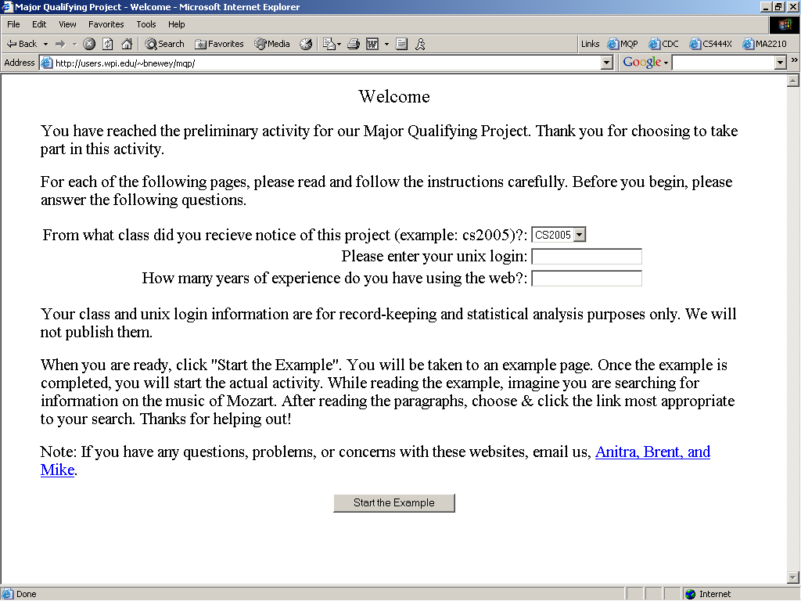
APPENDIX 2
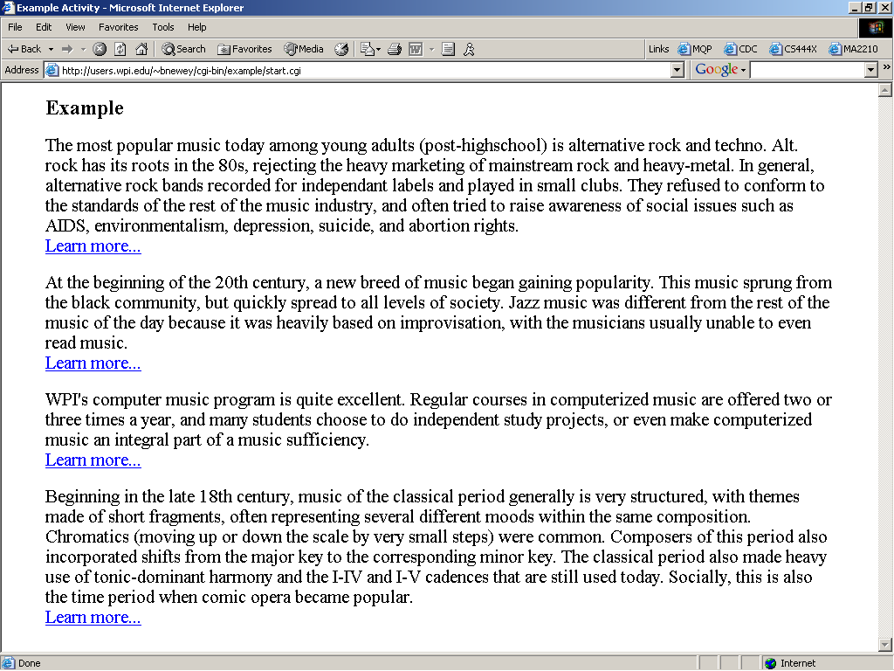
APPENDIX 3
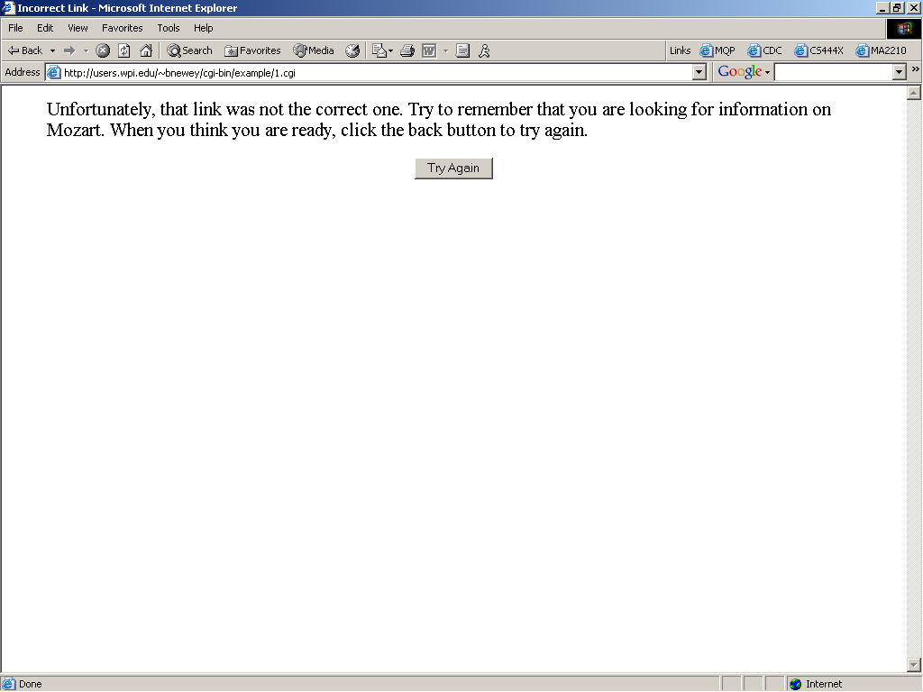
APPENDIX 4
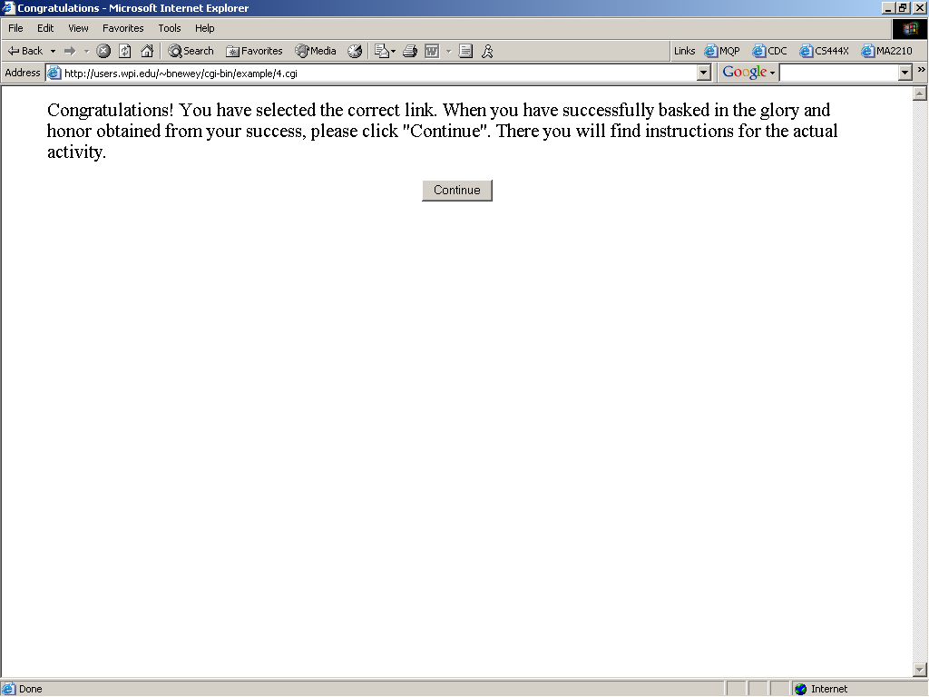
APPENDIX 5
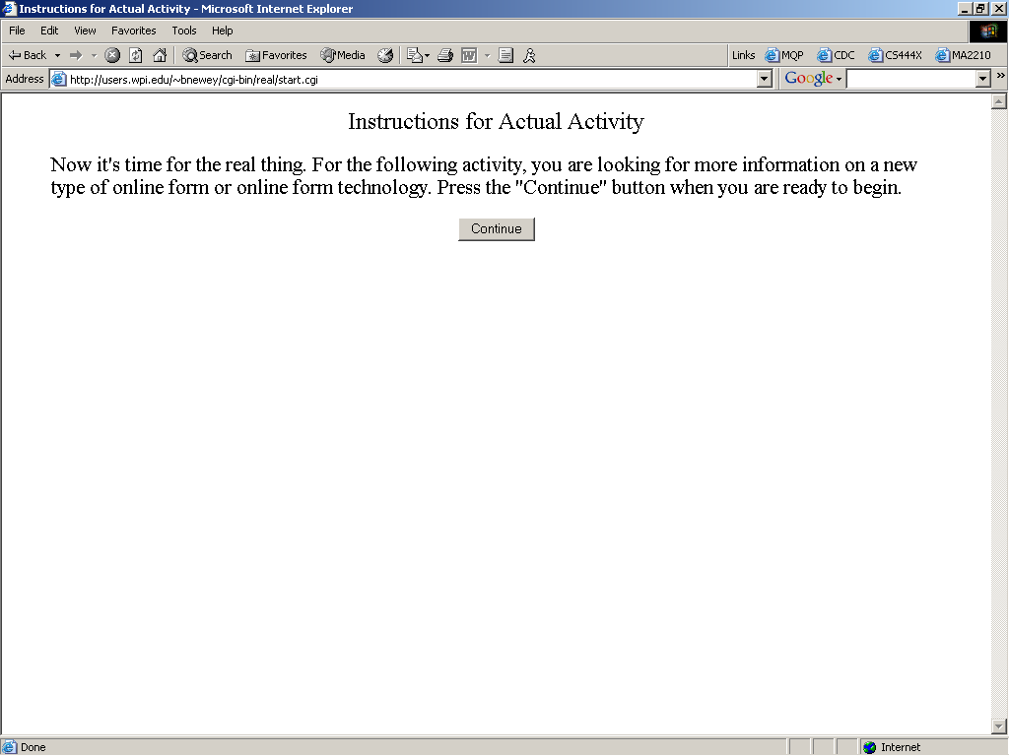
APPENDIX 6
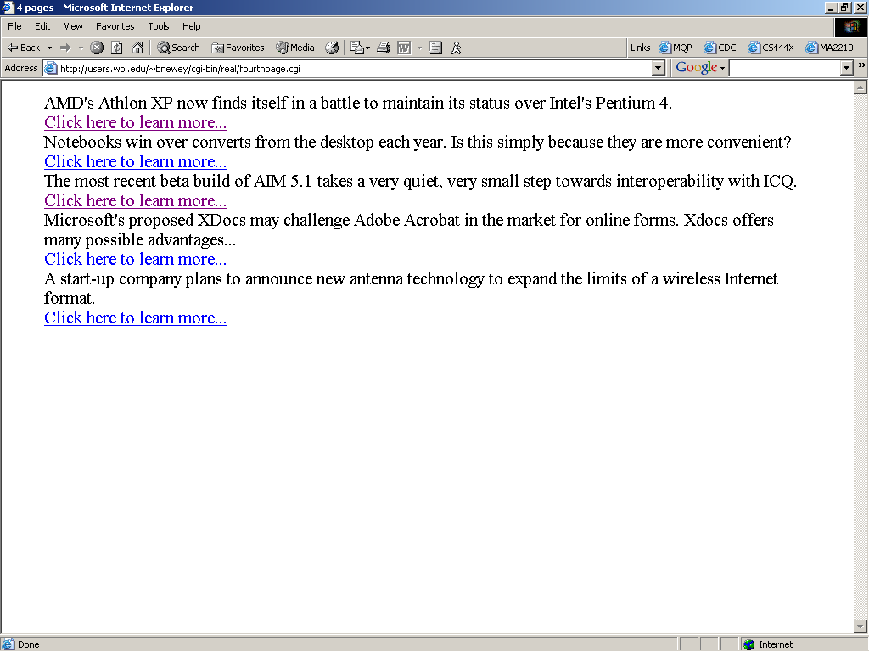
APPENDIX 7
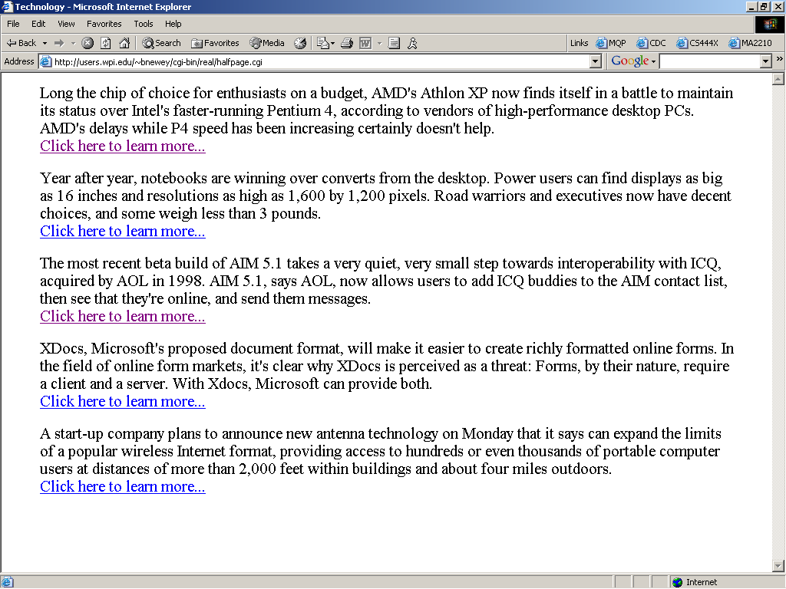
APPENDIX 8
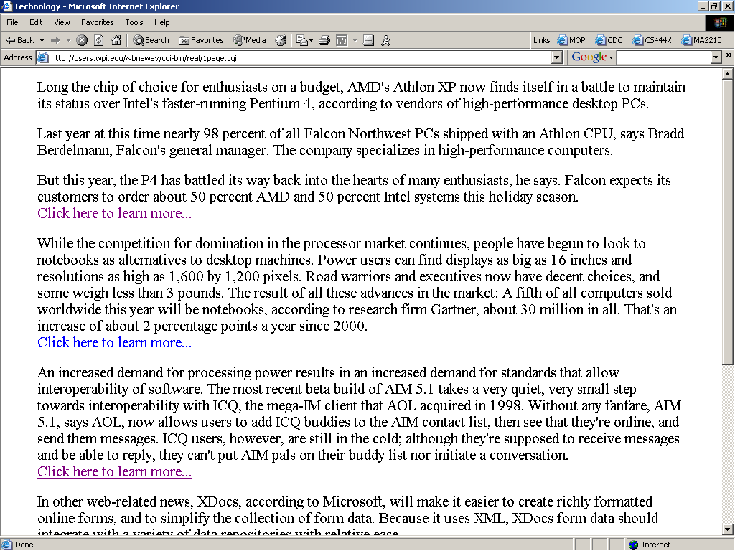
APPENDIX 9
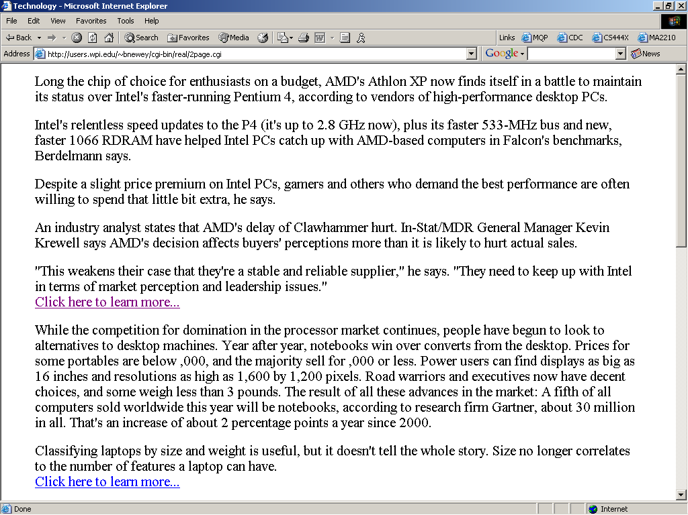
APPENDIX 10
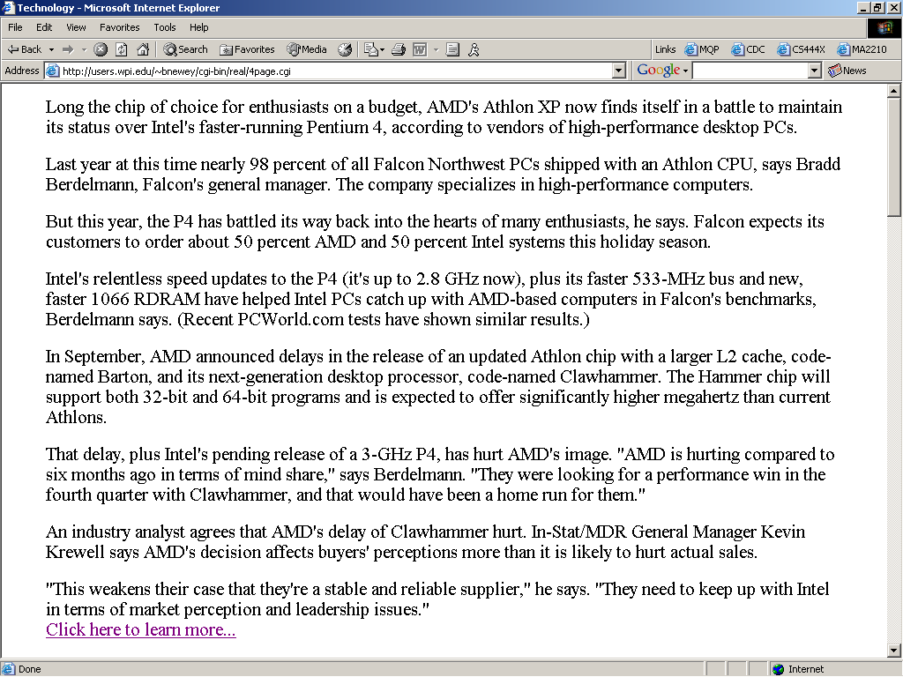
APPENDIX 11 (1280 x 1024)
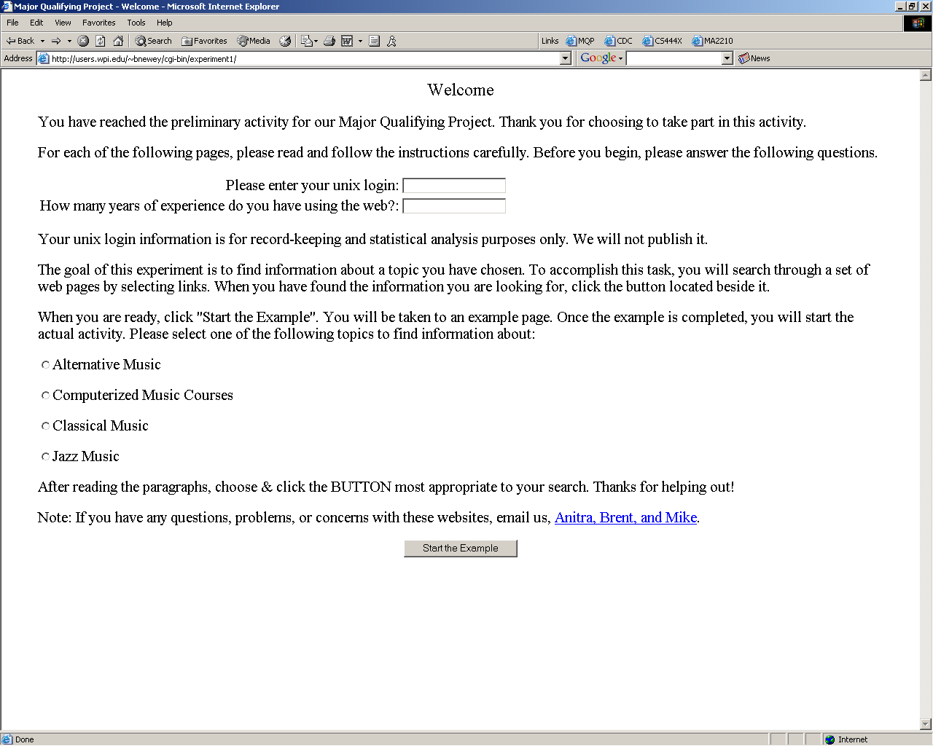
APPENDIX 12
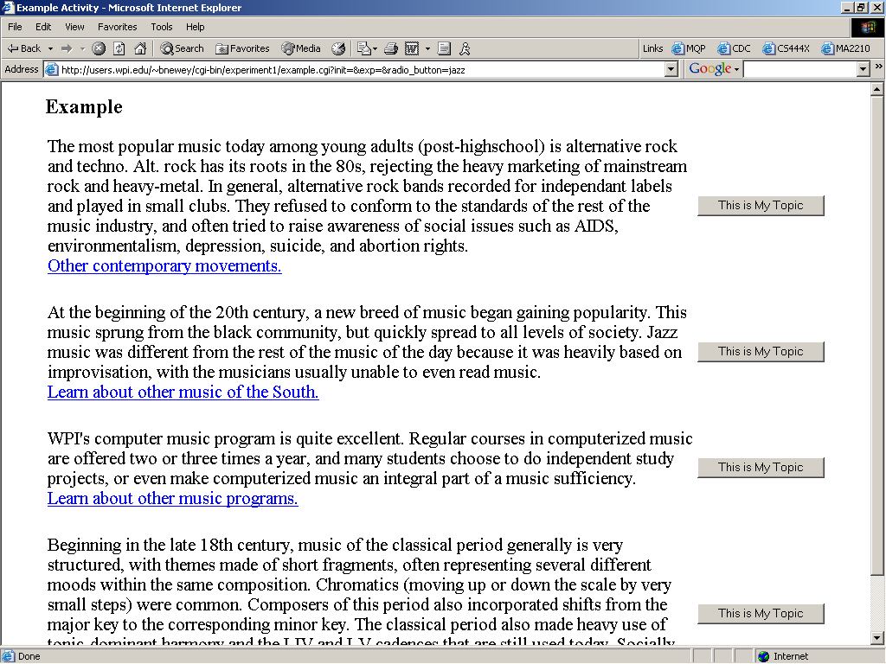
APPENDIX 13
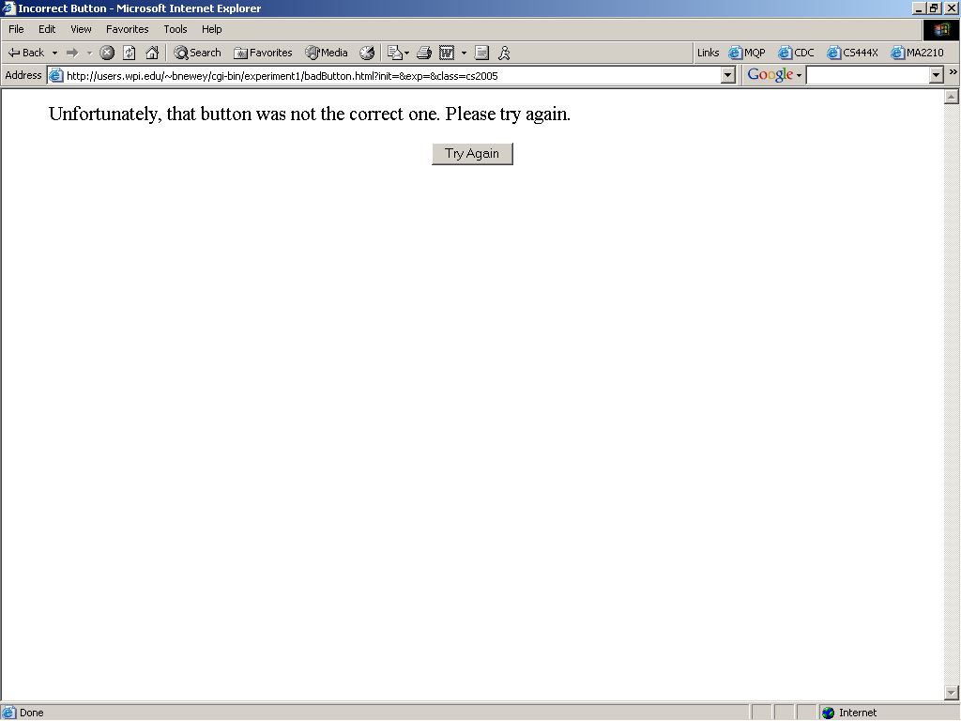
APPENDIX 14
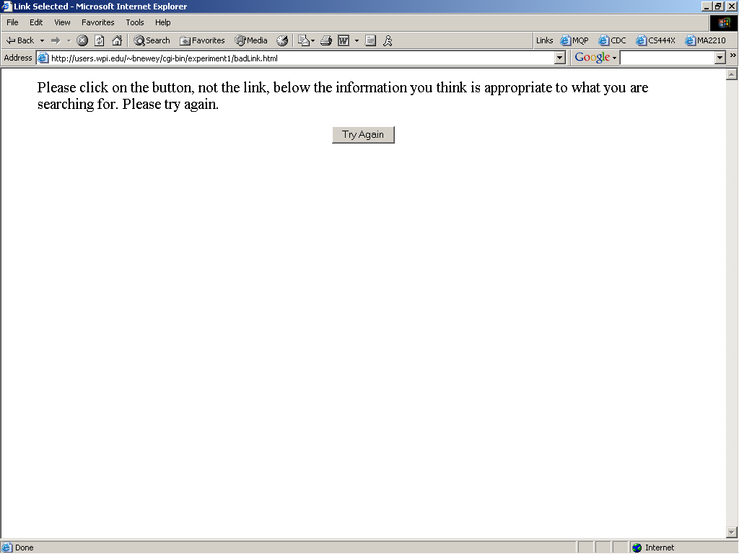
APPENDIX 15
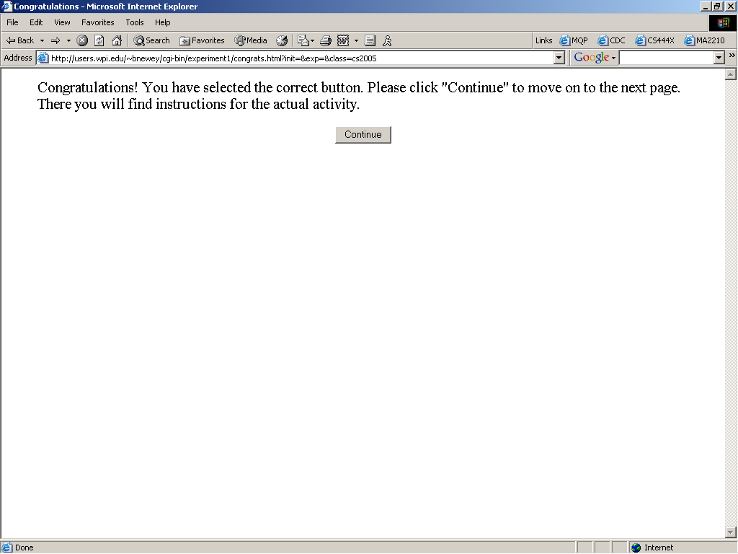
APPENDIX 16
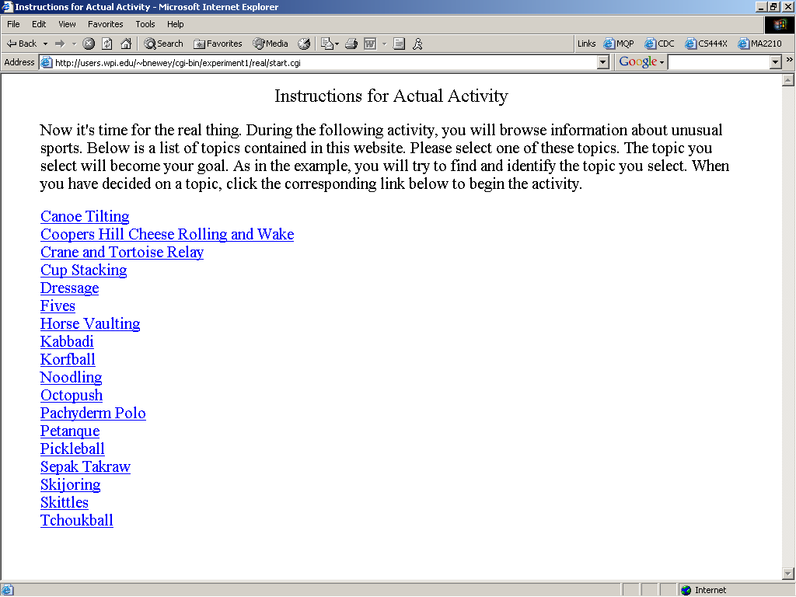
APPENDIX 17
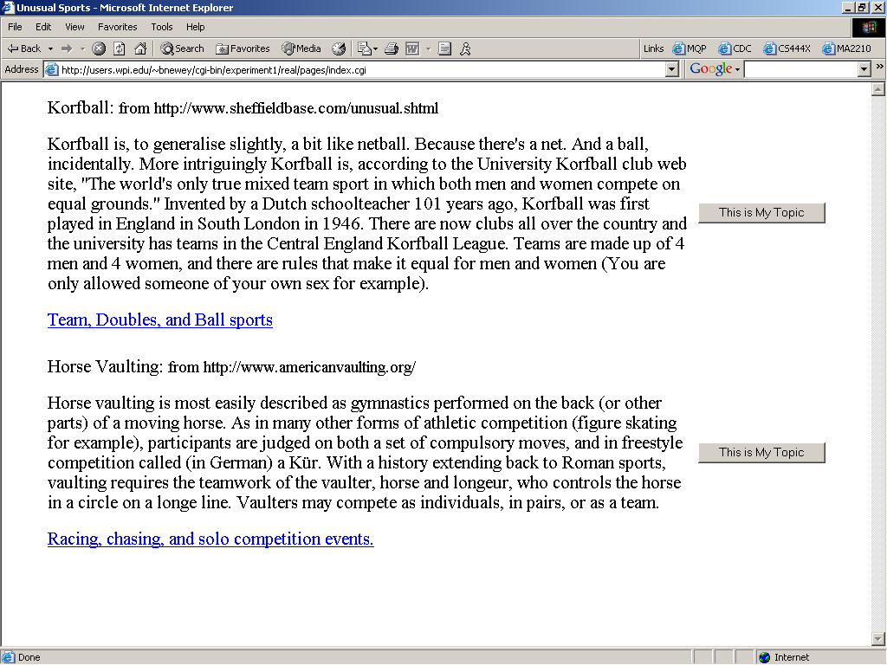
APPENDIX 19
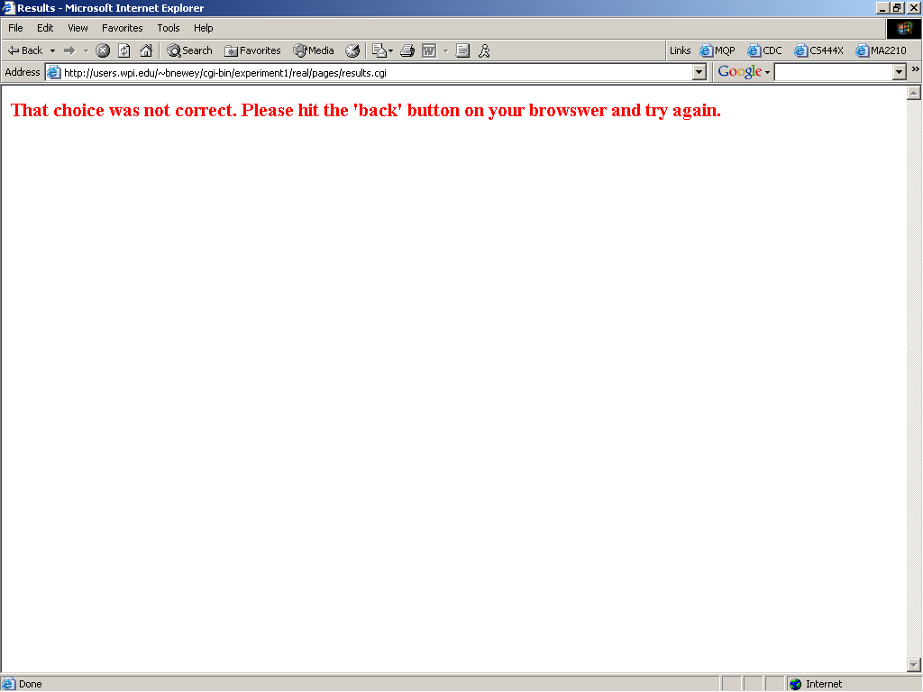
APPENDIX 20
