To construct a solution for the problem of adapting a website, several approaches were considered. Each of these solutions involved the use of a genetic algorithm, but differed in metrics collected, experiments run, fitness function, or other more minor concerns.
The first concept of the solution considered here is the fitness function. This aspect of the genetic algorithm is one that is perhaps most time consuming. Because it must be able to simulate a type of behavior and transform a data object (website hierarchy) into a single number that summarizes that object’s “fitness” in relation to the criteria set, we determined that some outside data would be required for this function to operate accurately.
A unique, and admittedly complex, solution would be to assign a value to each attribute of the object, and use a set of pre-experiments to allow the function to “learn” the weights these attributes should have. This approach was rejected for a number of reasons, chiefly because of complexity and time constraints, but also because we were no longer limiting ourselves to the application of one artificial intelligence tool to solve the problem.

The solution opted for can be illustrated in the following diagram:

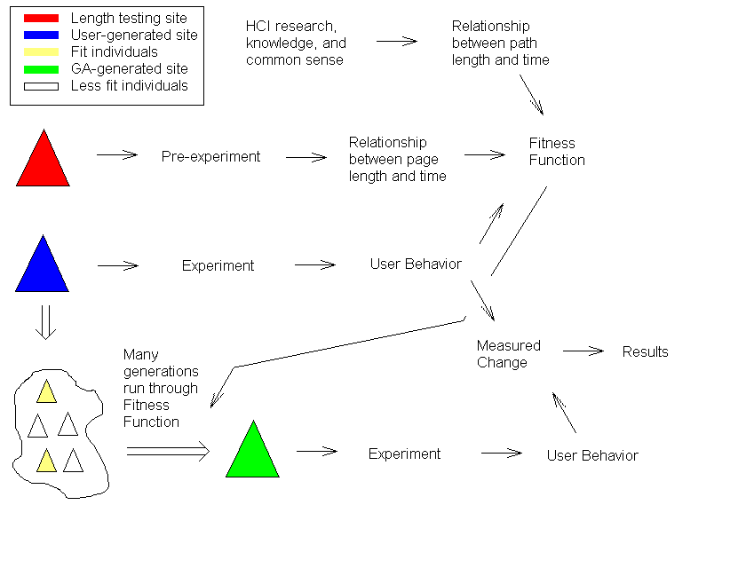
Each arrow in the above diagram can be interpreted as “yields”. That is to say, for example, that an experiment yields user behavior, or a measured change yields results. Note that in this diagram, the fitness function has three requirements. In our case, we are using two variables and the data from the pre-experiment
The fitness function illustrated here will use the two variables it receives to calculate a total time for any set of user behavior. The user behavior will consist of the list of links clicked for the user to achieve his or her goal. This list will allow the fitness function to determine the path length of a user on any given site, and the length of the pages that he or she will traverse, and thus calculate an aggregate time for the entire site for each user. It will then average these times to achieve a fitness rating for that site.
The first variable, path length, has a fairly linear and simple relationship to time. It will be used to calculate which pages are visited. Once this is done, each page will be given a value for the amount of time a user would spend on that page based on page length. This data will be collected from the pre-experiment.
Once the initial experiment is run on the human generated page, the user behaviors gathered therein will be used in the genetic algorithm, represented by the arrow to the right of the “cloud” of generated sites in the lower left of the diagram. After sufficient iterations of this algorithm, the program will produce a result, and further metrics will be gathered. This process will be repeated, using the generated site (the green triangle), to create a new set of sites for the genetic algorithm to run on. Finally, there will be a statistical comparison between all sites generated by the algorithm and the initial human site (the blue triangle), to determine the success of the experiment.

