Throughout this experiment, the fundamental piece of data that is being manipulated and ultimately improved is what is referred to as a “site”. While there are a lot of different ways to manipulate a site, this project will limit the alterations to produce changes in two metrics. Once the attributes to be changed are chosen, the representation of a site can be done using a simplified data structure. In this instance, the decision was made to use three data structures of increasing inclusiveness and magnitude, as illustrated below.

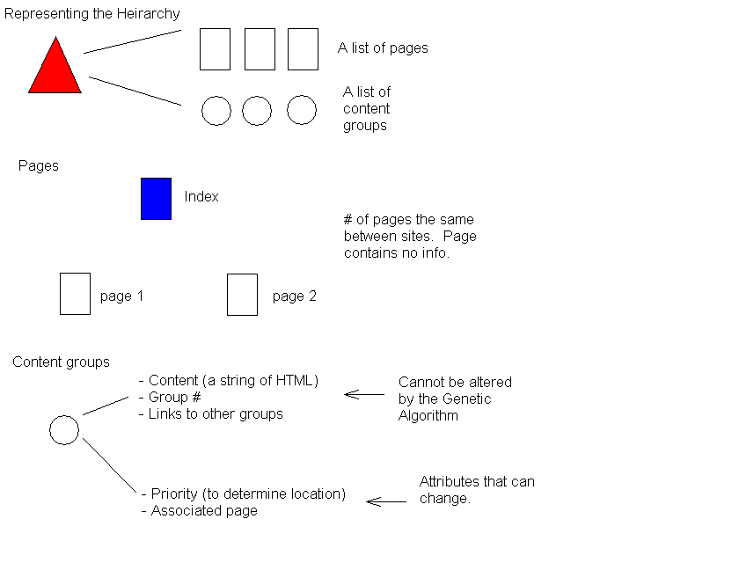

Design:
Type of Site: Informational with navigation links, both within the text and possibly as separate groups. The page will offer a type of information that will be of some interest to a large amount of WPI students (Academic information, football scores, book reviews, or something). The initial site will have a hierarchical structure at least three levels deep, although this is by no means a permanent attribute. The genetic algorithm will allow alternative structures.
Users: WPI Students. These can be most easilly obtained through professors of B-term classes. The users will be divided into two groups, a control group and an experimental group. There are no current plans to evaluate or classify the users at this time. However, some observations can be associated with WPI students in general (intelligent? knowledgeable?).
Collected Information: Upon scrutinous inspection, it was found that most "usage statistics" boil down to evaluating which pages were visited. This is the only information that the browser sends to the server in order to navigate the site. From this information can be derived time spent on a page (before another page is loaded), order of pages loaded, and length of the "path" from one page to another. Of these three, only the latter two are currently being considered for use in this project. The former has been eliminated because of its unpredictable assignation of meaning.
Another form of information that can be gathered is user feedback. In the case of this experiment, it is most desireable to reduce the intrusiveness of the gathering techniques, and so we opted for a simple rating system. We ask two fundamental questions to which they reply positively or negatively. These questions are "Is the layout of the page helpful in accomplishing your task?", and "Does the layout provide a comfortable nagivating experience?"
The information will be collected in an experimental format. There will be a control group and an experimental group, so a comparison can be made. The control group will recieve "placebo" sites, in which nothing has actually changed, but the task the individual recieves may be different. Hence, the same average data should be collected while minimizing the lear
Collection logistics:All server side activies (such as they are), will be conducted using Perl scripts. Since this will mostly consists of recording links, this information can be output to a file and given as such to the genetic algorithm.
Metrics to Improve: Access time, retention, path length, user satisfaction, ability to learn material, ability to learn system. HCI Research may be required.
Effect of Metrics on Collection: ???
Genetic Algorithm Representation:For each attribute of a given webpage, it can be represented as a list of attributes. The smallest atom within a webpage will consist of a sentence, and these sentences will be placed in groups that relate the sentences in some way (sentences that would normally be in a paragraph or list together, for example). Finally, each page within the site is represented as it's own object, with attributes for page attributes such as background color or text style. Each group will have an associated page, and the stucture of the site can be changed dynamically by changed the pages to which each group is assigned (and hence the links).
What we can change:For each individual unit we can change the priority of the unit in respect to its location within a group. Priorities can have any range, so the higher the priority, the earlier it appears in a group. The group associations would be stored in the unit. Thus, this priority rating can be applied to an unit in any group with effective results.
Bearing some similarity to location is a type of "appearance bit". The appearance bit can be toggled to determine if the sentence actually appears or not.
Many similar attributes apply to groups. For example, the order of groups within a page parallels the order of units within a group. Appearance of an entire group may be toggled as well. However, other properties specific to groups will include the indentation of the group, and perhaps annotations. Also, the type of group is important, say a list or paragraph.
Genetic Algorithm Details: The internal representation will be divided into sections: unit, group, and page representation. If one thinks of the aggragate representation as a stack of arrays, then all websites with an equal amount of content will have these attributes interchangeable without breaking the system. Actual content is stored separately (one can think of each unit as an array and a sentence: the sentence is untouched by the algorithm). To create a site with some content missing, simply flip the "appearance" bit.
Mutation is accomplished though what is known as "real number creep". The process is simple: Choose some attributes at random and move them in a set positive or negative direction. Representation is inherently ordered, which means that similar attributes will be close together on the number scale (Color is a good demonstration: Lighter colors are higher numbers, darker colors are lower numbers).
Effects of the Adaptation:There will be a pre-experiment to determine the general effects of different values for attributes. Participants will be given one of five pseudo-randomly generated sites and behavior will be recorded. Sites with high scores will have their associated attribute sets given more value in the fitness function, with sites that score poorly having the opposite effect.

