2. Problem Definition v. 3
The purpose of this project is to modify a website generated by human beings using an algorithm that simulates evolution (Genetic Algorithm) to achieve a positive change in user behavior. Positive change means that the user must improve in some measurable way. Three distinct sub goals form the basis for this problem: the website must be adapted significantly, an algorithm must be tailored to perform evolution and produce results, and a change in user behavior must be observed and analyzed.
Adaptations to the website must be significant. For this to be true there must be some way to define a significant change. “Significant”, in this instance, means that it will likely produce an alteration in the behavior of visitors to the website. Hence, we must gather information on the effects of alterations to the website. This information can then be used to determine a set of variables in the page that can be adapted. We must also know what the results of a significant change will be. In order to do this we will need to decide on a metric that will improve when a website has been “adapted for the better”.
Each aspect of the Genetic Algorithm must be considered carefully. The algorithm must be able to instantiate an initial population to which it will apply the evolutionary process. This population will be based on the website to be modified. The algorithm must have the necessary tools to simulate evolution on this initial population. Once this is done, the algorithm will output the result of this evolutionary process.
A change in user behavior must be observed between the original site and the output from the Genetic Algorithm. To accomplish this we must observe a metric that correlates to how “good” the site is. This metric must be observed in both the original site and in the output from the genetic algorithm. Hence, if this metric improves, then a positive change in user behavior has bee successfully achieved, and the project will have accomplished its goals.

4. Solution v. 3
A solution to the problem of adapting a website using a Genetic Algorithm must inevitably include an explanation of parts of the Genetic Algorithm. It must also list the experiments necessary to gather the appropriate data. However, the true purpose of this section is to illustrate the relationships between the experiments, dependent parts of the Genetic Algorithm (fitness function), and the final evaluation. These relationships thus form an infrastructure for the entire solution. Figure 5 represents this infrastructure.
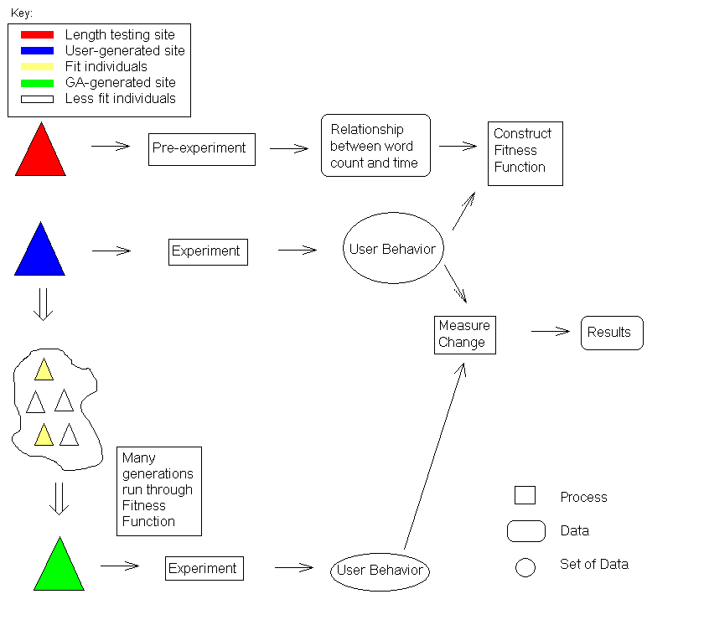

Figure 5: Overall design.
The solution opted for is illustrated in Figure 5. Each arrow in the diagram can be interpreted as “yields”. That is to say, for example, that an experiment yields user behavior, or a measured change yields results. Note that in this diagram, each process yields data, which is then used to undergo another process.
Once the experiment is run on the initial human-generated page, the user behaviors gathered therein are used in the genetic algorithm, represented by the arrow to the right of the “cloud” of generated sites in the lower left of Figure 5.
The first tasks that must be accomplished relate to the adaptation of a webpage. The relationship between a variable and the metric representing the “goodness” of the site must be established. Our variable is the amount of words present before a link. This was selected because it is easy to measure and control in a web environment, and because it is likely to have a significant impact on the metric. The metric selected is time, both because it is easy to measure and is a significant factor in the use of a website.
The tasks mentioned above are illustrated on the first line of Figure 5. The pre-experiment is designed to obtain the relationship between page length and time. This data is the core of the fitness function, the second line of Figure 5 and the second major problem that must be solved.
It is helpful to think of the fitness function as requiring two variables. While only one hard variable is being presented, the word count before a link on the page, the second variable can be used to find a sum of the times calculated from the word counts. This variable is path length.
With the two variables mentioned above, the fitness function of the genetic algorithm can function. Other parts of the genetic algorithm, such as the initial site generator or evolutionary processes, do not have requirements and are thus not represented on the diagram. The fitness function takes the information gathered from the initial experiment (not the pre-experiment) and creates a profile of each participating user. This profile will tell the fitness function what pages to consider when calculating a total time. Once it has this data, it will use the information gathered in the pre-experiment (the relationship between page length and time), to calculate a fitness value for each page. It will then find the sum of this value to achieve a total fitness for any website.
The final step to solving the problem entails the comparison of the original site with the output of the Genetic Algorithm. There is a statistical comparison between the final site (green triangle) generated by the algorithm and the initial human-generated site (the blue triangle), to determine the success of the experiment. This comparison factors in to a final evaluation of the project, and must measure the change using a variety of tools.

5. Website Design v. 3
Throughout this experiment, the fundamental piece of data that is being manipulated and ultimately improved is referred to as a site. While there are a lot of different ways to manipulate a site, this project will limit the alterations to produce changes in two metrics (discussed above). Once the attributes to be changed are chosen, the representation of a site can be done using a simplified data structure. In this instance, the decision was made to use three data structures of increasing inclusiveness and magnitude, as illustrated in Figure 6. This illustration shows how the website will be represented to the Genetic Algorithm (we have essentially condensed all the required information into some data structures).
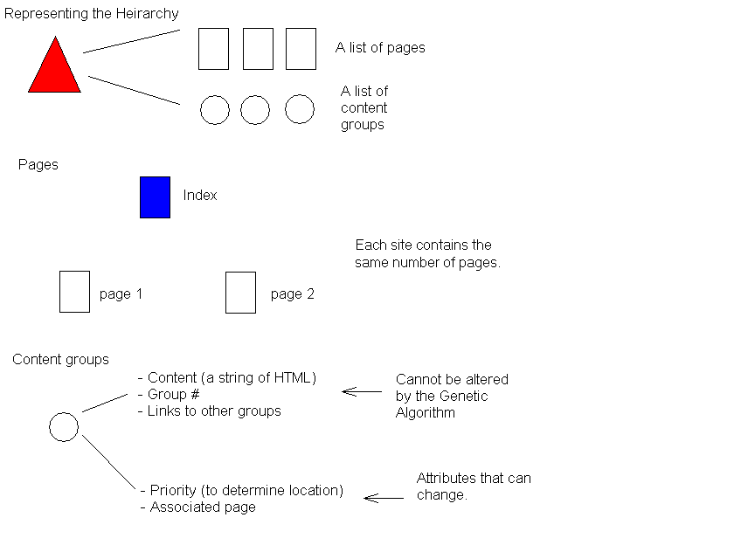
Figure 6: Data representation.
The triangles and circles in this diagram are data structures, while the rectangular “pages” are implied. Hence, each content group is assigned an “associated page”, although the actual pages are not represented with data structures.
On the top of this diagram is the site data structure. As the highest level data structure it contains a list of the lower level data structures that form the content for the page, as well as information that the Genetic Algorithm uses internally. We use this data structure to store fitness values, for example.
The lowest level data structure in this representation is a “Content Group”. There are two types of information that are stored here: mutable and immutable. Information is immutable for reasons of continuity. The content within one of these groups cannot be changed because we do not want to alter the information that is being presented. We instead want to alter how it is being presented. “Group #” and “Links to other groups” are important pieces of information that allow content groups to reference each other via links and form a hierarchy.
Mutable variables are those that allow us to produce changes in the way information is presented and also produce a change in metrics, as determined by the pre-experiment. Important information within the mutable category is anything that will yield a change in page length (the primary metric).
The experiments are performed using an informational page with navigation links within the text. The page offers a type of information that is of some interest to a large amount of WPI students (Academic information, football scores, book reviews, etc.). For the purposes of the experiment, the initial site has a hierarchical structure of three levels. However, the structuring of data allows for realization of any number of hierarchical levels, and the genetic algorithm provides alternative structures.

