Project Number: CS-DCB-0205

ADAPTIVE WEBSITES USING GENETIC ALGORITHMS
A Major Qualifying Project Report:
submitted to the faculty
of
WORCESTER POLYTECHNIC INSTITUTE
in partial fulfillment of the requirements for the
Degree of Bachelor of Science
by:
_________________________
_________________________
_________________________
Brent Newey
Anitra Setchell
Michael S. Wicks
Date: FUTURE
Approved:
_________________________
Professor David Brown

1. Introduction
One could reasonably say that the Internet is becoming the world’s electronic library, with information readily available on practically any topic imaginable. However, as the Internet’s bookshelves grow, it becomes harder to find specific information. Once a user finds a website related to an informational query, the user may have trouble navigating through that site in search of the information. One way to deal with this problem is to make the website adaptive. “An adaptive website is a website that uses information about user access patterns to improve its organization and presentation.” [Perkowitz & Etzioni 1997]. By improving these aspects of the website, a user might be able to find desired information more easily.
A new approach to making a website adaptive is through the use of a Genetic Algorithm (GA). GAs are used to simulate evolution in a computerized environment. Just as in natural evolution, where only the strongest specimens survive, GAs use a process where only the fittest websites survive. In order to determine what are the fittest websites, multiple generations, or populations, or websites must be generated, similar to natural evolution. With each generated population only the fittest websites are allowed to survive and ultimately one, or more, depending on the application, will be selected as the fittest. The task of deciding what websites are the fittest is done by a fitness function, which measures the quality of each website according to certain metrics. Each member (website) of the generation is put through the fitness function and assigned a fitness. The websites with the best fitness have a better chance of contributing to the next generation.
In this project we will be conducting three experiments. The first experiment will allow us to determine the effect of page length on how long it takes for a user to find a specific link. This experiment will consist of five rudimentary web pages of different lengths containing information on technology information. Each web page will have information on five different technology topics. At the end of each topic, these will be a link that reads “Click here to learn more…”. These links will be equally distributed on the page, i.e. the first link will be located 20% from the top of the page, the second link 40%, etc. The user will be given a task of finding the correct link to learn more about a given subject. We will record the time it takes the user to find this link, along with the length of the web page. By conducting this experiment we hope to obtain an equation that relates web page length and the amount of time it takes a user to find a desired link.
The second experiment will allow us to obtain a user behavior. The user behavior will be the access patterns to certain web pages within the experiment’s site. For this experiment the site will be more developed compared to the rudimentary site in the first experiment. The site will be three-tiered and will contain information on animals. Users will again be given a task, as in the first example. The path that they take to find the desired information, along with the time it took, will be recorded. From this experiment we hope to obtain a user behavior, for the animal website, that we can use to evaluate the fitness of the websites generated by the GA.
The third experiment will be conducted on an animals website that was generated by the GA, and evaluated to be most fit, according to the two metrics obtained from the above experiments. Users will be given similar tasks as in the second experiment, and again the user access patterns will be recorded along with their times.
After having completed all of the experiments, we will compare the relative times for each task obtained in the second and third experiments. By doing this we will be able to see if their was an improvement in time it takes to accomplish similar tasks on regular website versus one generated by a GA.

2. Problem Definition
This project hinges on the comparison of two fundamental methods for producing web media. The first, and most common, is simple human generation: a person or group of people designs, implements, and maintains a page or group of pages using a set of knowledge and “designer’s intuition”. By doing this, they hope to produce an optimal site. In the case of many professional sites, research is also done to determine the effects of certain aspects of the website on user performance. Additionally, the site will be tested and “tweaked” before and/or after its publication.
This method is essentially a “design first, test later” program, in which a website is generated, analyzed, evaluated, and modified based on findings. An alternative method attempts to reverse these processes by predicting the outcome of tests before they are actually performed and eliminating less desirable options using an algorithm. While this technique is much less common, it may have several applications worth exploring.
This project attempts to utilize the second method: it generates a site by standard means, and then modifies this site using a Genetic Algorithm. When this is done, we can compare the performance of a group of users on both the original and modified sites. We can then use this information to determine the usefulness and feasibility of a Genetic Algorithm for the application of adapting a website.
This task is accomplished in accordance with certain criteria. For starters, the general user of the website to be adapted must be modelled. This model is later used to calculate fitness in the genetic algorithm. The model must show a relationship between certain factors in a member of the population and its corresponding fitness.
There must be a website to adapt, and it must begin as a human-generated website. Performance measurements must be gathered for use with the fitness function and as a means for comparison with the final product, generated by the Genetic Algorithm.
The algorithm used must function effectively as a Genetic Algorithm. It must generate a population, assign each member of the population a fitness value, select the most fit individuals for breeding, perform mutation and crossover to provide diversity, and iterate the latter three steps enough times to produce a significant increase in fitness. Finally, it must select a single individual to replace the human-generated website.
Once these tasks have been accomplished, the project will be evaluated. Its success is dependent on the existence of improvement in the metric tested. In the case of this project, that is the average time it takes for a user to complete a random task on the site. It must meet this goal without causing an unacceptable loss of comfort with the website.

3. Related Research
In this section, we will explain the purpose of adaptive websites and genetic algorithms, how they work, and what considerations must be taken when designing them.

3.1. Adaptive Websites
Adaptive websites automatically improve their organization and presentation by learning from visitor access patterns [Perkowitz & Etzioni 1997]. By learning from many visitors’ access patterns, these websites can change their structure and presentation in order to make the user’s goals easier to obtain. It is important to consider why this genre of websites is becoming increasingly necessary, the domains it can be useful in, the aspects of a website that can be modified, and factors that should be taken into account when designing an adaptive website.
Websites should be designed to help the user accomplish his goal as easily as possible; otherwise the user may become mislead and annoyed. However, the designing a website is not that straightforward. It is obvious that not all visitors to the same website are going to be looking for the same information, but the information that is most popular should be the most accessible. Adaptive websites can address this problem by having the ability to customize the website for different types, or groups, of users, not just individual users or all users as a whole. They also can address the problem that arises when user perceptions of the website differ from how the site was originally designed.
Another downfall of static websites that adaptive websites rectify is that of keeping up with the user’s needs over time. By learning user's access patterns, they can more or less predict what information a user is going to be looking for, and then decide what information to present when [Perkowitz & Etzioni 1997].

3.2. Adaptive Hypermedia Domains

According to Brusilovsky [1998], the most common application areas in which adaptive hypermedia can be useful are educational hypermedia systems, on-line information systems, on-line help systems, information retrieval hypermedia, institutional hypermedia, and personalized views. Table 1 shows some existing adaptive hypermedia systems and in which application area they are being applied.
Educational Hypermedia Systems | Anatom-Tutor, C-Book, [Clibbon], ELM-ART, ISIS-Tutor,
 | ITEM/PG, HyperTutor, Land Use Tutor, Manuel Excel,
 | SHIVA, SYPROS, ELM-PE, Hypadapter, HYPERCASE
On-line Information Systems | Hypadapter, HYPERCASE, KN-AHS, MetaDoc, PUSH,
 | HYPERFLEX, CID, Adaptive Hyperman
On-line Help Systems | EPIAIM, HyPLAN, Lisp-Critic, ORIMUHS, WING-MIT, SYPROS
Information Retrieval Hypermedia | CID, DHS, Adaptive HyperMan, HYPERFLEX, WebWatcher
Institutional Hypermedia | Hynecosum
Personalized Views | Basar, Information Islands

Table 1. Existing adaptive hypermedia systems classified according to their application areas. Adapted from Brusilovsky[1998].

Educational hypermedia systems generally are used in order to teach the user material on a particular subject; accordingly, they present information systematically in a structure most convenient for learning purposes. Adaptive hypermedia can be used in this domain in order to accommodate for the user’s knowledge level of the subject. Novice users may become lost within the website due to their lack of knowledge on the subject and may need navigational help, whereas advanced users may find the website trivial and boring [Brusilovsky 1998].
Another domain in which adaptive hypermedia can be useful is online information systems. These systems provide users with more direct access to numerous subjects, rather than systematically displaying information, as with an educational hypermedia system. For this reason, it is difficult to accommodate all types of users. Again, the knowledge gap between novices and advanced users becomes a problem. An advanced user may seek detailed information on a subject, while a novice may desire a broader overview. In the situation of the advanced user, it may be difficult to find the detailed information needed, thus requiring the user to spend more time searching for it. By using adaptive hypermedia, the system can adapt to suit each type of user accordingly.
On-line help systems are another domain in which adaptive hypermedia can be helpful. This domain is a subset of online information systems described above, where the knowledge of the user is again a problem. The difference is that with an online-help system the general subject (the relevant application) is already known.
Another domain that adaptive hypermedia has recently been applied to is informational retrieval (IR) systems. “[This] is a new class of IR systems which combine traditional information retrieval techniques with a hypertext-like access from the index terms to documents and provide the possibility of browsing the hyperspace of documents using similarity links between documents.” [Agosti et al., 1995; Helmes et al., 1995] Adaptive hypermedia is used in this domain to deal with the problem of having a large hyperspace, which is difficult to manually structure. Instead, the structure of the pages is adapted, creating links where appropriate [Brusilovsky 1998].
Institutional information systems provide information within a particular organization, unlike many of the previously mentioned systems, which have a more general audience. These systems are usually the combination of multiple databases. Adaptive hypermedia allows the system to tailor the way it structures and presents the hyperspace in order for different types of users to access their desired information more easily.
Adaptive hypermedia can also be used to make user access to a subset of a large amount of information readily available by using a system to manage personalized views within the information space. Each view can be devoted to a single goal or interest related to the work of the user [Brusilovsky 1998]. These views may also change over time to compensate for new, altered, or out-of-date information.

3.3. Adaptation Methods
Many aspects of a website can be modified in order to aid the user in achieving his goal. Some of these aspects are the ideas of promoting and demoting links, highlighting, linking, and clustering.
“Promotion makes a link or page easier to find by placing a reference to it closer to the front page of the site or by moving a link closer to the top of a page.” [Perkowitz & Etzioni 1997] The idea of promotion and demotion of links is simple: a link is promoted if it is popular, and demoted it if it isn’t. However, although the idea may seem simple, the reasoning behind it can be complicated depending on the method used to decide how popular a link is.
In order to make the point more clear, the method discussed here will be one discussed by Perkowitz & Etzioni [1997]. They determined the popularity of an object, i.e. a page or link, in term of how many times it was accessed. The more accessed a page or link was, the more popular it was considered. Along with popularity, they also rated each page or link in terms of its accessibility. They did this by measuring the distance (number of pages that had to be accessed) between the page or link and the front page. By combining accessibility and popularity, it is clear that a page or link should be promoted if its popularity is high and its accessibility is low, and demoted if its popularity is low and its accessibility is high.
Another method of adapting a website in order to aid a user in obtaining his goal is by linking (unlinked) relevant pages together, as well as unlinking pages that do not need to be linked. The fact that many users visit two pages suggests that they are conceptually related in users’ minds [Perkowitz & Etzioni 1997]. If many users consistently access the same two pages in a single visit to the website, these two pages should be linked together. On the other hand, two pages that are linked together and are seldom accessed within the same visit to the website probably should not be linked.
Clustering can also be used to aid the user in his task. This method, like the one above, presumes web pages are conceptually related in users’ minds if many users visit the same pages during the same visit to a website. The adaptive system can reasonably assume that by combining these pages into one new page and creating a link to that page, the users will find it easier to access the information.
One approach to implementing this concept is used by Perkowitz and Etzioni[1997]: they consider the filenames of the pages, their locations in the website’s hierarchy, and the frequencies of access by users during the same visit.
This can be exemplified by a clothing site organized primarily by brand. For each clothing name brand there exists a web page that displays all the shorts the name brand offers, i.e. nike/clothing/shorts.htm, reebok/clothing/shorts.htm, etc. If multiple “shorts” pages were accessed frequently by users during the same visit, a possible solution would be to put all the information about shorts on a new page and create a link to it at some higher level in the hierarchy based on its popularity.
Another way to help users access the information they are looking for is to highlight the links that are most popular. Highlighting makes links more visible by modifying their fonts and colors. In order for this method to be effective, not all links can be highlighted, since this would defeat the purpose of highlighting. Therefore, the number of links that are highlighted should be a small percentage of the total number of links on a page.

3.4. Adaptation Usefulness
In practice, creating an “optimal” website is unrealistic. “Most adaptive methods tend to focus on hill climbing from the initial state to another state that is likely to be better.” [Perkowitz & Etzioni 2000] Once an adaptive method is applied to a website, its usefulness can be determined by two factors: benefit – how much the site improved for those who use it, and impact – how many users actually benefit from the changes. When judging the usefulness of an adaptive method on a website, one may consider:
(1) whether or not the adaptation created more or less work on average for users, (2) did the adaptation make the website easier to use for everyone, both novices and experts, (3) did the adaptation make more or less work for the webmaster, (4) has the site been adapted in a manner that disrupts the original design, and (5) is the human webmaster still in control of the website.

3.5. Genetic Algorithms
Genetic algorithms are used to simulate evolution in a computerized environment. Natural evolution has long been recognized as a superb adaptive mechanism. Genetic algorithms are robust, able to solve many types of problems, but are also relatively efficient.
The two operations used in a genetic algorithm are simply copying strings and swapping partial strings. We start with a randomly selected population of strings. We then evaluate each string and give it a fitness value, which Goldberg [1989] urges us to think of "as some measure of profit, utility, or goodness that we want to maximize." We then copy over strings according to their fitness values; strings with a higher fitness have a greater probability of contributing one or more offspring to the next generation – an artificial version of Darwin's “survival of the fittest”. Each string copy is entered into a “mating pool” [Goldberg 1989]. The members of the pool are mated at random. Each pair then undergoes crossover (Figure 1): a position is chosen on the pair of strings and all the characters in the string after that position are copied over to the other string instead. There is also a small chance that one of the offspring produced may mutate, which would change a single value at random within the string.
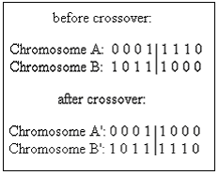
Figure 1: Basic crossover.
Now that we know the basics of genetic algorithms, we can see that their power comes from several factors which make them different from traditional optimization algorithms [Goldberg 1989]. First, genetic algorithms work off of a representation of the parameters, not the actual parameter set. Second, they search from a population of points, as opposed to a traditional algorithm, which would search from a single point. Third, instead of trying to determine the single best answer, genetic algorithms are based on probability. Last, but most important for their robustness, is the fact that genetic algorithms work only off of the information given to them by the previous solutions. They do not need any auxiliary knowledge (example – derivatives of a continuous function) to find a solution. Goldberg [1989] calls the previous solutions "payoff information", that is, the payoff from the previous attempt. Traditional algorithms always need additional information (unless they are just a random walk); instead of working from previous solutions, they try to determine which solutions are good before trying them.
Genetic algorithms are intrinsically parallel [Davis 1991]. They work on many possible solutions at once. Reproduction of population members maintains this parallelism. There are two types of reproduction: generational and steady-state. Generational reproduction replaces a whole generation with the children it produces. Steady-state reproduction [Davis 1991] produces one or two children at a time, and inserts them into the current population. Generational replacement is superior in noisy functions, in which the same chromosome may return a different value each time it is evaluated. Steady-state reproduction can be used to reduce or eliminate the chances of having duplicate chromosomes in a population. It can also allow a higher rate of mutation and crossover, without the fear of losing many good chromosomes. Another method to prevent loss of good chromosomes is elitism. The concept of elitism makes generational replacement more like steady-state: the best individual from the generation is copied over to the next generation.
Crossover and mutation are the two major operations used in reproduction. [Goldberg 1989; Davis 1991] Crossover in its simplest form, known as one-point crossover, has been described above. Two-point crossover is similar (Figure 2), but sets both starting and ending points for the exchange of genetic material.
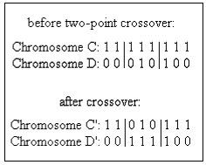
Figure 2: One-point and two-point crossover.
The methods for two-point crossover can be extended for longer chromosomes, but they begin to lose their effectiveness. When diversity in the population is greatly desired, a third type of crossover, called uniform crossover (Figure 3), is used. In uniform crossover, bits from the parents are randomly divided between the children. This is done by means of a template. The problem with uniform crossover is that it can easily destroy valuable schemata (defined below).
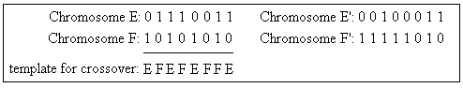
Figure 3: Uniform crossover.
Mutation is the other important operation used in genetic algorithms. A unary operation, it changes the value of a single bit within one chromosome. Mutation is used to introduce diversity into a population, finding solutions that would not be possible if only crossover were used. Crossover, on the other hand, can spread favorable mutations quickly, and allows the mutations to be combined (extremely unlikely without crossover).
Schemata are important to understanding how genetic algorithms work. A schema is essentially a template of a chromosome. In a binary representation, the template has three possible values for each position: 1, 0, or "don't care" (represented in Figure 4 by the # symbol). It is the strings of 1s and 0s that make up the schema and provide a basis for comparison of genes. The Schema Theorem states that a schema which occurs in chromosomes with above-average fitness will tend to occur more frequently in the next generation. This is especially true with shorter schemata, as they are less likely to be broken by crossover.
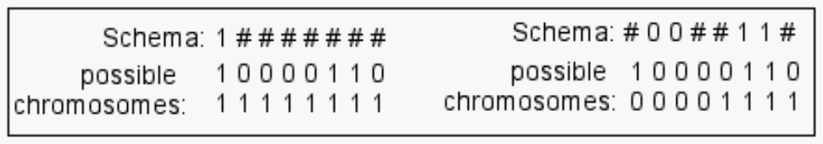
Figure 4: Simple schemata & binary chromosomes that fulfil them.
The last important part of any genetic algorithm is its fitness function. This function evaluates all the chromosomes in a generation based on the desired outcome. The individuals that produce the answers closest to what is desired are given the highest fitness. The individuals with the highest fitness are more likely to be chosen to reproduce for the next generation. The fitness function is separate from the evaluation of an individual. This evaluation is highly dependent on the problem that the genetic algorithm is trying to solve. According to Davis [1991], there are three popular techniques for computing fitness.
The first technique is very simple: the evaluation of the chromosome is its fitness. While uncomplicated, this method has its disadvantages. At the beginning of a run, when there have not been many generations, an “super-individual” (one that is much better than the average) can quickly wipe out all its competitors, even if it is not very close to being optimal. When the algorithm has been slowly converging on an optimal solution, individuals in the late generations will be “close competitors” in fitness, and the best of the group will not stand out. This technique must also be modified if it is possible for an individual to have a negative evaluation, because fitness must be positive.
The second technique is called "windowing." In this technique, the minimum evaluation within the population is found. Each chromosome is then assigned a fitness value equal to the amount it exceeds this minimum.
The third technique is linear normalization, which orders the chromosomes by their evaluation. The best evaluation gets the highest fitness value and the worst evaluation gets the lowest fitness value.
Both of these later techniques compute fitness by a relative scale of the current population, so they are less likely to be affected by the “super-individual” or “close competitor” scenarios that can happen at the beginning or end of the algorithm.
Davis [1991] asserts that the concept of fitness can also be applied to the operations performed on the chromosomes. At the beginning of a run, crossover is most effective at finding good solutions. However, at the end of a run, when all the individuals are relatively close, mutation is the better operator. By assigning the operators a fitness that increases or decreases over time, the algorithm can perform more efficiently. This also allows the operators to work independently of each other; a chromosome may be mutated without using crossover first.
So far, we've only discussed genetic algorithms that use a binary representation for the chromosomes. However, genetic algorithms can be used with other representations as well. In fact, this is desirable if it helps understandability of the problem [Davis 1991]. For a problem where steps must be ordered, each chromosome in the algorithm is a permutation of the list of steps. With this representation, crossover is similar to the uniform crossover described earlier, but incorporates the idea that order matters. Mutation rearranges the steps within a sub-list of the entire chromosome.
If a real number representation is used for the chromosomes, the operators are again modified. A simple crossover for real numbers is to average the two parents. A value within the chromosome may be mutated either by replacing it with a randomly selected real number, or by shifting the value up or down a small, random amount.
Population size is important to consider when designing a genetic algorithm. Usually, the algorithm is constrained to a certain number of evaluations, so a smaller population will be able to have more generations, and a larger population must have fewer generations. A rule of thumb is that a larger population will work more slowly (needing more generations), but achieve a better answer than a smaller population [Davis 1991]. Unfortunately, the only way to find if this is true is through experimentation.

4. Solution
To construct a solution for the problem of adapting a website, several approaches were considered. Each of these solutions involved the use of a genetic algorithm, but differed in: metrics collected, number and type experiments run, fitness function, or minor concerns.
The first component of the solution considered here is the fitness function. This aspect of the genetic algorithm is the one that is perhaps the most time consuming. Because the fitness function must be able to simulate a type of behavior and transform a data object (website hierarchy) into a single number that summarizes that object’s “fitness” in relation to the criteria set, we determined that some outside data would be required for this function to operate accurately.
A unique, and admittedly complex, solution would be to assign a value to each attribute of the object, and use a set of pre-experiments to allow the function to “learn” the weights these attributes should have. This approach was rejected for a number of reasons, chiefly because of complexity and time constraints, but also because we were no longer limiting ourselves to the application of one artificial intelligence tool to solve the problem.
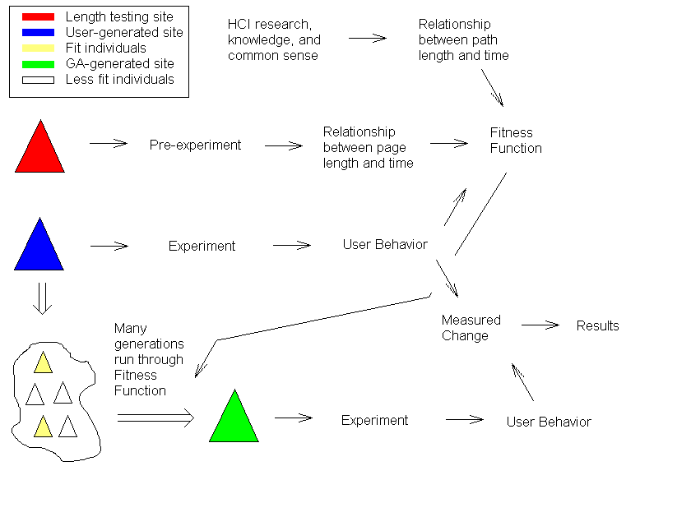
Figure 5: Overall design.
The solution opted for is illustrated in Figure 5. Each arrow in the diagram can be interpreted as “yields”. That is to say, for example, that an experiment yields user behavior, or a measured change yields results. Note that in this diagram, the fitness function has three requirements: the data from the experiment and the two variables relating path or page length and time.
The fitness function illustrated here uses the two variables it receives to calculate a total time for each set of user behavior. The user behavior consists of the list of links clicked for the user to achieve his or her goal. This list allows the fitness function to determine the path length associated with user behavior for any site generated by the genetic algorithm and the length of the pages that he or she would traverse, and thus calculate an aggregate time for the entire site for each user. It then averages these times to achieve a fitness rating for that site.
The first variable, path length, has a fairly linear and simple relationship to time. It will be used to calculate which pages are visited in the simulated environment of the genetic algorithm. Once this is done, each page is given a value for the amount of time a user would spend on that page based on page length. This data was collected from the pre-experiment.
Once the experiment is run on the initial human-generated page, the user behaviors gathered therein are used in the genetic algorithm, represented by the arrow to the right of the “cloud” of generated sites in the lower left of Figure 5. Finally, there is a statistical comparison between the final site (green triangle) generated by the algorithm and the initial human-generated site (the blue triangle), to determine the success of the experiment.

5. Design
Throughout this experiment, the fundamental piece of data that is being manipulated and ultimately improved is referred to as a site. While there are a lot of different ways to manipulate a site, this project will limit the alterations to produce changes in two metrics (discussed above). Once the attributes to be changed are chosen, the representation of a site can be done using a simplified data structure. In this instance, the decision was made to use three data structures of increasing inclusiveness and magnitude, as illustrated in Figure 6.

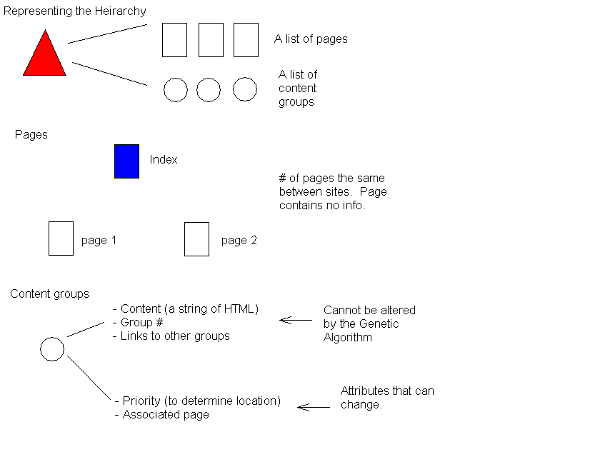
Figure 6: Data representation.
The basic data structure in this representation is a “Content Group”. There are two types of information that are stored here: mutable and immutable. Information is immutable for reasons of continuity. The content within one of these groups cannot be changed because it would not make sense. “Group #” and “Links to other groups” are important pieces of information that allow content groups to reference each other via links and form a hierarchy. Important information within the mutable category is anything that will yield a change in page length (the primary metric).
The page object contains no real data. In point of fact, the important information contained here is simply the number of pages within the hierarchy. Content objects store page associations, the important information for constructing pages, and link information, for building the hierarchy. Together, these two sets form the hierarchy object, the largest data structure and a representation of the entire site.
The experiments are performed using an informational page with navigation links within the text. The page offers a type of information that is of some interest to a large amount of WPI students (Academic information, football scores, book reviews, etc.). For the purposes of the experiment, the initial site has a hierarchical structure of three levels. However, the structuring of data allows for realization of any number of hierarchical levels, and the genetic algorithm provides alternative structures.
The user base for this experiment is WPI students with a computer science background, most easily obtained through professors of B-term classes. The users are divided into two groups, a control group and an experimental group. Users are classified by levels of web experience to provide a structured form of data for the fitness function.
Another form of information that can be gathered is user feedback. In the case of this experiment, it is most desirable to reduce the intrusiveness of the gathering techniques, and so we opted for a simple rating system. We ask two fundamental questions to which they reply positively or negatively. These questions are "Is the layout of the page helpful in accomplishing your task?", and "Does the layout provide a comfortable navigating experience?" This goes somewhere else.
All server side activities are conducted using Perl scripts. Since this mostly consists of recording links, this information is output to a file and given as such to the genetic algorithm.
Mutation is accomplished though what is known as "real number creep". The process is simple: choose some attributes at random and move them in a set positive or negative direction. Representation is inherently ordered, which means that similar attributes will be close together on the number scale (Color, for example: lighter colors are higher numbers, darker colors are lower numbers).

6. Experiment Design

6.1. Data collection
The subjects of our experiment will be WPI Computer Science (CS) students. The reasoning behind using only CS students is to have a more homogenous population, therefore resulting in a population having relatively similar levels of computer experience. They will be solicited using class email lists and word of mouth.
What are the experiments for? Will help you explain what they do.
The subjects will first be asked to perform a certain task on a selected website from the first population of websites. The first population of websites will be rudimentary and will have pages of varying length. The reasoning behind making the websites basic that we are not interested in the user’s behavior yet, but are more interested in the effect of page length on the user’s time to accomplish his given task.
Next the subjects will be asked to again perform a task on a selected website, only this time, the web pages will have more information on them. For this experiment we will be concerned with the user’s behavior, i.e. the path lengths taken and relative times.
Finally we will ask the users to again perform a similar task on a selected website. This time, the website will be one generated from the GA. For this experiment, we will be recording the user’s time.

6.2. Data Storage
For each experiment explained above, Perl scripts are run to obtain information on each user’s access patterns. By doing this we are able to access the user’s path length and relative times. We store the data on a user-to-user basis, i.e. User 1: a->c->b->d (47 seconds), User 2: c->d->b->a (53 seconds), etc. By storing the data this way we are able to run all the websites generated by the GA through each user’s path and predict how long it would take for the same behavior on the new page, compared to the times it took in the experiment.

6.3. Statistical Analysis

7. GA design/implementation: (Outline)

each website design is encoded (described in another part of the design)
from that encoding, we distill a [array] representing the parts that can be modified.
A population will consist of – [50] such arrays.
There will be [200] generations.
Arrays are picked for reproduction randomly, with weighting according to fitness. Possible weightings:
By fitness (fitness proportion to whole is probability of being chosen)
Weighted 1-50 – best fitness gets highest weighting, worst fitness gets lowest weighting
A point is chosen along two matched arrays at random for crossover
The offspring of a crossover have a small (.01?) chance of mutating, using real number creep with an interval of [2]
Reminder: two populations must be maintained – parents & offspring. A complete offspring generation becomes the next parent generation.
Schedule for B-term:
 | Oct 29-Nov 2 |  | Nov 3-9 |  | Nov 10-16 |  | Nov 17-23 |  | Nov 24-30 |  | Dec 1-7
Pre-experiment:
make pages
Create tasks
enlist test subjects
Run experiment
Determine metrics/ff
Experiment:
Design site
Run user tests
Compile user behavior
Genetic Algorithm:
Design site generator
Produce site population
Design GA
Run GA on population
Evaluation Experiment:
Run tests
Compile behavior

References:
Brusilovsky, P. et al. (eds.) "Methods and Techniques of Adaptive Hypermedia." Kluwer Academic Publishers, 1998.
Davis, L., ed. Handbook of Genetic Algorithms. New York: Van Nostrand, 1991.
Goldberg, D. Genetic Algorithms in Search, Optimization, and Machine Learning. Reading: Addison-Wesley, 1989.
Jameson, A. "Designing User-Adaptive Systems." 2001. German Research Center for Artificial Intelligence, Santa Fe, New Mexico. Intelligent User Interfaces (IUI) 2001 <http://www.cs.uni-sb/users/jameson>.
Langley, P. and Hirsh, H. "User Modeling and Adaptive Interfaces." Seventeenth National Conference on AI.
Oliver, A., Regragui, O., Monmarché, N., Venturini, G. "Genetic and Interactive Optimization of Web Sites." 2002. Eleventh International World Wide Web Conference. 12 September 2002. <http://www2002.org/CDROM/poster/57/>.
Perkowitz, M., and O. Etzioni. "Adaptive Sites: Automatically Learning from User Access Patterns." 1997. Sixth International World Wide Web Conference. 27 August 2002 <http://www.scope.gmd.de/info/www6/posters/722/index.html>.
Perkowitz, M., and O. Etzioni. "Towards Adaptive Websites: Conceptual Framework and case study" Reading: Artificial Intelligence, July 2000.
Winston, P., "Artificial Intelligence: Third Edition" 1992, Addison-Wesley, Chapter 25: Learning by Simulating Evolution, pp. 505 – 528.

