Project Number: CS-DCB-0205

ADAPTIVE WEBSITES USING GENETIC ALGORITHMS
A Major Qualifying Project Report:
submitted to the faculty
of
WORCESTER POLYTECHNIC INSTITUTE
in partial fulfillment of the requirements for the
Degree of Bachelor of Science
by:

_________________________
Brent Newey

_________________________
Anitra Setchell

_________________________
Michael S. Wicks

Date: FUTURE (April…)
Approved:
___________________________
Professor David Brown
Computer Science Department

Table of Contents
Table of Contents 1
1. Introduction 2
1.1 Experiments 2
2. Problem Definition 4
3. Related Research (OLD) 5
3.1. Adaptive Website 5
3.1.1. Adaptive Hypermedia Domains v. 3 6
3.1.2. Adaptation Methods v. 3 8
3.1.3. Adaptation Usefulness v. 3 10
3.2. Genetic Algorithms 11
3.2.1. Why Genetic Algorithms? 11
3.2.2. How genetic algorithms work 12
3.2.3. Reproduction 14
3.2.4. Crossover, Mutation, Schemata 15
3.2.5. Fitness 16
3.2.6. Other Representations 18
3.2.7. Generations and population size 19
4. Solution 21
5.1. Representing a Website 24
5.2. Using Websites to Construct a Hierarchy 28
6. Experiment Design v. 1 32
6.1. Data collection v. 3 32
6.1.1. Experiment #1 v. 3 32
6.1.2. Experiment #2 v. 3 33
6.1.3. Experiment #3 v. 3 33
6.2. Data Storage v. 3 34
Appendix 2: Three-tiered Animal Website References: 36
References: 37

1. Introduction
One could reasonably say that the Internet is becoming the world’s electronic library, with information readily available on practically any topic imaginable. However, as the Internet’s bookshelves grow, it becomes harder to find specific information. Once a user finds a website related to an informational query, the user may have trouble navigating through that site in search of the information. One way to deal with this problem is to make the website adaptive. “An adaptive website is a website that uses information about user access patterns to improve its organization and presentation.” [Perkowitz & Etzioni 1997]. By improving the organization and presentation of the website, a user might be able to find desired information more easily.
A new approach to making a website adaptive is through the use of a genetic algorithm (GA). GAs are used to simulate evolution in a computerized environment. One principle of evolution is sexual reproduction. Just as in natural evolution, a GA produces new websites by breeding two individuals from a set of websites (a population).
Another principle of natural evolution is survival of the fittest: the “best” individuals in a population have the greatest chance of reproducing. Similarly, a GA assigns a fitness value to each member of the population. This fitness value determines which individuals are most likely to reproduce. The fitness value is determined by a fitness function. This function measures the perceived quality of each website.

1.1 Experiments
To enable us to construct a genetic algorithm and test its effectiveness, we conducted three experiments. In each experiment, subjects had to navigate a website to find a specific target. The first experiment gathered data on the effect of word count on the time taken to find a target. This data was essential to the fitness function.
The second experiment was conducted on the website to be used in the genetic algorithm. This experiment provided data on time and frequency of access specific to the site to be modified. It also provided a basis for comparison with the third experiment.
The third experiment was performed on the site modified by the GA. When compared with the data from the second experiment, the data shows that the GA produces a more useful website.

2. Problem Definition
The purpose of this project is to improve a website using a genetic algorithm. Improvement in this context means a desirable change in user behavior.
This goal of improvement has three distinct sub goals. A genetic algorithm must be implemented to make changes to the site. The website must be adapted significantly so that improvement can also be significant. User behavior must be observed and analyzed, to determine the amount of improvement.
Each aspect of the genetic algorithm must be considered carefully. The algorithm must be provided an initial population to which it will apply the evolutionary process. This population will be based on the website to be modified. The algorithm must have the necessary tools to simulate evolution on this initial population. Once this is done, the algorithm will output the result of this evolutionary process.
Adaptations to the website must be significant. For this to be true there must be some way to define a significant change. “Significant”, in this instance, means that it will likely produce a measurable change in user behavior. Hence, we must gather information about the effects of alterations to the website. This information can then be used to determine what can be adapted.
Changes in user behavior can be expressed in a variety of metrics. Therefore, we must decide on a metric that represents improvement. This metric must be observed in both the original site and in the output from the genetic algorithm. Hence, if this metric improves, then a positive change in user behavior has been successfully achieved, and the project will have accomplished its goals.

3. Related Research (OLD)
In this section, we will explain the purpose of adaptive websites and genetic algorithms, how they work, and what considerations must be taken when designing them.

3.1. Adaptive Websites
Adaptive websites automatically improve their organization and presentation by learning from visitor access patterns [Perkowitz & Etzioni 1997]. By learning from many visitors’ access patterns, these websites can change their structure and presentation in order to make the user’s goals easier to obtain. It is important to consider why this genre of websites is becoming increasingly necessary, the domains for which it is suitable in, the aspects of a website that can be modified, and factors that should be taken into account when designing an adaptive website.
Websites should be designed to help the user accomplish a goal as easily as possible; otherwise the user may become mislead and annoyed. However, the designing of a website is not that straightforward. It is obvious that not all visitors to the same website are going to be looking for the same information, but the information that is most popular should be the most accessible. Adaptive websites can address this problem by having the ability to customize the website for different types, or groups, of users, not just individual users or all users as a whole. They also can address the problem that arises when user perceptions of the website differ from how the site was originally designed.
Another downfall of static websites that adaptive websites rectify is that of keeping up with the user’s needs over time. By learning user's access patterns, they can more or less predict what information a user is going to be looking for, and then decide what information to present when [Perkowitz & Etzioni 1997].

3.1.1. Adaptive Hypermedia Domains v. 3
According to Brusilovsky [1998], the most common application areas in which adaptive hypermedia can be useful are educational hypermedia systems, on-line information systems, on-line help systems, information retrieval hypermedia, institutional hypermedia, and personalized views. Table 1 shows some existing adaptive hypermedia systems and in which application area they are being applied.
Educational Hypermedia Systems | Anatom-Tutor, C-Book, [Clibbon], ELM-ART, ISIS-Tutor,
 | ITEM/PG, HyperTutor, Land Use Tutor, Manuel Excel,
 | SHIVA, SYPROS, ELM-PE, Hypadapter, HYPERCASE
On-line Information Systems | Hypadapter, HYPERCASE, KN-AHS, MetaDoc, PUSH,
 | HYPERFLEX, CID, Adaptive Hyperman
On-line Help Systems | EPIAIM, HyPLAN, Lisp-Critic, ORIMUHS, WING-MIT, SYPROS
Information Retrieval Hypermedia | CID, DHS, Adaptive HyperMan, HYPERFLEX, WebWatcher
Institutional Hypermedia | Hynecosum
Personalized Views | Basar, Information Islands
Table 1: Adaptive hypermedia systems and their application areas. Adapted from Brusilovsky[1998].

Educational hypermedia systems generally are used in order to teach the user material on a particular subject; accordingly, they present information systematically in a structure most convenient for learning purposes. Adaptive hypermedia can be used in this domain in order to accommodate for the user’s knowledge level of the subject. Novice users may become lost within the website due to their lack of knowledge on the subject and may need navigational help, whereas “advanced users may find the website trivial and boring” [Brusilovsky 1998].
Another domain in which adaptive hypermedia can be useful is online information systems. These systems provide users with more direct access to numerous subjects, rather than systematically displaying information, as with an educational hypermedia system. For this reason, it is difficult to accommodate all types of users. Again, the knowledge gap between novices and advanced users becomes a problem. An advanced user may seek detailed information on a subject, while a novice may desire a broader overview. For the advanced user, it may be difficult to find the detailed information needed, thus requiring the user to spend more time searching for it. By using adaptive hypermedia, the system can adapt to suit each type of user accordingly.
On-line help systems are another domain in which adaptive hypermedia can be helpful. This domain is a subset of online information systems described above, where the knowledge of the user is again a problem. The difference is that with an online-help system the general subject (the relevant application) is already known.
Another domain that adaptive hypermedia has recently been applied to is informational retrieval (IR) systems. “[This] is a new class of IR systems which combine traditional information retrieval techniques with a hypertext-like access from the index terms to documents and provide the possibility of browsing the hyperspace of documents using similarity links between documents.” [Agosti et al., 1995; Helmes et al., 1995]. Adaptive hypermedia is used in this domain to deal with the problem of having a large hyperspace, which is difficult to manually structure. Instead, the structure of the pages is adapted, creating links where appropriate [Brusilovsky 1998].
Institutional information systems provide information within a particular organization, unlike many of the previously mentioned systems, which have a more general audience. These systems are usually the combination of multiple databases. Adaptive hypermedia allows the system to tailor the way it structures and presents the hyperspace in order for different types of users to access their desired information more easily.
Adaptive hypermedia can also be used to make user access to a subset of a large amount of information readily available by using a system to manage personalized views within the information space. Each view can be devoted to a single goal or interest related to the work of the user [Brusilovsky 1998]. These views may also change over time to compensate for new, altered, or out-of-date information.

3.1.2. Adaptation Methods v. 3
Many aspects of a website can be modified in order to aid the user in achieving his goal. Some of these aspects are the ideas of promoting and demoting links, highlighting, linking, and clustering.
“Promotion makes a link or page easier to find by placing a reference to it closer to the front page of the site or by moving a link closer to the top of a page.” [Perkowitz & Etzioni 1997]. The idea of promotion and demotion of links is simple: a link is promoted if it is popular, and demoted it if it isn’t. However, although the idea may seem simple, the reasoning behind it can be complicated depending on the method used to decide how popular a link is.
In order to make the point more clear, the method discussed here will be one discussed by Perkowitz & Etzioni [1997]. They determined the popularity of an object, i.e., a page or link, in term of how many times it was accessed. The more accessed a page or link was, the more popular it was considered. Along with popularity, they also rated each page or link in terms of its accessibility. They did this by measuring the distance (number of pages that had to be accessed) between the page or link and the front page. By combining accessibility and popularity, it is clear that a page or link should be promoted if its popularity is high and its accessibility is low, and demoted if its popularity is low and its accessibility is high.
Another method of adapting a website in order to aid a user in obtaining his goal is by linking (unlinked) relevant pages together, as well as unlinking pages that do not need to be linked. The fact that many users visit two pages suggests that they are conceptually related in users’ minds [Perkowitz & Etzioni 1997]. If many users consistently access the same two pages in a single visit to the website, these two pages should be linked together. On the other hand, two pages that are linked together and are seldom accessed within the same visit to the website probably should not be linked.
Clustering can also be used to aid the user in his task. This method, like the one above, presumes web pages are conceptually related in users’ minds if many users visit the same pages during the same visit to a website. The adaptive system can reasonably assume that by combining these pages into one new page and creating a link to that page, the users will find it easier to access the information.
One approach to implementing this concept is used by Perkowitz and Etzioni[1997]: they consider the filenames of the pages, their locations in the website’s hierarchy, and the frequencies of access by users during the same visit.
This can be exemplified by a clothing site organized primarily by brand. For each clothing name brand there exists a web page that displays all the shorts the name brand offers, e.g., nike/clothing/shorts.htm, reebok/clothing/shorts.htm, etc. If multiple “shorts” pages were accessed frequently by users during the same visit, a possible solution would be to put all the information about shorts on a new page and create a link to it at some higher level in the hierarchy based on its popularity.
Another way to help users access the information they are looking for is to highlight the links that are most popular. Highlighting makes links more visible by modifying their fonts and colors. In order for this method to be effective, not all links can be highlighted, since this would defeat the purpose of highlighting. Therefore, the number of links that are highlighted should be a small percentage of the total number of links on a page.

3.1.3. Adaptation Usefulness v. 3
In practice, creating an “optimal” website is unrealistic. “Most adaptive methods tend to focus on hill climbing from the initial state to another state that is likely to be better.” [Perkowitz & Etzioni 2000]. Once an adaptive method is applied to a website, its usefulness can be determined by two factors: benefit – how much the site improved for those who use it, and impact – how many users actually benefit from the changes. When judging the usefulness of an adaptive method on a website, one may consider:
(1) whether or not the adaptation created more or less work on average for users, (2) did the adaptation make the website easier to use for everyone, both novices and experts, (3) did the adaptation make more or less work for the webmaster, (4) has the site been adapted in a manner that disrupts the original design, and (5) is the human webmaster still in control of the website.

3.2. Genetic Algorithms
Genetic algorithms are used to simulate evolution in a computerized environment. Natural evolution has long been recognized as a superb adaptive mechanism. Genetic algorithms are robust, able to solve many types of problems, but are also relatively efficient.

3.2.1. Why Genetic Algorithms?
Genetic algorithms are one of many optimization methods. So why use a genetic algorithm when there are so many other ways to optimize? Many optimization methods have gaps in their effectiveness, which a genetic algorithm may be able to fill. For example, most traditional methods work best on continuous functions, and might not work at all if the data points were not connected. Most are work poorly in functions with multiple peaks, often finding only a local optimum instead of the best value.
Goldberg [1989] lists several reasons why genetic algorithms work differently from traditional optimization methods. First, genetic algorithms use a representation of the parameters, not the actual parameter set. Second, they search from a population of points, as opposed to a traditional algorithm, which would search from a single point. This is especially important in multiple-peak functions, as the algorithm can be climbing many hills at once. Third, instead of trying to determine the single best answer, genetic algorithms are based on probability. So while the chances of finding the absolute best answer are the same or lower than what they would be in traditional algorithms, it is much more likely that the genetic algorithm will find a solution that is very close to the optimum. Last, but most important for their robustness, is the fact that genetic algorithms only use the information given to them by the previous solutions. They do not need any auxiliary knowledge (example – derivatives of a continuous function) to find a solution. Goldberg [1989] calls the previous solutions “payoff information”, that is, the payoff from the previous attempt. Traditional algorithms always need additional information (unless they are just a random walk); instead of working from previous solutions, they try to determine which solutions are likely to be good before trying them.

3.2.2. How genetic algorithms work
Genetic algorithms are easiest to understand when applied to a black-box problem. The box has a number of switches which can be toggled on or off. The output from the box depends on which switches are toggled, but we don’t know which combination will give the best result. We can represent each switch with a digit – 1 if the switch is on, and 0 if it is off. So a complete representation of the switches is a string of ones and zeros. To use a genetic algorithm to solve this problem, we first generate a few possible combinations for the switches by flipping a coin and recording the result, until we end up with several strings of ones and zeros that represent possible solutions to the black box problem. (We later refer to these strings as chromosomes.)
The genetic algorithm will use only two basic operations on these strings to find an answer: copying the strings and swapping partial strings. First, we evaluate each string and give it a fitness value, which Goldberg [1989] urges us to think of “as some measure of profit, utility, or goodness that we want to maximize.” We then copy over strings according to their fitness values; strings with a higher fitness have a greater probability of contributing one or more offspring to the next generation – an artificial version of Darwin's “survival of the fittest”. Each string copy is entered into a “mating pool” [Goldberg 1989]. The members of the pool are selected for mating at random. Each pair then undergoes crossover (Figure 3-1): a position is chosen on the pair of strings and all the characters in the string after that position are copied over to the other string instead. There is also a small chance that one of the offspring produced may mutate, which would change a single value at random within the string.
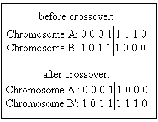
Figure 3-1: Basic crossover.
So, in short, there are four main parts to a genetic algorithm: evaluation (or fitness), reproduction, crossover, and mutation. The basic steps in a genetic algorithm are shown in Figure 3-2.
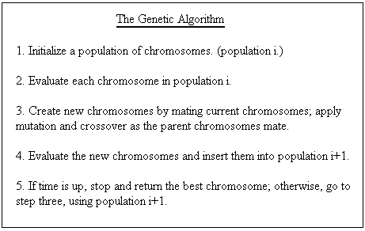
Figure 3-2: Genetic algorithm. Adapted from Davis [1991].

3.2.3. Reproduction
Genetic algorithms are intrinsically parallel [Davis 1991]. They work on many possible solutions at once. Reproduction, which maintains the population of possible solutions, makes this parallelism possible.
The simplest method for choosing parents is often called “roulette wheel selection” [Davis 1991; Goldberg 1989], because it can be thought of as assigning a slice of a wheel to each chromosome, with the size of the slice corresponding to the chromosome’s fitness. If the fitness values for the whole population are summed, we may then calculate each chromosome’s fitness in proportion to the whole. This proportion is the probability that the chromosome will be selected for reproduction.
There are two replacement techniques that can be used in reproduction: generational and steady-state. Replacement refers to what population new children are inserted into. Generational replacement replaces a whole generation with the children it produces. Steady-state replacement [Davis 1991] produces one or two children at a time, and inserts them into the current population. Noisy functions, in which the same chromosome may return a different value each time it is evaluated, are better served by generational reproduction. Steady-state reproduction can be used to reduce or eliminate the chances of having duplicate chromosomes in a population. It can also allow a higher rate of mutation and crossover, without the fear of losing many good chromosomes.
Another method to prevent loss of good chromosomes is elitism. The concept of elitism makes generational replacement more like steady-state: the best individual from the generation is copied over to the next generation. Some approaches extend this concept by encouraging duplicates of good chromosomes in the population in order to increase the chance of these chromosomes being involved in crossover.

3.2.4. Crossover, Mutation, Schemata
Crossover and mutation are the two major operations used in reproduction. [Goldberg 1989; Davis 1991] Crossover in its simplest form, known as one-point crossover, has been described above. Two-point crossover is similar (Figure 3-3), but sets both starting and ending points for the exchange of genetic material.
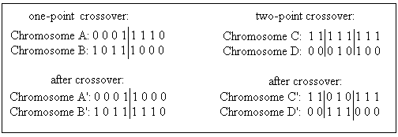
Figure 3-3: One-point and two-point crossover.

The methods for two-point crossover can be extended for longer chromosomes, but they begin to lose their effectiveness. When diversity in the population is greatly desired, a third type of crossover, called uniform crossover (Figure 3-4), is used. In uniform crossover, bits from the parents are randomly divided between the children. This is done by means of a template. The problem with uniform crossover is that it can easily destroy valuable schemata (defined below).
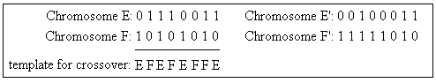
Figure 3-4: Uniform crossover.

Mutation is the other important operation used in genetic algorithms. A unary operation, it changes the value of a single bit within one chromosome. Mutation is used to introduce diversity into a population, finding solutions that would not be possible if only crossover were used. Crossover, on the other hand, can spread favorable mutations quickly, and allows the mutations to be combined (extremely unlikely without crossover).
Schemata are important to understanding how genetic algorithms work. A schema is essentially a template of a chromosome. In a binary representation, the template has three possible values for each position: 1, 0, or “don't care” (represented in Figure 5 by the # symbol). It is the strings of 1s and 0s that make up the schema and provide a basis for comparison of genes. The Schema Theorem states that a schema which occurs in chromosomes with above-average fitness will tend to occur more frequently in the next generation. This is especially true with shorter schemata, as they are less likely to be broken by crossover.
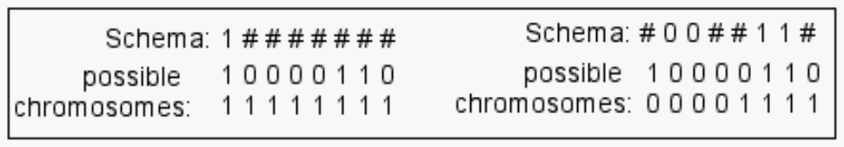
Figure 3-5: Simple schemata & binary chromosomes that fulfil them.

3.2.5. Fitness
The last important part of any genetic algorithm is its fitness function. This function is based on an evaluation function. The evaluation function determines how well the chromosome performs in its domain. This evaluation is highly dependent on the problem that the genetic algorithm is trying to solve. The individuals that have the highest evaluation (the answers closest to what is desired) are given the highest fitness. The individuals with the highest fitness are more likely to be chosen to reproduce for the next generation. According to Davis [1991], there are three popular techniques for computing fitness.
The first technique is very simple: the evaluation of the chromosome is its fitness. In this technique, the numerical value given to the chromosome by the evaluation function is simply copied to the fitness. While uncomplicated, this method has its disadvantages. At the beginning of a run, when there have not been many generations, a “super-individual” (one that is much better than the average) can quickly wipe out all its competitors, even if it is not very close to being optimal. When the algorithm has been slowly converging on an optimal solution, individuals in the late generations will be “close competitors” in fitness, and the best of the group will not stand out. This technique must also be modified if it is possible for an individual to have a negative evaluation, because fitness must be positive.
The second technique is called “windowing.” In this technique, the minimum evaluation within the population is found. Each chromosome is then assigned a fitness value equal to the amount it exceeds this minimum.
The third technique is linear normalization, which orders the chromosomes by their evaluation. The best evaluation gets the highest fitness value (equal to the size of the population) and the worst evaluation gets the lowest fitness value (usually one or zero).
Both of these later techniques compute fitness by a relative scale of the current population, so they are less likely to be affected by the “super-individual” or “close competitor” scenarios that can happen at the beginning or end of the algorithm.
Davis [1991] asserts that the concept of “fitness” (in this application, we’ll refer to it as preference) can also be applied to the operations performed on the chromosomes. At the beginning of a run, crossover is most effective at finding good solutions. However, at the end of a run, when all the individuals are relatively close, mutation is the better operator. By assigning the operators a preference value that increases or decreases over time, the algorithm can perform more efficiently. This also allows the operators to work independently of each other; a chromosome may be mutated without using crossover first.

3.2.6. Other Representations
So far, we've only discussed genetic algorithms that use a binary representation for the chromosomes. However, genetic algorithms can be used with other representations as well. In fact, this is desirable if it helps understandability of the problem [Davis 1991]. For a problem where steps must be ordered, each chromosome in the algorithm is a permutation of the list of steps. With this representation, crossover is similar to the uniform crossover described earlier, but incorporates the idea that order matters. Mutation rearranges the steps within a sub-list of the entire chromosome. Among other applications, order-based representations are an important part of genetic programming [Koza 1999].
If a real number representation is used for the chromosomes, the operators are again modified. A simple crossover for real numbers is to average the two parents. A value within the chromosome may be mutated either by replacing it with a randomly selected real number, or by shifting the value up or down a small, random amount.
If some information contained in an individual cannot be changed, or is dependent on other individuals, a more structured representation must be used. For this case, Koza [1999] describes a form of structure-preserving crossover, which restricts which parts of an individual can be changed.

3.2.7. Generations and population size
Population size is important to consider when designing a genetic algorithm. Usually, the algorithm is constrained to a certain number of evaluations, so a smaller population will be able to have more generations, and a larger population must have fewer generations. A rule of thumb is that a larger population will work more slowly (needing more generations), but achieve a better eventual answer than a smaller population [Davis 1991]. This has been tested to some degree [Goldberg 1989], but cannot be proven to always hold true, due to the random nature of genetic algorithms.
The examples Goldberg [1989] and Davis [1991] use generally have a population size of 100, because it is an easy number to deal with. The real world applications they mention use population sizes around 30, because they cannot afford the slower nature of the larger populations. Other constraints can apply to the selection of population size, as well. Oliver et. al. [2002] use a population size of only 12, because their design requires the whole population to be displayed simultaneously on a monitor.
The number of generations also varies depending on the application and resources. The general rule is to run as many generations as time allows, because increased generations should result in a better solution. Since their algorithm was based on human decisions instead of a programmed fitness function, the users in the experiments of Oliver et al. [2002] were able to indicate when an acceptable solution had been found, ending the algorithm.

4. Solution
A solution to the problem of adapting a website using a Genetic Algorithm must inevitably include an explanation of parts of the Genetic Algorithm. It must also list the experiments necessary to gather the appropriate data. However, the true purpose of this section is to illustrate the relationships between the experiments, dependent parts of the Genetic Algorithm (fitness function), and the final evaluation. These relationships thus form an infrastructure for the entire solution. Figure 4-1 represents this infrastructure.
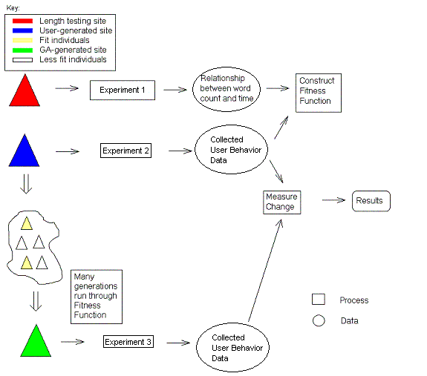
Figure 4-1: Overall design.

The solution opted for is illustrated in Figure 4-1. Each arrow in the diagram can be interpreted as “yields”. That is to say, for example, that an experiment yields user behavior, or a measured change yields results. Note that in this diagram, each process yields data, which is then used to undergo another process.
Once the experiment is run on the initial human-generated page, the user behaviors gathered therein are used in the genetic algorithm, represented by the arrow to the right of the “cloud” of generated sites in the lower left of Figure 4-1.
The first tasks that must be accomplished relate to the adaptation of a webpage. The relationship between a variable and the metric representing the “goodness” of the site must be established. Our variable is the amount of words present before a link. This was selected because it is easy to measure and control in a web environment, and because it is likely to have a significant impact on the metric. The metric selected is time, both because it is easy to measure and is a significant factor in the use of a website.
The tasks mentioned above are illustrated on the first line of Figure 4-1. The pre-experiment is designed to obtain the relationship between page length and time. This data is the core of the fitness function, the second line of Figure 4-1 and the second major problem that must be solved.
It is helpful to think of the fitness function as requiring two variables. While only one hard variable is being presented, the word count before a link on the page, the second variable can be used to find a sum of the times calculated from the word counts. This variable is path length.
With the two variables mentioned above, the fitness function of the genetic algorithm can function. Other parts of the genetic algorithm, such as the initial site generator or evolutionary processes, do not have requirements and are thus not represented on the diagram. The fitness function takes the information gathered from the initial experiment (not the pre-experiment) and creates a profile of each participating user. This profile will tell the fitness function what pages to consider when calculating a total time. Once it has this data, it will use the information gathered in the pre-experiment (the relationship between page length and time), to calculate a fitness value for each page. It will then find the sum of this value to achieve a total fitness for any website.
The final step to solving the problem entails the comparison of user performance on the original site with performance on the site produced from the Genetic Algorithm. A statistical comparison will be made between the final site (green triangle) generated by the algorithm and the initial human-generated site (the blue triangle), to determine the success of the experiment. This comparison factors in to a final evaluation of the project, and must measure the change using a variety of tools.
5. Website Design v. 4 NEW

5.1. Representing a Website
There is a new method for representing the websites. It relies on a hierarchical structure that is enforced by the design such that any website generated using this structure will be viable.
It is helpful to start with the underlying data structure, which is the array of content units. A content unit represents an amount of web content roughly equivalent to a paragraph. How does this translate into a data structure? For certain, there must be some way to store what the content unit will display on the webpage. Take the following simple web page as an example:

Figure 5-1: A Simple Webpage
There is one content unit on this website, and it contains the string “Welcome to my website.” Therefore, the data structure must also contain the string “Welcome to my website.” For a website as simple as this example, there is no need to represent the website any further, and so the data structure would look like this:
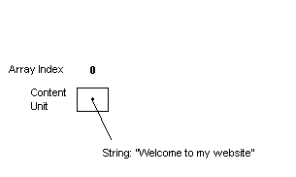
Figure 5-2: Representing a Simple Webpage
Adding another content unit to a website increases its complexity. Now, there must be multiple content units in the array, and there must be some way to distinguish the order of the content units. Array indices are not used in this regard, and the reason why will be discussed later.
The following website must be represented:

Figure 5-3: Adding a Content Unit
There are now two content groups in the array, and a second variable is added to each, representing its “priority” on the webpage:
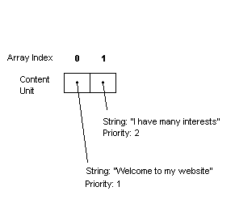
Figure 5-4: Representing the New Webpage
The priority number is of arbitrary size, and the genetic algorithm converts these numbers into relative order. So, if there are three content units which have priorities of 3, 1, and 9, the website would contain the content unit with priority 1 first, the content unit with priority 3 second, and the content unit with priority 9 third.
In this hierarchy, each paragraph is assumed to have a link to another page. This assumption will be implicit to the website structure
Crossover and mutation must be performed such that no content information is modified, because all websites contain the same content. If content information is exchanged through crossover or changed through mutation, the websites are no longer considered the same. The information presented by each member of the population must be the same. This algorithm is changing the presentation of this information. The priority attribute does not relay any content information and is not based on another content unit’s attributes. Because of this independence, altering the priority produces different ordering results without changing the content.
Consider the following array:
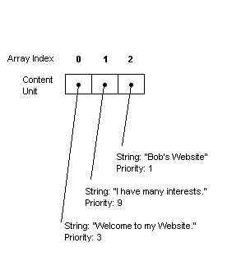
Figure 5-5: Three Content Units
The array produces the following web site:

Figure 5-6: Website for Figure 5-5
Let us now consider that an arbitrary amount of mutations or crossovers have been performed to achieve new priority results, as such:
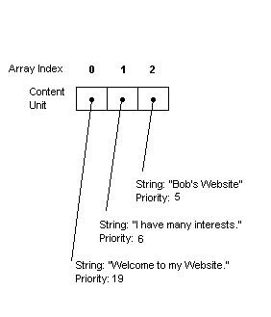
Figure 5-7: Changing the Priority
Now, the following website is produced:

Figure 5-8: Website for Figure 5-7
As shown, priority can be arbitrarily changed to produce new presentations without modifying the data.

5.2. Using Websites to Construct a Hierarchy
The above examples are not hierarchies. To include the hierarchical structure of an actual website in the algorithm, it is assumed that websites link downwards, as a tree, and the graph of this tree contains no cycles (There is only one path for each page in the tree). This assumption allows us to easily represent the site in a fashion acceptable to the Genetic Algorithm.
This algorithm performs linking implicitly by binding multiple content units to a page. Consider the following array:
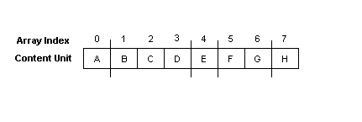
Figure 5-9: Representing Pages
In this example, content unit A is bound to the first page, content units B-D are bound to the second page, etc. To create the hierarchy from this setup, we perform the algorithm as follows. First, the algorithm will place the index page, represented by the first group of content units before the first line. In this case, it is just “A”:
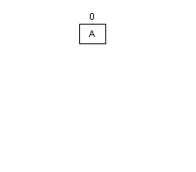
Figure 5-10: Step One in Constructing the Hierarchy
Now, there is a site containing a single page with a single content unit. The next group of content units represents page 2 of the hierarchy. These are content units B, C, and D, located between the first and second divisions in Figure 5-9, above. When added, the site looks like this:
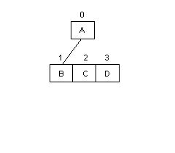
Figure 5-11: Step Two in Constructing the Hierarchy
The second page contains three content units. Because each content unit contains exactly one link, this means that the tree will now contain three more branches. Content unit B will point to the next page. According to Figure x, that page will contain only content unit E.
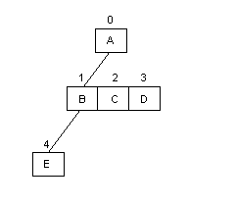
Figure 5-12: Step Three in Constructing the Hierarchy
The algorithm contains performing these operations until the entire hierarchy is constructed. It looks like this:
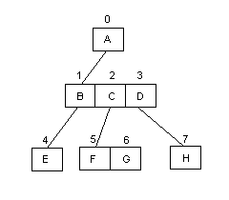
Figure 5-13: Completing the Hierarchy
Were another page to be added to this hierarchy, it would fall below content unit E.
To represent the divisions in Figure 5-9, the algorithm uses “flag-based separation”. Flag-based separation is based on a content unit’s location in the array. In the example above, binary flags are placed on the array values that have a page break directly following them. In this example, the flags would be placed in content units A, D, E, and G. The final content unit is assumed to be at the end of a page.

6. Experiment Design v. 1
In this section, we will explain the design of each of the three experiments. We will also explain how we collect our data.

6.1. Data collection v. 3

The subjects of our experiment will be WPI Computer Science (CS) students. The rationale for using only CS students is to have a more homogenous population, therefore resulting in the experimental subjects having relatively similar levels of computer experience. They will be solicited using class email lists and word of mouth.

6.1.1. Experiment #1 v. 3
The first experiment will allow us to determine the effect of page length on how long it takes for a user to find a specific link. This experiment will consist of five rudimentary web pages of different lengths containing information on technology. Each web page will have information on five different technology topics. At the end of each topic, these will be a link that reads “Click here to learn more…”. These links will be equally distributed on the page, i.e., the first link will be located 20% from the top of the page, the second link 40%, etc. The user will be given a task of finding the correct link to learn more about a given subject. The pages will be presented to the user in a round-robin method in order for each of the five pages to be equally tested. We will record the time it takes the user to find this link, along with the length of the web page. By conducting this experiment we hope to obtain an equation that relates web page length and the amount of time it takes a user to find a desired link.

6.1.2. Experiment #2 v. 3
The second experiment will allow us to obtain user behaviors. These user behaviors will be the access patterns to certain web pages within the experiment’s site. For this experiment the site will be more developed compared to the rudimentary site in the first experiment. The site will be three-tiered (see Appendix 2) and will contain information on animals. Users will again be given a task, as in the first example. The path that they take to find the desired information, along with the time it took, will be recorded. From this experiment we hope to obtain a user behavior, for the animal website, that we can use to evaluate the fitness of the websites generated by the GA.

6.1.3. Experiment #3 v. 3
The third experiment will be conducted on an adapted animals website that was generated by the GA, and evaluated to be most fit, according to the two metrics obtained from the above experiments. Users will be given similar tasks as in the second experiment, and again the user access patterns will be recorded along with their times.
Another form of information that will be gathered from the third experiment is user feedback. In this case, it is most desirable to reduce the intrusiveness of the gathering techniques, and so we opted for a simple rating system. We ask two fundamental questions to which they reply positively or negatively. These questions are "Is the layout of the page helpful in accomplishing your task?", and "Does the layout provide a comfortable navigating experience?"

6.2. Data Storage v. 3
For each experiment explained above, Perl scripts will run on the websites in order to obtain information about each user. The data collected in each experiment will be recorded in a comma-delimited text file. Each user’s information will have it’s own line in the file. We are using this type of file to store our data because of its ability to be put into an Excel spreadsheet easily. Also, by storing the data per user we are able to run all the websites generated by the GA through each user’s path and predict how long it would take for the same behavior on the new page, compared to the times it took in the experiment.
Appendix 1: Schedule
This should be a full schedule for the entire project.
 | Oct 29-Nov 2 |  | Nov 3-9 |  | Nov 10-16 |  | Nov 17-23 |  | Nov 24-30 |  | Dec 1-7
Pre-experiment:
make pages
Create tasks
enlist test subjects
Run experiment
Determine metrics/ff
Experiment:
Design site
Run user tests
Compile user behavior
Genetic Algorithm:
Design site generator
Produce site population
Design GA
Run GA on population
Evaluation Experiment:
Run tests
Compile behavior

Appendix 2: Three-tiered Animal Website
Amphibians
Komodo Dragon
Bush Master

Xenosaur
Tasmanian
Devil
Dwarf Mongoose
Darwin’s Frog

Mantella
Pacific Giant Salamander
Reptiles
Mammals
Amazon River Dolphin
Animals

References:
Brusilovsky, P., ed., Methods and Techniques of Adaptive Hypermedia. Kluwer Academic Publishers, 1998.
Davis, L., ed., Handbook of Genetic Algorithms. New York: Van Nostrand, 1991.
Goldberg, D. Genetic Algorithms in Search, Optimization, and Machine Learning. Reading: Addison-Wesley, 1989.
Jameson, A. "Designing User-Adaptive Systems." 2001. German Research Center for Artificial Intelligence, Santa Fe, New Mexico. Intelligent User Interfaces (IUI) 2001 <http://www.cs.uni-sb/users/jameson>.
Koza, J., et. al. Genetic Programming III: Darwinian Invention and Problem-Solving. San Francisco: Morgan Kaufmann, 1999.
Langley, P. and Hirsh, H. "User Modeling and Adaptive Interfaces." 2000. American Association for Artificial Intelligence, Austin, Texas.
Oliver, A., Regragui, O., Monmarché, N., Venturini, G. "Genetic and Interactive Optimization of Web Sites." 2002. Eleventh International World Wide Web Conference. 12 September 2002. <http://www2002.org/CDROM/poster/57/>.
Perkowitz, M., and Etzioni O. "Adaptive Sites: Automatically Learning from User Access Patterns." 1997. Sixth International World Wide Web Conference. 27 August 2002 <http://www.scope.gmd.de/info/www6/posters/722/index.html>.
Perkowitz, M., and Etzioni O. "Towards Adaptive Websites: Conceptual Framework and case study." Reading: Artificial Intelligence, July 2000.
Winston, P., Artificial Intelligence: Third Edition. 1992, Addison-Wesley, Chapter 25: Learning by Simulating Evolution, pp. 505 – 528.

