5. Website Design v. 4 NEW
There is a new method for representing the websites. It relies on a hierarchical structure that is enforced by the design such that any website generated using this structure will be viable.
It is helpful to start with the underlying data structure, which is the array of content units. A content unit represents an amount of web content roughly equivalent to a paragraph. How does this translate into a data structure? For certain, there must be some way to store what the content unit will display on the webpage. Take the following simple web page as an example:
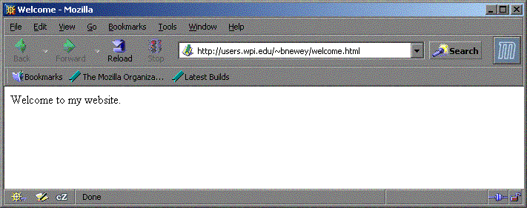
Figure 5-1: A Simple Webpage
There is one content unit on this website, and it contains the string “Welcome to my website.” Therefore, the data structure must also contain the string “Welcome to my website.” For a website as simple as this example, there is no need to represent the website any further, and so the data structure would look like this:
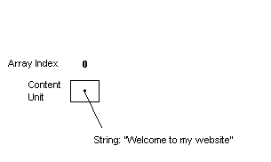
Figure 5-2: Representing a Simple Webpage
Adding another content unit to a website increases its complexity. Now, there must be multiple content units in the array, and there must be some way to distinguish the order of the content units. Array indices are not used in this regard, and the reason why will be discussed later.
The following website must be represented:
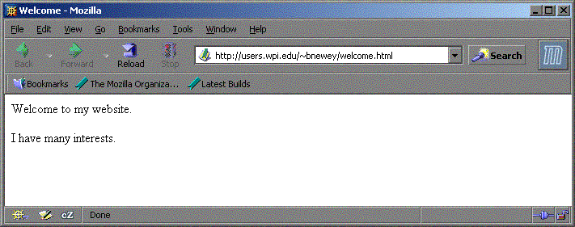
Figure 5-3: Adding a Content Unit
There are now two content groups in the array, and a second variable is added to each, representing its “priority” on the webpage:
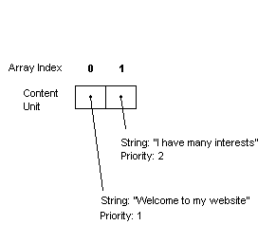
Figure 5-4: Representing the New Webpage
The priority number is of arbitrary size, and the genetic algorithm converts these numbers into relative order. So, if there are three content units which have priorities of 3, 1, and 9, the website would contain the content unit with priority 1 first, the content unit with priority 3 second, and the content unit with priority 9 third.
In this hierarchy, each paragraph is assumed to have a link to another page. This assumption will be implicit to the website structure
Crossover and mutation must be performed such that no content information is modified, because all websites contain the same content. If content information is exchanged through crossover or changed through mutation, the websites are no longer considered the same. The information presented by each member of the population must be the same. This algorithm is changing the presentation of this information. The priority attribute does not relay any content information and is not based on another content unit’s attributes. Because of this independence, altering the priority produces different ordering results without changing the content.
Consider the following array:
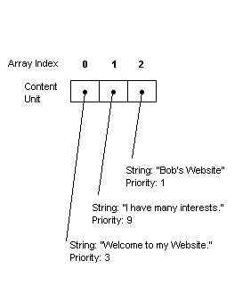
Figure 5-5: Three Content Units
The array produces the following web site:
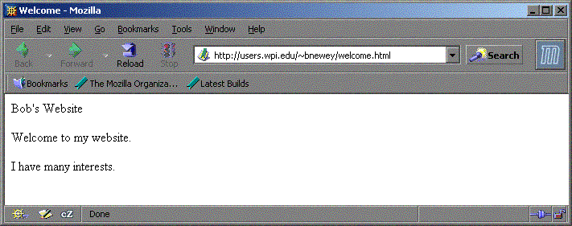
Figure 5-6: Website for Figure 5-5
Let us now consider that an arbitrary amount of mutations or crossovers have been performed to achieve new priority results, as such:
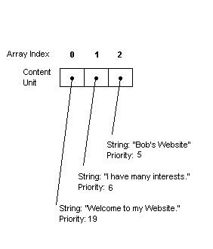
Figure 5-7: Changing the Priority
Now, the following website is produced:
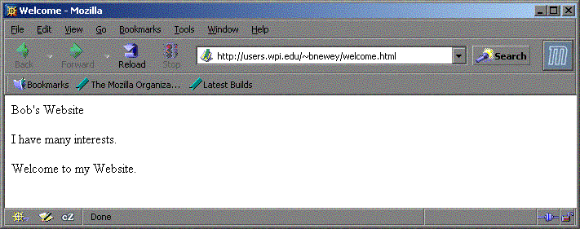
Figure 5-8: Website for Figure 5-7
As shown, priority can be arbitrarily changed to produce new presentations without modifying the data.
The above examples are not hierarchies. To include the hierarchical structure of an actual website in the algorithm, it is assumed that websites link downwards, as a tree, and the graph of this tree contains no cycles (There is only one path for each page in the tree). This assumption allows us to easily represent the site in a fashion acceptable to the Genetic Algorithm.
This algorithm performs linking implicitly by binding multiple content units to a page. Consider the following array:
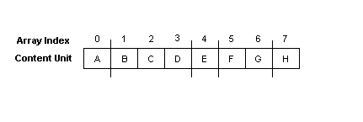
Figure 5-9: Representing Pages
In this example, content unit A is bound to the first page, content units B-D are bound to the second page, etc. To create the hierarchy from this setup, we perform the algorithm as follows. First, the algorithm will place the index page, represented by the first group of content units before the first line. In this case, it is just “A”:
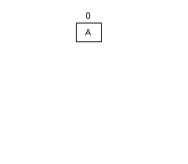
Figure 5-10: Step One in Constructing the Hierarchy
Now, there is a site containing a single page with a single content unit. The next group of content units represents page 2 of the hierarchy. These are content units B, C, and D, located between the first and second divisions in Figure 5-9, above. When added, the site looks like this:
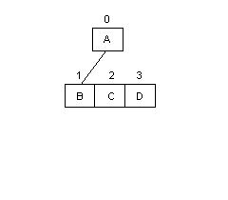
Figure 5-11: Step Two in Constructing the Hierarchy
The second page contains three content units. Because each content unit contains exactly one link, this means that the tree will now contain three more branches. Content unit B will point to the next page. According to Figure x, that page will contain only content unit E.
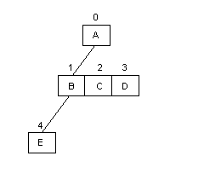
Figure 5-12: Step Three in Constructing the Hierarchy
The algorithm contains performing these operations until the entire hierarchy is constructed. It looks like this:
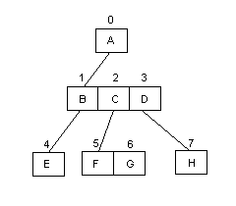
Figure 5-13: Completing the Hierarchy
Were another page to be added to this hierarchy, it would fall below content unit E.
To represent the divisions in Figure 5-9, the algorithm uses “flag-based separation”. Flag-based separation is based on a content unit’s location in the array. In the example above, binary flags are placed on the array values that have a page break directly following them. In this example, the flags would be placed in content units A, D, E, and G. The final content unit is assumed to be at the end of a page.

