Technical Documentation for the Cobalt Grid Forecasting Prototype
EU AI Act Annex IV style summary for the LoRA rank ablation
Document status Course capstone evidence package, version 1.0
Provider in scenario Cobalt Grid
Prepared by Brent Oatis, ML Research Engineer

Purpose and main conclusion
This prototype forecasts six hours of electricity demand from the preceding 48 hours of demand, temperature, and time-of-day features. The study asked whether LoRA rank 4, 8, or 16 changes target-cooperative forecast error when every other experimental choice is fixed. Across five seeds per rank, the seed-level ranges overlapped. The evidence does not establish an accuracy advantage for any rank. Rank 4 is retained because it uses fewer trainable parameters and slightly less GPU memory without a demonstrated accuracy penalty.
This document follows the subject areas in Annex IV of Regulation (EU) 2024/1689. It is an educational prototype summary, not a legal determination that the prototype is a high-risk AI system or a completed conformity assessment.

Intended purpose and deployment boundary
- Intended output: six hourly point forecasts of aggregate electricity demand in kilowatts.
- Intended user: a trained utility analyst evaluating short-horizon planning support.
- Permitted use in this evidence package: offline research and model-selection analysis.
- Excluded use: autonomous dispatch, billing, customer-level decisions, safety-critical control, or production deployment.

System form and computing environment
The system is a Python package with a YAML-controlled command-line entry point and a thin Colab launcher. The confirmatory run used Python 3.13.15, PyTorch 2.9.1 with CUDA 12.8, and one NVIDIA Tesla T4 GPU. The package captures the complete installed environment in artifacts/environment/environment.json.

Development methods and system architecture
A compact transformer receives 48 time steps with four features: demand, temperature, sine of hour, and cosine of hour. It produces six future demand values. A shared backbone was pretrained once on three source-cooperative traces with seed 2026. For target adaptation, the backbone remained frozen and LoRA adapters were trained only on the query and value projections. The tested ranks were 4, 8, and 16. Adapter scaling remained constant because alpha equaled rank, making alpha divided by rank equal to one.
Controlled element | Fixed implementation
Data | One generated dataset and one chronological split
Backbone | One shared pretrained checkpoint
LoRA placement | Query and value projections
Optimization | Same learning rate, batch size, weight decay, and 10 epochs
Randomness | Paired seeds 101, 202, 303, 404, and 505
Changed factor | LoRA rank only; parameter count changes as a direct consequence

Data provenance and governance
The package generated all data locally with src/data.py and generation seed 62707. It created three source traces and one shifted target trace with programmed daily, weekly, and annual structure, weather response, trend, and autocorrelated noise. No personal or customer data were used. The target series produced 17,467 windows and was split chronologically into 70 percent training, 15 percent validation, and 15 percent test partitions. Normalization statistics came only from the target training partition.
The dataset SHA-256 is 201633d0f0c629a39a66ec4d16089c85497ebab0715fa42cca66237a974ba2ef. The metadata file records the split boundaries, features, seed, and the central representativeness limitation: programmed synthetic behavior is not observed utility behavior.

Reproducibility controls
- Configuration, dataset generation, seeds, run order, and output paths are stored in versioned text files.
- Python, NumPy, and PyTorch random generators are seeded; cuDNN benchmarking is disabled; deterministic algorithms are requested with warnings enabled.
- The training random-number stream is reset after rank-specific adapter construction so paired seeds do not receive shifted dropout streams.
- The package promises procedural and statistical reproduction, not bitwise identity across hardware or software versions.

Validation design and confirmatory results
The primary metric was test mean absolute percentage error. Mean absolute error and root mean squared error supplied scale-sensitive checks. The preregistered decision rule required a lower mean MAPE and nonoverlapping seed-level min-max ranges before declaring a rank superior. Five seeds were selected after a separate full-size timing benchmark projected that 15 adaptations would remain well below the 144-minute compute limit. The timing benchmark used generation seed 62708 and non-study seed 909 and was excluded from confirmatory results.
Rank | Mean MAPE ± SD | Min–max | MAE kW | RMSE kW | Parameters | Peak MB
4 | 3.2396 ± 0.0381 | 3.1860–3.2931 | 5.8105 | 7.3270 | 2,048 | 123.02
8 | 3.2487 ± 0.0466 | 3.1854–3.3143 | 5.8289 | 7.3522 | 4,096 | 123.42
16 | 3.2669 ± 0.0578 | 3.1825–3.3333 | 5.8638 | 7.3951 | 8,192 | 124.21

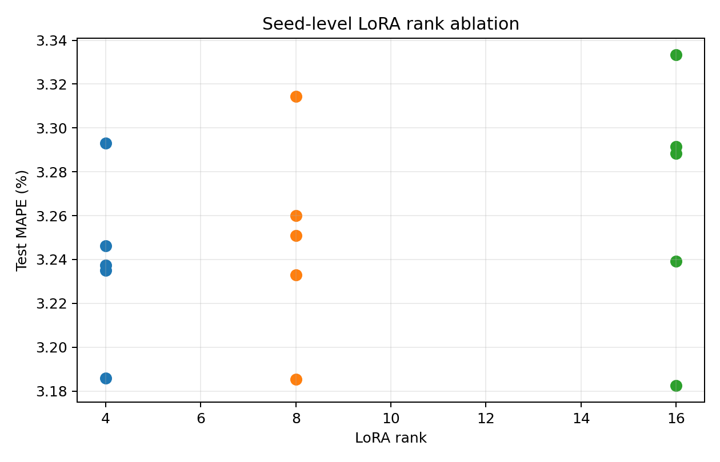
Figure 1. Test MAPE for every confirmatory seed. Lower values are better.
Rank 4 had the lowest mean MAPE, but its advantage was 0.0092 percentage points over rank 8 and 0.0274 points over rank 16. Both differences sit inside the observed seed variation, and all min-max ranges overlap. The study therefore does not support an accuracy-superiority claim. Average adaptation time was approximately 14 seconds for every rank; the small nonmonotonic differences are operational noise rather than a speed advantage.

Capabilities limitations and known risks
The validated capability is narrow: the code can reproduce a controlled synthetic-data comparison and six-hour forecasts under the tested configuration. The following limitations prevent a production claim.
Limitation or risk | Current control | Required next evidence
Synthetic data may omit real demand behavior | No production claim; explicit provenance and scope | Backtest on governed multi-cooperative data
One target regime and one horizon | Chronological holdout and narrow intended purpose | Seasonal, geographic, and horizon stress tests
Small seed sample | Five seed-level values and spread reported | Power analysis and more seeds for smaller effects
MAPE can distort near-zero targets | Demand floor plus MAE and RMSE | Review operational cost-weighted metrics
Hardware and software variation | Pinned dependencies and captured environment | Reproduction on a second supported stack
Forecast misuse or automation bias | Offline analyst-only use; no automated control | Human-factors review and operating procedures
Cybersecurity not assessed | Local package and recorded artifacts | Threat model, dependency scan, and access controls

Human oversight and risk decision
A qualified analyst must review forecasts with current operational context and may disregard them. The prototype must not issue control actions. The model owner must treat out-of-range inputs, missing data, distribution shift, and unexplained error growth as reasons to stop use and investigate. The present decision is to retain rank 4 for further research because ranks 8 and 16 add adapter capacity without a demonstrated accuracy benefit.

Monitoring and change control
- Record model version, dependency versions, dataset checksum, configuration, seed, hardware, and run artifacts for every release candidate.
- Track MAPE, MAE, RMSE, missing-input rates, demand-range drift, and performance by season and cooperative after real data become available.
- Trigger review when data provenance changes, dependencies or hardware change, accuracy crosses an approved threshold, or deployment scope expands.
- Repeat the ablation before adopting a different rank or modifying LoRA targets, training budget, forecast horizon, or backbone architecture.

Framework crosswalk and evidence index
Annex IV subject | NIST AI RMF connection | ISO IEC 42001 context | Package evidence
Purpose and system description | MAP 1 and MAP 2 | Context and documented objectives | README and configuration
Development and data provenance | GOVERN and MEASURE 2.1 | Lifecycle and data governance controls | Source code and dataset metadata
Validation metrics and uncertainty | MEASURE 1 and MEASURE 2 | Performance evaluation and retained records | Seed CSV summary CSV and plot
Risk decision and limitations | MANAGE 1 | Risk treatment and accountability | Pre-registration and this summary
Monitoring and changes | MEASURE 3 and MANAGE 4 | Monitoring and continual improvement | Environment capture and proposed plan

The crosswalk is an alignment aid rather than a certification statement. NIST AI RMF calls for repeatable testing, documented metrics, uncertainty, and limits on generalizability. ISO/IEC 42001 provides an organizational management-system structure for risk ownership, performance evaluation, records, and continual improvement.

References
European Parliament and Council of the European Union. (2024). Regulation (EU) 2024/1689 laying down harmonised rules on artificial intelligence. Official Journal of the European Union. https://eur-lex.europa.eu/eli/reg/2024/1689/oj
International Organization for Standardization. (2023). ISO/IEC 42001:2023 Information technology—Artificial intelligence—Management system. https://www.iso.org/standard/42001.html
National Institute of Standards and Technology. (2023). Artificial intelligence risk management framework (AI RMF 1.0) (NIST AI 100-1). https://doi.org/10.6028/NIST.AI.100-1
PyTorch Contributors. (2026). Numerical accuracy. PyTorch documentation. Retrieved October 22, 2026, from https://docs.pytorch.org/docs/main/notes/numerical_accuracy.html
PyTorch Contributors. (2026). torch.use_deterministic_algorithms. PyTorch documentation. Retrieved October 22, 2026, from https://docs.pytorch.org/docs/main/generated/torch.use_deterministic_algorithms.html

Primary artifact paths
Results: artifacts/results/seed_level_results.csv and summary_by_rank.csv. Figure: artifacts/plots/seed_level_mape.png. Provenance: artifacts/data/synthetic_demand_metadata.json. Environment: artifacts/environment/environment.json. Shared pretraining record: artifacts/checkpoints/pretraining_log.json.

