Project: Conway’s Game of Life
Date: 01/20/22

New project! The goal here is to replicate John Conway’s Game of Life with vanilla JavaScript. This text file will contain the pseudo-code / general logic and my thoughts while I work thru this and probably won’t be very organized.

OVERVIEW:
1. A cell can be alive (black) or dead (white).
2. For each evaluation, cells are individually evaluated based on the previous state.
3. Cell evaluation depends on the state of neighboring cells in the previous state.

GAME OF LIFE RULES:
1. Any cell with fewer than 2 live neighbors dies (under-population!).
2. Any live cell with 2 or 3 live neighbors lives for the next state.
3. Any active cell with more than 3 neighbors dies in the next state (over-population!).
4. Any dead cell surrounded by 3 live neighbors is born in the next state.

USER INPUTS TO WEB APP:
1. Grid size.
2. Initial structure of the cell. (will be some ready made shapes as well, ex; Gospers glide gun)
3. Progression of the game (arrow keys to advance / reverse 1 state at a time, play button to advance automatically with adjustable speed)
Day 1: 01/20/2022
Goal 1: Set up the game board.

Basic pseudo-code for the game board:

- Initialize a grid of 16x16 blank div elements. (Never mind! Using html canvas instead)
- Add “click” eventlisteners to each element in the grid.
- If clicked, add “active” to element classList, turning the cell black.
- Press “Start” to remove eventlisteners and start the game.
- Change grid size by entering new number in size form and hitting “update” button.
- Stop the game and reset the board by hitting “reset” button.

End of day update:
After doing some research, it looks like using an HTML canvas element is the best way to make the grid system required for the game. I spent most of the time following a basic canvas tutorial. The end result for tonight is a 50x50 grid on the canvas consisting on blank white cells. Tomorrow I’ll be
learning how to add event listeners to each canvas grid element so that they will change color when clicked before the start button is pressed. It isn’t clear to me how these objects on the canvas compare to an OOP object, but I’ve been playing around with a Game of Life done with canvas, so I’m assuming it will be workable.

For now, I am going to stick with a hard coded 50 by 50 grid for simplicity. Should start to get interesting tomorrow!

Day 2: 01/26/22

Took time off due to visitors, back to work! Goal for today is adding event listeners to each canvas element and being able to activate cells upon click before the start button is pressed. Start with more canvas tutorial.

Day 3: 02/16/22

Took more time off working on other stuff and yesterday was the first day of working on this project again. A big issue I was having was activating the proper canvas tiles by clicking. A click on a tile would activate the square to the right of it. In addition, the left-most squares on the board cannot be activated at all.

For now, I fixed the first issue by modifying the value of the x coordinate mouse click in relation to the canvas element, which results in a leftward shift on screen. This works well enough.

The second issue I am not sure on. Working on it for a bit today, but after an hour or two I will be proceeding either way.

UPDATE: Moving on to the next part of the project. Issue two not resolved yet.

Next Task: Remove canvas “click” eventlistener upon pressing start button.
- Done! This took about two minutes. I’ve had a hard time with removeEventListener in the past, but it worked!

Next Task: Start the game logic!

Pseudo-code for general game flow upon pressing start button:

1. gameArr is passed to game_logic.js
2. game_logic.js computes the next state of gameArr with the Game of Life rules and passes it back to script.js.
3. setInterval function is executed for a period based on “play speed” control value.
4. DrawCanvas() is called to draw the canvas with the newly computed gameArr.

Pseudo-code for game_logic.js:

1. initialize nextGameArr[] as a copy of gameArr to store the next iteration of the game as it is generated.
2. Establish number of active neighbors for each cell.
3. Based on game rules, determine whether cell lives or dies, save active status to nextGam eArr
3. Once done, return nextGameArr to script.js!

function neighbor_count(game_arr):
for element i in game_arr:
let neighbor_count = 0;
if ( ì – 51 exists ):
If (game_arr[i-51].active):
neighbor_count++;
if (game_arr[i-50].active):
neighbor_count++;
if (game_arr[i-49].active):
neighbor_count++;

if (game_arr[i-1] exists && game_arr[i-1].active):
neighbor_count++;

if (game_arr[i-1] exists && game_arr[i-1].active):
neighbor_count++;

repeat first segment for i + 49 / i + 50 / i + 51 cells.

nextGameArr[i].active = lives_or_dies(neighbor_count);

return nextGameArr (saved as gameArr in script.js for next DrawCanvas call)

2. Based on neighbor_count, determine whether cell remains active or not. Returns boolean value.

Function lives_or_dies(neighbors):
if (neighbors < 2) return false; → Rule 1.
if (2 <= neighbors <= 3) return true; → Rules 2 and 4.
if (neighbors > 3) return false; → Rule 3.

Progress Update:
Today I learned about Cross Origin Requests. Will be keeping my game logic functions in script.js to get around this for now and refactor once the project is done.

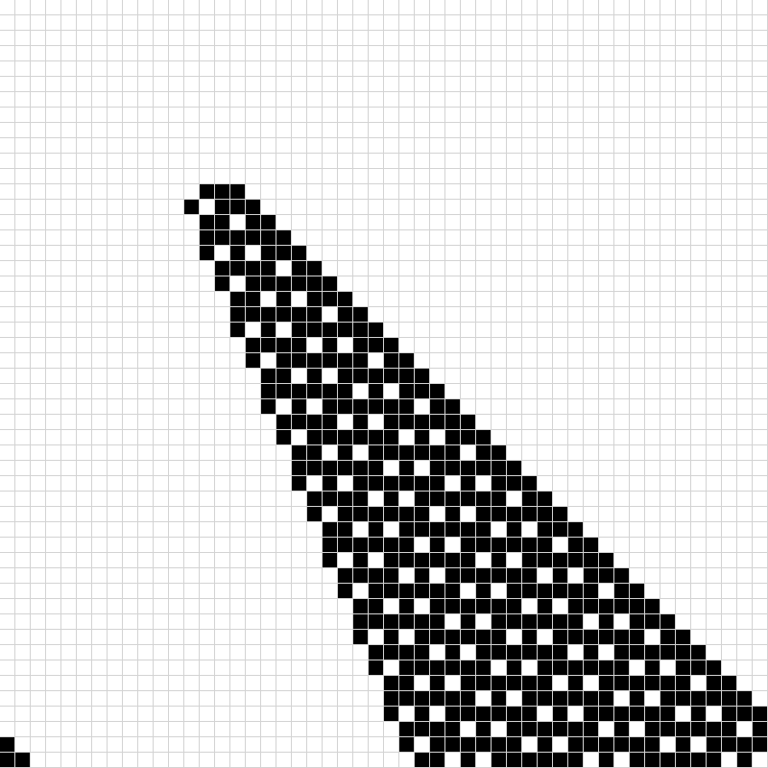
02/16/22 End of day update:

After writing out the logic above, implementing it in code took maybe 20 minutes. After testing one iteration, an isolated cell dies as expected! Two adjacent cells produced the image below though… Time to stop work for now, but that is definitely not what I’m going for. The good news is that the program is sorta working and runs at a decent speed, just gotta do some tinkering.

Image: 2 adjacent pixels produced this thing...

Day 4: 02/21/22

Back after another little break… Trying to get the rule set for cell growth / destruction working today.

Update: After some tinkering, I found that I forgot a rule in the livesOrDies function that accounts for dead cells remaining dead if they don’t have 3 neighbors. After adding this new rule, all of the “still life” shapes (block, beehive, loaf, boat and tub) behave as expected and the crazy behavior demonstrated above is no more. Testing oscillators and spaceships tells me that I’m not quite there yet.

Next task: Get “blinker” oscillator shape to work. This is a really simple shape, so hopefully figuring out where the faulty logic is will be pretty simple. Maybe the other stuff will work after too! Currently, a blinker converts to a static block in 2 iterations.

Update: Having trouble figuring out what is wrong with the oscillator shape. Now it is time to go back and make sure that all parts of the game I’ve made up to this point work perfectly and look clean. Once this is done, other problems should be able to be solved easier. Was kinda dumb to assume I could get away with not doing that first anyway.

02/21/22 End of day update:

Code refactor still in progress but many improvements made so far! I redesigned the GridSquare class to allow for perfectly accurate clicking rather than the shoddy offset that I was doing before. Now you can actually click on any square and it will highlight, including the ones that weren’t working previously.

Otherwise, I reorganized the code a bit so that it flows more logically and added comments for clarity. Hopefully now that everything is cleaned up, getting the game logic working will go smoothly. More tomorrow!

02/21/22 End of day update Number 2:

Ended up doing more work. While working on getting the blinker shape to behave properly, I realized that arrays in JS don’t work like they do in Python. My copy (nextGameArr) of gameArr was a shallow copy, and as such, any modification to nextGameArr modified gameArr as well. Once I made it a deep copy instead the game worked perfectly.

There is still plenty of work to be done, including adding an automatic play mode, allowing shapes to transfer from the top / bottom edges of the screen, and surely some edge cases. But for now I am pretty happy.

Day 5: 02/22/22

Goals: Clean up the HTML, add functionality to reset and right arrow buttons, add automatic play mode (with adjustable speed input!).

Now that the game works, it is time to improve the user experience!

02/22/22 End of day update:

Pretty straightforward today. Did some improvements on page styling and added functionality to start, pause, adjust play speed and reset the canvas. I still need to type of up description pop up page but that shouldn’t be too bad.

The biggest remaining task is getting a cell object to transfer from the bottom to the top of the screen (and vice versa). Will be starting on that problem tomorrow I guess. If that goes smoothly, hopefully this project will be wrapped up by then!

