GoRules PoC.
Built in Streamlit with the Gorules engine in python
Input random or manual date/time.
Get whether business is open or closed; includes public holidays.
Two sets of rules – checks holidays first, then opening hours, and gives result.
Switch is inside python – but can be inside the Zen (GoRules) engine.
Writes to a log csv each time.
(json/jdm file can be read in from a container, or webapp)
Public holidays was a csv file that was simply converted to a json file

JDM view:
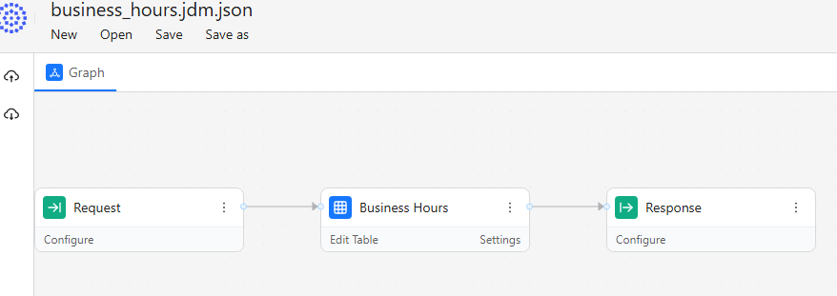
View inside the table
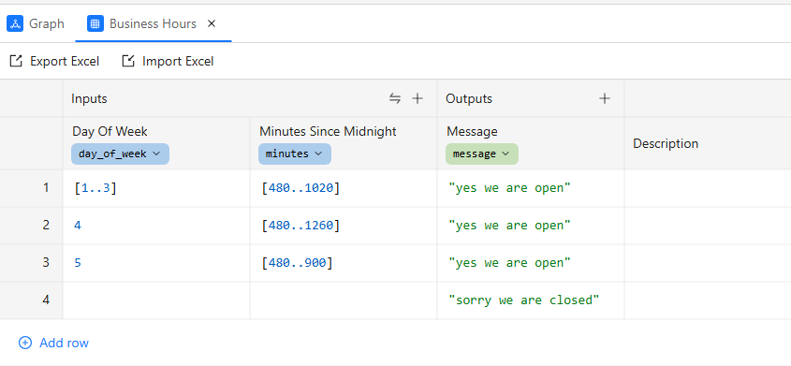
Streamlit front end:
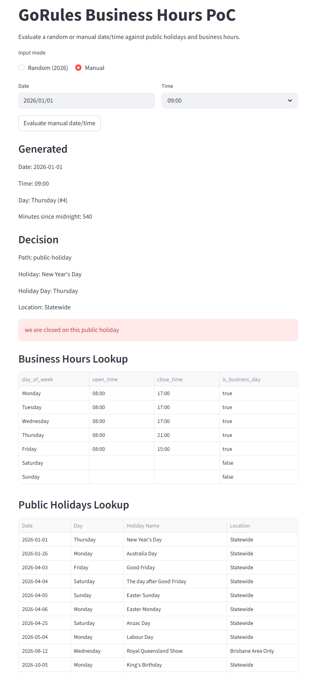

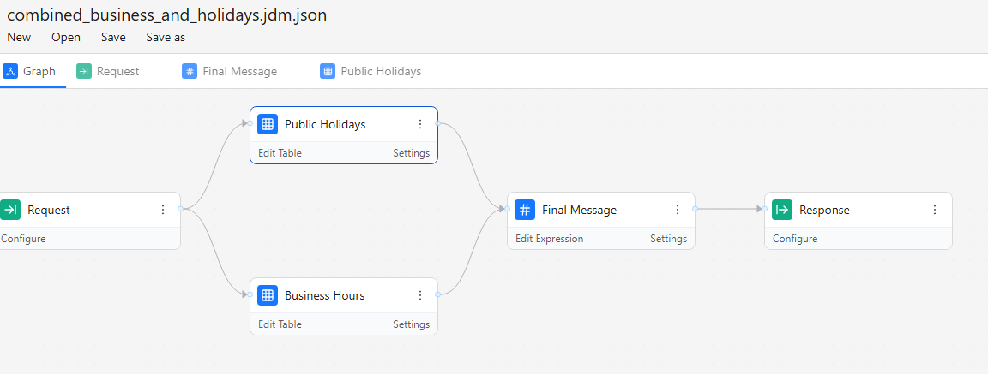

Output log (csv)
