# Office of Homeland Security Statistics Style Guide

## Use the DHS Style Guide

We follow the [DHS Grammar and Style Guide](https://usdhs.sharepoint.com/sites/dhsconnect/org/offices/opa/web/Pages/Grammar-and-Web-Style.aspx), with a two exceptions.

* The DHS Style Guide does not use the serial (Oxford) comma. We do use it, to ensure clarity.
* The DHS style guide uses lowercase for “website,” but capitalizes “Web” in the body of the guide. We use lowercase for both.

As is the case with the DHS Grammar and Style Guide, if we don’t directly address a style here, our fallback is to use AP style.

## Use Plain Language

Review the [plain language training](https://usdhs.sharepoint.com/:p:/t/OHSSWebTeam882/EW9tA_fYDEJLn1seRefaK08B3Z0hep_s0VCZaOHZ_wj0ag?e=cW841B).

Use a tool like [Hemingway Editor](https://hemingwayapp.com/) to simplify your text. Don’t enter personally identifiable information (PII) or other sensitive information into a web-based tool like Hemingway Editor.

## Headings

Use meaningful headings and structure. Only use one Heading 1. Make sure your headings are sequential.

When writing a report, make sure to use meaningful headings in your Word document (or word processor of choice).

For example, here is a summary of the heading structure for our website’s homepage:

* Heading 1: Office of Homeland Security Statistics
  + Heading 2: Data and Reports by Topic
    - Heading 3: Immigration
    - Heading 3: Law Enforcement
  + Heading 2: What’s New
    - Heading 3: New Products
      * Heading 4: Interactive Map: Immigration by State
      * Heading 4: Coast Guard Maritime Response Activities
    - Heading 3: Latest Report Releases
      * Heading 4: FY 2024 Enforcement Lifecycle Report
      * Heading 4: DHS Repatriations – November 2024

Try to avoid going beyond Heading 5. If you are using Heading 6 or beyond, consider reorganizing the structure of your text.

## Casing

We use title case for headings.

Example:

* State Immigration Data

## Date Ranges

We use the word “to” or the en dash for date and year ranges. On Windows, you can type the en dash using alt + 0150.

Examples:

* Fiscal Years 1920 to 2023
* 2014–2023

## Percent Symbol

We use the % symbol when referring to percentages (instead of the word “percent”).

Example:

* LPR Type: 54% adjustment of status, 46% new arrivals

## Offset Phrases

When using dashes to offset phrases or parentheticals—such as this—use em dashes. You can use alt + 0151 to type an em dash.

## Ampersands

Use the word “and” instead of an ampersand (&), unless it’s part of an official title or name.

## Bulleted Lists

We don’t punctuate bulleted items unless the bullet forms a complete sentence.

* Largest subcategory: 47% immediate relatives of U.S. citizens
* The largest subcategory is 47% immediate relatives of U.S. citizens.

Use bulleted lists instead of separating several terms with commas in a sentence. Bulleted lists support readability compared to list items in a sentence.

## Quotation Marks

Use “smart”/curly quotes instead of straight quotes. Microsoft Word and many other word processors will automatically apply curly quotes, but you may have to manually add them in some situations. You can do so using alt + 0147 (“) and alt + 0148 (”). You can apply single quotes with alt + 0145 (‘) and alt + 0146 (’).

Only use straight quotes (") for code examples. For example:

df3.loc[df3["Month"].isin(cy_months), "Calendar Year"] = df3["Fiscal Year"] - 1

## Spacing

We use a single space between clauses.

We don’t use spacing or indentation alone to convey nesting or hierarchy.

|  |  |  |  |  |  |  |  |
| --- | --- | --- | --- | --- | --- | --- | --- |
| 3.0 | Europe | 61,520 | 8.3% | 75,610 | 7.4% | 80,280 | 6.8% |
| 4.0 | North America | 240,440 | 32.5% | 332,670 | 32.7% | 450,310 | 38.4% |
| 4.1 | Caribbean | 77,560 | 10.5% | 109,870 | 10.8% | 193,580 | 16.5% |
| 4.2 | Central America | 45,410 | 6.1% | 72,430 | 7.1% | 64,110 | 5.5% |
| 4.3 | Other North America | 117,460 | 15.9% | 150,380 | 14.8% | 192,620 | 16.4% |

Note the use of a numerical outline to convey subgrouping.

## Acronyms and Initialisms

If an acronym is necessary for future reference, spell the full word and follow with the acronym in parentheses on the first reference. For example, *The Department of Homeland Security (DHS)*.

Some acronyms are more recognizable than their full spellings. For example, *NASA*, *NAACP*, *FBI,* and *FEMA*. In such instances, the acronym is acceptable, at the writer’s discretion.

## Possessive Apostrophes

Use the conventional plural-possessive apostrophe (for example, *two weeks’ holiday*), but **don’t** use the plural-possessive apostrophe for acronyms or initialisms ending in S. For example, use *DHS’s* instead of *DHS’*, since the Department of Homeland Security is singular.

## Footnotes

Use numerical footnotes (instead of * or Roman Numerals). If you only have one footnote, use an asterisk (*).

For website references and citations, link your [text to the source](example.com) instead of using a footnote.

Use superscript for footnote references. On the website, we may use a different format to make the footnotes easier to click or tap, given we link the footnotes to their respective reference.

## Descriptive Link Text

Use descriptive link text. Don’t use “click here,” “read more,” or similar wording that, when read by itself, doesn’t describe where the user will end up when they interact with the link.

For example, instead of:

* [Click here](https://ohss.dhs.gov/topics) to review our data and reports by topic.

use:

* Review our [data and reports by topic](https://ohss.dhs.gov/topics).

## Don’t Repeat Yourself

If a citation or definition already exists on our website (or another DHS website), avoid duplication. For example, you can link to specific definitions, such as [Lawful Permanent Resident (LPR)](https://ohss.dhs.gov/glossary#LPR), in our glossary instead of repeating the definition in a report.

## Alt text

Alternative text, also known as alt text, is descriptive text that conveys the meaning of an image in digital content.

Alt text should communicate the same information as the visual content. When writing alt text, imagine how you would describe the image to someone over the phone, assuming they can’t see the image.

If you use a complicated chart or infographic, you need to convey in the alt text the meaningful characteristics of the image content.

For example, here is a report graph with its associated alt text.

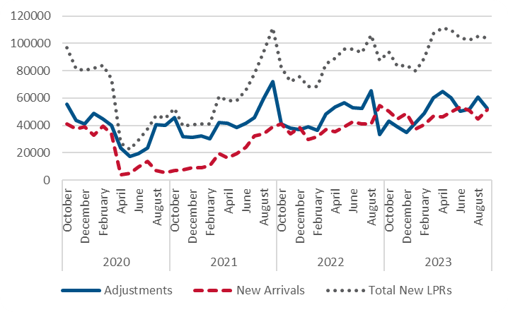  
*Figure showing a timeseries graph of persons obtaining Lawful Permanent Residence from 2020 to 2023 by month, both the total and broken out by new arrivals and adjustments of status. This shows monthly total counts generally remaining within 80,000 to 100,000 per month until March 2020, when they significantly drop off and remain low until they begin to rise to pre-pandemic levels in June 2021 and remained until present.*

## Specific Words and Phrases

### U.S. and United States

Spell out United States when used as a noun. Abbreviate to U.S. when using as an adjective.

Examples:

* The United States granted LPR status to just over 10 million individuals in the past decade.
* Immediate relatives of U.S. citizens

### Components

Use “component agency” when referring to components. We use the term “components,” but it might not be clear to people outside DHS what we mean by that term.

### We, Us, and Our

When referring to OHSS, use “we,” “us,” and “our” instead of OHSS or Office of Homeland Security Statistics. If the reader is reading a report on our website, it should be clear that the “we” is referring to OHSS.

Only refer to “OHSS” or “Office of Homeland Security” if you need to clearly distinguish the office from the Department of Homeland Security, a component agency, or another group.