Brent Gaither Kevin Portland Leiyang Guo

- There are five terminal nodes. This is because we placed in five animals. There are four internal nodes that represent animals diverging.
- The most recent ancestor of whales and terrestrial mammals is node D.
- The rat sequence is the outgroup for the phylogram. It is the most divergent group and is placed in its own branch.
- The difference in evolutionary distance between whale and dolphin mean dolphins more recently diverged from the common ancestor. Dolphins stayed more similar to the common ancestor before they diverged.
- Whales and dolphins should be grouped together because they share a close common ancestor. They both share the hippopotamus as their closest living terrestrial ancestor. However; the whale and dolphin are more closely related to each other than the hippopotamus. This is evident because dolphin's and whale's last common ancestor lived more recently than the last common ancestor of whales dolphins and hippopotamus.
- Jukes-Cantor shows the most similar sequence to the whale is the porpoise. This makes sense and agrees with the results from phylogeny.fr The least similar was the rat which was the outgroup and therefore would be the least related group.
- The Kimura model slightly increases the distance for the relationships with the whale. It is difficult to determine the importance of transitions and transversions based solely on the numbers without other evidence of distance. I would argue that transition bias is somewhat important to take into account because it does change the distances. The model does show they are not as closely related as the Jukes-Cantor model would suggest.
- The Tamura model decreases the relatedness by a slight amount. The distances remain proportional but they are very close to the Kimura model. The GC content does not appear to play a large role in distances for these sequences, but bacteria for example GC content would play a much larger role.
- The trees are similar except for one important difference in how dogs and horses are related. The most recent ancestor of dogs and horses is on a separate internal node on pylogeny.fr. On our tree the common ancestor is on the main branch leading to whales. This means our phylogeny shows dogs are more closely related to camels than to horses which differs from the phylogeny.fr tree.

Calculations for distance
Jukes-Cantor porpoise - 0.04620585704211779
Kimura porpoise -0.046218928925617825
Tamura porpoise- 0.04621955399734102
Jukes-Cantor rat- 0.5307039478013814
Kimura rat - 0.5427477637193078
Tamura rat - 0.5427866733804134
Jukes-Cantor horse - 0.2856228234502973
Kimura horse- 0.29316363781426247
Tamura horse-0.2932021425453095
Jukes-Cantor dog-0.24952931536930198
Kimura dog-0.25206778161149024
Tamura dog-0.2520596360641719
Jukes-Cantor camel-0.18344886473660188
Kimura camel-0.1853554386608102
Tamura camel-0.18537437637730925
Jukes-Cantor giraffe-0.176339806770694
Kimura giraffe-0.17782909356297738
Tamura giraffe-0.17785217476522636
Jukes-Cantor hippo-0.11414386150644393
Kimura hippo-0.11500488078622795
Tamura hippo-0.11502085837205422
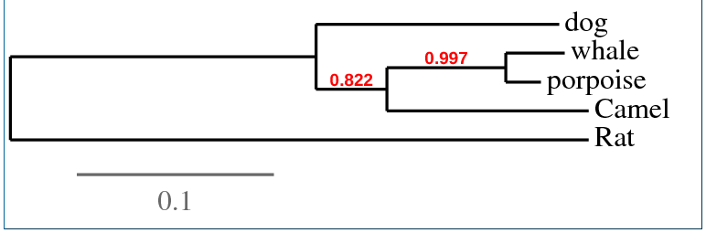
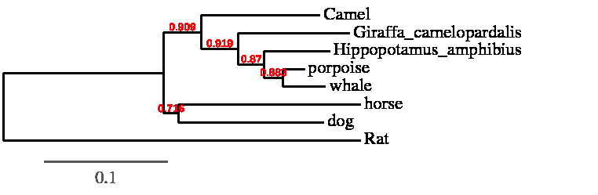
A
B
C
D

