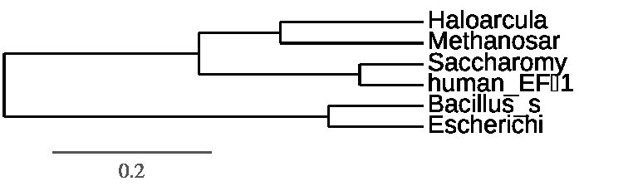
Web Exploration 7
Brent Gaither Bill Moers

- UPGMA both and neighbor joining are bottom up clustering methods. However unlike neighbor joining, UPGMA assumes that there is a constant rate of evolution. We believe that neighbor joining is a more reliable tree because a constant rate of evolution is unlikely. There will be selection for and against mutations that speed up or slow down evolutionary rates.
- The tree we created follows exactly what we have found in other sources. Humans and fungi are closely related, the two bacteria species are related and the archaea are related. Humans and fungi are more closely related to the archaea than the bacteria and we can see that from the last common ancestor of humans and archaea is more similar to humans and archaea than bacteria and archaea. The branch lengths differ in neighbor joining because the model does not assume constant evolutionary rates. The tree branch lengths were consistent with common evolutionary trees.
- The HSP 70 phylogenetic tree is very different from the other tree. This tree shows that subtilis is closely related to methanosar and those are related to haloarcula. The problem with this is that subtilis is a bacteria and methanosar and haloarcula are both archaea bacteria. This also shows that the archaea are more closely related to bacteria than eukaryote which we believe due to many other genes relatedness to not be the case. This is a very big change in how the tree is constructed. The tree we created was based off one gene that appears to show a different evolutionary relationship between the species. Two reasons behind this could be there was gene transfer between two unrelated species, archaea and bacteria, or the genes relatedness is random chance. It is likely that the common tree shows a more likely scenario of evolution and shows a possibility of horizontal gene transfer across taxa. By looking at one gene we might be able to see indications of relatedness, but they do not always give the most accurate information since it is a small subset of data.

UPGMA tree Eta

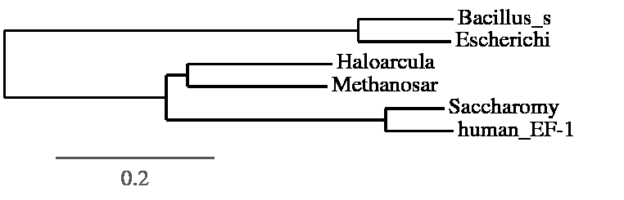
Neighbor joining tree eta

neighbor joining HSP70
