fork_branch

Peter Higgins

1/12/2019

## Creating a fork/branch/pull-request workflow

There are several steps to collaborating on someone else’s github project in R. Note that a lot of this is adapted from excellent (but not Rstudio specific) instructions at <https://blog.scottlowe.org/2015/01/27/using-fork-branch-git-workflow/>

### Forking

The first step is to fork - or create a copy in a new location (your github account). Do this by:

1. log into your github account
2. go to the github repo of the project you want to fork
3. for example, “<https://github.com/brentthorne/posterdown>”
4. at the top right, click on the “Fork” button
5. This will create a copy of the repo, with the same name, in your github account.
6. this will be named something like “<https://github.com/higgi13425/posterdown>”

### Cloning

The second step is to clone, or copy, this repo to your local computer as a project. Do this by:

1. Opening RStudio
2. Select New Project/Version Control/Git
3. Go back to your newly forked github repo, “<https://github.com/higgi13425/posterdown>”
4. Click on the Clone or download button on the right
5. click on the clipboard to copy the link
6. Go back to Rstudio
7. Paste the link into the Repository URL box
8. give the project folder a reasonable name, like posterdown
9. Confirm that you this will be in a reasonable directory, like “~/Documents/Rcode”
10. Click the “New Session” box at lower left
11. Click on Create Project

Now you have a Forked Github repo, and you have cloned this to a linked Rstudio Project on your local computer. Great!

This will allow you to work on the project locally, and push updates/changes to your Github repo. But the project is not linked back to the original repo. If you want to contribute to the original project, through pull requests, you need to link this as an upstream repo.

## Linking to the upstream repo

Now you will create this link:

1. Open the Terminal in Rstudio

* View/Move Focus to Terminal

1. at the cursor prompt ($), type **git remote add upstream** (but don’t hit return yet)
2. This prepares to add a remote upstream link to your project, but now you need the link - to the original github repo.
3. Go back to your browser, and go back to the original github repo

* for example, “<https://github.com/brentthorne/posterdown>”

1. use the Clone or download button to copy the link
2. Go back to Rstudio, to the Terminal window
3. after **git remote add upstream**, leave one space, then paste in the link to the original repo
4. this wil now look like **git remote add upstream** [**https://github.com/brentthorne/posterdown**](https://github.com/brentthorne/posterdown) (now press return)
5. Now your local project on your computer is linked to your github repo (<https://github.com/higgi13425/posterdown>), and also linked upstream to the original github repo (<https://github.com/brentthorne/posterdown>)
6. This will allow you to push changes to your repo, and also to suggest changes to the original project repo (a pull request)
7. The original project/repo owner can review your pull request, and decide which changes to incorporate into their repo.

## 

summary(cars)

## speed dist   
## Min. : 4.0 Min. : 2.00   
## 1st Qu.:12.0 1st Qu.: 26.00   
## Median :15.0 Median : 36.00   
## Mean :15.4 Mean : 42.98   
## 3rd Qu.:19.0 3rd Qu.: 56.00   
## Max. :25.0 Max. :120.00

## Including Plots

You can also embed plots, for example:

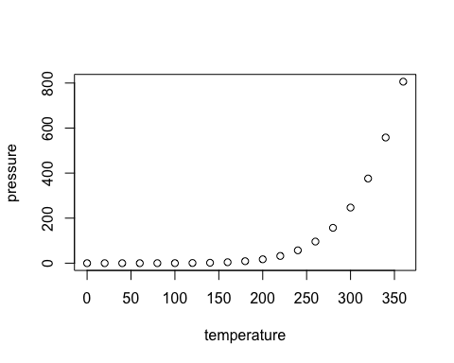

Note that the echo = FALSE parameter was added to the code chunk to prevent printing of the R code that generated the plot.