**TA check list and tips for the CMB lab**

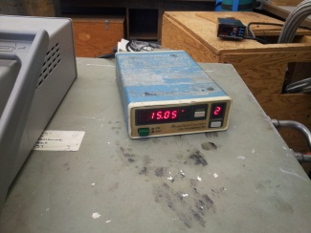

* Before the lab check the readout of temperature in the cryostat enclosure: it should be ~15K and stable
* Identify cold load and “hot” load – the two copper horns on a wooden stick. The cold load is longer. The hot load with thermometer at the end of the wooden stick is pictured here:

* Check digital thermometer at the end of the hot load. If off turn it own, make sure that C sign next two temperature reading is not blinking. If it’s blinking the thermometer is on hold. Press hold button to bring it back into the measuring mode.
* Check that the main dewar and the secondary dewar have sufficient amount of liquid nitrogen. The main dewar should have enough nitrogen to fully submerge the copper part of the cold load. The secondary dewar can hold some additional amount of liquid nitrogen for quick refill of the main dewar.
* If you need to add liquid nitrogen, open the valve on the big metallic tank. Let the air exit the tank and then, when nitrogen starts appearing from the hose, put the hose into dewar. USE GLOVES while handling liquid nitrogen! Do not put the hose straight down – the stream from the tank will be blowing existing nitrogen up and will lead to spills as you try to fill up the dewar. Point the hose sideways towards the wall of the dewar as shown below. This way there will be almost no spills and the nitrogen will swirl inside instead of overflowing outside:
* Put the cold load into the main dewar and leave it there for a few minutes, so it can reach the temperature of the liquid nitrogen (77.4K). Make sure that the copper part of the cold load is all under the surface (fully submerged):

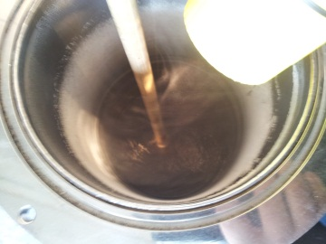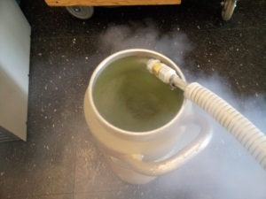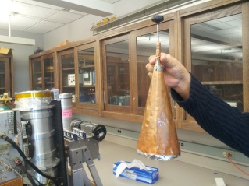

*Make sure the copper part of the cold load is fully submerged under the nitrogen surface*

*Good way to pour liquid nitrogen into dewar*

*“hot” load with digital thermometer at the top*

*Cryostat enclosure temperature readout*

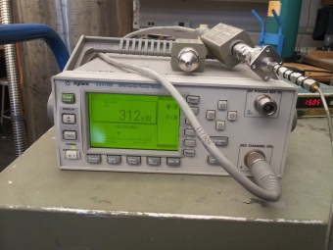

* Check the power reading on the power monitor when you close the top window of the receive with the hot load and then when you close it with the cold load a couple of seconds after you take it out of the liquid nitrogen:
* The ratio of powers you get for the hot and cold loads should be close to 3.5. If it’s not, something is probably wrong and you should alert your lab instructor or lab manager.
* Before making measurements of the sky temperature, make sure that the digital angle meter was properly calibrated. To calibrate take a level and place it at the shoulder of the cryostat next to the wheel that controls its tilt and rotate the wheel until the cryostat is vertical and bubble of the level is in the middle:
* Then replace the level with the digital angle meter and make sure it shows 0.0. If not, press “Zero” button to recalibrate it:
* Before taking the receiver outside to make measurements, assign roles to students to play (one student records power readings, one handles cold load, one handles hot load, one handles shield, etc. Practice measurement sequence inside with everyone playing their role).
* When you will be carting off the receiver onto patio involve students to help you and make sure that cables going into receiver do not bang into anything or do not get pulled.
* When making measurements make sure the cold and hot load fully cover the upper window of the receiver, but do not press them onto the plastic wrap too hard, because you will tear it.
* When you rotate the cryostat to point to different elevations do it so it tilts in the direction AWAY from the cables that feed into it.
* When using ground shield for sky measurements get one of the taller students to hold it (again fully enclosing the receiver window), while two people looking at the shield from two orthogonal directions can help the person holding the shield to align it along the axis of the cryostat. This alignment is important, because if the shield is misaligned receiver will be seeing the shield, not the sky.

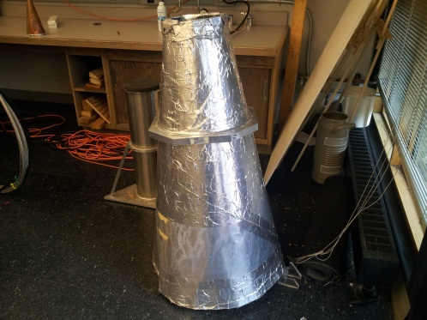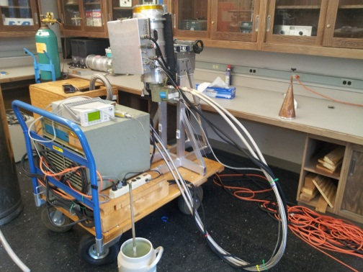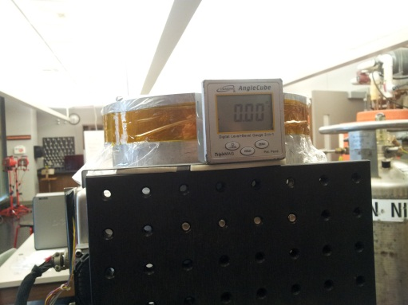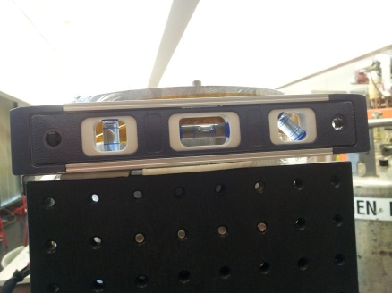

*Power readout*

*Zero elevation established with level*

*Digital angle indicator*

*Receiver on the cart with cables*

*Ground shield*

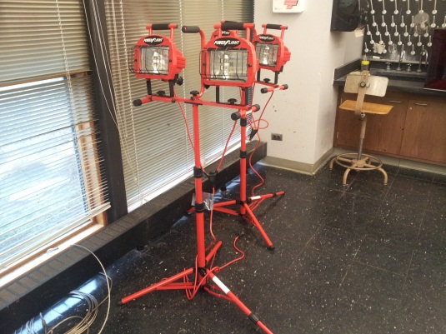

*Flood lights for lab sessions during dark hours*

* If clouds are present, be careful in measuring the sky. Measure sky power just before the shield is put on, and right after. Monitor variability of the sky signal and compare this variability to the effect of the shield. High variability means you may need more measurements at a fixed elevation to average down the variability.
* If the weather is bad (raining, snowing heavily) show movie about Penzias and Wilson inside, measure body temperature, discuss how measurements will be done.
* If your lab session is during dark hours, use electric flood lights for lighting the patio. There should be extension cords with outlets setup outside for this. Make sure you place the flood lights behind the instrument, near the lab doors, so that receiver points in the direction opposite of the lamps when you are making sky measurements to minimize any signal coming from the hot lamps.