# Bachrach and Katzir 2017. *Linearizing Structures.*

Syntax 20:1, March 2017, 1–40.

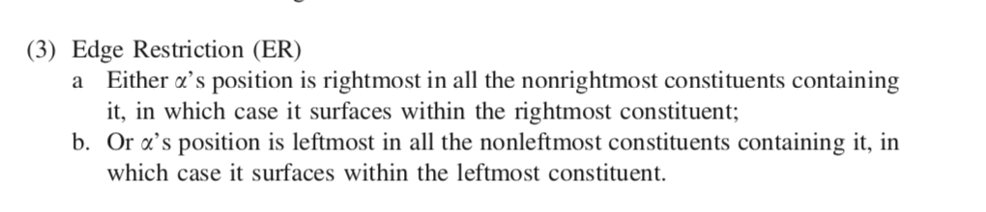

(4) a. * John likes Sue and Bill hates __.

b. * John gave __ presents and Bill kissed Sue.

## 2. Empirical picture of GNR

Three camps for GNR:

1. **Movement**: regardless of how α is analyzed, there is an additional, higher instance of the α
2. **Ellipsis**: clearly not movement, phonological ellipsis
3. **Multidominance**: syntactic sharing of α
4. (Hybrid accounts)
5. (Nonsyntactic accounts)

Characteristics of GNR:

1. Islands
2. Beyond Phrases
3. Beyond Coordination
4. Morphosyntactic identity
5. GNR interacts with hierarchy
6. Restricted Wrapping
7. On the Left
8. Center-Node Raising
9. Restriction by the ER

Characteristics of GNR:

1. **Islands**

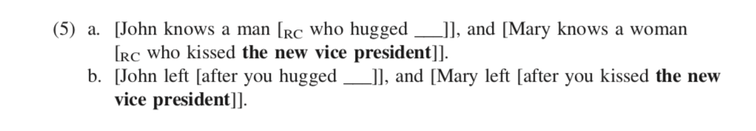

*Generally kiss of death for movement theories, but Sabbagh (2007) has given an account based on cyclic spellout.*

Also, CSC:

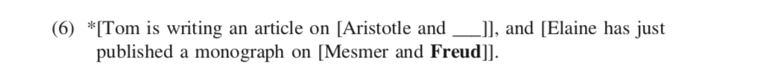

1. **Beyond Phrases**

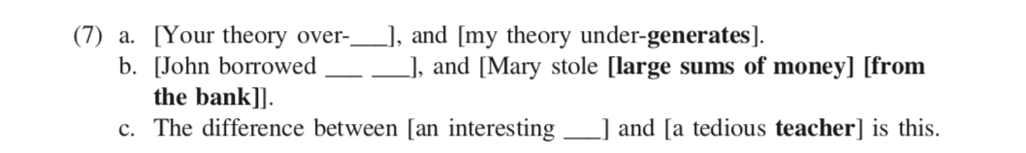

1. **Beyond Coordination**



1. **Morphosyntactic identity**



*(10a) cannot mean that Alice can see her face in the mirror  
 (10b) cannot mean that Alice can see her new suitcase*





*The interpretation sought for (10a) is perfectly acceptable for (13).*

1. **GNR interacts with hierarchy**

Quantificational α can take wide scope over coordination in GNR. But not in ellipsis (14c).

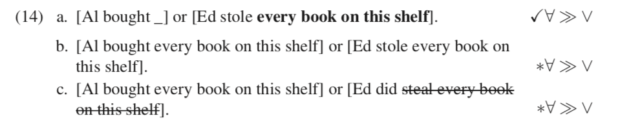

GNR may also allow α to take scope that crosses scope islands. (15a) shows GNR allows α to take scope outside a relative clause. More challenges for ellipsis (15c)

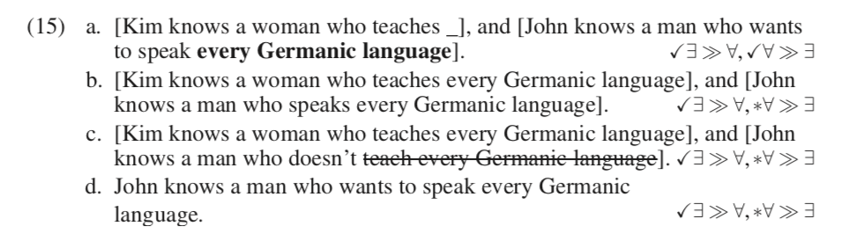

RNR can feed overt syntactic movement to the left:

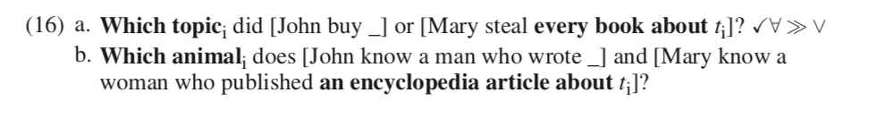

*Cannot be ATB + backward DP ellipsis*

1. **Restricted Wrapping**

The ER does not prevent Right-Node Wrapping: α is not rightmost in the last conjunct, just in case it is rightmost in non-final conjuncts.

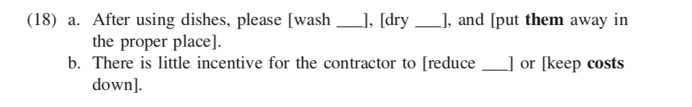

1. **On the left**

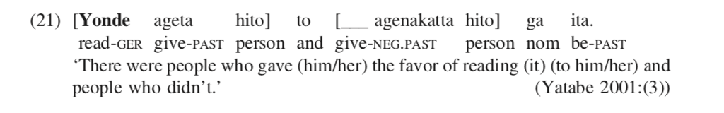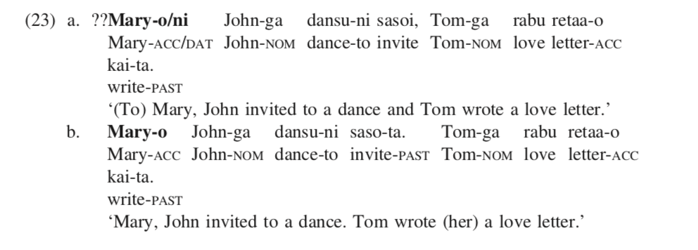

1. **Center-Node Raising**

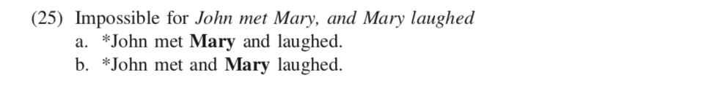

(25a) violates ER, (25b) respects ER.   
**\*\*The present account rules (25b) out via linearization\*\***

1. **Restriction by the ER**

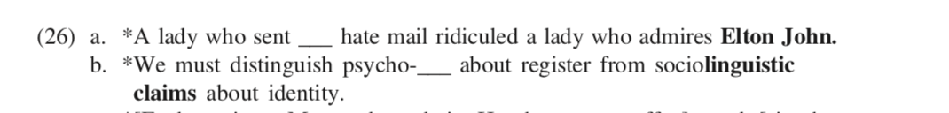

There is no ER equivalent for forward or backward ellipsis.



**The ER poses challenges for ellipsis. Movement, and most MD accounts of GNR.**

* **Ellipsis:** see (28)
* **Movement:** Sabbagh’s account rules out leftward movement after RNR, but (16)
* **MD: (a)** Wilder only rules out literally RIGHT edge—what about LNR?;   
   (b) overgenerates by allowing things like:  
  (29) a. *[Joss edited one review __ for Blackwell], and [Maria edited two reviews **of my new book** for Oxford ].

***Section 3. Linearization through Local Compatibility Checks.***

The general idea: the ordering specified in the mother must be compatible in some informal sense with the ordering in each of its daughters

(4a) *John likes **Sue** and Ben hates __  
 **Sue** appears after **hates** in one of the daughters, but not in the mother

(4b) *John gave __ presents and Bill kissed **Sue**

**Sue** precedes presents in one daughter, but not in the mother

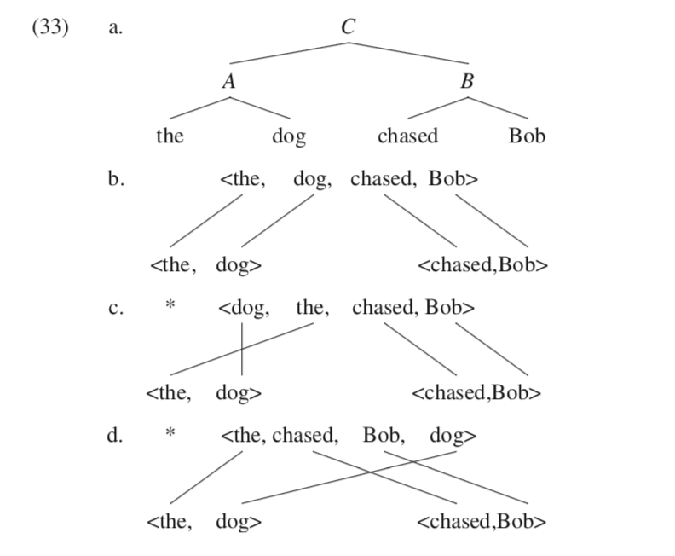 (2) John likes __ and Bill hates Sue

OK

1. Two preliminary, working requirements:
   1. **Universal Alignment (to be abandoned)**: any element from leftmost daughter is left of anything in the right daughter
   2. **Conservativity:** relative ordering within each daughter is preserved
2. Linearization notions
   1. **D-list for X:** contains info about linearization of terminals dominated by X
   2. **(31) Linearization Terminal Condition:** if X is terminal, then D-list(X) = <X>
   3. **(32) Linearization Mapping Condition (working):** Universal Alignment + Conservativity  
        
      (33b) *Conserv.  
      (33d) *UAlign
3. 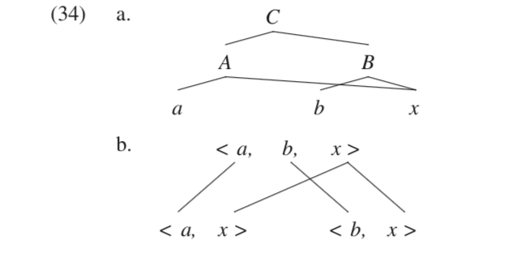Shared structure (as in GNR) will inevitably crash UAlign, x must somehow precede b (34b)
4. We modify UAlign to be weaker **‘Edge Alignment**
   1. **Edge Alignment:** only the respective edges of A precede the respective edges of B.
   2. 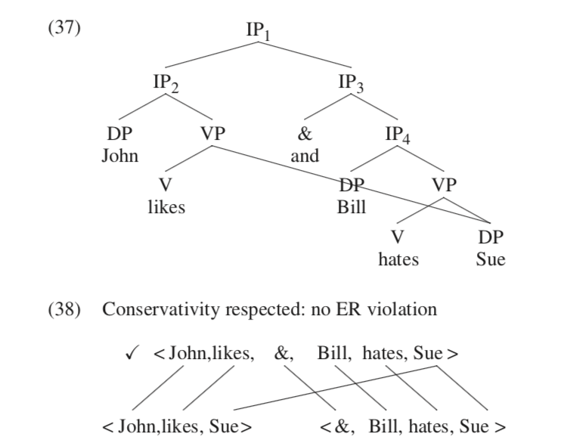x is no longer required to precede b
   3. **EAlign** rules out *The chased Bob dog.

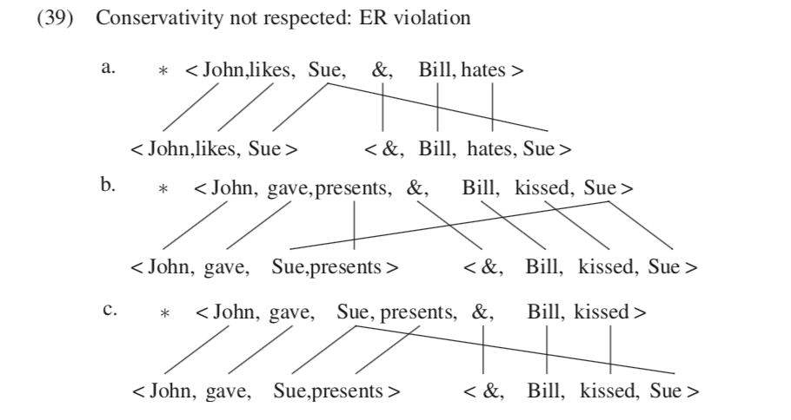

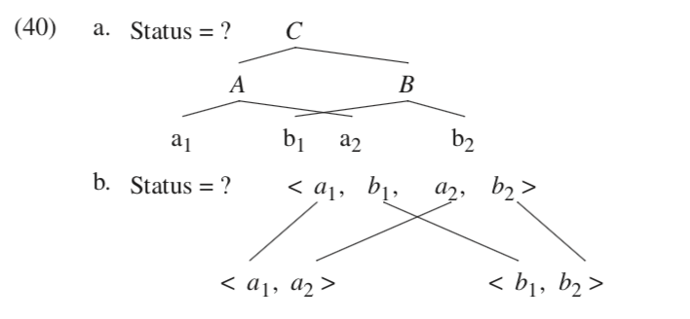

**Interleaving.**

1. (38) shows us interleaving. Is this permitted?
2. Not generally (40). It is ruled out by factors that have nothing to do with linearization per se: the * is due to the cyclic nature of derivations
3. Syntactic derivations are broken down into **phases**
4. Spellout yields a **string**, an immutable linearization object notated as <a1, a2>. Separating these terminals is impossible.
5. Following Uriagereka 1999: SO occurs dynamically throughout the derivation (rather than only in designated categories, as in Chomsky 2001) (p20)
6. **Stipulation Regarding Spellout: whenever A and B merge, at least one of them has to undergo spellout**
7. We demand spellout only of material that is **completely dominated**
8. Then, in GNR, α is not completely dominated in either of its containing constituents until the moment they are merged, so it is not frozen.

* From the perspective of MP, linear order is not a property that the syntactic computation should be sensitive to
* PF interpretability can be rephrased as a requirement than any syntactic node is potentially a phase node.
  + **Linearization WF Condition:** If element is incompletely dominated by X, it can appear more than once on D-list(X). Once completely dominated, only once.

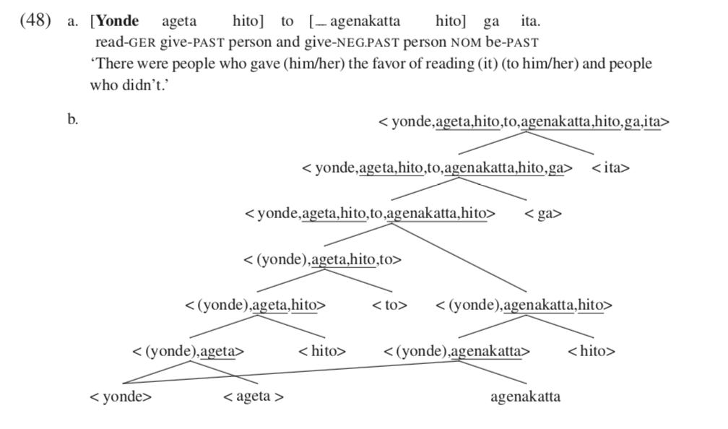

* Being agnostic about (a) categories, (b) where in the structure, (c) sharing right/left, (d) specifics of combining operation is what you want to account for all the properties.
* GNR applies in islands, beyond phrases, beyond coordination, on the left…
* Can’t cover (non)identity but neither can others

**Partial wrapping?**

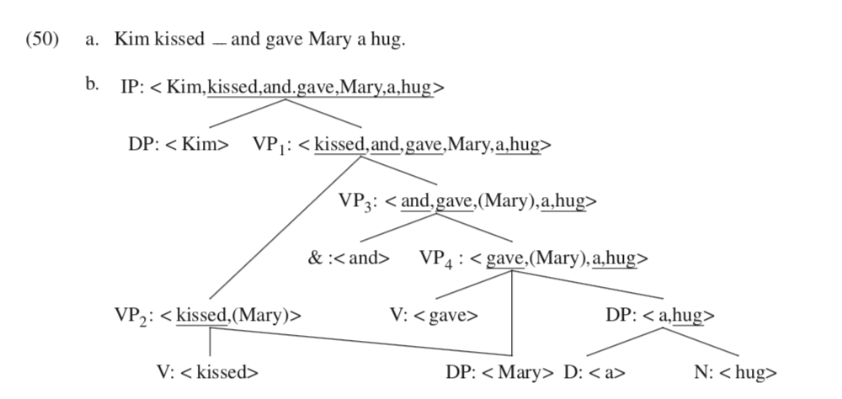

OK: Conservativity, EAlign,

VP3, VP4 don’t have to be SO’d. “Nothing forces the SO of either”

***Section 5. Linearization of Movement***

1. At first glance, IM as MD will violate either Conservativity or EAlign
2. OR you could pronounce it twice, but that’s not well-formed
3. If D is a phase, then B is Specifier/Escape hatch and exempt
4. But which B is SO’d? Variation.
5. Escape hatch for IM, not ParMerge. **Parallel Merge provides no escape from Conservativity.** (at no point is there two occurrences of α on the same D-list = **deriving a distinction between IM and PM)**

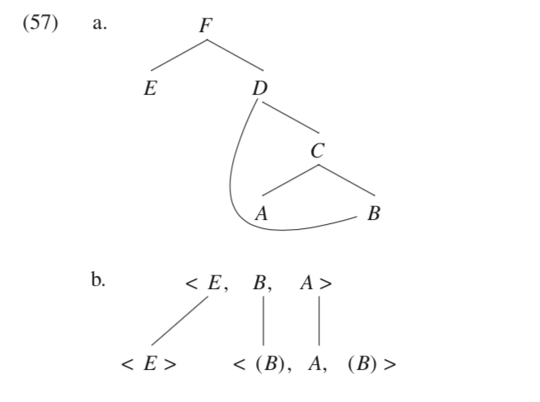

**Multiple Specifiers:** Generally ruled out. Only one thing can move to phase edge since everything else freezes. OR, multiple wh-elements are conjoined before moving out.

**ATB, no covertATB**: GNR feeds ATB

**Multiple pivots?:** A problem. Shared objects don’t have multiple occurrences.  
  
 (64) Who do you think, and who don’t you think that John will see?

**MD and CSC**: CSC: if a constituent X is incompletely dominated within one conjunct, it must be incompletely dominated within all conjuncts

(67) * [Tom is writing an article on [Aristotle and __]], and  
 [Elaine has just published a monograph of [Mesmer and **Freud**]].

WRT [*Aristotle and Freud]*, *Freud* is not dominated AT ALL in [*Aristotle]*

________________

*B. Woo*

*LING 580 Topics in Phases  
Spring 2018*