Mantooth Assignment
The image comes from a Windows computer. The computer in question is part of a criminal investigation. The suspicion is that the owner may be involved in illegal activities. In this assignment, you will be looking for the flags below and writing a report based on your findings.
Your report should contain the following items:
- Executive Summary: One paragraph directed at a non-technical user
- Methods: Tools used, your process, how you verified the artifacts
- Findings: What did you find? Provide your artifacts in the form of screenshots, evidence and flagged items from the questions below. (PROTIP: Make sure you properly label and refer to your screenshots.)
- Timeline: Create a structured timeline of your findings. When were files open? When were applications opened? When were websites accessed?
- Conclusion: Provide the story that the evidence shows. Make sure the evidence and your artifacts support your narrative. Make sure that you refer to specific artifacts that back up your reasoning.
- Tools: Autopsy, Windows Registry Explorer, Prefetch Windows Event Viewer, Screenshot tool (PicPick, Greenshot are good choices)
Screenshot Example:
Properly labeled and marked-up screenshots are essential to your reporting. Make things as easy as possible for your reader. Here is an example of a screenshot. Use this format.
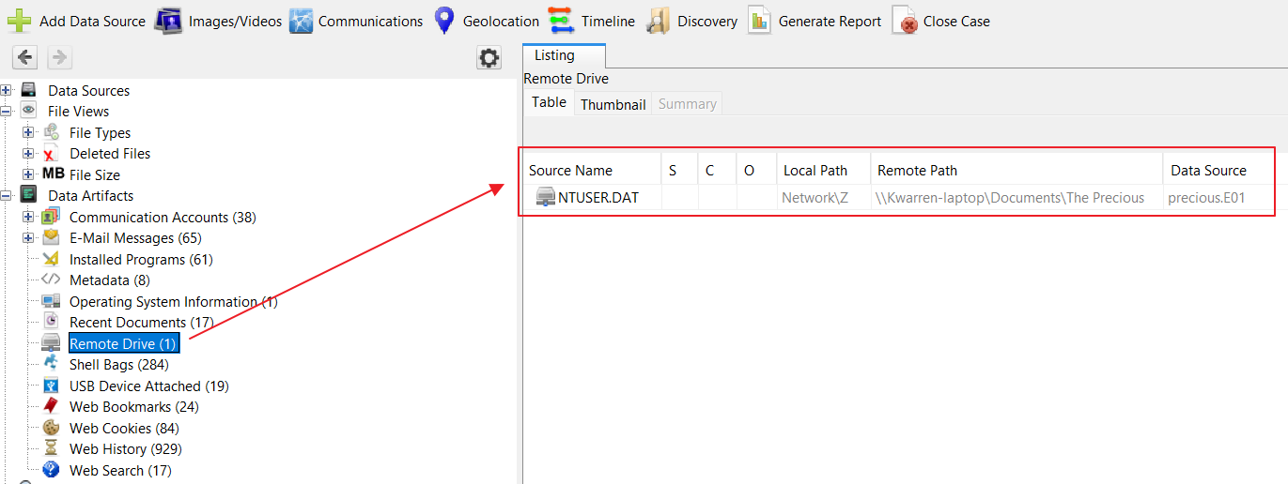
Figure 1: Artifact of remote drive connected to the Precious computer (from Autopsy)
Goals:
- Reconstruct the user behavior, identify any incriminating evidence and present a report.
- Create a narrative of the user’s behavior, don’t just find isolated artifacts.
- Communicate the meaning of your findings supported by evidence with your reader.
High-level investigative questions:
- What story does the user’s activity tell? What do web browsing and internet history tell you about the user?

- How do artifacts from different sources corroborate with each other? Make sure you are looking at the output from Autopsy and Registry Explorer as well as any other resources to verify your evidence. Make sure you know where the evidence came from. Make sure your reader knows where the evidence comes from.

- What evidence could be relevant in a legal or corporate investigation? What artifacts and evidence are most significant?
Essential Flags:
- Verify the MD5 hash of the image with the related Mantooth.E01.txt file.
- User Account Discovery: What is the name of the main Windows user account?
- User Account Discovery: What is the last login time of the main user?
- Operating System Version: What operating system is installed?
- Time Zone: What time zone is the computer set to?
- USB Device History: Find one USB storage device that was connected to the computer and provide the make/model/serial number.
- Browser History: Identify at least three websites the user has visited.
- Browser History: Identify any suspicious search queries.
- Email Attachments: Find at least one email attachment that the user sent.
- Email Artifacts: Locate at least one email address used on the computer.
- Pictures: Identify at least three images that could be meaningful.
- Software: Identify at least three programs that are installed on the computer. Note any suspicious applications and why.
- Software: Identify any suspicious applications that the user has recently launched. When were the applications last run?
- Deleted Files: Identify and recover a deleted file.
- Did you discover any other interesting evidence on the computer?

