

Database User Guide

Nov 2016
Updated 17 Jul 2017
Getting Started
Simply enter your username and password
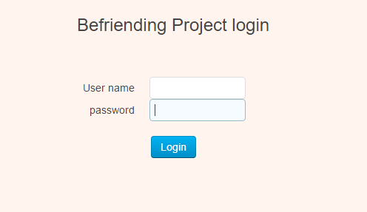
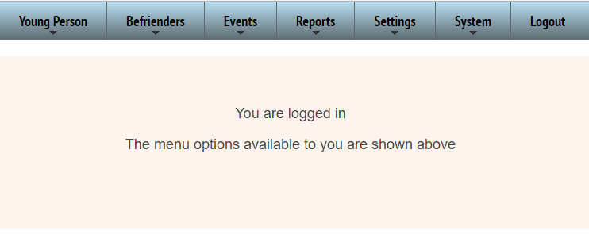
Young Person

We will start at the beginning of the YP Process
To send out a referral form Choose Referrers from the drop down.

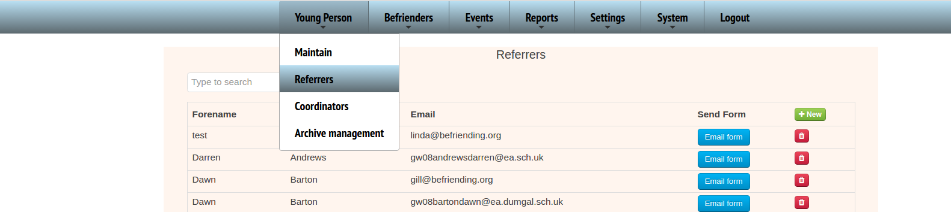

Find your referrer and click
If the Referrer does not exist simply press the green ‘New’ button and enter their details to create a new Referrer and then press the email button.
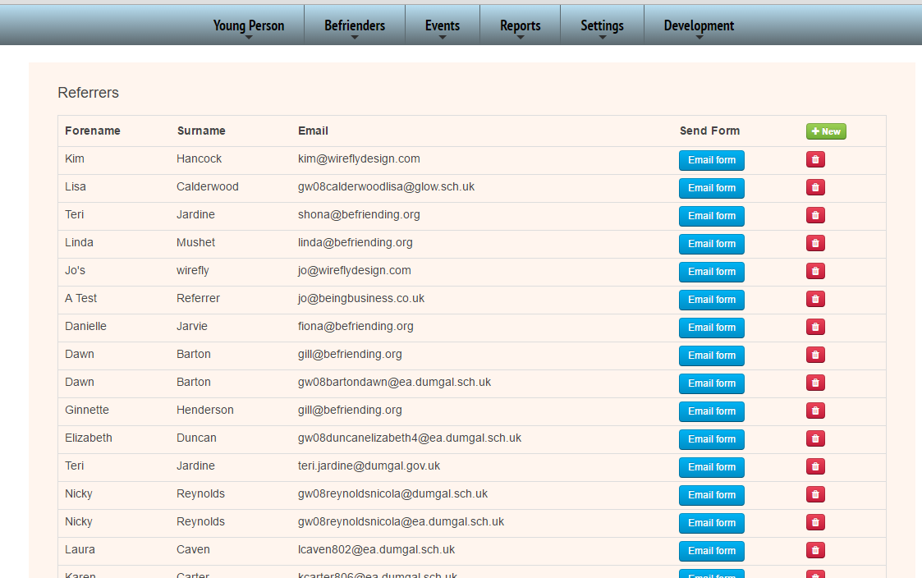

When the email has been sent successfully you will get the pop to confirm
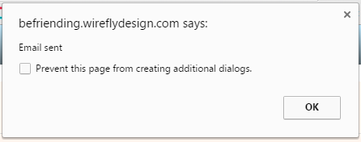
The Referrer will get an email with a link to the Referral form with 7 pages.
- Page 1 asks for confirmation of their contact details
- Page 2 asks for the Young Person’s details
- Page 3 asks for the anticipated outcomes
- Page 4 asks for the medical information
- Page 5 requests additional information
- Page 6 requests additional contacts
- Page 7 asks them to confirm they have added all contacts, to confirm that the Young Person is aware of the referral and the Referrer is able to press a submit button. This will add a time and date to the Referral, at which point they get the message below.

If there is an additional file to sent with the email you can upload this in the System / Configuration menu option, under referral form attachment.
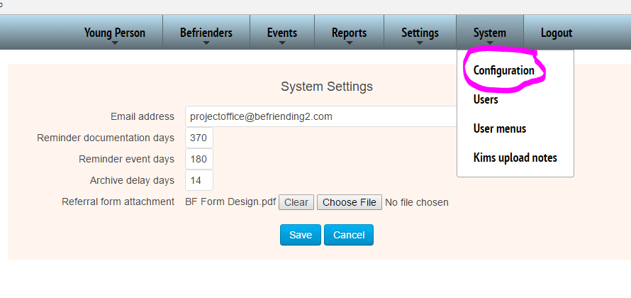
To see what new YP have been entered into the database via a referral form, head to Young Person > Maintain to see the list.

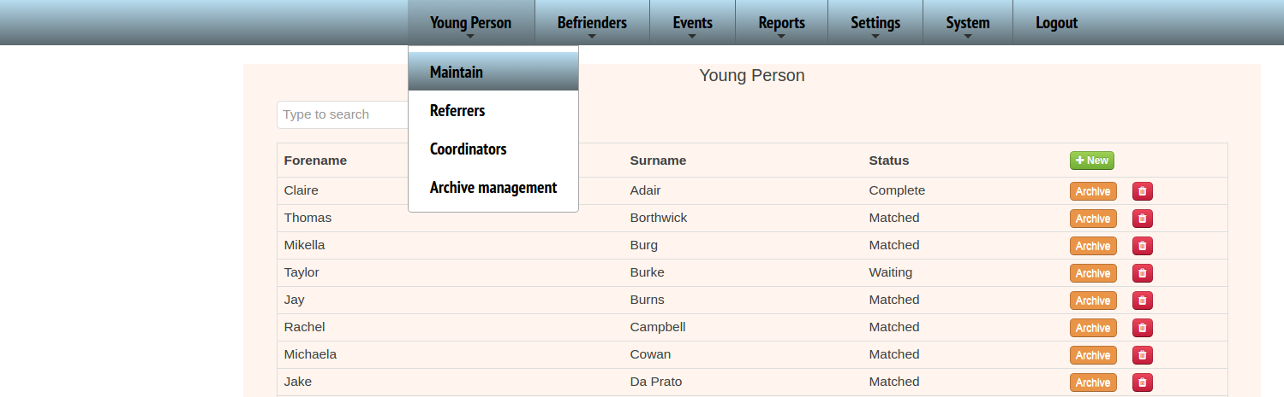

Here you can either search for an individual in the search box or sort by status to find the new blank ones.

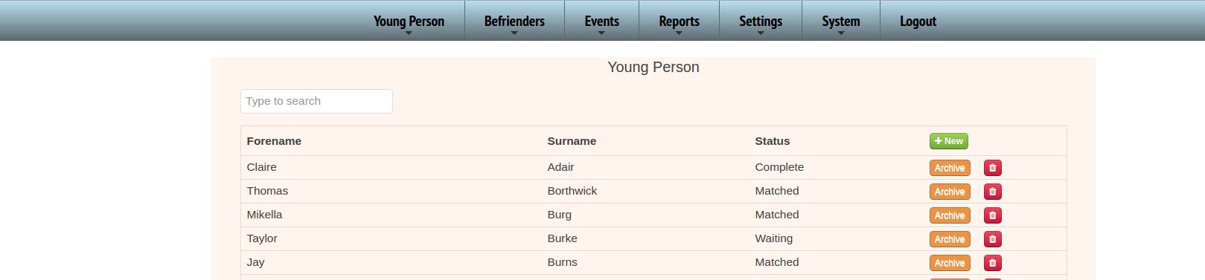
To add a new person manually click on the green ‘New’ button.

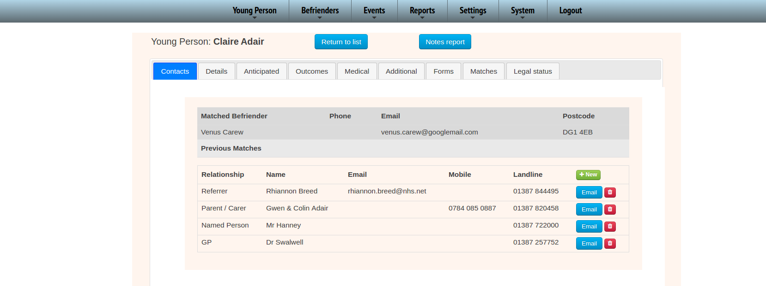
And to edit a Young Person simply click on the relevant line.
The Young Person has the following information split across several tabs, the first default one being all their contacts including their Befriender if they have one….

The next tab is the basic detail for each YP…
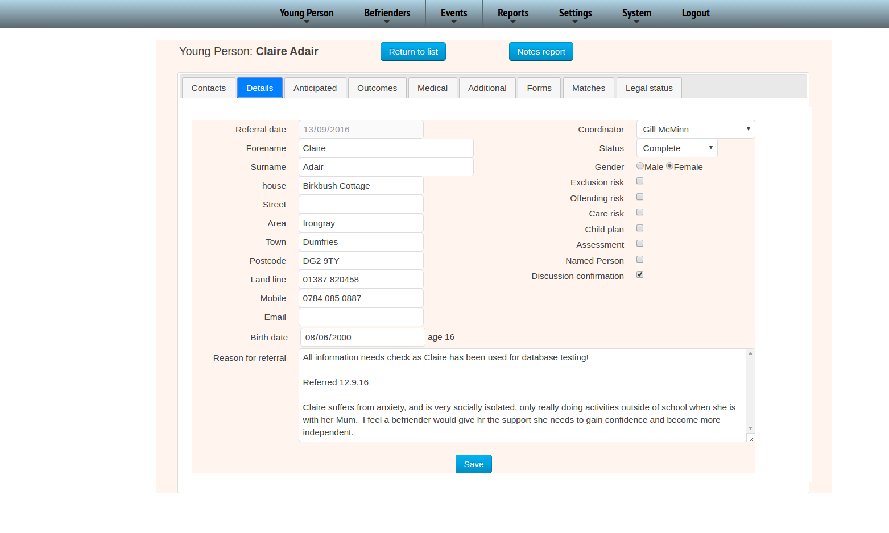
If you are unsure of what some of the checkboxes are simply hover over them for an explanation.

Anticipated …
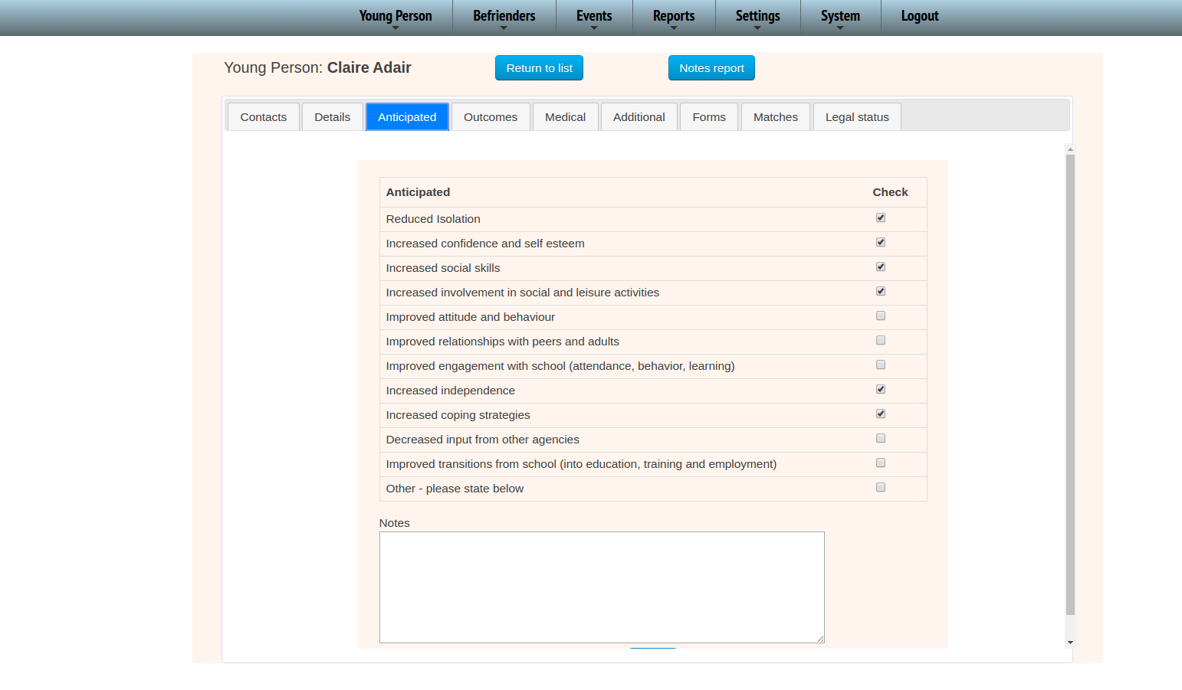
Outcomes will give you the YP progress across the Girfec Form scores…
For the details behind these scores click on the date in blue above the scores and this will open a new tab for the forms attached to that ‘event’
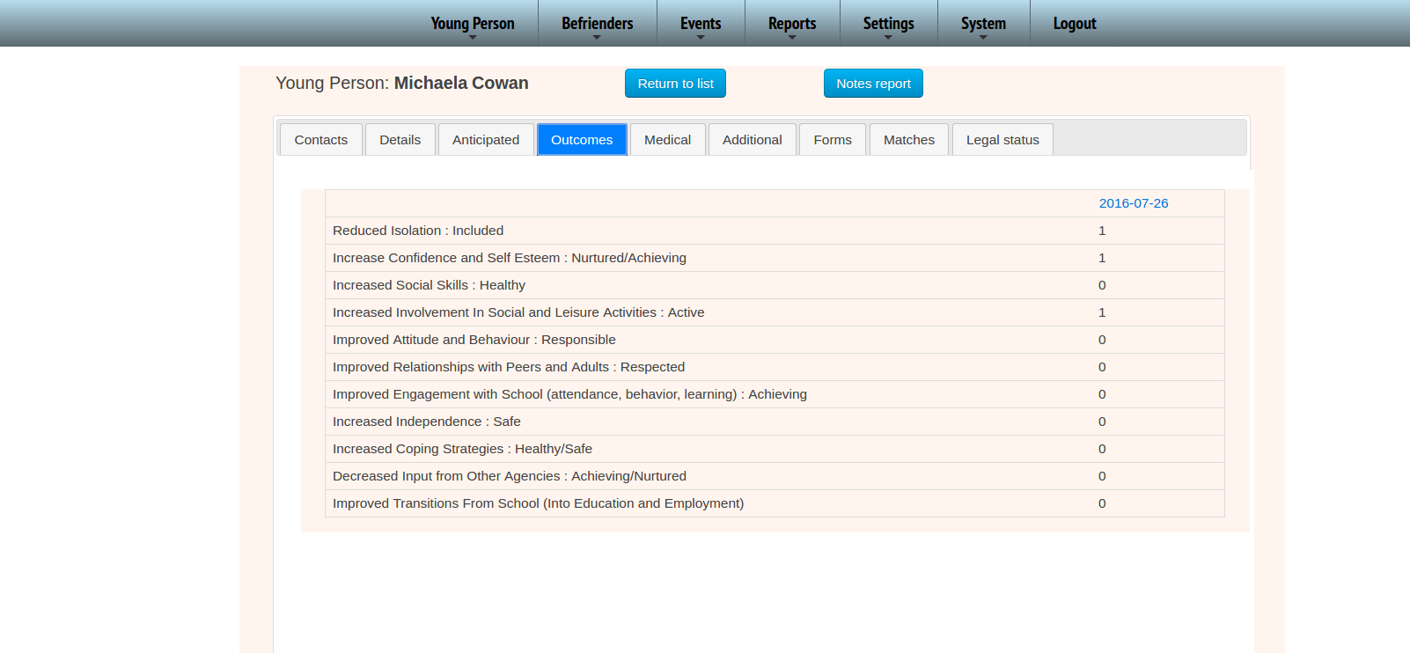

First you will see the basic ‘Event’ details ….
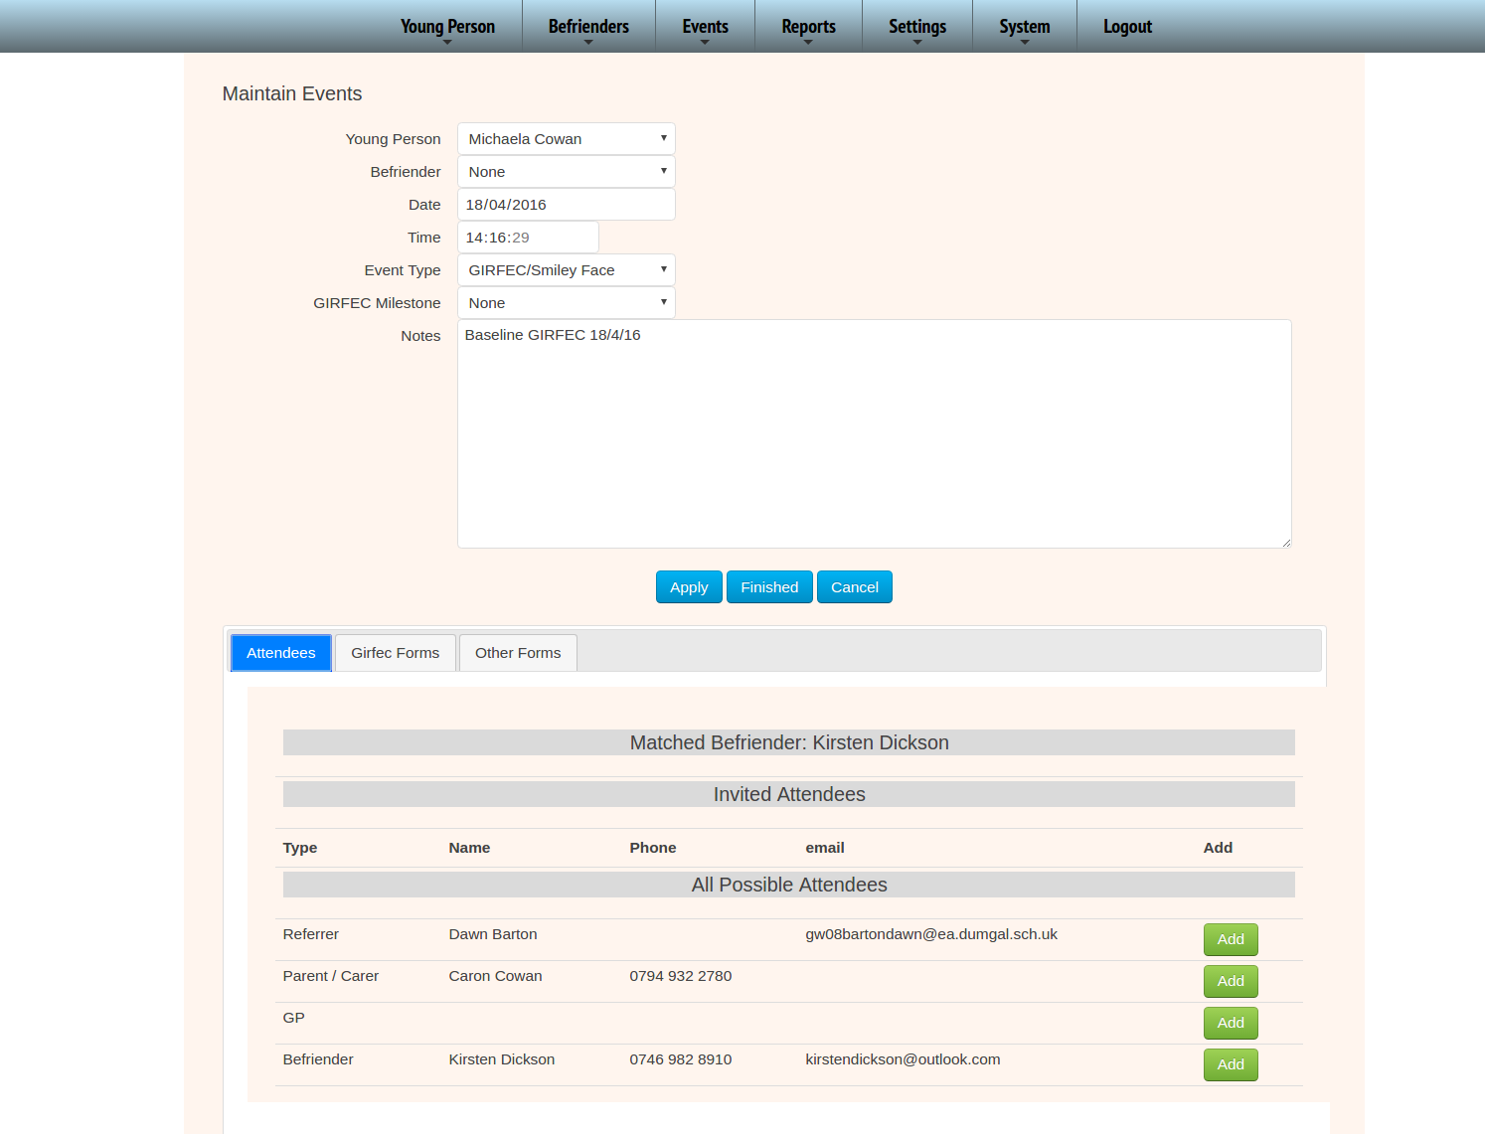
And for the Girfec comments etc click on the GIRFEC tab. This tab allows you to upload a copy of the GIRFEC form as well as record the scores and notes for easy checks and future analysis…

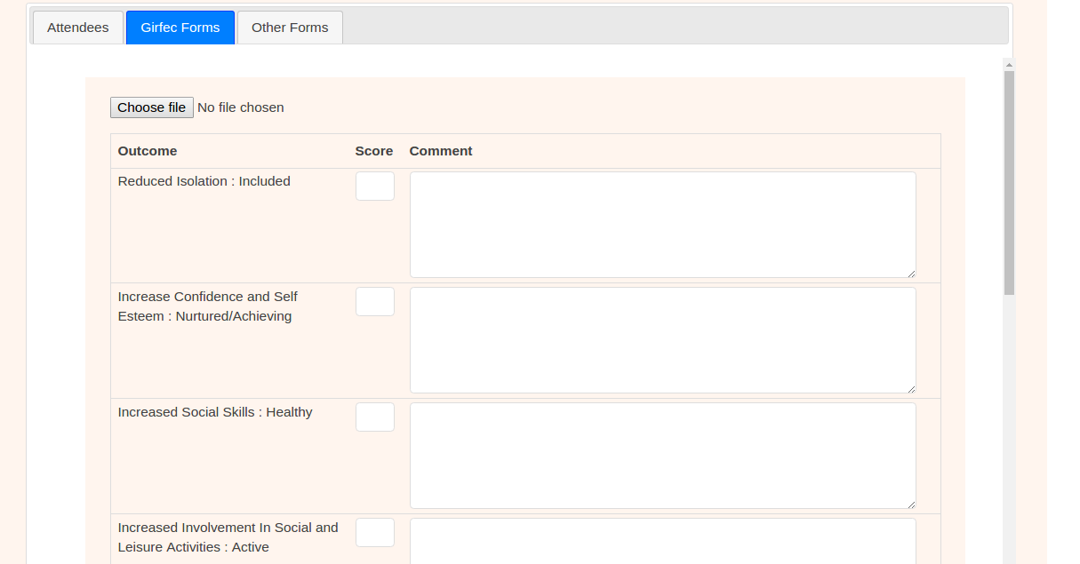
Any other uploaded documents are housed in the ‘Other Forms’. PDFs will open in your browser, Microsoft documents will normally download but this does depend on your browser settings and extensions. Wirefly can not dictate how MS documents are opened as it is dependent on external software installed.

To close this view simply close the tab and you will come back to the YP details.

‘Medical’ and ‘Additional’ tabs are simply more detailed static information about the YP.

The ‘Forms’ tab displays all the forms uploaded from various events for easy access. You can not upload here, all forms are tied to an event as only an event of some description such as a meeting triggers a form. The view button, like the date on the GIRFEC scores will open the event in a new tab so that you can access all details including notes for the event that the form is tied to.
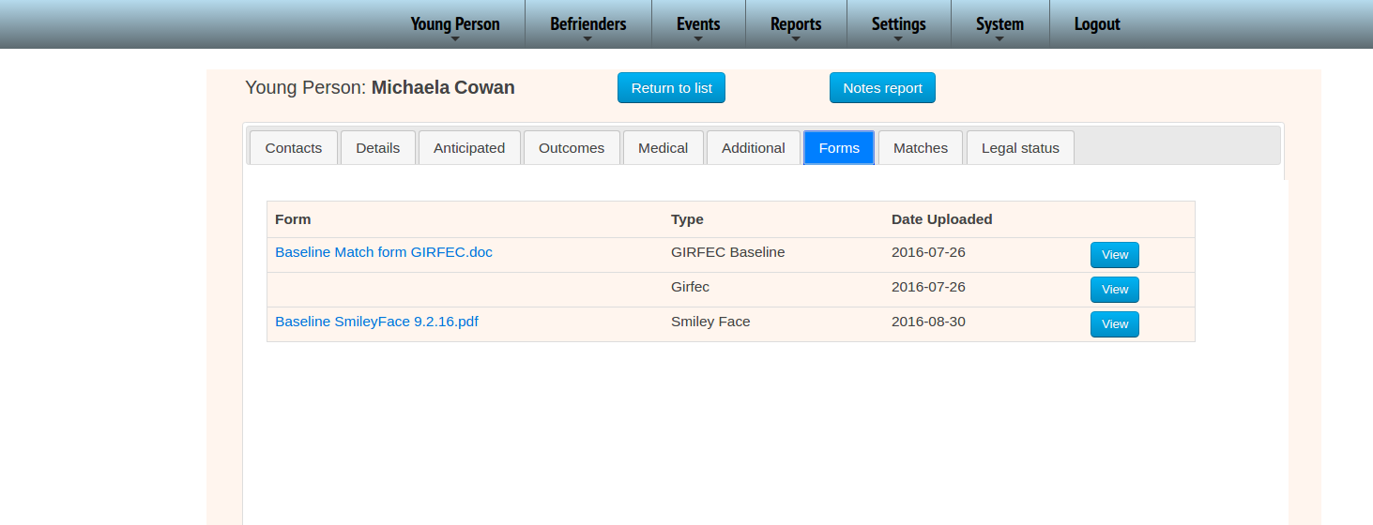
To maintain a match between a Befriender and a YP use the Matches tab and here you can add a new match, end one using the dates and remove a BF if you have accidentally put the wrong befriender up there.
All possible befrienders only lists those BFs with the requisite space for a match. There will be other BFs in the system but not everyone is available to the matching process.
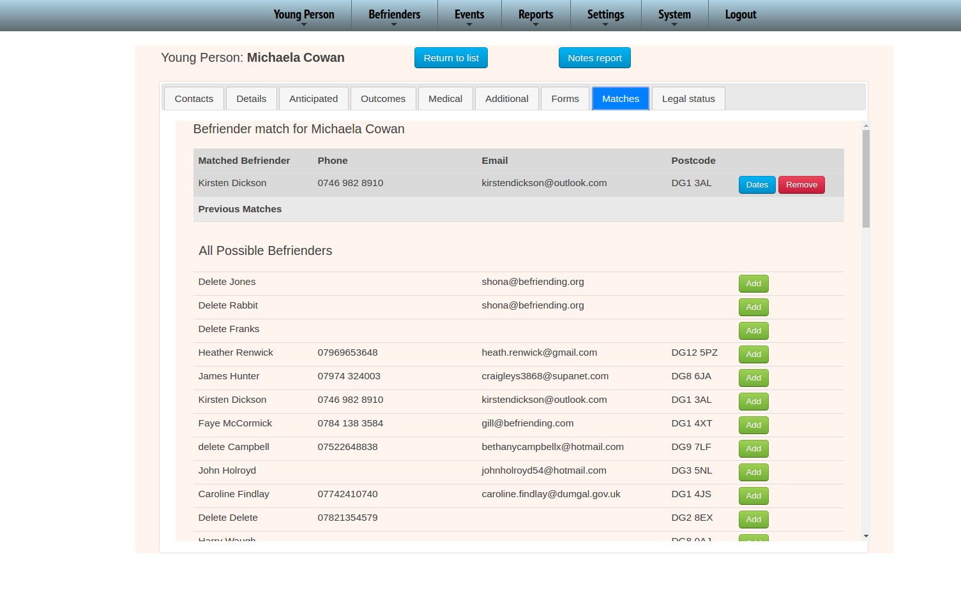
To enter a start and / or a finish date simply click on the blue ‘Dates’ button. If there is any data that exists for a match the remove button will no longer be operational.
Clicking on the Dates button will give you this view…
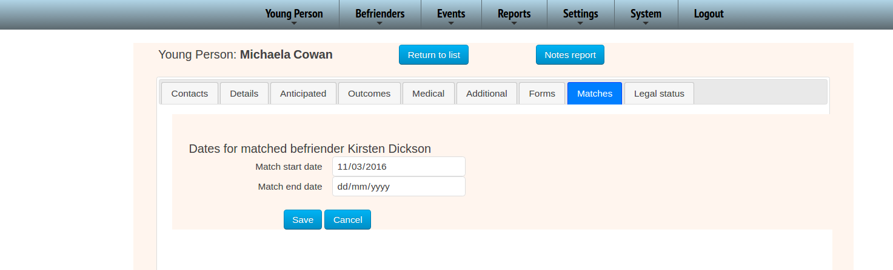
The last tab is for the Young Person's legal status. Note that is is possible for several to apply at one time, and each may be assigned a date.
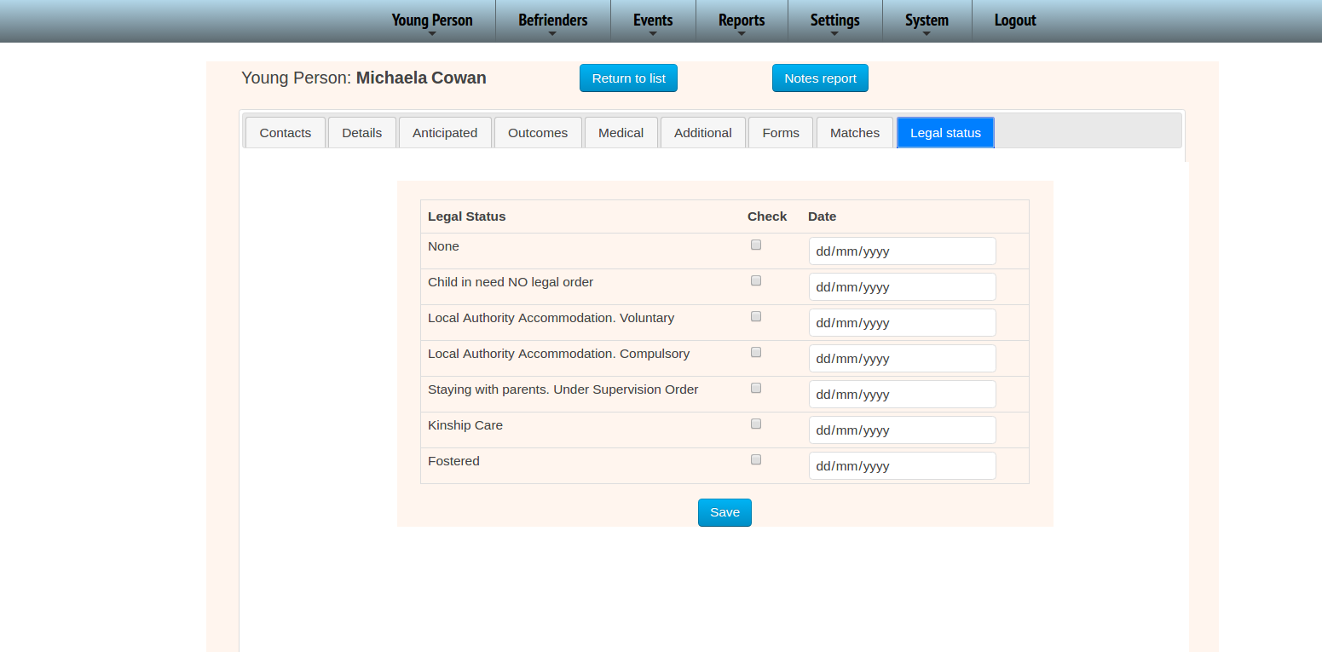
The final part of the YP are the Notes Report. Click on the Notes Report to get the full case file notes form all meetings in chronological order.
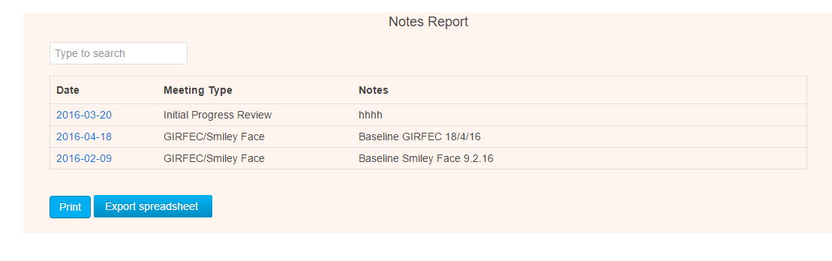
(Please note if you do not use the Event Notes for sensible entries you will not find this feature of much use, So please enter meaningful text here. This will also aid the Year End report)

Befrienders
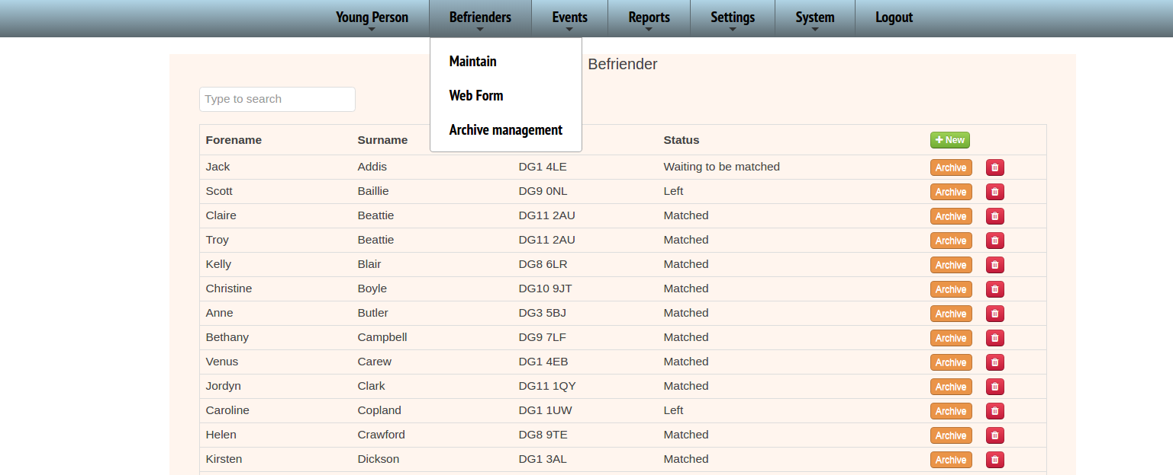
The Webform allows you access to the form which is also on the website should you want to enter an application form into the system yourselves, this is just the initial enquiry form with some basic details to allow a coordinator to follow up with the individual…
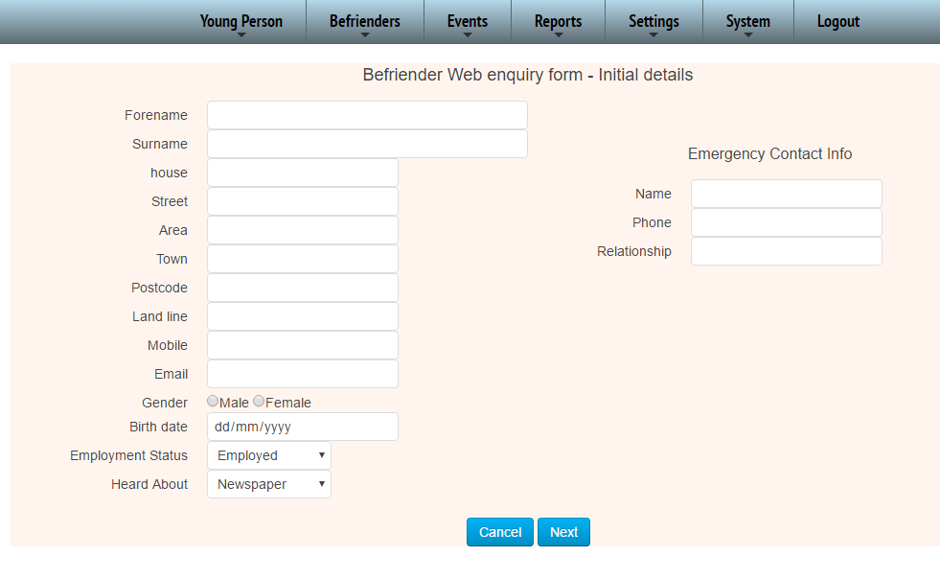

… and a few questions…
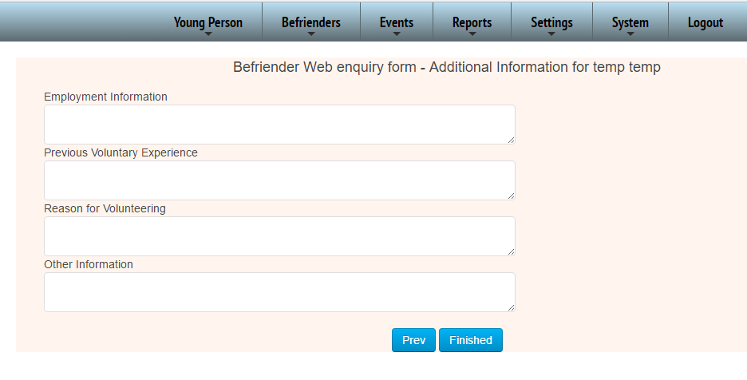
These questions can be edited in the Settings section by your System Admin.
If you already have most of the relevant details you can go directly to the ‘New’ button on the ‘Maintenance’ view.

Click on the individual lines to edit an entry. The Details are the main default view, and here you can also see the Match Capacity.
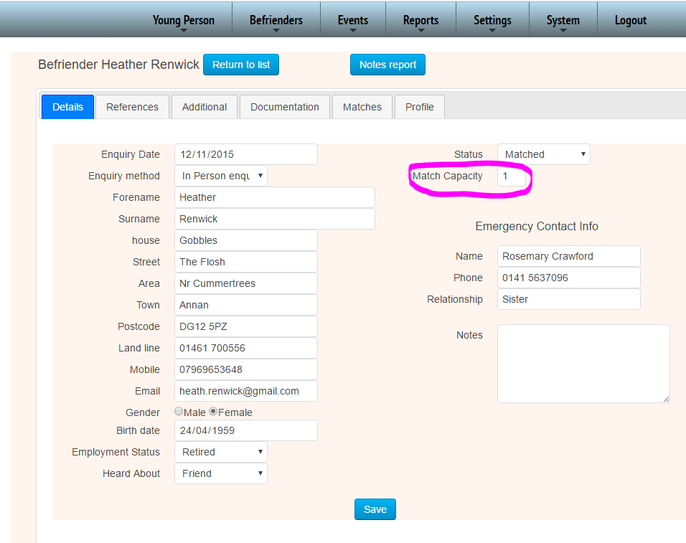
The Match Capacity allows the system to determine if an individual is available, despite the status that has been set. For example if an individual has a capacity of 2 YP and they have one match, they will show up on the list of available Befrienders. If they go on a break, as well as changing the status for the office to easily recognise what status they are actually in you will also need to set the capacity to 0.

The References allow you to upload those details prior to taking the application further…
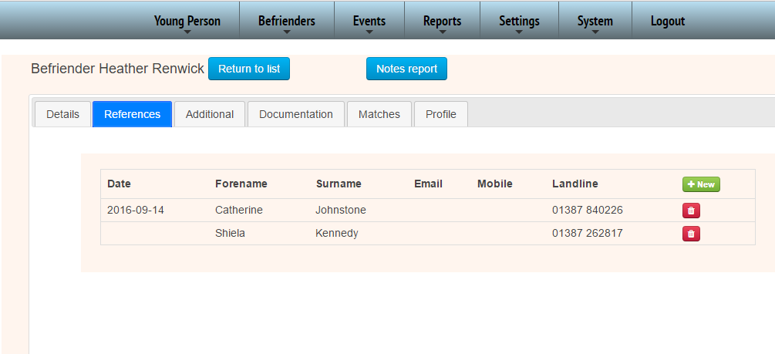
The documentation is the area where you need to have reminders for expiry dates such as an MOT. To view the actual document simply on the relevant PDF link highlighted below.
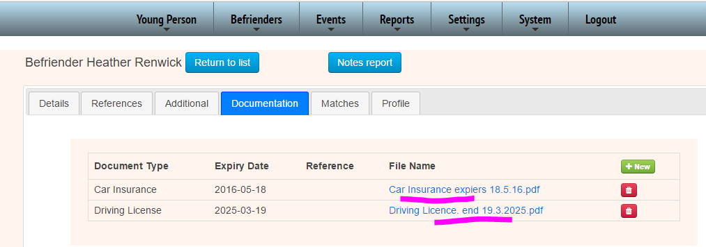
When a document is uploaded in this view the ‘N/A option refers to the expiry. This is to make sure that if a date has been left blank others know if the item is blank specifically because there is no expiry date
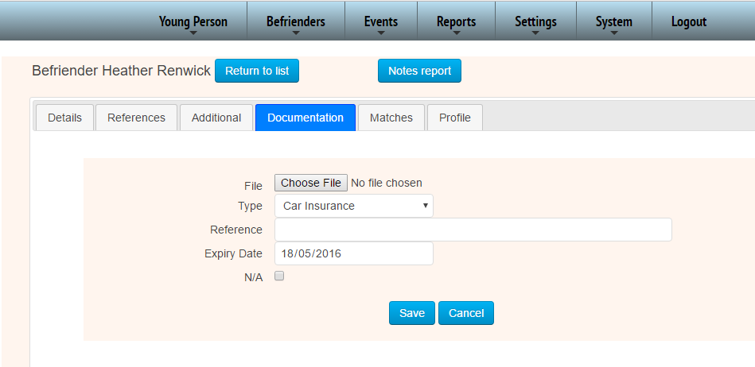

The matches section is only for information and includes their history.
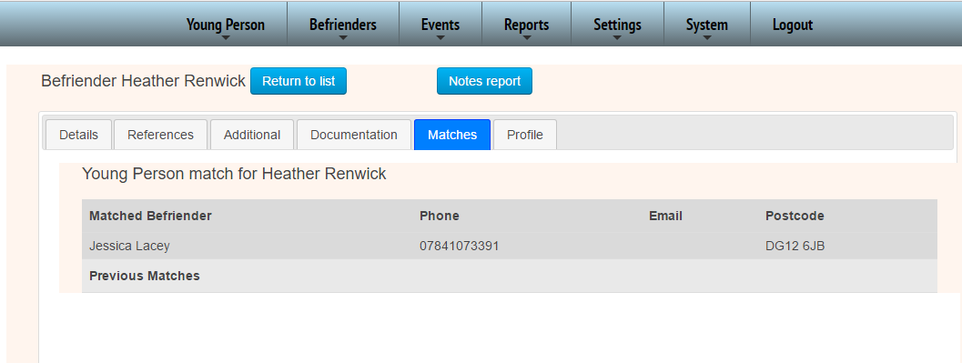
The profile is simply any background info plus their photo for reference.
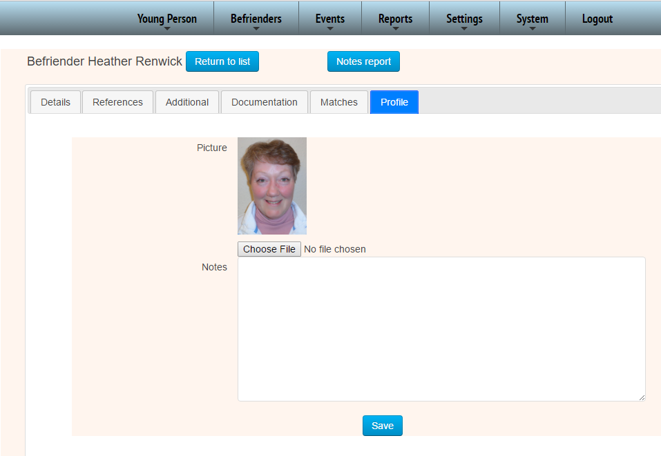
The Notes Report for the BF, is exactly the same as the YPs in that it brings up all event (and meeting) notes for that individual in chronological order for easy reading.

Archiving
Common to both the YP and the BF is the Archiving function where anyone with coordinator or admin access can set the files to Archive, which removes this from general view.
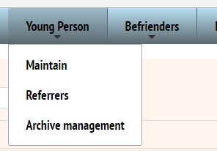
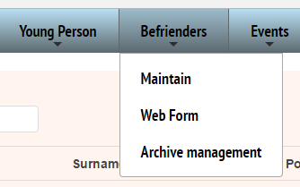
It then sits in an Archive section waiting for approval by the Project Manager.
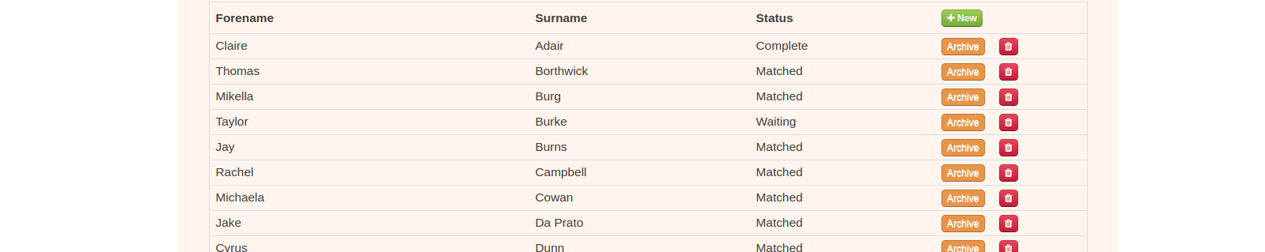
You will see there is a red Archive button next to each BF or YP in the Maintenance views. Once you press this button it will ask you for a reason as to why the person should be removed from the system.
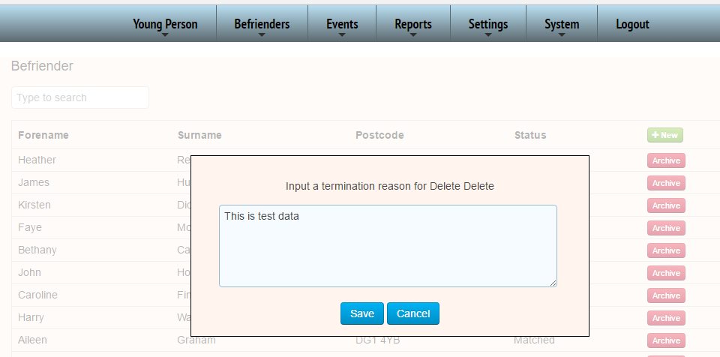

*NB if you Do Not see this box please scroll up to the top of the window, it is probably just out of view.
Once you have pressed Save the record is completely removed from the Maintenance view. But it can be found here in the Archive section and the Project Manager will get an emailed notification that a record has been requested for Archive.
Don’t forget the System Admin sets the number of days to be archived in the System Config page before removal of the file details are completed….
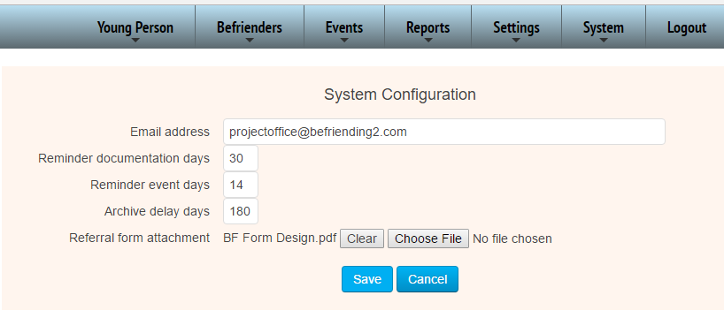
In this case you have 6 months (180) days before archive.
Events
Events as far as the Database is concerned is anything that prompts an action that requires an action on a particular date… such as a meeting. The term Event has been used because it does not always have to be a meeting, just a date or time sensitive action that needs to be recorded, and the System Admin is able to set up what these events are in the Events Type page.
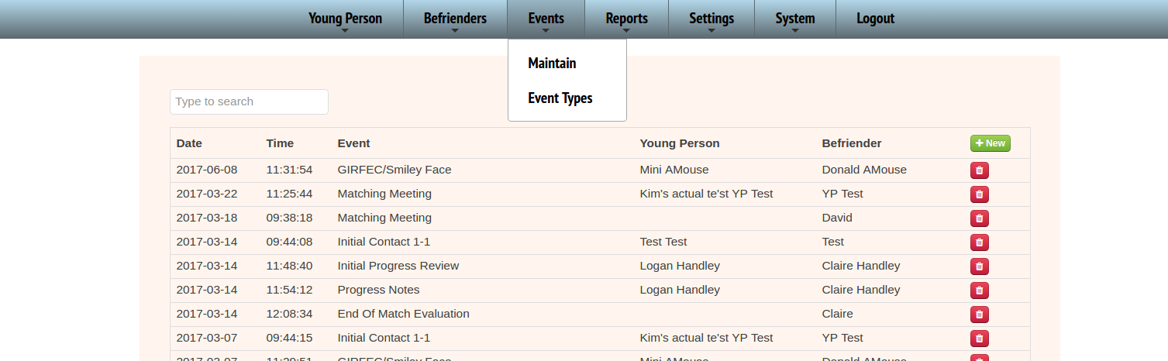
In the Maintenance view, which you see above you can enter a new event either before or after the event has taken place.If you create an event before time you are able to send out invites to the meeting for a YP, otherwise you are able to mark who was in attendance from the YP’s contact list.

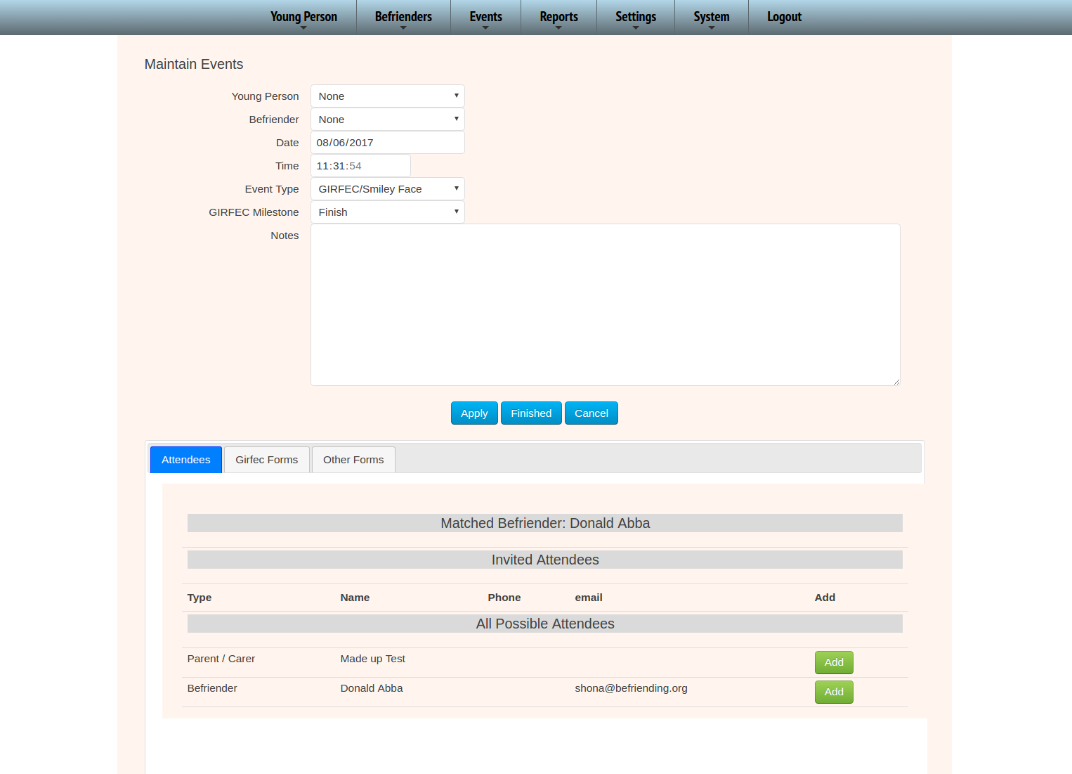
As discussed with the forms for the Young Person, it is in the events that you upload your relevant documents and forms as the event happens, remembering to put in some meaningful notes in the ‘Notes’ Section which can be referred back to at a later date.

Settings
The Settings are all similarly operated
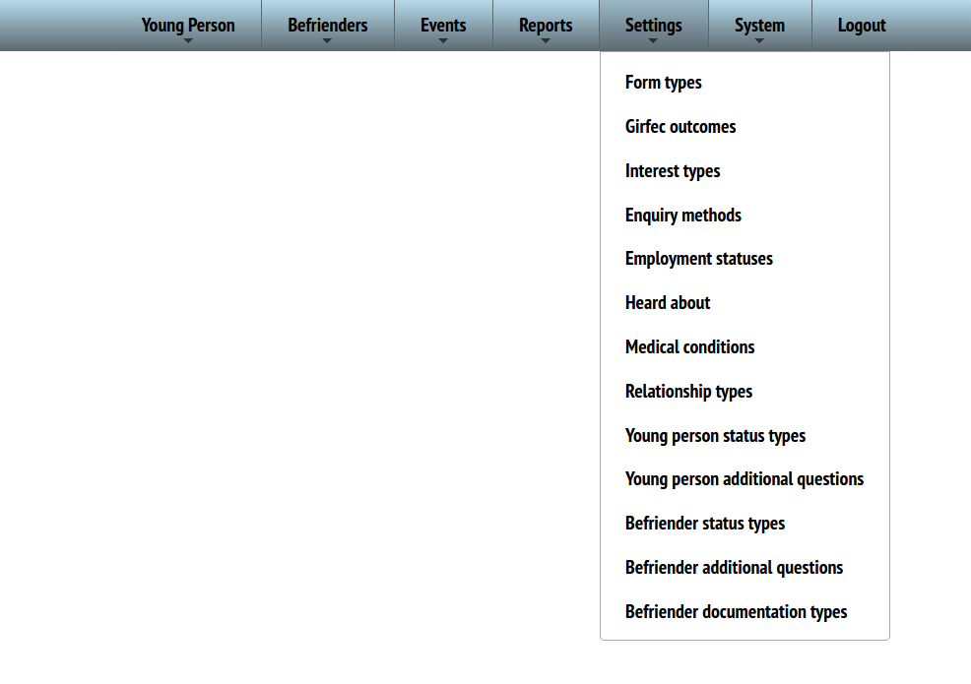
They are a list of options that you can add to and edit. This will possibly only be accessible by your System Admin.

Edits and Additions are extremely easy, to Add simply press the green button, to Edit simply type over the existing text
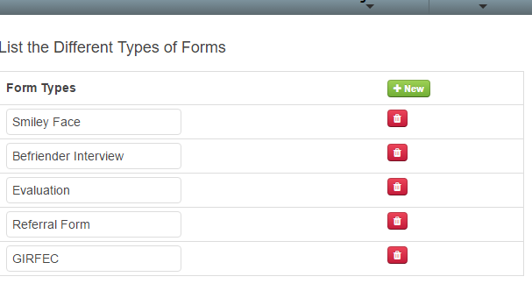
However if you are editing remember the system doesn’t know the meaning of the phrases. It just displays the phrases as you type them. So if you had an option for example over Documentation Types called MOT and then you changed it to something completely different such as ‘Fishing Licence’, anything previously marked with a date against MOT would now show that date against the Fishing License… so use your edits with care. If you do want to change the meaning entirely you need to make sure the data it was using now makes sense in the relevant area,
If you try to remove or delete an item the system will only allow the removal if there is no other data tied to the option. Say for example you decided to remove the above example of a Fishing Licence but there was dates for a befriender against it, you won’t be allowed to delete it.
If it was a brand new item and there was no information within that category, the system will allow you to delete it. This will allow you to delete those you have created by mistake but not delete used and established items.

System
In the System section you are able to add new users in the Users page and then assign what screen they are able to access in the User Menus.
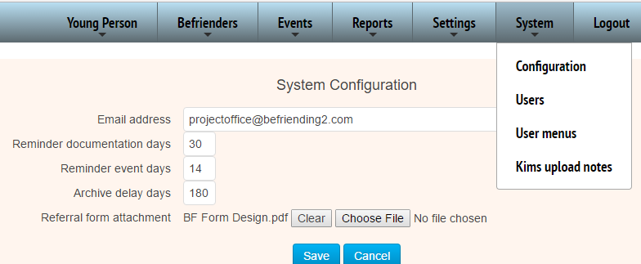
When you click on the Users you get this view…
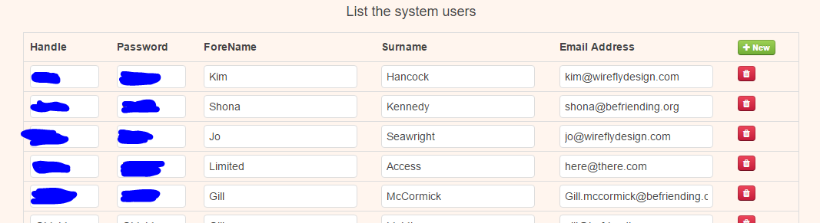
… where you can assign any new users their password etc, or remove users.
Don’t forget to click the finish button at the bottom to save your changes. There is no menu to this view so that you don't accidentally navigate away without saving.

Once you have a new user log in details set up you cane then head to User Menus to give them the required access…
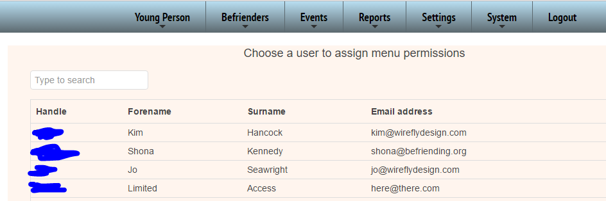
Here we can see the test ‘Limited’ account with access to only certain levels….
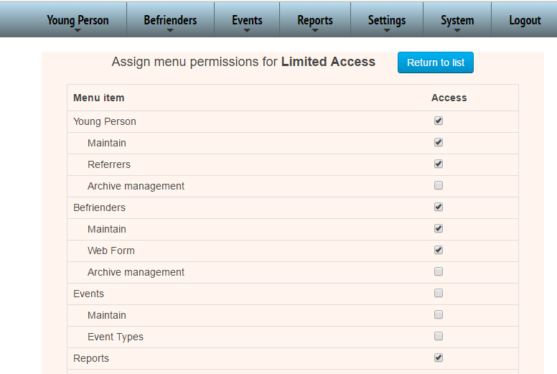

Server Setup

Installation of the Befriending software on a Linux server

Prerequisites
A configured and working LAMP environment with build_essentials. This software has been developed and tested on Ubuntu 14.04 LTS but should run fine on any Linux variant.

Install
Unzip the distribution file into a temporary location (eg /tmp)
Copy the public_html/jam directory to your website document root (usually public_html)
Copy the public_html/.htaccess file to your website document root, or APPEND to yours if the file already exists.

Configure Apache
Insert the following directive into the /etc/apache2/sites-available/yourwebsite.conf configuration file, substituting 'yourwebsite' with your own. This assigns CGI access permissions.

<Directory /path/to/your/public_html/jam>
AddHandler cgi-script .cgi
allow from all
Options -Indexes +SymLinksifOwnerMatch +ExecCGI
AllowOverride All Options=ExecCGI, Includes, IncludesNOEXEC, Indexes, MultiViews, SymLinksIfOwnerMatch
</Directory>

Configure MySql
Import the database from the supplied befriending_wireflydesign_com.sql. The format is standard mysqldump.

That should be it, barring perhaps a dependency which you can install via your package manager. The Befriending database should now be ready for use. Test with a browser at 'http://yourwebsite/run/menu'. This should not affect the normal running of your website.

Directories and files
All paths listed are relative to the website Document Root.

.htaccess Access rights and convenience mapping
/jam Container for the Befriending Database
/jam/cgi System entry point via Apache server
/jam/css Basic styling for user forms
/jam/doc Documentation and worksheets
/jam/sys Program binaries and non application-specific scripts
/jam/sys/extern Open source components this system was built with
/jam/run Templates used to generate browser content
/jam/run/html Javascript / css / html sent to browsers
/jam/uploads All user-uploaded content here. Images, Word docs, other.

