TourneyKeeper

Manual

V1.7

Contents

1 Document history 2

2 What is TourneyKeeper? 3

3 Creating your username and password 4

4 Creating a tournament 5

5 Editing a tournament 8

6 Adding players to a tournament 10

6.1 Self-registration 10

6.2 Signed in by an organizer 11

7 Singles tournament 12

7.1 Create pairings 12

7.2 Enter results 13

7.3 Ranking 14

7.4 ITC Export 14

8 Team tournament 16

8.1 Managing teams 16

8.2 Joining a team 18

8.3 Create pairings 19

8.4 Enter results 20

9 Scoring app 21

# Document history

|  |  |  |
| --- | --- | --- |
| **Version** | **Date** | **Comments** |
| 1.1 | 8 May 2014 | New document, offline not yet documented |
| 1.2 | 30 August 2014 | Offline removed, options to switch players, clubs |
| 1.3 | 8 October 2015 | Major revision |
| 1.4 | 20 February 2016 | Minor fixes |
| 1.5 | 8 October 2017 | Updated on the app  Settings are fixed |
| 1.6 | 27 February 2018 | Payment via Stripe |
| 1.7 | 27 September 2019 | Major overhaul to fit the new design |

# What is TourneyKeeper?

TourneyKeeper is several things:

* A tool for running tabletop tournaments
* A centralized database for players to view a history of their previous results
* Self-service for admins and players during a tournament
* Runs on any browser
* Offers an android app for scoring
* Supports:
  + Age of Sigmar
  + Bolt Action
  + Flames Of War
  + Infinity
  + Kill Team
  + Kings of war
  + Malifaux
  + Middle Earth Strategy Battle Game
  + The 9th Age
  + Warhammer 40K
  + Warhammer Fantasy
  + Warhammer Underworlds
  + Warmachine / Hordes
  + Warzone Resurrection
  + X-Wing

You can visit the website here: <http://tourneykeeper.net>

The app is downloadable from Google Play as usual: <https://play.google.com/store/apps/details?id=tourneykeeper.tourneykeeper&rdid=tourneykeeper.tourneykeeper>

TourneyKeeper is designed as an online application, meaning that it communicates with a centralized server using the internet.

TourneyKeeper is free to use. See later in this document for how to create your own login.

# Creating your username and password

Visit [Tourneykeeper.net](http://tourneykeeper.net/) and click Login / Create user.

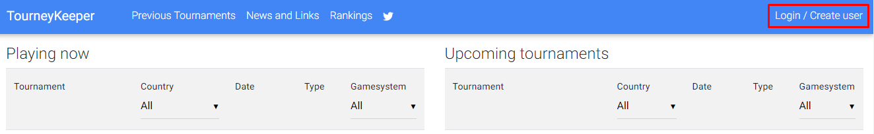

Fill out the and click Register.

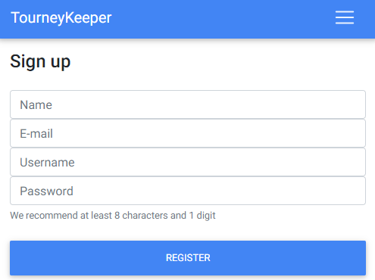

This login can be used to create your own tournaments as an organizer, and it can be used to sign up for tournaments as a player.

# Creating a tournament

When logged in you can then create your own tournament. First click on your name.

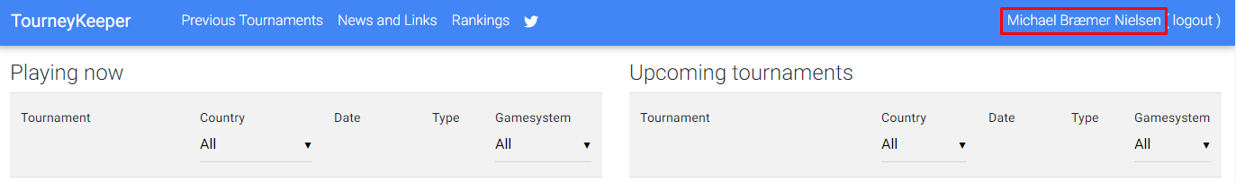

You can then see your personal area where you can create and edit your tournaments, set up your army lists and see your previous games. Click Create Tournament

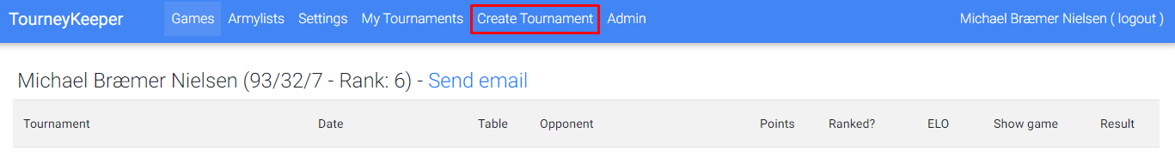

Now you can enter data for the tournament you want to create. The information is split into logical sections as shown. First is the Basic information, such as the name of the tournament:

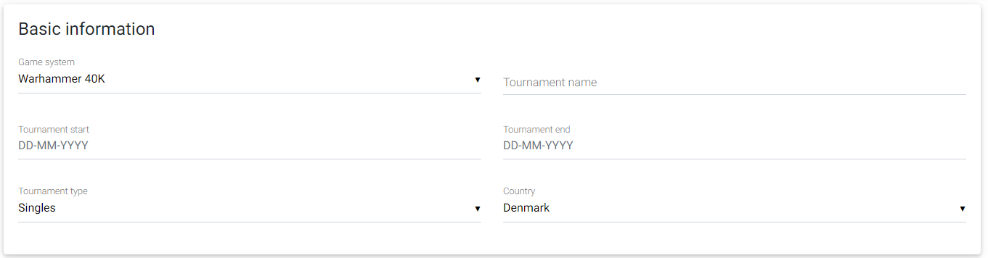

Depending on the tournament type selected, you are either prompted for input for singles or team settings:

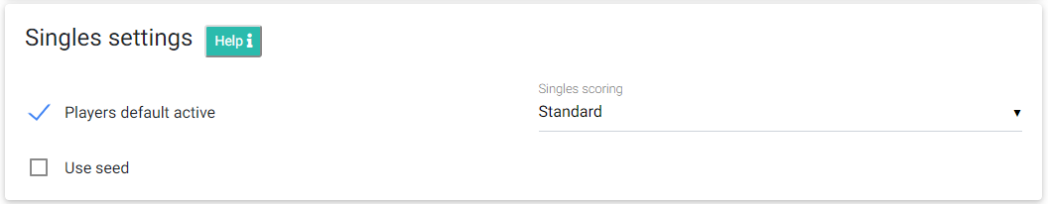

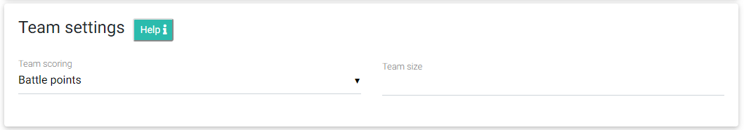

Then follows miscellaneous options:

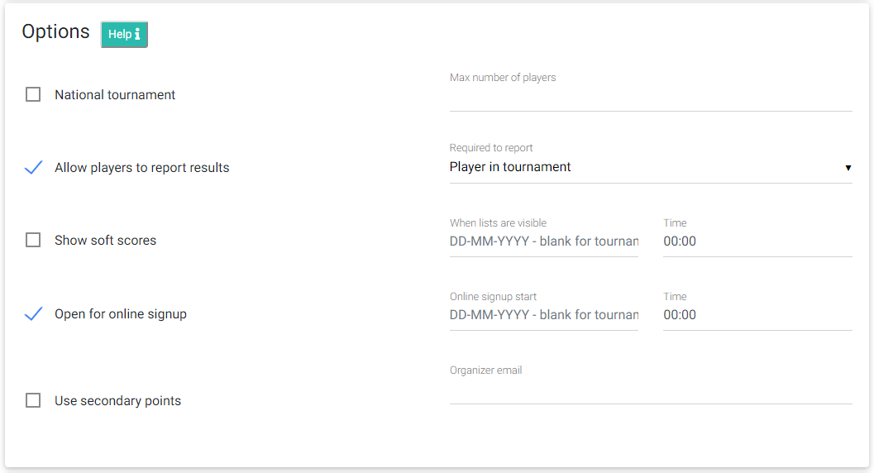

Lastly is about, please leave it not selected if you are not using it. Selecting it and not filling it in will result in a blank page as your frontpage for your tournament. About could leave useful information, such as the time table, links to army selection or whatever you choose.

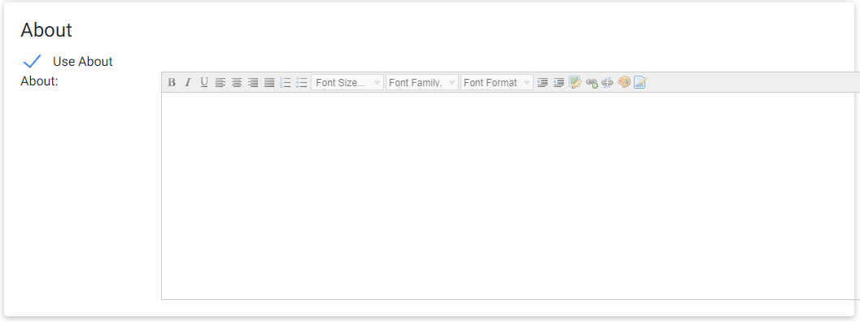

Each field is explained in the following table.

|  |  |
| --- | --- |
| **Field** | **Usage** |
| Game system | A wide range of options, please contact me if your system is not represented here. |
| Tournament type | Possible options:   * Singles * Team |
| Tournament name | Name of the tournament, name must be unique |
| Tournament start | Start date of the tournament |
| Tournament end | End date of the tournament |
| Country | The country where the tournament is played |
| Active | If unselected, the tournament is not shown on the website. |
| Team size  (Team only) | Number of players for each team, only used for team tournaments |
| Team scoring  (Team only) | Possible options:   * Battle points (default) Straight up scoring using battle points * Battlefront scoring * Cutoff Ruleset used for 9th Age ETC, with the addition of writing in your own caps. Meaning that a match with 160 points and the caps set at 60 and 100 will enforce the scores at a minimum of 60 points and a maximum of 100 points. * Max Ruleset used for Warhammer 40K ETC, with the addition of writing in your own caps. Meaning that a match with 160 points and the caps set at 74 and 86 will award 2 points for a team getting 86 or more points, 1 point for a team getting more than 74 points and 0 points for a team getting 74 points or less. * X-Wing 5-1 MAX |
| Singles scoring  (Singles only) | Possible options:   * Standard (default) Battle points (and soft scores if used) are used for pairing and deciding who wins * ITC Wins, draws, losses and secondarily battle points are used for pairing and deciding who wins. Soft scores are not added to the total score. It also opens up for exporting the results – see section 8.4. |
| Players Default Active (Singles only) | This is the default value players will be assigned when signing up for a tournament. **This is important as only active players will be used for pairing.** You can use this as a check for players showing up and you can use it for signaling that players have dropped out and will not be used for further pairings. |
| Use seed (Singles only) | Seeding will be used, lowest score is highest seed. |
| National tournament | Tournaments will only be visible to players from the same country as the tournament. |
| Allow players to report results | If selected, then players will be able to self-register for the latest round for the tournament. |
| Show soft scores | Must be selected for soft scores to be shown and added to a player’s total. Used to keep the excitement alive until after an award ceremony. |
| Open for online sign up | If selected, then players will be able to self-register for the tournament. |
| Use secondary points | Can be used to track secondary points from games, used for e.g. small points in Flames of War or victory points for Warhammer 40K |
| Max number of players | Maximum players allowed. Any player trying to sign up after the maximum number of players has signed up will not be allowed to sign up. |
| Required to report | Possible options:   * Player in tournament (default) A player must be signed up for the tournament to report a score * Player in game A player must be a player in the game to report a score |
| When lists are visible | Lists will only be visible after this date |
| Online sign up start | Online sign up will only be possible after the selected time has been passed, a timer will be shown until the time has passed. |
| Organizer Email | If filled in, will show this at the bottom of all pages connected to this tournament. |
| Use About | If selected will show the text entered on a frontpage for the tournament, where you can enter whatever information you like about your tournament, including links and images. |

# Editing a tournament

You can edit a tournament by visiting your personal area and clicking on the tournament you want to edit under My Tournaments.

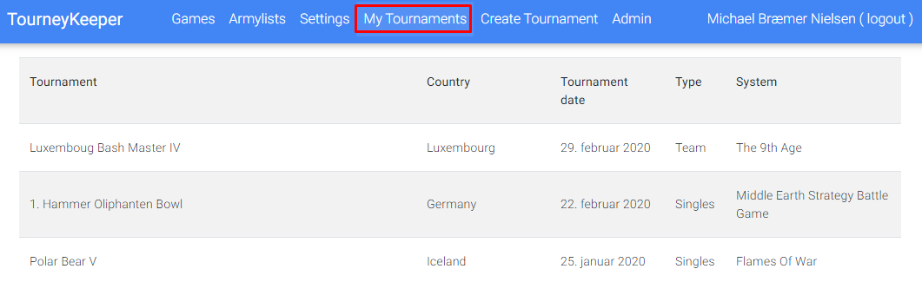

All fields are then available for edit.

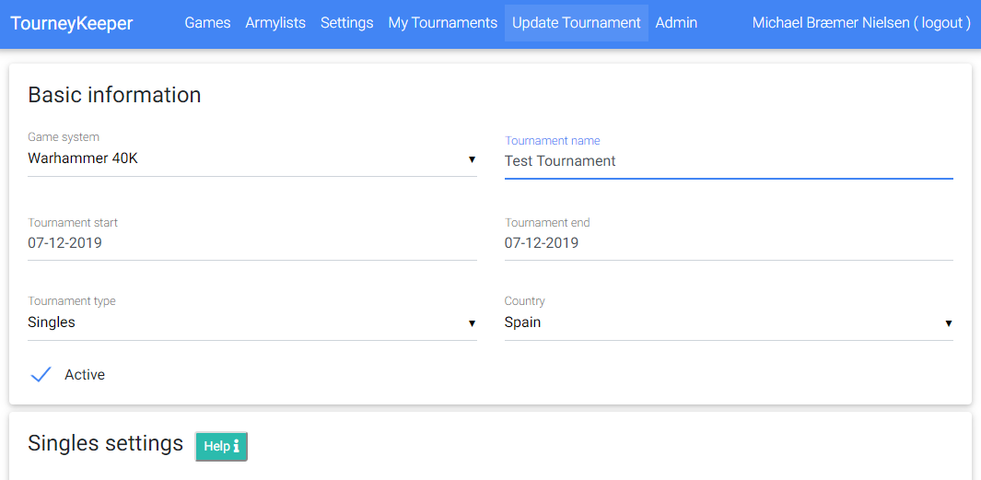

# Adding players to a tournament

There are two ways a player can join a tournament:

1. Self-registration
2. Signed in by an organizer

Each of these are described in the following sections.

## Self-registration

In order for a player to self-register he has to:

1. Login on the website
2. Open the tournament he wants to join
3. Click Sign up! As shown below

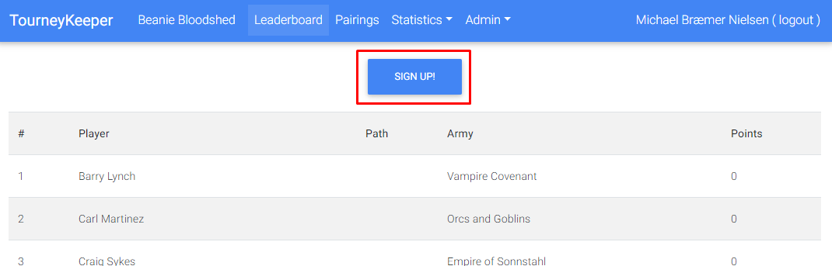

The player will be presented with the option of selecting the codices he will play, this can also be filled out later.

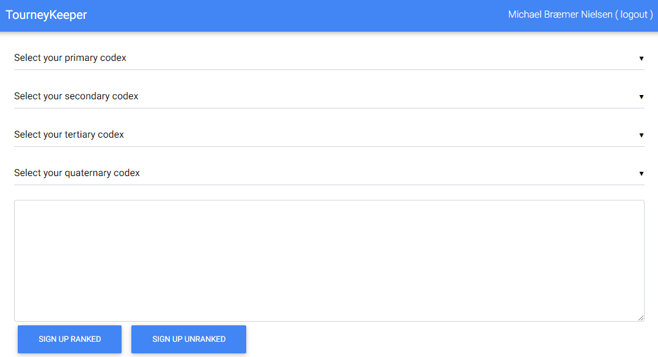

## Signed in by an organizer

For the organizer to register a player to a tournament, he has to:

1. Login on the website
2. Open the tournament he wants to add players to
3. Click Admin->Players

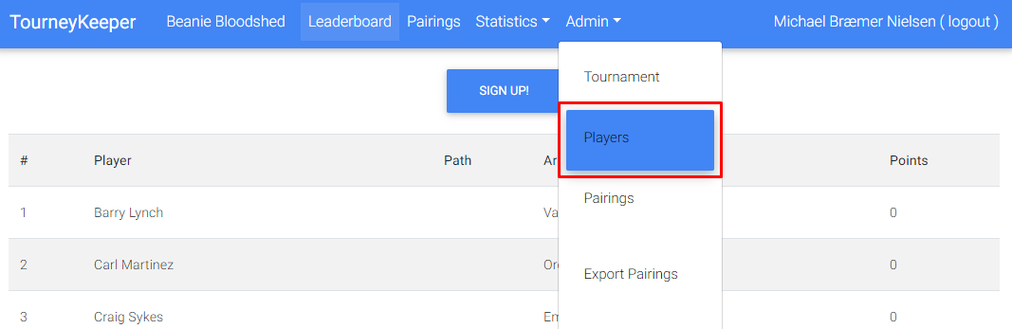

Click Add player and find the player you want to add to the tournament. Note that the player has to have been created prior to this.

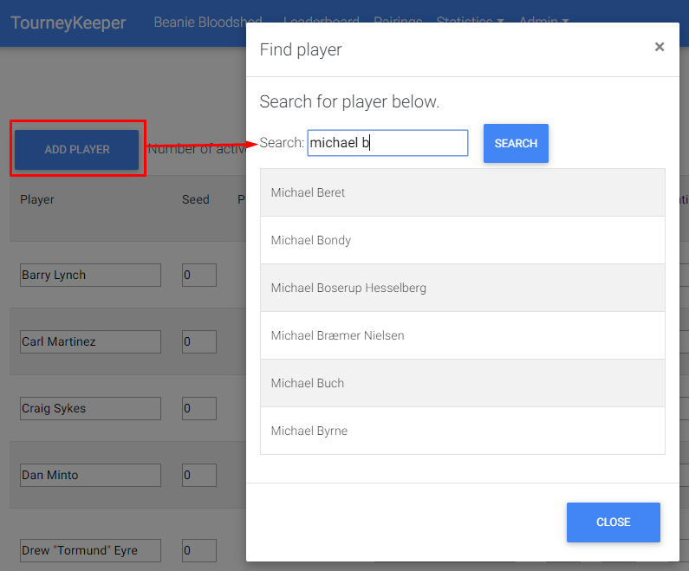

# Singles tournament

At this point you should have all players signed in for the tournament.

## Create pairings

An organizer can create pairings by visiting Admin->Pairings:

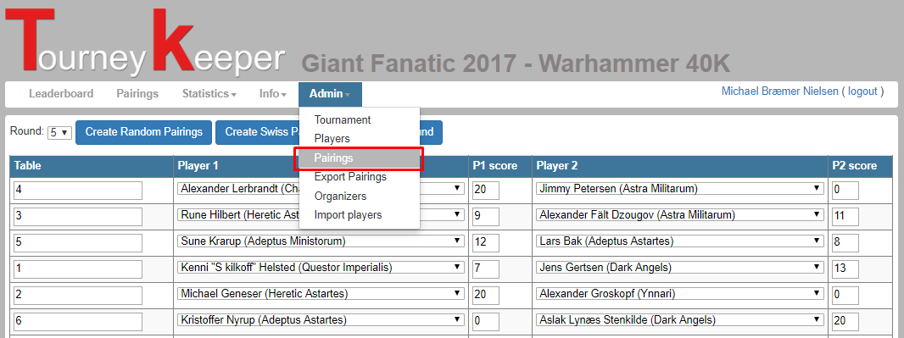

You have 2 options for creating pairings:

* Random pairings  
  Players are randomly paired
* Swiss pairings  
  Player are paired using the swiss draw system.

Pairings can be changed in two ways, either swapping players or editing games. I recommend swapping players. You swap players by selecting the players to be swapped in the drop down and click Swap players as shown.

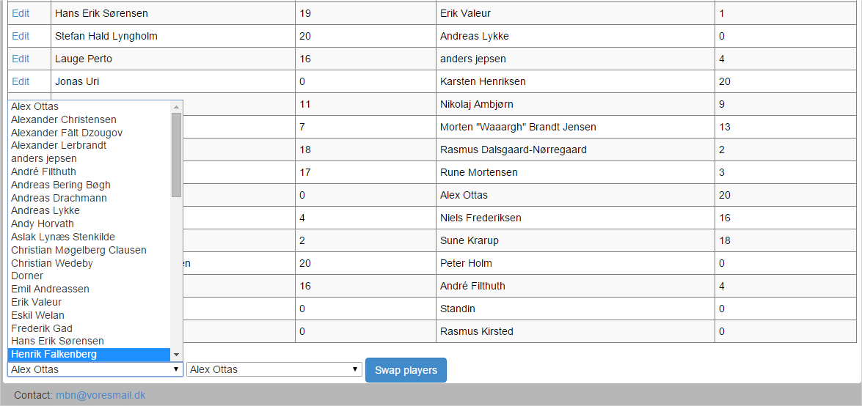

## Enter results

Results are then entered by visiting Pairings, finding your game and clicking Results, here you can enter the results of the game. This can be done by players if Allow players to enter results is selected and by organizers.

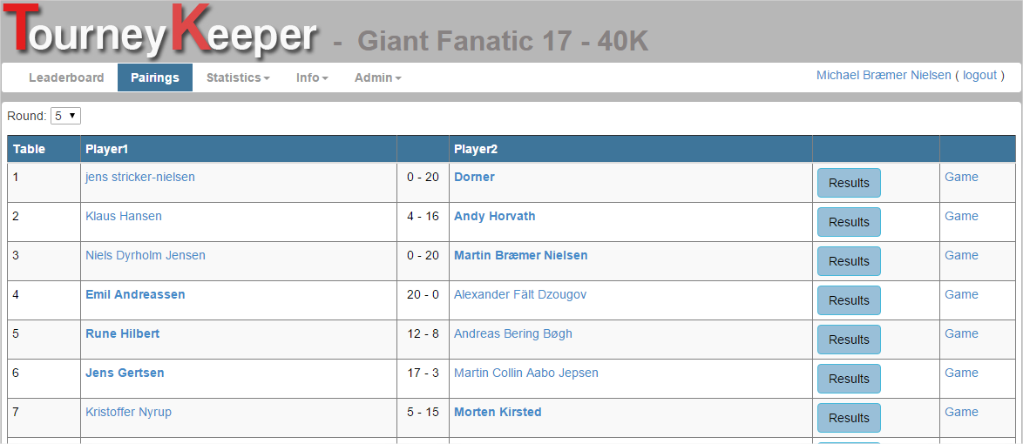

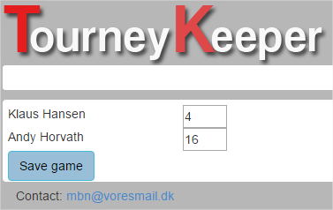

## Ranking

After finishing the tournament, you can contact me and I will perform ranking for the tournament. If your country doesn’t have a ranking, I will create one for you. All results will be added to an international ranking.

Only singles tournaments are ranked.

## ITC Export

When finished playing an ITC tournament, you can easily export the results to the ITC TO Scoring Template (<https://drive.google.com/file/d/0ByVzaY23LOX-S0JWZGF4c2xHbGM/view>), just follow the guide below.

Open the export function.

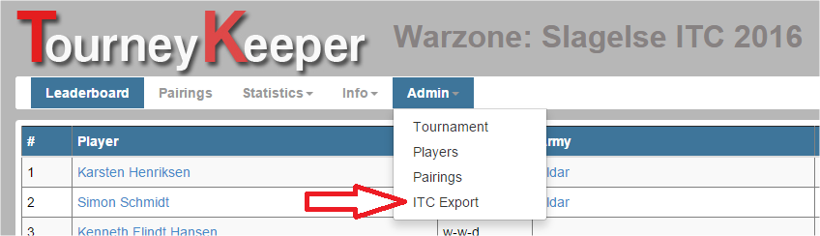

Mark all text in the window as shown and copy to clipboard.

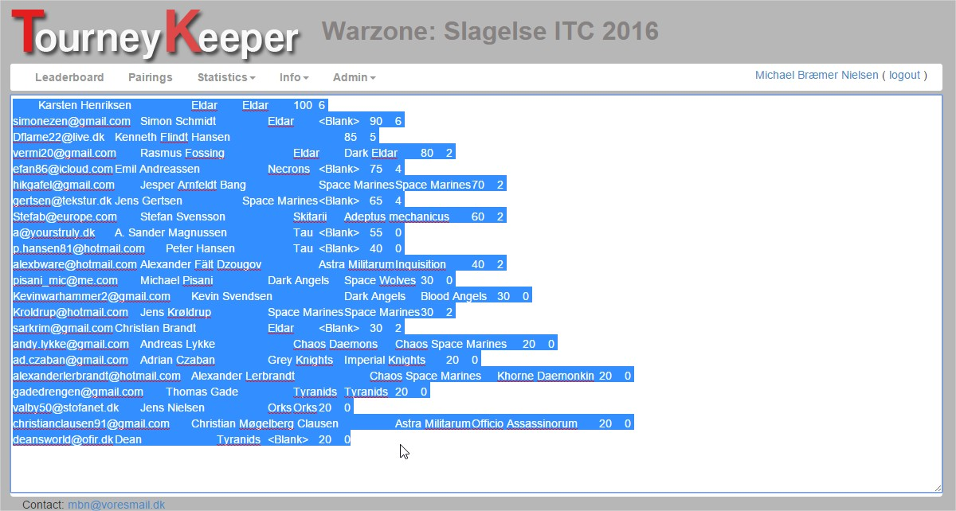

Open the ITC TO Scoring Template and set the cursor as shown.

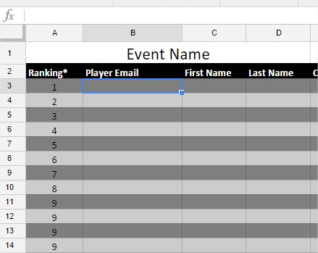

Paste the contents from your clipboard and the sheet will fill out with correct data.

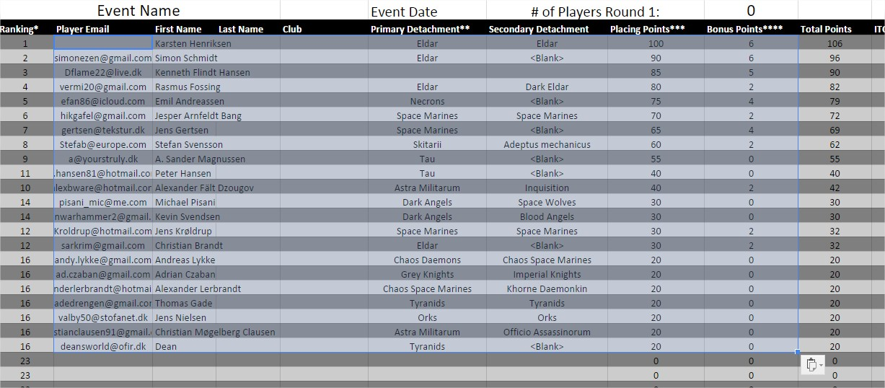

# Team tournament

You can add teams and players independently of each other, I suggest only adding players to teams when the number of players and teams are final.

## Managing teams

An organizer can manage teams by visiting Admin->Teams:

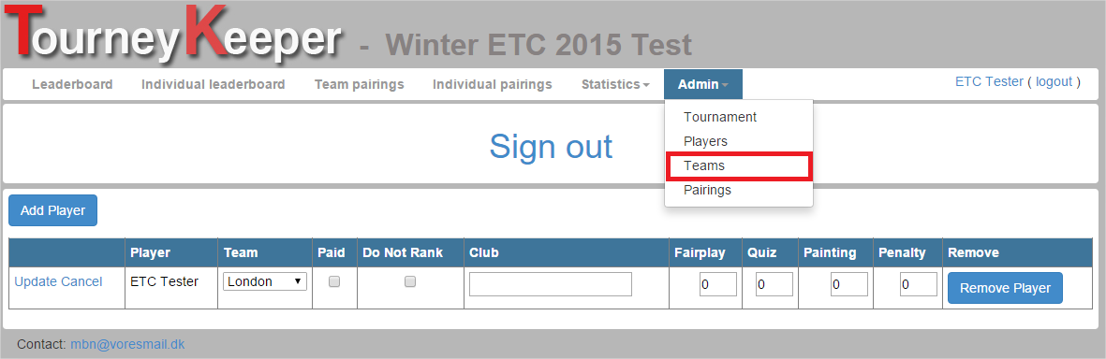

Here the organizer can create, edit and delete teams. The organizer can also get a quick overview of which teams are complete and which are not. The Players column will be green if all players on the team are checked in and red otherwise.

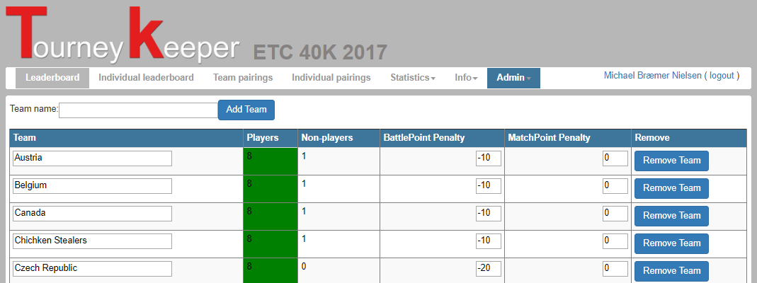

## Joining a team

There are two ways of joining a team:

1. Self-join
2. Joined by an organizer

The player has to be logged in to self-join a team.

When registered to a team tournament, the player can select a team to play for as shown below.

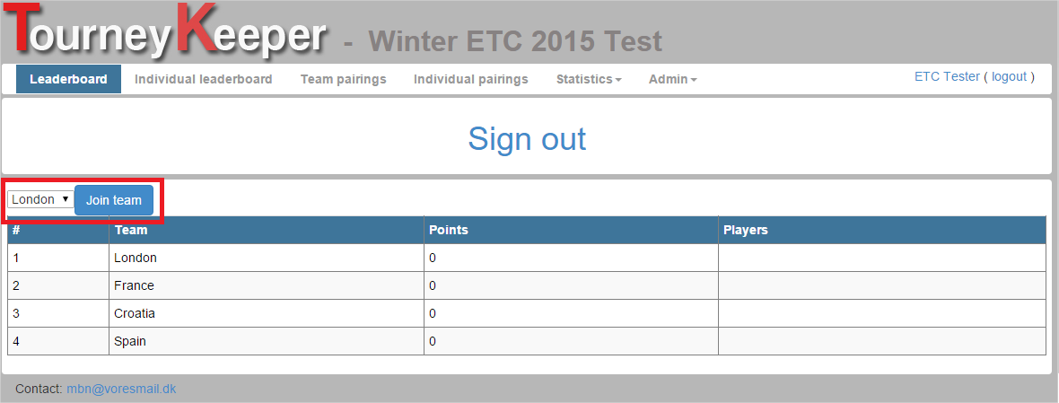

The organizer can join a player to a team by visiting Admin->Players under the tournament. Simply changed the required info, such as selecting a team from the drop down.

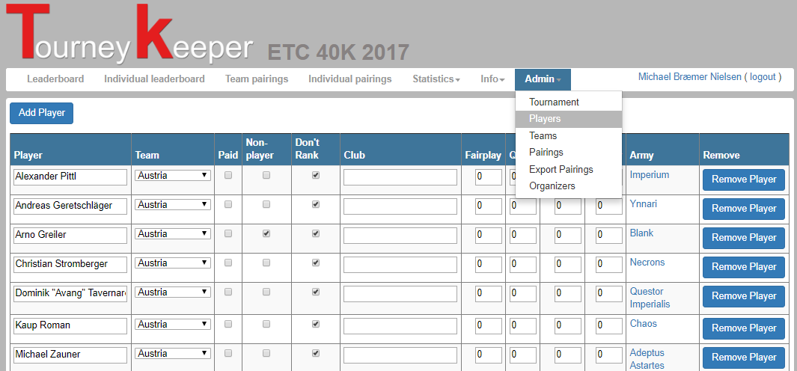

## Create pairings

An organizer can create pairings by visiting Admin->Pairings:

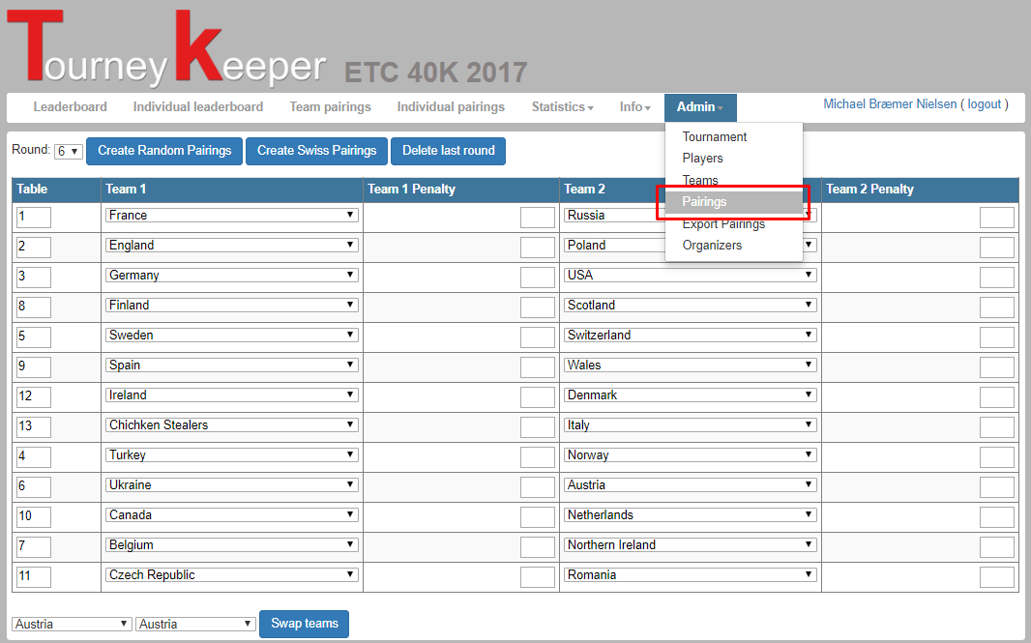

You have 2 options for creating pairings:

* Random pairings  
  Teams are randomly paired
* Swiss pairings  
  Teams are paired using the swiss draw system.

You can change pairings by editing the individual matches and selecting which team should play against which team or swap them using the drop downs at the bottom. Swapping is recommended.

The individual games can then be setup by either the organizer or the players themselves. Visit Team Pairings and then setup the match wanted.

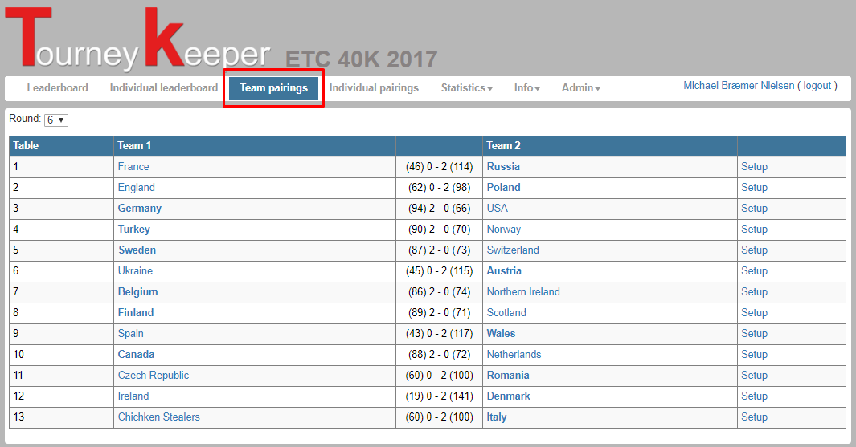

Clicking setup allows you to setup each game.

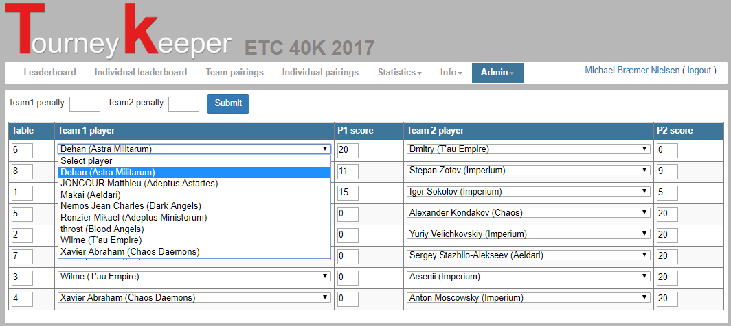

## Enter results

It is required that pairings are setup prior to entering results, as shown in section 9.3. Results are entered as described in section 8.2.

# Scoring app

The app for scoring is available free from Google Play: <https://play.google.com/store/apps/details?id=tourneykeeper.tourneykeeper&rdid=tourneykeeper.tourneykeeper>

The app is solely for scoring, but will notify the player when he has a new game, who his opponent is and which table he is playing on via standard notification.