

## INFORMATION TECHNOLOGY EDUCATION DEPARTMENT

**IOS 102 LAB**

**(Operating Systems Laboratory)**

**<LABORATORY SCHEDULE>**

EXERCISE

8

**How to Write Shell Scripts?**

<STUDENT NAME 1>

<STUDENT NAME 2>

DATE

**Experiment No. 8: How to Write Shell Scripts**

**Objectives:**

In this experiment, the students are expected:

* to know how to write and execute shell scripts
* to create shell scripts using the input/output commands
* to use arithmetic operations in creating shell scripts

**Discussion:**

* **What is a SHELL SCRIPT?**

Shell Script is series of command written in plain text file. Shell script is just like batch file is MS-DOS but have more power than the MS-DOS batch file.

* **Why to WRITE a Shell Script?**

Shell script can take input from user, file and output them on screen.

* Useful to create our own commands.
* Save lots of time.
* To automate some task of day today life.
* System Administration part can be also automated.
* **How to WRITE a Shell Script?**

Following steps are required to write shell script:

* Use any editor like vi or mcedit to write shell script.
* After writing shell script set execute permission for your script as follows:

***Syntax:***

chmod permission your-script-name

***Examples:*** $ chmod +x your-script-name  
 $ chmod 755 your-script-name

**Note:** This will set read write execute(7) permission for owner, for group and other permission is read and execute only(5).

* **How to EXECUTE a Shell Script?**

***Syntax:***

bash your-script-name  
 sh your-script-name  
 ./your-script-name

***Examples:*** bash bar  
 sh bar  
 ./bar

**NOTE:** In the last syntax ./ means current directory, But only . (dot) means execute given command file in current shell without starting the new copy of shell.

* **Variables in SHELL**

To process our data/information, data must be kept in computers RAM memory. RAM memory is divided into small locations, and each location had unique number called memory location/address, which is used to hold our data.

Programmer can give a unique name to this memory location/address called memory variable or variable (It is a named storage location that may take different values, but only one at a time).

In Linux (Shell), there are two types of variable:

***System variables*** - Created and maintained by Linux itself. This type of variable defined in CAPITAL LETTERS.

***User defined variables (UDV)*** - Created and maintained by user. This type of variable defined in lower letters.

**Procedures:**

Perform the following instructions:

* **echo: Output Command**

Now you are ready to write first shell script that will print **"Knowledge is Power“** on screen.

***Syntax:***  $ vi first  
 ***Type:*** # My first shell script  
 clear  
 echo "Knowledge is Power“

***To Save & quit:*** Alt+Shift : wq

After saving the above script, you can run the script as follows:  
 ***Syntax:***  ./first

This will not run script since we have not set execute permission for our script first; to do this type command  
 ***Syntax:*** chmod 755 first  
 ./first

***Output:*** First screen will be clear, then **Knowledge is Power** is printed on screen.

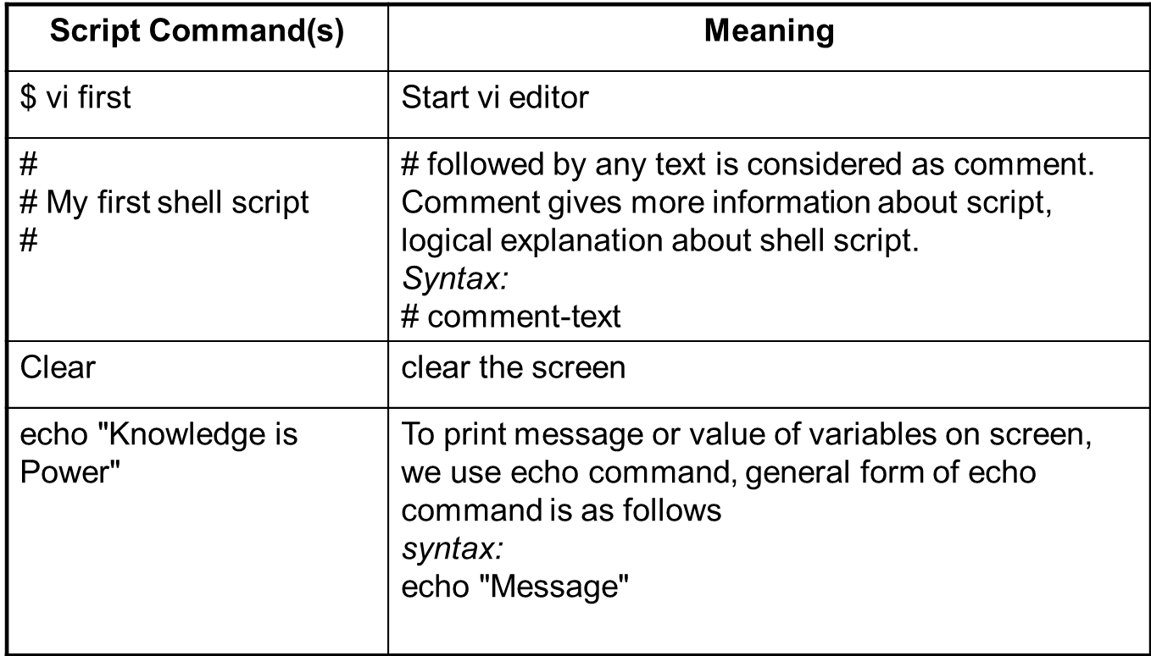

* **Variables in Shell using User Defined Variables**

***Syntax:***  $ vi second  
 ***Type:*** # My second shell script  
 clear  
 x=hello

y=world

echo $x $y

***To Save & quit:*** Alt+Shift : wq

***Change File Permission:*** chmod 755 second

***To Execute:*** ./second

***Output:*** First screen will be clear, then **Hello World** is printed on screen.

* **Shell Arithmetic Operations**

***Syntax:***  expr op1 math-operator op2  
  
 ***Examples:***   
 expr 1 + 3  
 expr 2 - 1  
 expr 10 / 2  
 expr 20 % 3  
 expr 10 \* 3  
 echo `expr 6 + 3`

**Note:**  
expr 20 %3 - Remainder read as 20 mod 3 and remainder is 2.  
expr 10 \* 3 - Multiplication use \* and not * since its wild card.

* **How to create a Shell Script using Arithmetic Operators?**

***Syntax:*** vi sum

***Type:*** echo “Enter 1st number: “

read x

echo “Enter 2nd number: “

read y

echo “The sum of $x and $y is” `expr $x + $y`

***To Save & Exit:*** *A*lt+Shift: wq

***Change File Permission:*** chmod 755 second

***To Execute:*** ./sum

***Output:* Enter 1st number: 5**

**Enter 2nd number: 2**

**The sum of 5 and 2 is 7**

**Supplementary Problems:**

* Write a shell script that will ask for student name, student number, three (3) subject names, Prelim, Midterm and Final Grade for each subject. Computer for the average of each subject and Total Average of the 3 subjects’ average.

**Answers:**

|  |
| --- |
| **Codes**  (Paste your captured codes below) |
|  |

|  |
| --- |
| **Sample Output**  Paste your captured output/s below. |
|  |