Web Services DYNAMIC CLIENT

Guide

USAGE RESTRICTED ACCORDING TO LICENSE AGREEMENT.
Version: 2.1
Last update: 20-Ago-2010.
Authors: Enrico Scagliotti, Giovanni Caire

Copyright (C) 2009 Telecom Italia

JADE - Java Agent DEvelopment Framework is a framework to develop multi-agent systems in compliance with the FIPA specifications. JADE successfully passed the 1st FIPA interoperability test in Seoul (Jan. 99) and the 2nd FIPA interoperability test in London (Apr. 01).
Copyright (C) 2000 CSELT S.p.A. (C) 2001 TILab S.p.A. (C) 2002 TILab S.p.A. (C) 2003 TILab S.p.A.
(C) 2004 TILab S.p.A (C) 2005 TILab S.p.A
This library is free software; you can redistribute it and/or modify it under the terms of the GNU Lesser General Public License as published by the Free Software Foundation, version 2.1 of the License.
This library is distributed in the hope that it will be useful, but WITHOUT ANY WARRANTY; without even the implied warranty of MERCHANTABILITY or FITNESS FOR A PARTICULAR PURPOSE. See the GNU Lesser General Public License for more details.
You should have received a copy of the GNU Lesser General Public License along with this library; if not, write to the Free Software Foundation, Inc., 59 Temple Place - Suite 330, Boston, MA 02111-1307, USA.

TABLE OF CONTENTS
1 Introduction 3
1.1 Compliance to standards 3
1.2 Compatibility 3
1.3 Requirements 3
1.4 Installation 4
2 DYNAMIC WEB SERVICE INVOCATION - BASICS 4
2.1 Initialization 4
2.2 Invocation 5
2.3 Structured parameters 6
3 Dynamic Web Service Invocation - Advanced 7
3.1 Headers 7
3.2 Proxy 7
3.3 Security 8
3.4 Caching 10
4 READING WSDL informations 11
5 DYNAMIC CLIENT SHELL 11
6 APPENDIX I. Description of the examples 13
7 Appendix II. WSDC configuration properties 14
8 Appendix III. Current limitations 15

Introduction

This document describes the Web Services Dynamic Client (WSDC) add-on that provides support for dynamically invoking web services. Unlike the majority of web service oriented tools in facts WSDC allows invoking web services operations without the need of generating new classes. Furthermore it provides a simple and intuitive API to inspect services described by a WSDL (Web Service Description Language) retrieving for instance available operations as well as names and types of parameters.
Though WSDC belongs to the JADE software suite and requires the Jade library to be in the classpath, developers don’t need to be familiar with JADE to use it.
This document only provides an overview of the main usages of the WSDC add-on. Refer to the Javadoc for a complete description of the API.

All bugs, issues, contributions and new feature requirements should be posted to the main JADE bug reporting system, and to the standard JADE mailing lists.
Version 2.1 of the WSDC add-on was developed by the JADE Team and is only guaranteed to work with JADE release 4.0.1 or later.

Compliance to standards
The WSDL service description language defines different binding styles (rpc and document) and uses (encoded and literal). WSDC supports the most commonly adopted combinations:
- rpc/encoded according to W3C standards (http://www.w3c.org)
- document/literal according to W3C standards (http://www.w3c.org)
- document/literal wrapped in compliance to the WS-I basic profile specification (http://www.ws-i.org).
All Date fields are encoded according to the ISO-8601 format.

Compatibility
WSDC 1.0 and later has been successfully tested with web services developed using AXIS 1.4 (http://ws.apache.org/axis) and 2.0 (http://ws.apache.org/axis2) and CXF 2.0 (http://cxf.apache.org) .

Requirements
The WSDC add-on requires Java JRE v5.0 (http://java.sun.com/javase/) or later, JADE v4.0.1 or later and the JADE misc add-on v2.1 or later. Furthermore the WSDC makes use of the following third party libraries already included in the WSDC distribution:
- Apache Axis v1.4 (http://ws.apache.org/axis/)
- Apache Commons (http://jakarta.apache.org/commons/)
- WSDL4J v1.6.2 (http://sourceforge.net/projects/wsdl4j)

Installation
The WSDC add-on does NOT require any installation. To use it from within a Java application it is sufficient to add all jar files included in the lib directory of the add-on and the JADE jar files to the application classpath.
To recompile the add-on, as usual for JADE add-ons, the distribution zip file must be unzipped into the home directory of the JADE installation so that to obtain a directory structure as below.
<jade-home>/
|--add-ons/
|--dynamicClient/
After that the lib ANT target can be used to recompile the add-on and re-create its jar file.

DYNAMIC WEB SERVICE INVOCATION - BASICS
As mentioned WSDC allows invoking web services without the need of generating new classes such as stubs, and beans representing complex data types. Developers are simply required to create a jade.webservice.dynamicClient.DynamicClient object, initialize it specifying the URI of the WSDL describing the target service, and call the invoke() method as exemplified in the following sections.

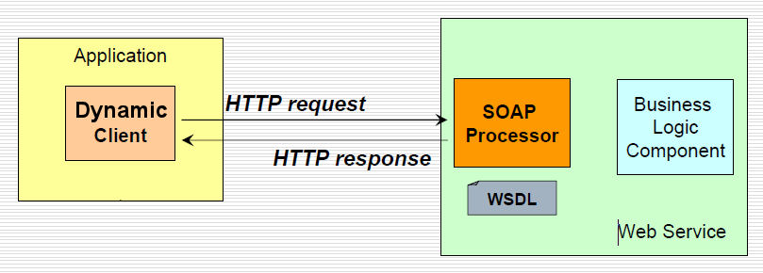

Initialization
The following code snippet show how to create a DynamicClient object and initialize it. The WSDL URI can point to both a resource in the network or a file in the file system (e.g. file:c:/foo/bar/myWsdl).

DynamicClient dc = new DynamicClient();
dc.initClient(new URI("http://localhost/MathFunctionsPort?wsdl"));

It should be noticed that the initClient() method requires the indicated URI to be reachable and may take a while (a few seconds) as the WSDL must be retrieved and parsed and WSDC must initialize all the internal data structures that will be used at invocation time.
In some cases, to properly deal with WSDL adopting particular forms or to force the WSDC to meet specific requirements, it is necessary/possible to modify the WSDC default configuration properties. This can be done by passing a properly configured DynamicClientPropertis object to the DynamicClient before invoking the initClient() method as exemplified below

DynamicClientProperties customProps = new DynamicClientProperties();
customProps.setNoWrap(true);
……
dc.setProperties(customProps);
dc.initClient(…..);

Parameters that can be configured are described in Appendix I.

Invocation
The following code snippet shows how to invoke a web service.

// Initialize input parameters
WSData input = new WSData();
input.setParameter("firstElement", 5);
input.setParameter("secondElement", 3);

// Invoke the sum operation
WSData output = dc.invoke("sum", input);

// Retrieve output parameters
float sum = output.getParameterFloat("sumReturn");

The invoke() method gets the name of the operation to be invoked and an instance of the WSData class that holds the input parameters if any. The result of the invoke() method is another WSData object that contains the output parameters.
In case the WSDL contains more that one service and/or port the DynamicClient class provides an overloaded version of the invoke() method that allows specifying them as shown below.

WSData output = dc.invoke(“myService”, “myPort”, “sum”, null, -1, input);

The above method also allows specifying a timeout for the invocation and an end-point different than that indicated in the WSDL.

Structured parameters
As shown in previous section, the WSData class allows dealing with un-structured parameters such as String, Date, int, boolean and so on directly. Values of complex parameters whose structure is defined by XSD schemas, must be handled using so called Abstract Descriptor classes. Abstract descriptor classes are part of the JADE core distribution and belong to the jade.content.abs package. It should be noticed however that WSDC users do not need to be familiar with JADE to use them. Furthermore, while the jade.content.abs package contains several Abstract Descriptor classes WSDC users only need to deal with three of them:
- AbsConcept - An Abstract Descriptor representing a complex data whose structure is described by an XSD schema
- AbsAggregate - An Abstract Descriptor representing a sequence of values
- AbsObject - The common base class for all Abstract Descriptors.
The following code snippet shows how to use Abstract Descriptors to manage values of structured parameters. More details on Abstract Descriptor classes can be found in the “Tutorial on Content Languages and Ontologies” (http://jade.tilab.com/doc/tutorials/CLOntoSupport.pdf) available on the JADE web site.

WSDL input data definition:

<xsd:complexType name="complex">
<xsd:sequence>
<xsd:element name="real" type="xsd:float"/>
<xsd:element name="imaginary" type="xsd:float"/>
</xsd:sequence>
</xsd:complexType>
……
<xsd:element name="sumComplex">
<xsd:complexType>
<xsd:sequence>
<xsd:element name="firstComplexElement" type="impl:complex"/>
<xsd:element name="secondComplexElement" type="impl:complex"/>
</xsd:sequence>
</xsd:complexType>
</xsd:element>

DynamicClient code to set input parameters:

WSData input = new WSData();
AbsConcept first = new AbsConcept("complex");
first.set("real", 4);
first.set("imaginary", 5);
input.setParameter("firstComplexElement", first);
....
input.setParameter("secondComplexElement", second);
....
WSData output = dc.invoke("sumComplex", input);
AbsConcept sum = (AbsConcept) output.getParameter("sumComplexReturn");
float real = sum.getFloat("real");
float imaginary = sum.getFloat("imaginary");

Dynamic Web Service Invocation - Advanced

Headers
Besides parameters, a web service operation may include “headers”. Headers are basically additional parameters that are carried inside the header of a SOAP request/response instead of in the body. In general headers are used to specify additional information not strictly related to the semantics of an operation such a as the credentials (username and password) required to invoke it.
The WSData class allows managing parameters and headers homogeneously: while the
void setParameter(<parameter-name>, < parameter-value>)
AbsObject getParameter(<parameter-name>)
String getParameterString(<parameter-name>),
int getParameterInteger(<parameter-name>),
boolean getParameterBoolean(<parameter-name>)
...
methods are available to manage parameters, the
void setHeader(<header-name>, <header-value>)
AbsObject getHeader(<header-name>)
String getHeaderString(<header-name>)
integer getHeaderInteger(<header-name>)
boolean getHeaderBoolean(<header-name>)
...
methods are available to manage headers.

Proxy
In many cases both the access to a WSDL (at DynamicClient initialization time) and the actual web service invocation require passing through an HTTP Proxy. The DynamicClient class provides the following methods to set proxy information.
- setProxyHost(<host>): Set the proxy host (e.g. 163.162.10.12)
- setProxyPort(<port>): Set the proxy port (e.g. 8080)
- setNonProxyHosts(<listOfAddresses>): Set a list of addresses (possibly including ‘*’) that will be accessed without using the proxy. The separator is the ‘|’ character
- setProxyAuthentication(<user>, <password>): Set the credentials (if any) required to access the proxy
The following code snipped provides an example.

dc.setProxyHost(“10.12.175.14”);
dc.setProxyPort(“8080”);

dc.setNonProxyHosts(“163.163.*|*.telecomitalia.it”);
dc.setProxyAuthentication(“myUser”, “myPwd”);
dc.initClient(new URI("http://myWSDL"));

Security
Certain web services require HTTP Basic Authentication. The DynamicClient class provides the following methods to set HTTP related information.
- setDefaultHttpUsername(): Specifies the http username used in all requests.
- setDefaultHttpPassword(): Specifies the http password used in all requests.
The following code snipped provides an example.

dc.setDefaultHttpUsername(“MyHttpUsername”);
dc.setDefaultHttpPassword(“MyHttpPassword”);

If the credential of HTTP Basic Authentication are different in all requests is possible specify them in invoke(…) method with SecurityProperties object.
Instead, if the credential of HTTP Basic Authentication are different for the WSDL discovery is possible specify them in initClient(…) method.
The following code snipped provides an example.

dc.initClient(new URI("http://myWSDL"), “MyHttpUsername”, “MyHttpUsername”);

Other web services require WS-Security Username Token. The DynamicClient class provides the following methods to set WSS related information.
- setDefaultWSSUsername(): Specifies the wss username used in all requests.
- setDefaultWSSPassword(): Specifies the wss password used in all requests.
- setDefaultWSSPasswordType(): Specifies the wss password type used in all requests (TEXT or DIGEST, see SecurityProperties object).
The following code snipped provides an example.

dc.setDefaultWSSUsername(“MyWSSUsername”);
dc.setDefaultWSSPassword(“MyWSSPassword”);
dc.setDefaultWSSPasswordType(SecurityProperties.PW_TEXT);

If the credential of WS-Security Username Token are different in all requests is possible specify them in invoke(…) method with SecurityProperties object.
Other web services require WS-Security Timestamp. The DynamicClient class provides the following method to set WSS related information.
- setDefaultWSSTimeToLive(): Specifies the wss request time to live (in second) used in all requests.
The following code snipped provides an example.

dc.setDefaultWSSTimeToLive(60);

If the credential of WS-Security Timestamp are different in all requests is possible specify them in invoke(…) method with SecurityProperties object.
Other web services require SSL connections with or without certificates. The DynamicClient class provides the following methods to set SSL related information.
- enableCertificateChecking(): Enables the certificates checking mechanism. When this mechanism is enabled (the default situation) a trust store holding certificates of trusted remote servers must be indicated (see the setTrustStore() method).
- disableCertificateChecking(): Disables the certificate checking mechanism.
- setTrustStore(<file.keystore>): Specifies the keystore holding certificates of trusted remote servers
- setTrustStorePassword(<password>): Specifies the password used to protect the keystore of trusted certificates
The following code snipped provides an example.

dc.setTrustStore(“C:/myFolder/cert.keystore”);
dc.setTrustStorePassword(“myPassword”);
dc.initClient(new URI("http://myWSDL"));

Caching
Considering that the initialization of a DynamicClient (initClient() method) is a long operation that may take some seconds, a good approach is to create a single DynamicClient instance for each WSDL and reuse it whenever an operation of a service described in that WSDL must be invoked (note that the invoke() methods of the DynamicClient class are thread safe and therefore can be called by two or more threads in parallel). In order to facilitate this practice the WSDC provides a class called DynamicClientCache that manages all issues related to creation, initialization and caching of DynamicClient objects in a thread safe mode. The DynamicClientCache class follows the singleton pattern and therefore the first step when using it is to retrieve the singleton DynamicClientCache instance by means of the getInstance() method.
The following code snippet shows how to use the DynamicClientCache class.
DynamicClientCache dcc = DynamicClientCache.getInstance();
DynamicClient client = dcc.get(new URI("http://myWSDL"));
……
WSData output = client.invoke(“sum”, input);

The get() method of the DynamicClientCache class first checks if a DynamicClient object was already created to access the given WSDL and returns it in that case. Only if no DynamicClient object is already available a new one is created and initialized.

READING WSDL informations
Besides invoking web service operations, the WSDC add-on also provides a simple and intuitive API to read WSDL information such as which operations are there in a service and which parameters they have. The following code snippet shows an example where the names, types and descriptions of the input parameters of the sumComplex operation of the mathService service exposed at port https are retrieved.
DynamicClient dc = new DynamicClient();
dc.initClient(new URI("http://localhost/MathFunctionsPort?wsdl"));
ServiceInfo si = dc.getService("mathService");
PortInfo pi = si.getPort("https");
OperationInfo oi = pi.getOperation("sumComplex");
Set<String> parNames = oi.getInputParameterNames();
for (String name : parNames) {
ParameterInfo par = oi.getParameter(name);
TermSchema schema = par.getSchema();
String description = par.getDocumentation();
System.out.println(name+": type = "+schema.getTypeName()+
", description = "+description);
}

It should be noticed that parameter types are described using JADE ontological schemas. Refer to the “Tutorial on Content Languages and Ontologies” (http://jade.tilab.com/doc/tutorials/CLOntoSupport.pdf) available on the JADE web site for details about ontological schemas.

DYNAMIC CLIENT SHELL

In the bin directory of the WSDC add-on is available a simple command line shell. The shell allows you to browse the wsdl informations and generate the java code to invoke operations.
To start the shell use DynamicClientShell command, the scripts are available for Linux (.sh) and Windows (.bat).
Its use is very simple: just specify the url of the wsdl and the possible options in case for instance the access to the wsdl is secured or must occur through an http proxy.
DynamicClientShell wsdl [options]

Options:
-wsdl-http-username <http basic authentication username to discover wsdl>
-wsdl-http-password <http basic authentication password to discover wsdl>
-http-username <http basic authentication username to invoke service>
-http-password <http basic authentication password to invoke service>
-wss-username <WS-Security username token profile>
-wss-password <WS-Security password token profile>
-wss-password-type <WS-Security password type token profile> (default: PasswordText)
-wss-must-understand <WS-Security must understand flag> (true/false)
-wss-time-to-live <WS-Security-Timestamp, LifeTime in seconds>
-proxy-host <proxy host>
-proxy-port <proxy port>
-proxy-username <proxy username>
-proxy-password <proxy password>
-ssl-trust-store <SSL trust store file>
-ssl-trust-store-password <SSL trust store password>
-ssl-disable
-endpoint <endpoint url to invoke services if different from that included in the wSDL>
-timeout <invokation timeout in ms> (0 = no timeout)

Example of navigation through the wsdl informations of MathFunction web-service (see appendix I).

DynamicClientShell http://localhost:2000/axis/services/MathFunctionsPort?wsdl

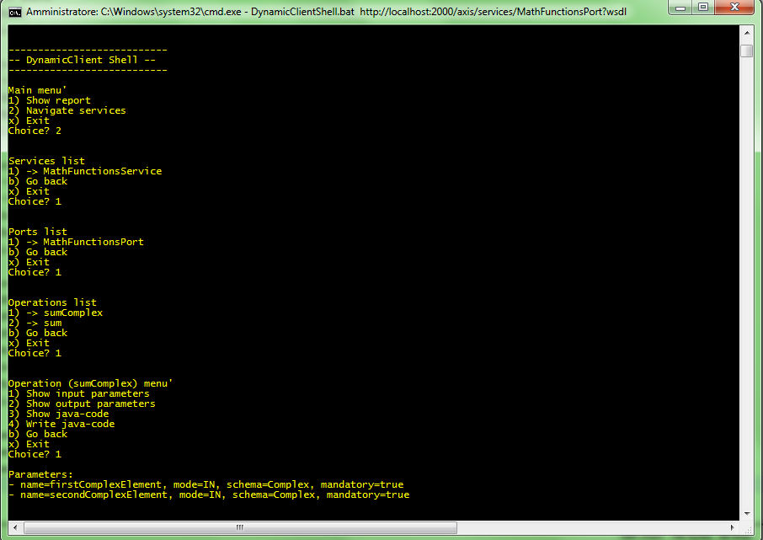

Example of java code to invoking the sumComplex operation.

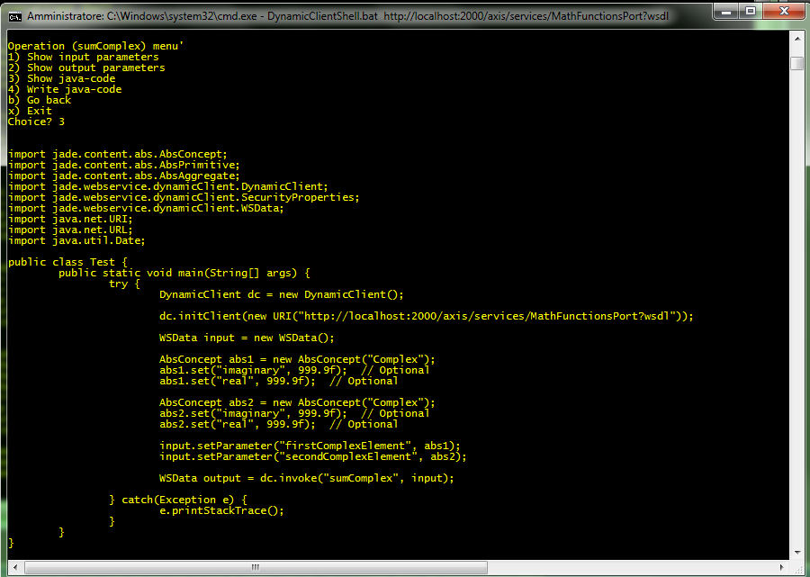

The shell also allows you to write into the file "Test.java" the class of test that can be compiled and executed using the command ExecuteTest.
The scripts ExecuteTest are available for Linux (.sh) and Windows (.bat) and is available in the lib directory.

APPENDIX I. Description of the examples

In the examples/client directory of the WSDC add-on a simple example is available showing how to use the DynamicClient class to invoke web services. A “micro-web server” (included in the examples/server directory) is also provided exposing two mathematical operations that are invoked by the example. In order to try the example it is sufficient to start the server by means of the startMathServer script and then to launch the client by means of the startMathClient script. Both scripts are included in the examples directory and are available for Linux (.sh) and Windows (.bat).

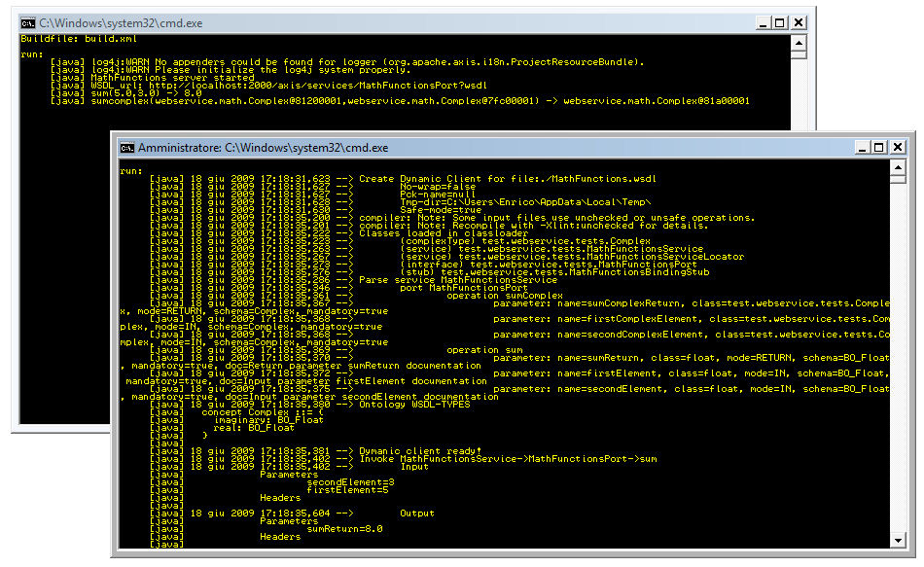

Appendix II. WSDC configuration properties
The following table summarizes the configuration properties that can be passed to a DynamicClient object before initialization.
Parameter | Type | Description | Default value
noWrap | boolean | Disables the automatic de-wrapping of parameters. | false
safeMode | boolean | In case a Document Literal WSDL does not appear to comply to the Wrapped convention, the noWrap mode is forced | true
packageName | string | Specify the java package for classes generated under the hood by WSDC and later used in the invocation phase | -
tmpDir | string | WSDC requires a temporary directory with R/W right sto work properly | System-property  java.io.tmpdir
classPath | StringBuilder | Specify an ad-hoc classpath for the compilation of the classes generated under the hood by WSDC and later used in the invocation phase | -

Appendix III. Current limitations
Version 1.0 of the WSDC add-on has the following known limitations:
- SOAP attachments are not supported
- Not all XSD complex type restrictions are not supported
- Not all XSD/SOAP types are supported

