JADE SHARP CONNector Guide

USAGE RESTRICTED ACCORDING TO LICENSE AGREEMENT.
Last update: 02-March-2007. JADE 3.4.1
Authors: Ennio Grasso (Telecom Italia), Federico Pieri (Reply Cluster), Marco Ughetti (Telecom Italia)

JADE - Java Agent DEvelopment Framework is a framework to develop multi-agent systems in compliance with the FIPA specifications. JADE successfully passed the 1st FIPA interoperability test in Seoul (Jan. 99) and the 2nd FIPA interoperability test in London (Apr. 01).
Copyright (C) 2000 CSELT S.p.A. (C) 2001 TILab S.p.A. (C) 2002 TILab S.p.A. (C) 2003 TILab S.p.A.
(C) 2004 TILab S.p.A (C) 2005 TILab S.p.A
This library is free software; you can redistribute it and/or modify it under the terms of the GNU Lesser General Public License as published by the Free Software Foundation, version 2.1 of the License.
This library is distributed in the hope that it will be useful, but WITHOUT ANY WARRANTY; without even the implied warranty of MERCHANTABILITY or FITNESS FOR A PARTICULAR PURPOSE. See the GNU Lesser General Public License for more details.
You should have received a copy of the GNU Lesser General Public License along with this library; if not, write to the Free Software Foundation, Inc., 59 Temple Place - Suite 330, Boston, MA 02111-1307, USA.

TABLE OF CONTENTS

Introduction
This document describes the rationale behind the Jade Sharp Connector Add-On and how to install, configure and use it.
The JADE SHARP (version 1.0) is a JADE add-on that comes as a .NET DLL (specifically developed for the Windows Mobile Environment), that provides support for connecting to a remote JADE Platform using the JICP protocol stack (JadeLeap protocol stack) and exchanging ACLMessage with Jade Agent. This release should be treated as a beta that is subject to change at any time.
The main body of this guide focuses on the process of starting and configuring the JADE SHARP Connector in order to connect to a running JADE platform. A dummy application (a sort of Dummy Agent) is also provided. Please refer to the xxdoc for a complete description of the APIs that allow programmatic access to all features.
All bugs, issues and feature requests should be made to the main JADE bug reporting system, or sent to the standard JADE mailing lists.
Version x.y of the Jade Sharp add-on was developed by the JADE Board and is only guaranteed to work with JadeLeap release 3.4.1 or later.

Target Audience
This document is intended for JADE users who are interested in connecting their agent applications with a .NET Compact Framework (Windows Mobile) application residing outside the JADE platform. The reader is assumed to be familiar with JADE. For those new to JADE we strongly recommend first reading the JADE Administrators Guide and Programmers Guide or the JADE Programming Tutorial, available on the JADE web site (http://jade.tilab.com).

Rationale
The Jade Sharp Add On has been thought as a library working on .NET Compact Framework (from version 1.0) useful to add to a .NET Windows Mobile Application the capability to connect to a remote JADE platform (based on JadeLeap). The aim is then to add to the Windows Mobile platform some JADE capabilities, particularly the ability to send and receive ACLMessage to/from agents running on a remote JADE Platform.

Current limitations
Version 1.0 of the Jade Sharp add-on as described in this document still has some limitations:
- The Jade Sharp Add-On doesn’t support ontologies but only Frames (both Ordered and Qualified).

Contact
All issues regarding the JADE SHARP should be addressed to the jade-develop mailing list.

JADE SHARP Files
The Jade Sharp Add-On comes with the typical directory structure:
- doc: containing this document and the API documentation
- lib: containing the JadeSharp dll already compiled for .NET Compact Framework 1.0
- src: containing the following files:
  - source files of JadeSharp.dll in directory JadeSharp
  - source files of Dummy Client in directory DummySharp
  - Visual Studio project and solution files

How to use THE JADE SHARP
This section provides instructions of how to set, configure and use the JADE SHARP. These instructions are related to configure, start and use the DummyClient in the Visual Studio environment with the . NET Compact Framework Device Emulator.

Building Configuring and Starting the JADE SHARP
The Visual Studio 2003-2005 installation with C# package is required.
The following steps are needed:
- Double click on Visual Studio slolution file: JadeSharp.sln
- Modify the in the app.properties file the host and port properties
- Build the projetcs (F5 shortcut) and deploy in the emulator
- Start a Jade Platform (using JadeLeap.jar) on localhost or on a remote one with the BEManagementService and optionally (in order to use the sniffer Agent) the NotificationService. The port where the BEManagementService is listening must be the same configured in app.properties file of DummySharp project.
- Start the Jade Sharp Connector clicking on MyDevice\Prtogram Files\dummysharp\dummysharp.exe on the emulator.

Uou should see a windows form emulating the Dummy Agent GUI as in Figure 1.

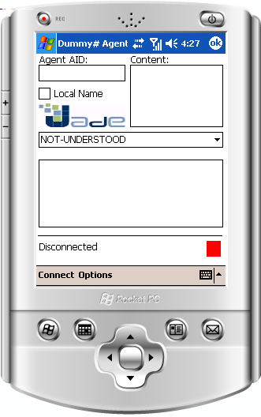
Figure 1: DummySharp Agent Emulator GUI.

Testing the JADE SHARP
In order to test the JadeSharp connector using the DummySharp agent emulator you have to:
- Connect DummySharp to the Jade Platform clicking on the Connect item on the emulator (see Picture 2)
- Start a Dummy Agent on Jade Platform
- Send an ACLMessage to DummySharp connector by DummyAgent and verify that it is received by him.
- Send an ACLMessage to DummyAgent from DummySharp and verify that it is received by him

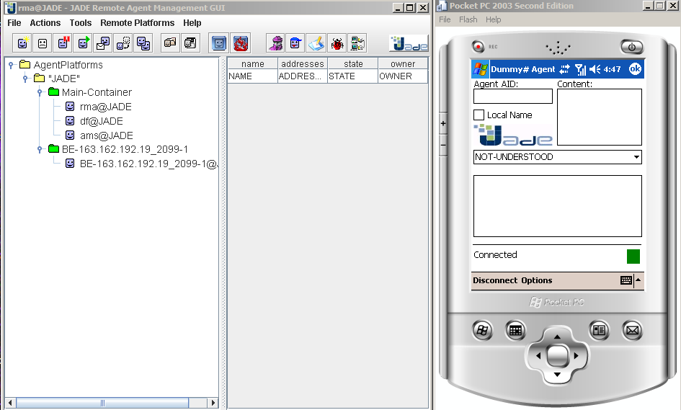
Figure 2: Dummy Sharp Emulator connected to Jade Platform

