Comparison of Female and Male Athletes' Squat Strength Based on Age and Weight
  - Author: Břetislav Kindl

Department of Sociology, Charles University
  - Prague 2024

Abstract
This study examines and compares squat strength across different age and weight categories for male and female athletes in powerlifting, with a specific focus on International Powerlifting Federation (IPF) events. Using a dataset of 22,803 records (7,967 female and 14,836 male). A regression model was employed to analyze the effects of gender, age, and weight on squat performance, controlling for equipment type and event specifics. The findings confirm that, generally, men outperform women in squat strength across most categories. However, in the 60+ age group and the under 52 kg weight category, the gender differences diminish, leading to the rejection of the null hypothesis in most cases but not all. This research provides insights into the factors influencing squat strength, contributing to a better understanding of gender differences in powerlifting.

Table of Contents
Introduction 3
Date cleaning and transformations 3
Analysis 3
Gender, age, weight and squat strength 3
Regression model for squat strength by gender, age and weight 6
Checking model assumptions 6
Analysis 6
Conclusion 7
Appendices 7

Introduction

The main research problem of this work is studying and comparing strength differences amongst male and female athletes in powerlifting disciplines. Specifically, I look for squat strength comparisons for different age and weight categories.

For this work, I specify hypotheses:

H1. Men generally have higher squat results than women in each age and weight category.

In this report, I analyze records of powerlifting competitions specifically limited to IPF (International Powerlifting Federation) events. The age and weights of lifters were recorded at the start of the meet. The value for squat strength is the maximum of the first three successful attempts for the lift.

Date cleaning and transformations

From the analysis, all records of recorded lifts that did not place (e.g., records of lifters that were 'Guest lifter', 'Disqualified', 'Doping', 'No-Show') were removed. Next, all records from events before 21-05-1980 were removed because, before this date, there were no records of female athletes. All records with missing age, weight, or without squat data were also removed.

Variables for age and weight were transformed into custom categories. These categories for ages are "18 - 19", "20 - 23", "24 - 29", "30 - 34", "35 - 39", "40 - 44", "45 - 49", "50 - 54", "55 - 59", and "60 and more". For weight, the categories are "less than 52 kg", "52 kg - 60 kg", "61 kg - 68 kg", "69 kg - 76 kg", "77 kg - 84 kg", "85 kg - 90 kg", and "90 kg and more". The categories for weight were chosen so that there is a representative number of male and female athletes for each category.

Analysis

Gender, Age, Weight and Squat Strength
The data contain 7,967 female and 14,836 male records.
In tables we can see descriptive statistics for age and weight.
Sex | Min. | 1st Qu. | Median | Mean | 3rd Qu. | Max.
Total | 10.5 | 21.5 | 29.5 | 33.4 | 43.5 | 86.5
Men | 13.5 | 22.5 | 30.5 | 34.5 | 44.625 | 86.5
Women | 10.5 | 21.5 | 27.5 | 31.3 | 40.5 | 81.5
Table 1 Descriptive statistics for age
Sex | Min. | 1st Qu. | Median | Mean | 3rd Qu. | Max.
Total | 37.3 | 59.9 | 74.7 | 80.1 | 92.9 | 214
Men | 44.4 | 71.8 | 82.7 | 88.2 | 103 | 214
Women | 37.3 | 51.8 | 60.9 | 65 | 72.6 | 162
Table 2 Descriptive statistics for bodyweight (kg)
Sex | Min. | 1st Qu. | Median | Mean | 3rd Qu. | Max.
Total | 40 | 157.5 | 212.5 | 216.2 | 270 | 490
Men | 50 | 207.5 | 250 | 251.1 | 292.5 | 490
Women | 40 | 120 | 147.5 | 151.3 | 175 | 322.5
Table 3 Descriptive statistics for squats weights (kg)
Here on graphs are displayed age and weight categories, together with color separation for each gender, so that we can see the gender ratios for each category.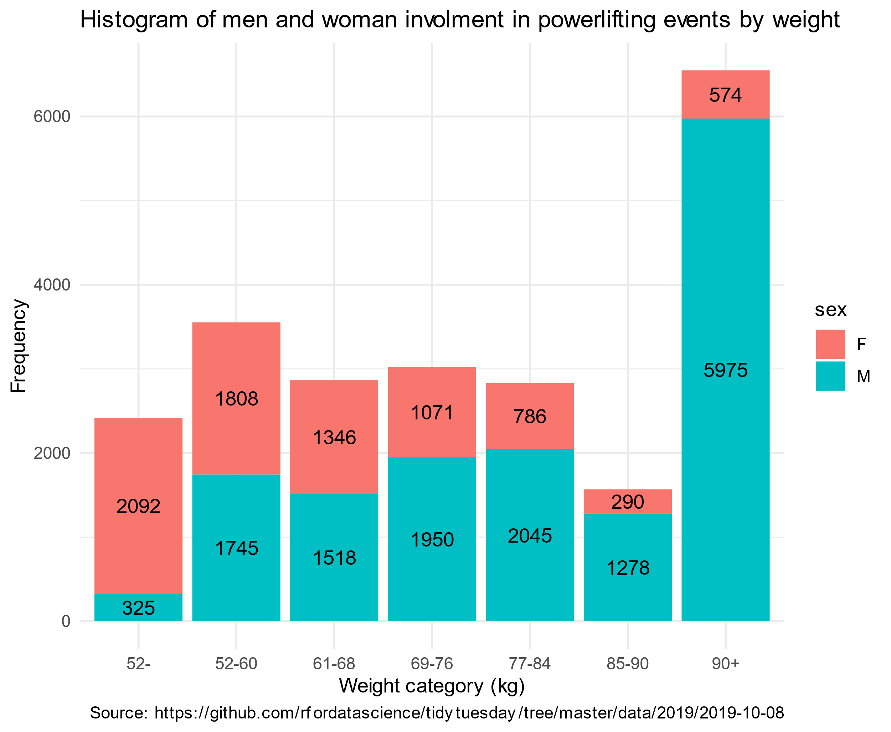
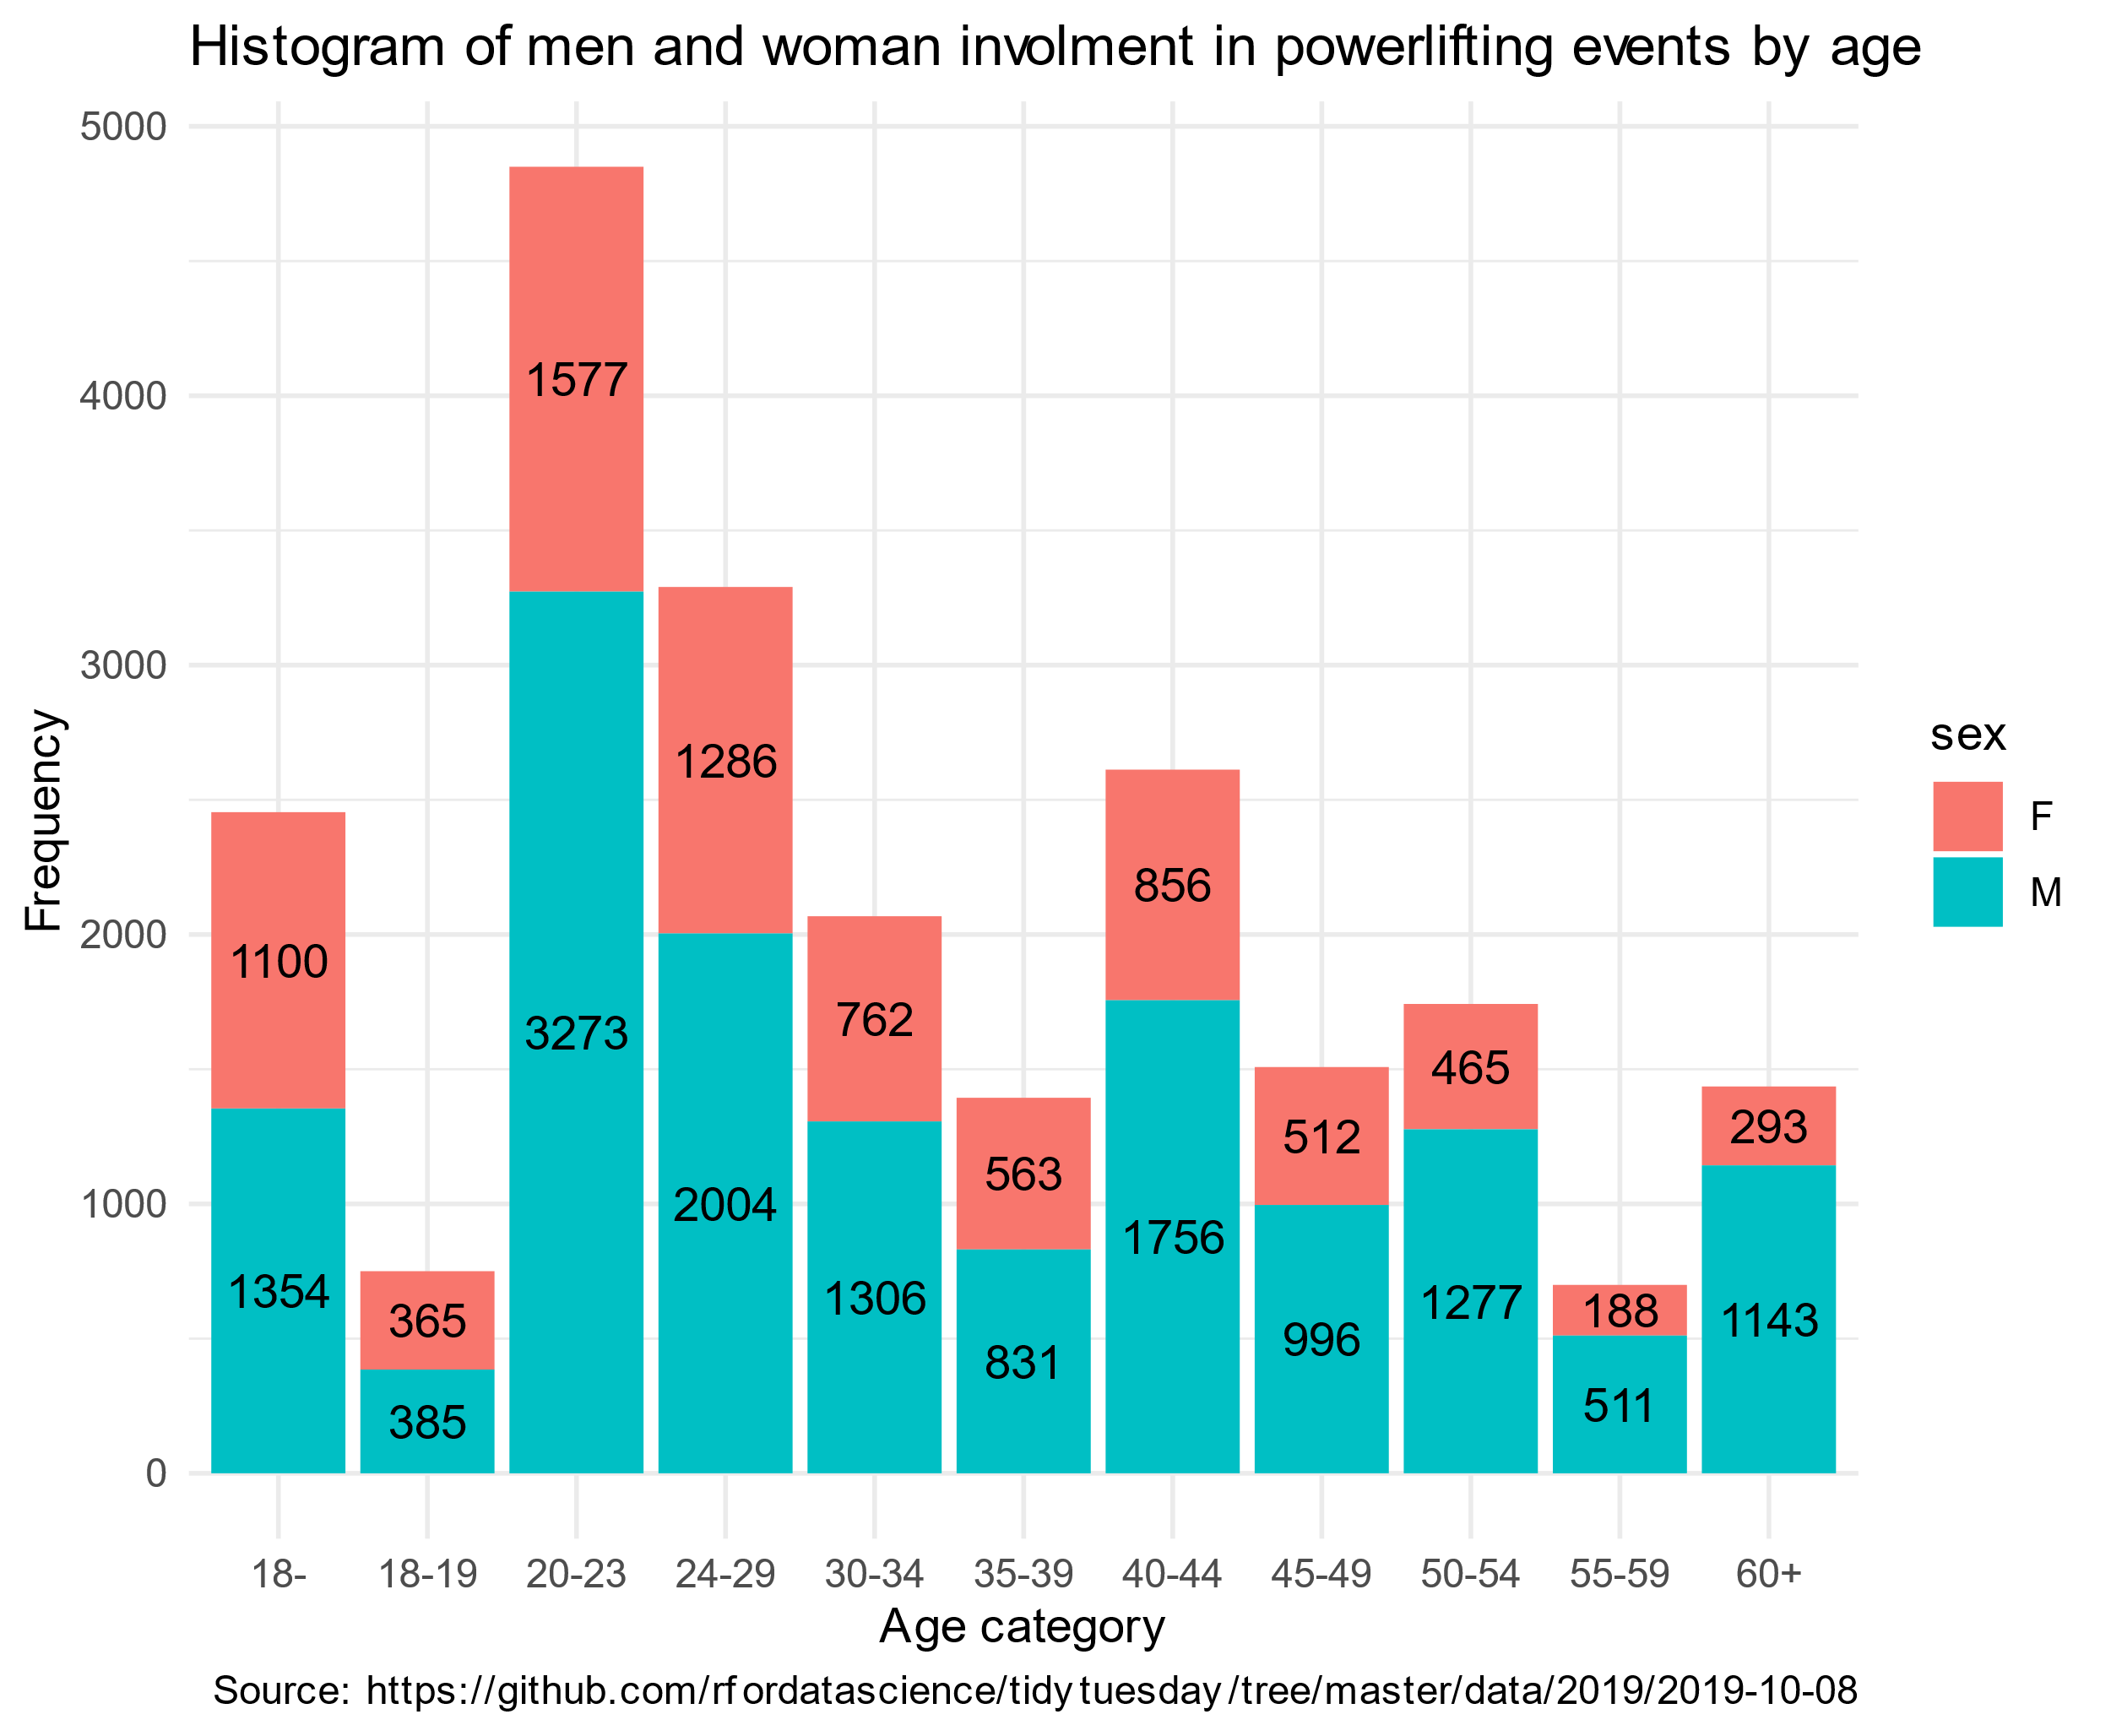

Regression model for Squat Strength by Gender, Age and Weight

I have created a regression model of lifters' squat strength that considers lifters' sex, age, weight, equipment used (Raw: Bare knees or knee sleeves, or Single-ply: Equipped single-ply suits), and meet name. I used this model to find the age and weight categories at which the difference in squat strength of male and female athletes is the smallest and the biggest.

Checking model assumptions

Validity and reliability are reliant on measuring equipment and practices of institutions from which the data is sourced.

In this work, I analyze the population of athletes that competed at IPF powerlifting events, so representativity is by definition assured.

There exists a possible dependence of errors due to the possibility of errors in equipment used at each of the events. However, for the different events, there should be an error independence.

Graphical tests for linearity, homoskedasticity, and normality can be seen on the graph.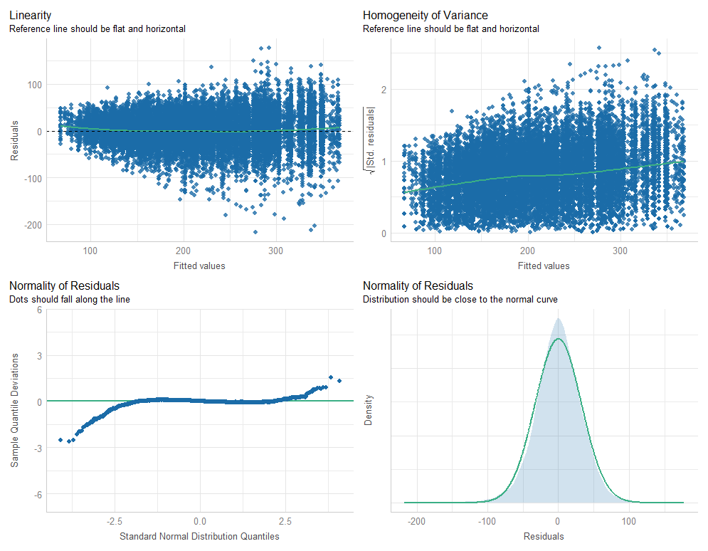Analysis
In the graph we can see the squat averages for each age and weight category for male and female athletes. For almost all age and weight categories the difference in male and female average squat strength is statistically significant (p<0.05), where male athletes have higher squat averages. Only for category age 60 and more and weight under 52 kg is p value is 0.11, so we can’t reject null hypothesis, that at this category the male and female average squat strength is equivalent. This category is thus the category with the lowest average strength difference between male and female athletes. The biggest average squat strength difference is for age categories above 30 years and above 85 kg of weight. Differences of estimated averages for each category can be seen in the Table 4.
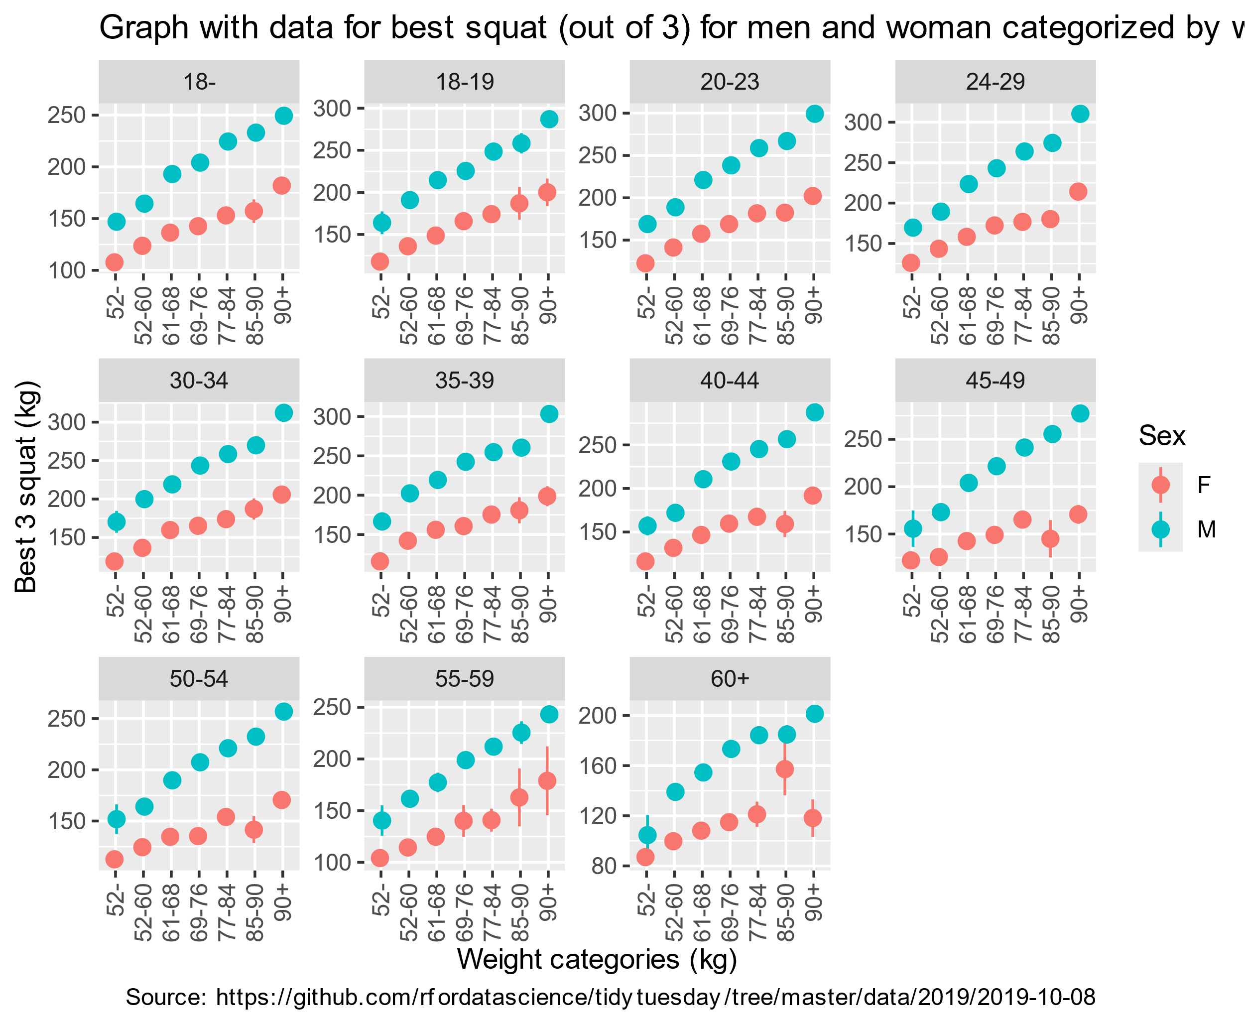

Conclusion
Hypothesis H1 is true for almost all weight and age categories, but not for the age category 60+ and weight under 52 kg, for this category, we can’t reject null hypothesis.

Appendices
age_class_stand | weight_class_kg_stand | estimate_round | std.error_round | statistic_round | p.value_round | s.value_round | conf.low_round | conf.high_round
18- | 52- | 39.3 | 4.67 | 8.41 | 0 | 54.43 | 30.14 | 48.46
18- | 52-60 | 40.78 | 2.94 | 13.88 | 0 | 143.18 | 35.02 | 46.53
18- | 61-68 | 56.68 | 3.45 | 16.44 | 0 | 199.45 | 49.92 | 63.43
18- | 69-76 | 61.48 | 3.76 | 16.35 | 0 | 197.13 | 54.11 | 68.85
18- | 77-84 | 71.42 | 4.19 | 17.05 | 0 | 214.06 | 63.21 | 79.64
18- | 85-90 | 75.86 | 6.29 | 12.05 | 0 | 108.68 | 63.52 | 88.2
18- | 90+ | 67.49 | 4.29 | 15.74 | 0 | 183.01 | 59.08 | 75.89
18-19 | 52- | 46.06 | 8 | 5.76 | 0 | 26.79 | 30.37 | 61.74
18-19 | 52-60 | 54.84 | 5.52 | 9.93 | 0 | 74.74 | 44.02 | 65.67
18-19 | 61-68 | 65.86 | 6.23 | 10.57 | 0 | 84.33 | 53.64 | 78.07
18-19 | 69-76 | 59.68 | 6.27 | 9.51 | 0 | 68.9 | 47.38 | 71.97
18-19 | 77-84 | 74.33 | 7.02 | 10.58 | 0 | 84.52 | 60.57 | 88.1
18-19 | 85-90 | 71.4 | 10.92 | 6.54 | 0 | 33.9 | 49.99 | 92.8
18-19 | 90+ | 86.9 | 7.49 | 11.61 | 0 | 101.03 | 72.22 | 101.57
20-23 | 52- | 46.33 | 4 | 11.59 | 0 | 100.74 | 38.49 | 54.16
20-23 | 52-60 | 47.53 | 2.36 | 20.1 | 0 | 296.17 | 42.89 | 52.16
20-23 | 61-68 | 63.51 | 2.69 | 23.59 | 0 | 406.46 | 58.24 | 68.79
20-23 | 69-76 | 69.38 | 2.73 | 25.46 | 0 | 472.4 | 64.04 | 74.72
20-23 | 77-84 | 77.06 | 3.07 | 25.07 | 0 | 458.18 | 71.03 | 83.09
20-23 | 85-90 | 84.62 | 4.5 | 18.8 | 0 | 259.53 | 75.79 | 93.44
20-23 | 90+ | 97.14 | 3.31 | 29.39 | 0 | 628.34 | 90.66 | 103.62
24-29 | 52- | 43.54 | 5.91 | 7.37 | 0 | 42.39 | 31.96 | 55.13
24-29 | 52-60 | 45.9 | 3 | 15.28 | 0 | 172.67 | 40.01 | 51.78
24-29 | 61-68 | 65.22 | 3.28 | 19.87 | 0 | 289.37 | 58.78 | 71.65
24-29 | 69-76 | 70.72 | 3.24 | 21.85 | 0 | 349.28 | 64.37 | 77.06
24-29 | 77-84 | 87.14 | 3.44 | 25.3 | 0 | 466.58 | 80.39 | 93.89
24-29 | 85-90 | 94.25 | 5.07 | 18.6 | 0 | 254.22 | 84.32 | 104.18
24-29 | 90+ | 96.15 | 3.49 | 27.53 | 0 | 551.81 | 89.3 | 102.99
30-34 | 52- | 51.5 | 7.27 | 7.09 | 0 | 39.43 | 37.26 | 65.74
30-34 | 52-60 | 63.36 | 3.75 | 16.9 | 0 | 210.37 | 56.01 | 70.7
30-34 | 61-68 | 59.44 | 4.62 | 12.85 | 0 | 123.21 | 50.38 | 68.5
30-34 | 69-76 | 78.35 | 4.34 | 18.04 | 0 | 239.35 | 69.84 | 86.86
30-34 | 77-84 | 84.63 | 4.79 | 17.67 | 0 | 229.75 | 75.24 | 94.01
30-34 | 85-90 | 82.82 | 7.62 | 10.87 | 0 | 88.95 | 67.88 | 97.76
30-34 | 90+ | 106.41 | 4.33 | 24.6 | 0 | 441.52 | 97.93 | 114.89
35-39 | 52- | 50.71 | 8.21 | 6.18 | 0 | 30.53 | 34.63 | 66.8
35-39 | 52-60 | 60.15 | 4.55 | 13.22 | 0 | 130.07 | 51.23 | 69.07
35-39 | 61-68 | 63.34 | 5.02 | 12.63 | 0 | 119.01 | 53.51 | 73.17
35-39 | 69-76 | 81.7 | 5.91 | 13.83 | 0 | 142.05 | 70.12 | 93.28
35-39 | 77-84 | 79.25 | 5.95 | 13.32 | 0 | 131.97 | 67.59 | 90.92
35-39 | 85-90 | 79.59 | 8.82 | 9.03 | 0 | 62.33 | 62.32 | 96.87
35-39 | 90+ | 104.54 | 5.22 | 20.03 | 0 | 293.96 | 94.31 | 114.77
40-44 | 52- | 40.86 | 6.82 | 5.99 | 0 | 28.85 | 27.49 | 54.22
40-44 | 52-60 | 40.24 | 3.57 | 11.27 | 0 | 95.38 | 33.24 | 47.25
40-44 | 61-68 | 64 | 4 | 15.98 | 0 | 188.57 | 56.15 | 71.84
40-44 | 69-76 | 71.31 | 3.72 | 19.18 | 0 | 269.91 | 64.02 | 78.59
40-44 | 77-84 | 77.76 | 3.9 | 19.93 | 0 | 291.25 | 70.11 | 85.4
40-44 | 85-90 | 97.4 | 7.02 | 13.87 | 0 | 142.84 | 83.63 | 111.16
40-44 | 90+ | 95.53 | 4.31 | 22.14 | 0 | 358.51 | 87.07 | 103.98
45-49 | 52- | 33.53 | 9.02 | 3.72 | 0 | 12.27 | 15.84 | 51.21
45-49 | 52-60 | 47.38 | 4.51 | 10.52 | 0 | 83.52 | 38.55 | 56.21
45-49 | 61-68 | 61.35 | 4.63 | 13.25 | 0 | 130.7 | 52.27 | 70.42
45-49 | 69-76 | 72.46 | 4.67 | 15.52 | 0 | 178 | 63.3 | 81.61
45-49 | 77-84 | 76.11 | 5.09 | 14.96 | 0 | 165.78 | 66.14 | 86.07
45-49 | 85-90 | 110.55 | 9.42 | 11.74 | 0 | 103.24 | 92.08 | 129.01
45-49 | 90+ | 106.5 | 6.24 | 17.07 | 0 | 214.62 | 94.27 | 118.72
50-54 | 52- | 39.25 | 7.91 | 4.96 | 0 | 20.46 | 23.75 | 54.75
50-54 | 52-60 | 39.64 | 4.69 | 8.46 | 0 | 55.02 | 30.45 | 48.82
50-54 | 61-68 | 55.11 | 4.51 | 12.22 | 0 | 111.67 | 46.27 | 63.95
50-54 | 69-76 | 72.05 | 4.33 | 16.63 | 0 | 203.91 | 63.56 | 80.54
50-54 | 77-84 | 67.07 | 5.84 | 11.49 | 0 | 99.13 | 55.63 | 78.51
50-54 | 85-90 | 90.84 | 9.21 | 9.86 | 0 | 73.84 | 72.79 | 108.89
50-54 | 90+ | 86.32 | 5.48 | 15.76 | 0 | 183.52 | 75.59 | 97.06
55-59 | 52- | 36.31 | 10.89 | 3.33 | 0 | 10.19 | 14.96 | 57.66
55-59 | 52-60 | 47.12 | 6.31 | 7.46 | 0 | 43.43 | 34.75 | 59.5
55-59 | 61-68 | 52.55 | 7.22 | 7.28 | 0 | 41.42 | 38.4 | 66.7
55-59 | 69-76 | 58.79 | 9.84 | 5.97 | 0 | 28.69 | 39.51 | 78.08
55-59 | 77-84 | 71.12 | 8.49 | 8.38 | 0 | 54.03 | 54.48 | 87.76
55-59 | 85-90 | 62.7 | 15.64 | 4.01 | 0 | 14.01 | 32.06 | 93.35
55-59 | 90+ | 64.31 | 11.2 | 5.74 | 0 | 26.69 | 42.37 | 86.25
60+ | 52- | 17.51 | 11.01 | 1.59 | 0.11 | 3.16 | -4.07 | 39.1
60+ | 52-60 | 39.35 | 5.12 | 7.69 | 0 | 45.98 | 29.33 | 49.38
60+ | 61-68 | 46.42 | 5.08 | 9.14 | 0 | 63.81 | 36.47 | 56.37
60+ | 69-76 | 58.43 | 6.5 | 8.98 | 0 | 61.73 | 45.69 | 71.18
60+ | 77-84 | 63.08 | 6.89 | 9.16 | 0 | 64.05 | 49.58 | 76.57
60+ | 85-90 | 27.65 | 11.45 | 2.42 | 0.02 | 5.99 | 5.21 | 50.09
60+ | 90+ | 83.14 | 7.2 | 11.55 | 0 | 100.17 | 69.04 | 97.25
Table 4 Differences of estimated averages for each age and weight category between male and female athletes

