
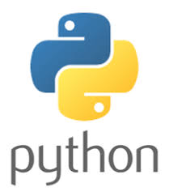

Developed a Python tutorial using JetBrains IntelliJ. Here is a link to the tutorials:

https://github.com/bretmullinix/python-for-beginners

Below is a summary of what tutorials I’ve worked on and I’m currently working on.

Currently, the tutorial walks the user through the following:

- Setting up a development environment using IntelliJ to make you a more productive Python developer. Also, a little nicer on the eyes. ;0)

- Teaches the user how to create and run their first Python program in IntelliJ.

- Teaches the user about variables and data types.

- Teaches the user how to start using Object Oriented Programming (OOP) to model their application(s). The tutorial uses an example of creating addresses using individual string data types and then using an Address class to create those same addresses.

- Teaches the user how to start using collections and introduces looping through collections. The tutorial uses an example of calculating the average student class size.

- Continue to work with Object Oriented Programming (OOP). Builds on the first OOP tutorial. Provides critical foundational skills in OOP. You will learn about inheritance, polymorphism, encapsulation, and composition. The example used in the tutorial will focus on working with the real world mammal. The tutorial is in the t5-oop-part2 folder.

I'm trying to make the tutorial as short as possible while not sacrificing key knowledge in the context of the current lesson.

