Find the PuTTY program in C:\Program Files\AES Link:

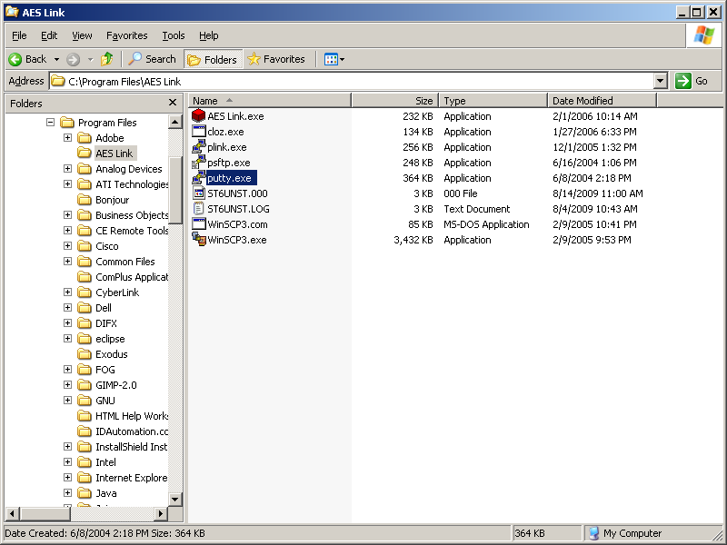

Run PuTTY to get a window like this:

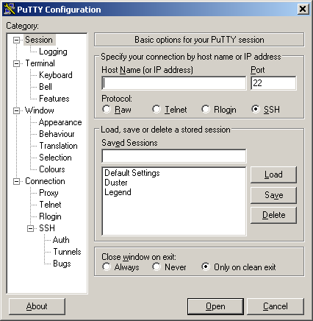

(Note that you probably won’t have Duster and Legend in your Saved Sessions.)

Enter Legend’s IP address in the “Host Name (or IP address)” box:

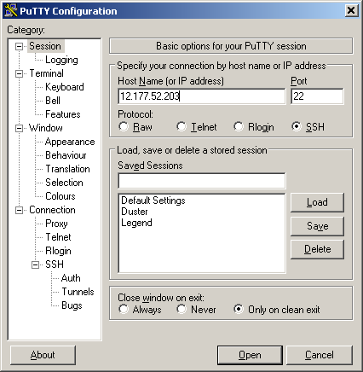

Hit Enter or click the Open button to bring up a terminal window, where you’ll enter your user ID and password:

