**l**

**Software Requirements Specification**

**for**

Poppin

**Version 1.0 approved**

**Prepared by Monica Agneta, Brett Palmer**

**WEBMB**

**2/15/24**

**Table of Contents**

**Table of Contents**

**Revision History**

**1. Introduction**

**2. Overall Description**

**3. External Interface Requirements3**

3.1 User Interfaces

**4. System Features**

**Revision History**

| **Name** | **Date** | **Reason For Changes** | **Version** |
| --- | --- | --- | --- |
|  |  |  |  |
|  |  |  |  |

# **Introduction**

## **Purpose**

Poppin is a social networking app for people to connect through the media that they consume. Through Poppin, users share their recent experiences with books, movies, music, and games. They can use captions and ratings to either recommend a piece or recommend that people avoid it. Users can not only keep up to date with what media their friends enjoy, but they can also see what media is trending on the entire app. In this way, Poppin can inspire users who are looking for new books or movies to enjoy.

# Assumptions

* This product should be accessible through any device that can load web pages through a browser. The development will be centered around a desktop layout, so the best experience will be on a laptop or desktop computer. The application is designed specifically for Android devices.

# Constraints

* This product is being created for a semester-long course, so there are only 14 weeks to create it.
* The development team consists of college students with conflicting schedules, so meetings are only possible twice a week.
* Since this product is being developed for a college course, there is no budget for its creation.

# **Overall Description**

To start, users access Poppin through a secure account with a username and password. This allows users to experience the app from a personalized perspective. Users can both follow people and gain followers, allowing them to develop a network of friends to keep in touch with. Through posts, users can share books, movies, music, and games that they enjoy. To indicate what form of media they are posting about, users are required to flag their posts with one of these categories. When sharing that a user has experienced a piece, the user has opportunities to describe it. They can give the piece a numerical rating from 0 to 10, or they can describe it with a caption. They can do one of these, both, or choose to share the piece’s title and nothing else. Other users can interact with posts in a few ways. Through their profiles, users can curate an online image. This includes a custom username, profile picture, custom usernames, a short bio, and favorite media. Each user can choose a post from each category to showcase on their profile, allowing them to display their favorite book, movie, album, and video game. When viewing a user’s profile, you can also view all of their posts, with the potential to filter by category just like the main feed. The overall objective of Poppin is to provide a positive platform for users to exchange ideas about the media they consume. As a result, interaction between users is a key component of Poppin. First, we want users to be able to cater the app to their interests. This is done by a filter at the top of the app, where users can decide what categories they would like to see posts from. Users can also use a “Trending” filter to see posts from the past 24 hours ranked by the number of likes. Additionally, we want users to be able to support each other’s posts. If a user enjoys a post, they can give it a like. If they have something they want to say about the post, they can leave a comment. If they like someone’s posts, they can follow them. Lastly, Poppin aims to encourage interaction without being a competition for interaction. Likewise, the app does not publicly display the count of likes and followers. This allows users to focus on what matters most: enjoying the discussion of art and entertainment in all its forms.

# **External Interface Requirements**

## **User Interfaces**

Home: The home page provides a short slogan and logo for Poppin. There are two labeled buttons with hyperlinks to other pages: one for Get Started, and One for Login.

Get Started: This page requires the user to enter a unique username with a corresponding password. If the username is available, it will allow the user to make an account. If not, it will ask the user to provide a different username. If a user successfully makes an account, it will take them to their profile page to add optional details about themself (bio, profile picture, etc.).

Login: This page requires the user to enter a username with a corresponding password. If the username and password are a valid combination in our database, it will take the user to their feed. If not, it will tell the user that their information is incorrect.

Feed: Here, the user can see posts. First, the user can filter posts by a specific type of media: just music, movies and books, all types, etc.. Users can also filter by who they want to see posts from Following or Trending. Then there is the feed itself, which is a list of posts. For each post, the user can see the image of the media being discussed, as well as the post’s caption and 1-10 rating of the media. The user can click the thumbs up emoji to like a post, or a comment emoji to type and enter a comment. Clicking the profile picture by a post takes the user to the poster’s profile. Clicking their own profile picture at the top right takes the user to their own profile.

Profile: The UI shown assumes a user is looking at someone else’s profile. The top shows their username, profile picture, and biography, as well as two buttons: follow and block. The follow button will say “Following” if the user is already following the profile, or “Follow” if they have not yet followed the profile. When making a profile, a user can select their favorite posts to showcase. Clicking the Poppin button on this page will take the user back to their feed.

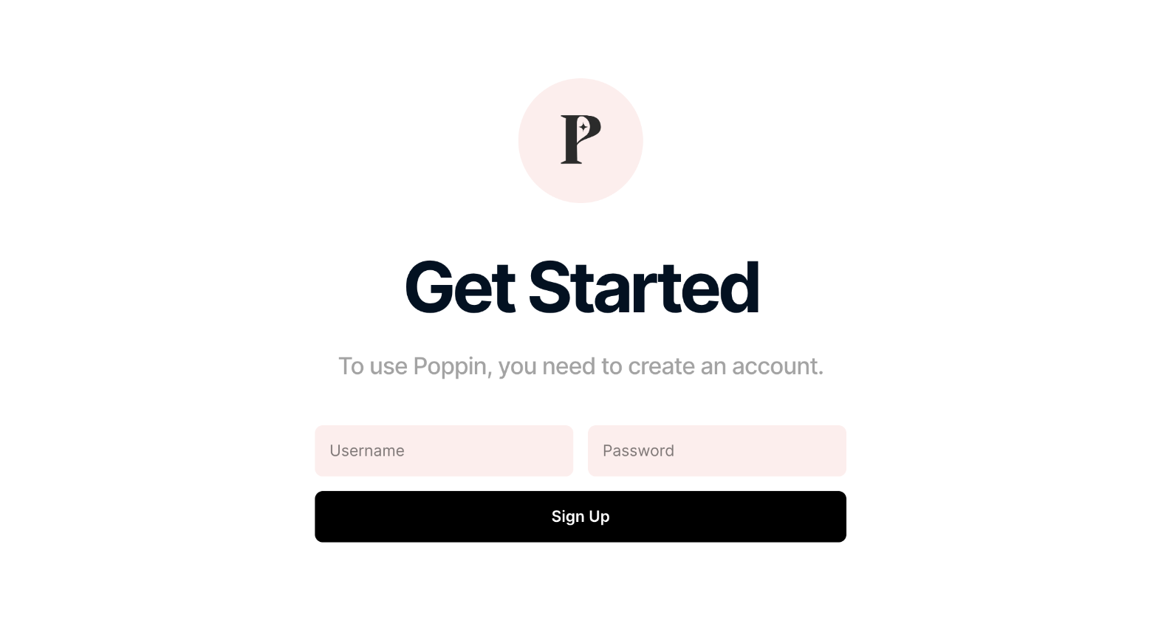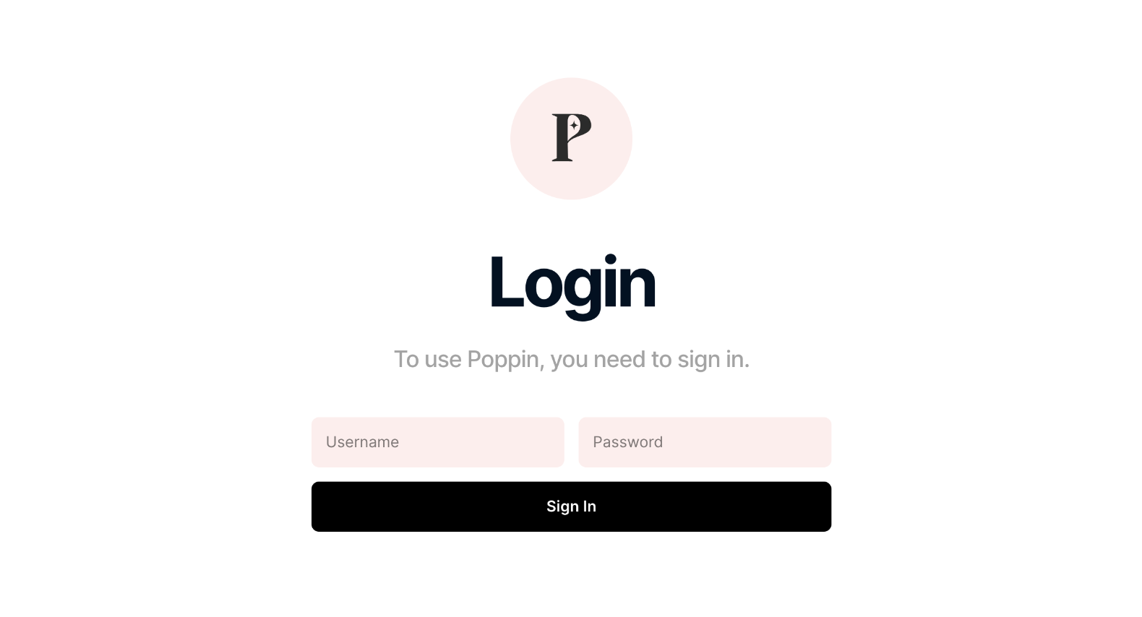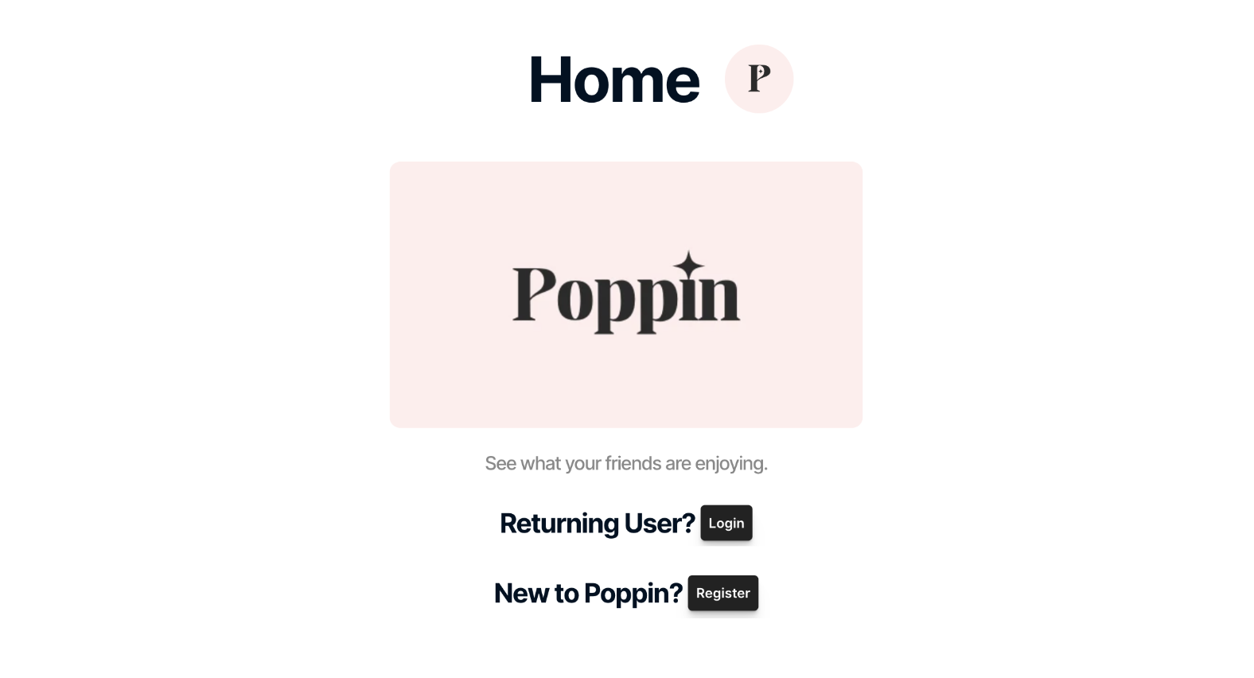

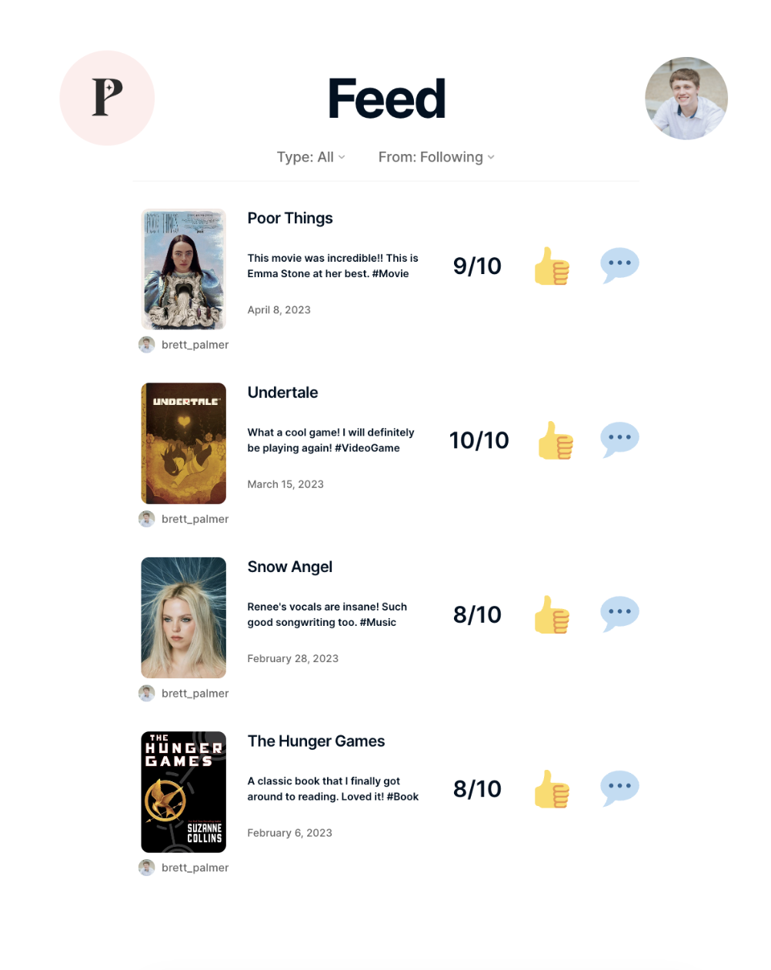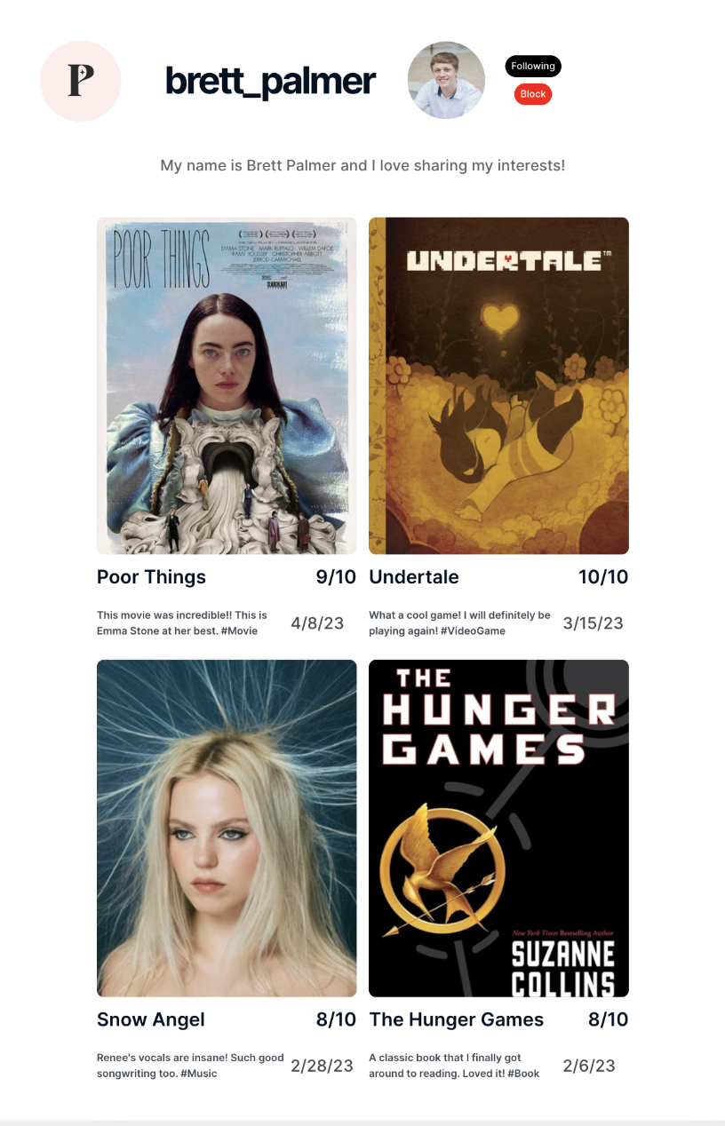



# **System Features**

**Functional Requirements**

1. The system shall allow the user to create an account with a username and password.
2. The system shall allow the user to log in with their username and password.
3. The system shall allow the user to post by uploading a photo.
4. The system shall allow the user to add tags to the pictures they post.
5. The system shall allow the user to add a 0-10 rating to their posts.
6. The system shall allow the user to add a caption to their posts.
7. The system shall allow the user to follow friends by username.
8. The system shall allow the user to filter their feed by tags of interest.
9. The system shall allow the user to have a public profile that showcases their current interests.
10. The system shall allow the user to access a “trending” feed via a button.
11. The system shall allow the user to like the posts of other users with a like button.
12. The system shall allow the user to leave comments on other users posts.
13. The system shall allow the user to filter other users posts by tags of interest.
14. The system shall allow the user to block other users by username.
15. The system shall allow the user to make their profile private.

**Non-Functional Requirements**

1. The system shall be capable of updating a typical workload of 10,000 user feeds within 5 seconds, 95% of the time.
2. The system shall process each user request within 5 seconds or less, 93% of the time.
3. The system must keep user personal information private from unauthorized users.
4. The system shall use strong encryption for users saved passwords.
5. The system shall be capable of updating the trending feed with the most popular posts every 30 minutes.
6. The system shall be capable of filtering user posts by selected tags of interest, 95% of the time.
7. The system shall request only necessary permissions (camera/camera roll access) from the user.
8. The system shall upload a user post within 3 seconds of their request to post, 95% of the time.
9. The system shall make viewing profiles unavailable to blocked users.
10. The system shall be capable of filtering friends posts from the public feed within 5 seconds or less, 95% of the time.