Use Case Model for WEBMB’s Poppin

by Emmanuelle Lenge,[Wesley Dumas](mailto:wesley.dumas@maine.edu), and Brett Palmer

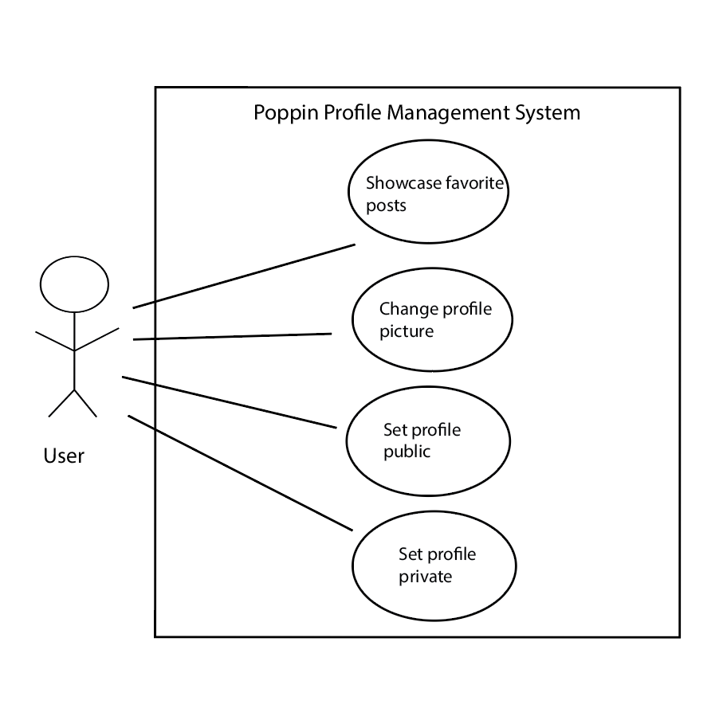

**1.**

| **Title:** | Showcase favorite posts |
| --- | --- |
| **Description**: | This allows users to showcase four of their favorite posts on their profile. |
| **System Under Design:** | Poppin Profile Management System |
| **Primary Actor**: | User |
| **Goal**: | Allow users to showcase their favorite posts on their profile. |
| **Precondition**: | The user has logged in to Poppin and is editing their profile. |
| **Success Postcondition**: | The user has successfully showcased a set of featured posts on their profile. |

| **STEPS**: (ACTOR)  1. The user clicks on the Showcase Featured Posts button.  3. The user selects up to 4 posts to display as featured, and clicks “Done” when finished.  5. The user views their featured posts displayed on their profile. | **ALTERNATIVES**: (SYSTEM RESPONSE)  2. The System displays posts that the user can display as featured.  4. The system adds all selected posts to the featured sections of the user’s profile. |
| --- | --- |

**2.**

| **Title:** | Change profile picture |
| --- | --- |
| **Description**: | This allows the user to change their profile picture. |
| **System Under Design:** | Poppin Profile Management System |
| **Primary Actor**: | User |
| **Goal**: | Allow the user to change the picture that is shown on their profile. |
| **Precondition**: | User has logged in to Poppin and is editing their profile. |
| **Success Postcondition**: | The user has changed their profile picture. |

| **STEPS**: (ACTOR)  1. The user clicks the Change Profile Picture button  3. The user uploads an image that they would like to have as a profile picture.  5. The user views their profile with the updated profile picture. | **ALTERNATIVES**: (SYSTEM RESPONSE)  2. The system prompts the user to upload an image to set as profile picture  4. The system sets the profile picture to the uploaded picture. |
| --- | --- |

**3.**

| **Title:** | Set profile public |
| --- | --- |
| **Description**: | This allows the user to make their profile public, so they can gain followers. |
| **System Under Design:** | Poppin Profile Management System |
| **Primary Actor**: | User |
| **Goal**: | Allow the user to set their profile as public, so anyone can view it. |
| **Precondition**: | The user has logged in to Poppin and is editing their profile privacy. |
| **Success Postcondition**: | The user has successfully set their profile privacy to public. |

| **STEPS**: (ACTOR)  1. User clicks the “Set Profile as Public” button.  3. The user clicks the confirm button.  5. The user sees “Public” marked on their profile, showing they have successfully made their profile public. | **ALTERNATIVES**: (SYSTEM RESPONSE)  2. The system asks the user to confirm that they want to set the profile as public.  4. The system sets the profile as public, so any Poppin users can view it. |
| --- | --- |

**4.**

| **Title:** | Set profile private |
| --- | --- |
| **Description**: | This allows the user to set their profile as private so the user has to approve other users following and viewing their profile. |
| **System Under Design:** | Poppin Profile Management System |
| **Primary Actor**: | User |
| **Goal**: | Allow the user to set their profile as private to restrict who is able to view it. |
| **Precondition**: | User has logged in to Poppin and is editing their profile privacy. |
| **Success Postcondition**: | The user has successfully set their profile to private. |

| **STEPS**: (ACTOR)  1. The user clicks on the “Set Profile as Private” button.  3. The user clicks the confirm button.  5. The user sees “Private” marked on their profile, showing they have successfully made their profile private. | **ALTERNATIVES**: (SYSTEM RESPONSE)  2. The system asks the user to confirm that they want to set the profile as private.  4. The system sets the profile as private, so only approved followers can view it. |
| --- | --- |

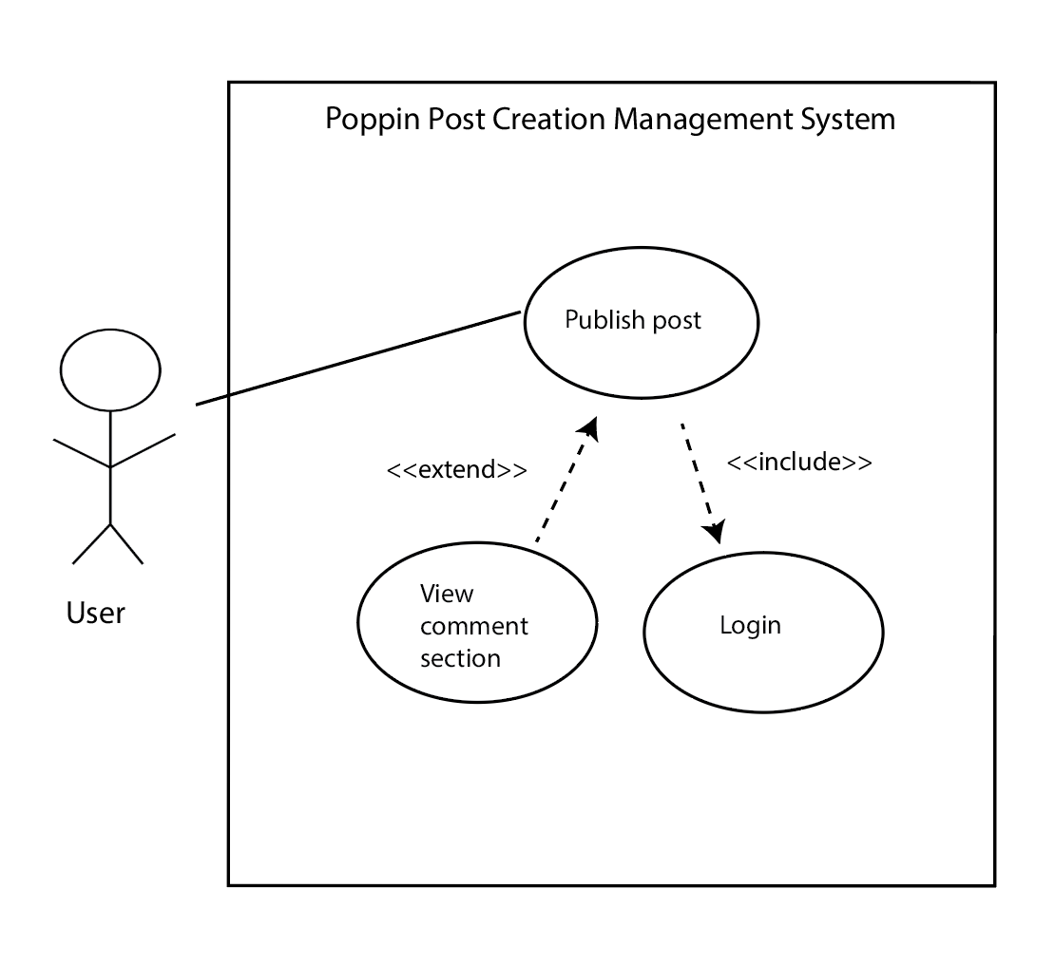

**5.**

| **Title:** | Publish post |
| --- | --- |
| **Description**: | This use case allows users to create and share posts using the Poppin app. |
| **System Under Design:** | Poppin Post Creation Management System |
| **Primary Actor**: | User |
| **Goal**: | To enable users to create and publish posts. |
| **Following Use Cases**: | Includes “Login” and is extended by “View comment section” |
| **Precondition**: | The user is logged into the Poppin app. |
| **Success Postcondition**: | The user successfully publishes a post. |

| **STEPS**: (ACTOR)  1. The user selects the option of creating a new post on their profile page.  3. The user uploads a photo from their device.  5. The user inputs the caption, rating, and tags in their corresponding sections..  7. The user clicks on “Publish post”  9) The user can see that their post has been published successfully. | **ALTERNATIVES**: (SYSTEM RESPONSE)  2. The system displays the post-creation interface.  4. The system displays the selected image on the post-creation interface, along with input text boxes for caption, rating, and tags.  6. The system displays all entered information about the post.  8. The system produces a post from the user’s input and displays it in the feed. |
| --- | --- |

**6.**

| **Title:** | View comment section |
| --- | --- |
| **Description**: | This use case allows the user to view the comment section on one of their posts. |
| **System Under Design:** | Poppin Post Creation Management System |
| **Primary Actor**: | User |
| **Goal**: | To enable the user to view their comment sections. |
| **Following Use Cases**: | Extension of “Publish post” |
| **Precondition**: | The user has published a post to Poppin and is viewing it. |
| **Success Postcondition**: | The user has viewed the comment section on their selected post. |

| **STEPS**: (ACTOR)  1. The user clicks the comment icon on a post from their profile.  3a) The user reads the comments on their post.  3b) The user sees that their post has no comments yet. | **ALTERNATIVES**: (SYSTEM RESPONSE)  2a. If comments have been made, the system displays any comments associated with the post.  2b. If the post has no comments, the system displays a dialogue reading “No Comments” |
| --- | --- |

**7.**

| **Title:** | Login |
| --- | --- |
| **Description**: | This use case allows users to log in to the Poppin app. |
| **System Under Design:** | Poppin Post Creation Management System |
| **Primary Actor**: | User |
| **Goal**: | To enable users to log in to the Poppin app. |
| **Following Use Cases**: | Inclusion of “Publish post” |
| **Precondition**: | The user clicks on the login link on the Poppin home page. |
| **Success Postcondition**: | The user has successfully logged into the Poppin app, and is brought to their feed. |

| **STEPS**: (ACTOR)  1. The user enters their username and password into two separate input fields.  3. The user clicks on the “Login” button.  5a.The user successfully logs in to the Poppin app and is viewing their feed..  5b. The user correctly re-enters their username and password, and successfully logs in to the Poppin app and views their feed. | **ALTERNATIVES**: (SYSTEM RESPONSE)  2. The system saves their inputs.  4a. The system verifies the user’s input. If it’s correct, the system logs the user into the Poppin app and takes them to their feed.  4b. If it’s incorrect, the system prompts the user to re-enter their username and password. |
| --- | --- |

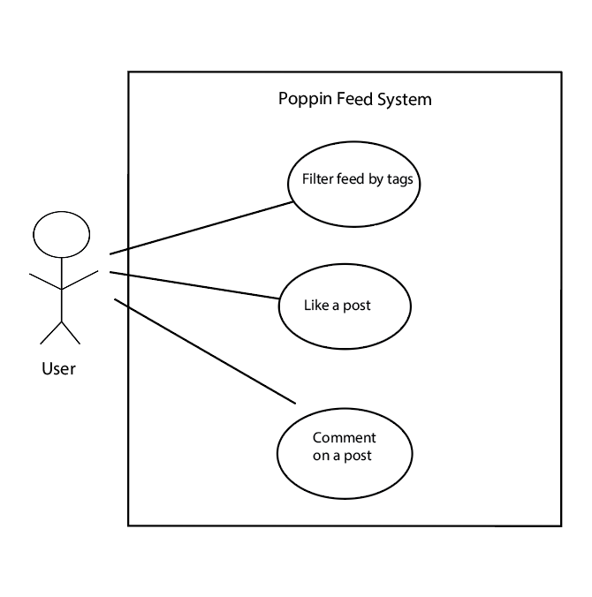

**8.**

| **Title:** | Filter feed by tags |
| --- | --- |
| **Description**: | This use case allows users to filter posts in the Poppin app based on their interests or selected tags. |
| **System Under Design:** | Poppin Feed System |
| **Primary Actor**: | User |
| **Goal**: | To permit users to adjust their feed based on their interests/preferences. |
| **Precondition**: | This use case assumes the user is logged into the Poppin app and is on the feed page. |
| **Success Postcondition**: | The user's feed is filtered to display posts based on the user’s preference. |

| **STEPS**: (ACTOR)  1. The user clicks on the filter option at the top of the page.  3a.The user chooses to only see posts categorized with certain tags(music, video games, books, movies).  3b. The user chooses to only see posts that are trending (posts receiving a lot of likes on Poppin).  5a. The user can view a feed of posts from their chosen tags.  5b. The user views a feed of trending posts. | **ALTERNATIVES**: (SYSTEM RESPONSE)  2. Poppin displays the filter option and presents a list of categories or tags for the user to choose from.  4a. The system updates the feed to only show posts from the selected tags.  4b. The system updates the feed to only show posts that are trending. |
| --- | --- |

**9.**

| **Title:** | Like a post |
| --- | --- |
| **Description**: | This use case allows the user to like other users' posts. |
| **System Under Design:** | Poppin Feed system |
| **Primary Actor**: | User |
| **Goal**: | To enable the user to like posts that they enjoy. |
| **Precondition**: | The user is logged in to Poppin and is viewing a post. |
| **Success Postcondition**: | The user can see that they have added a like to a post. |

| **STEPS**: (ACTOR)  1. The user clicks on the thumbs-up button attached to the post they are viewing.  3. The user sees that they have successfully liked a post, now that the thumbs-up icon is bigger. | **ALTERNATIVES**: (SYSTEM RESPONSE)  2. The system registers the user’s like on the post, and makes the thumbs-up bigger to indicate a successful like. |
| --- | --- |

**10.**

| **Title:** | Comment on a post |
| --- | --- |
| **Description**: | This use case authorizes the user to write a comment on another’s user page. |
| **System Under Design:** | Poppin Feed System |
| **Primary Actor**: | User |
| **Goal**: | To facilitate user interaction and communication through comments on posts. |
| **Precondition**: | The user is logged into Poppin and is viewing a post. |
| **Success Postcondition**: | The user’s comment has been successfully added to the post. |

| **STEPS**: (ACTOR)  1. The user clicks on the comment icon attached to the post.  3. The user clicks on Add Comment.  5. The user types the comment in the comment input field.  7. The user sends/submits their comment.  9. The user can view their comment added to the comment section of the post. | **ALTERNATIVES**: (SYSTEM RESPONSE)  2. The system displays any comments that are already made on the post.  4.The system activates the comment input field for the user.  6. The system saves the user’s input.  8. The system updates the comment section to include the user’s new comment. |
| --- | --- |