Domain Model For WEBMB’s Poppin

By Emmanuelle Lenge and [Wesley Dumas](mailto:wesley.dumas@maine.edu).

1. Post System 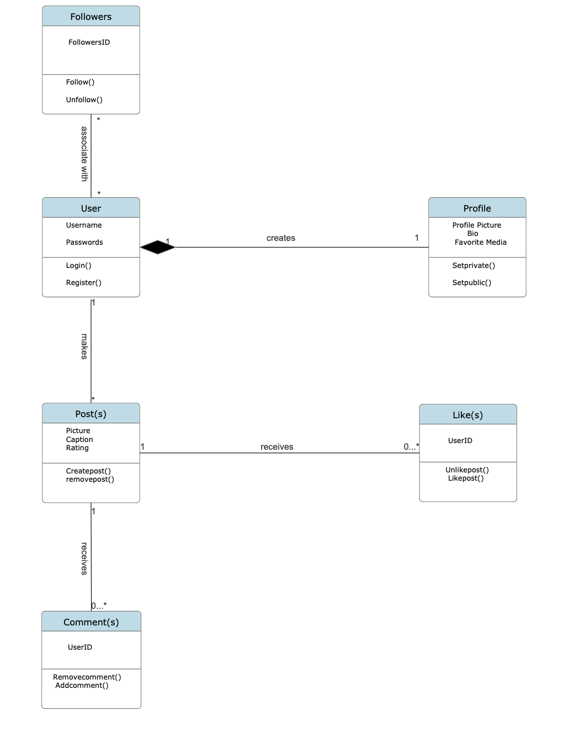
2. Feed System

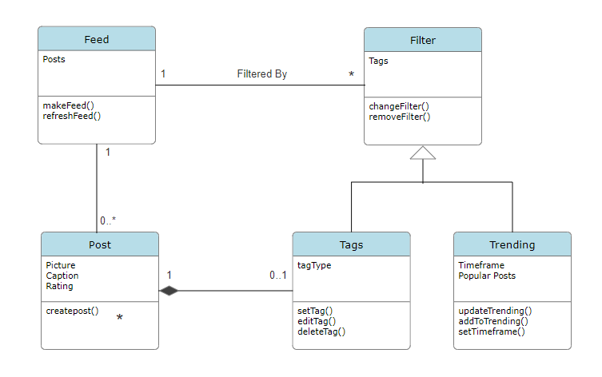

1. Description:

* The post system aims to provide its users with the ability to automate the process of:
  + Creating Posts
  + Creating a Profile
  + Following Users
  + Liking Posts
  + Commenting on Posts
* Posts will comprise a picture, caption, and rating.
* Users need to provide a username and password for registration.
* A profile comprises a profile picture, a bio, and favorite media pieces.
* A Like is comprised of a UserID
* A Comment is comprised of a UserID
* The feed system aims to provide its users with the ability to automate the process of:
  + Creating a Filter from tags or trending
  + Filtering their Feed
  + Viewing their Feed
  + Interacting with the posts in their Feed
* Posts will comprise a picture, caption, and rating.
* A feed will be made of posts and can be filtered by a filter.
* Filters are drawn from two primary groups
  + Tags and Trending
* In addition, the following information is needed to filter a feed
  + Trending - Time Frame
  + Tags - Tag types

In conclusion, both models are connected because the first model illustrates how the users create their profiles, create posts, gain followers, and interact with the posts through actions such as liking and commenting, whereas the second model goes further to show different interaction features with posts after creation.