Sequence Diagrams For WEBMB’s Poppin

By Monica Agneta and Brett Palmer

Analysis Sequence Diagrams and Steps

*Set profile to private*

4. The system sets the profile as private, so only approved followers can view it.

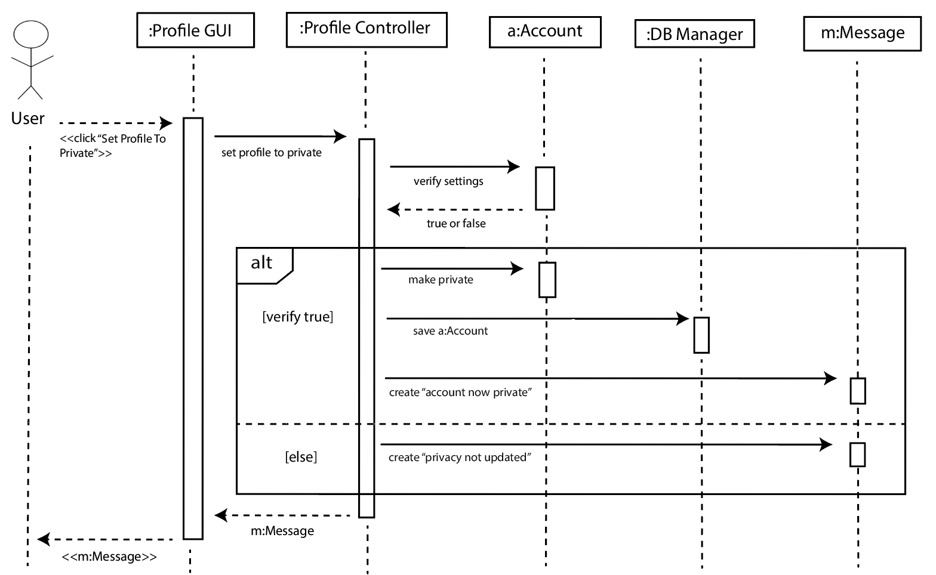

| # | Subject | Subject Action | Other Data/ Objects | Object Acted Upon |
| --- | --- | --- | --- | --- |
| 4.1 | User | clicks | “Set profile as private” button | Profile GUI |
| 4.2 | Profile GUI | sets | profile to private | Profile Controller |
| 4.3 | Profile Controller | verifies | settings | Account |
| 4.4 | Account | returns | true or false | Profile Controller |
| 4.4 | If true is returned then |  |  |  |
| 4.4.1 | Profile Controller | makes | private | account |
| 4.4.2 | Profile Controller | saves | Account | Database Manager |
| 4.4.3 | Profile Controller | creates | “Account now private” | message |
| 4.5 | else |  |  |  |
| 4.5.1 | Profile Controller | creates | “Privacy not updated” | message |
| 4.6 | Profile Controller | returns | message | Profile GUI |
| 4.7 | Profile GUI | Displays | message | User |

*Login*

4a. The system verifies the user’s input. If it’s correct, the system logs the user into the Poppin app and takes them to their feed.

4b. If it’s incorrect, the system displays an error message.

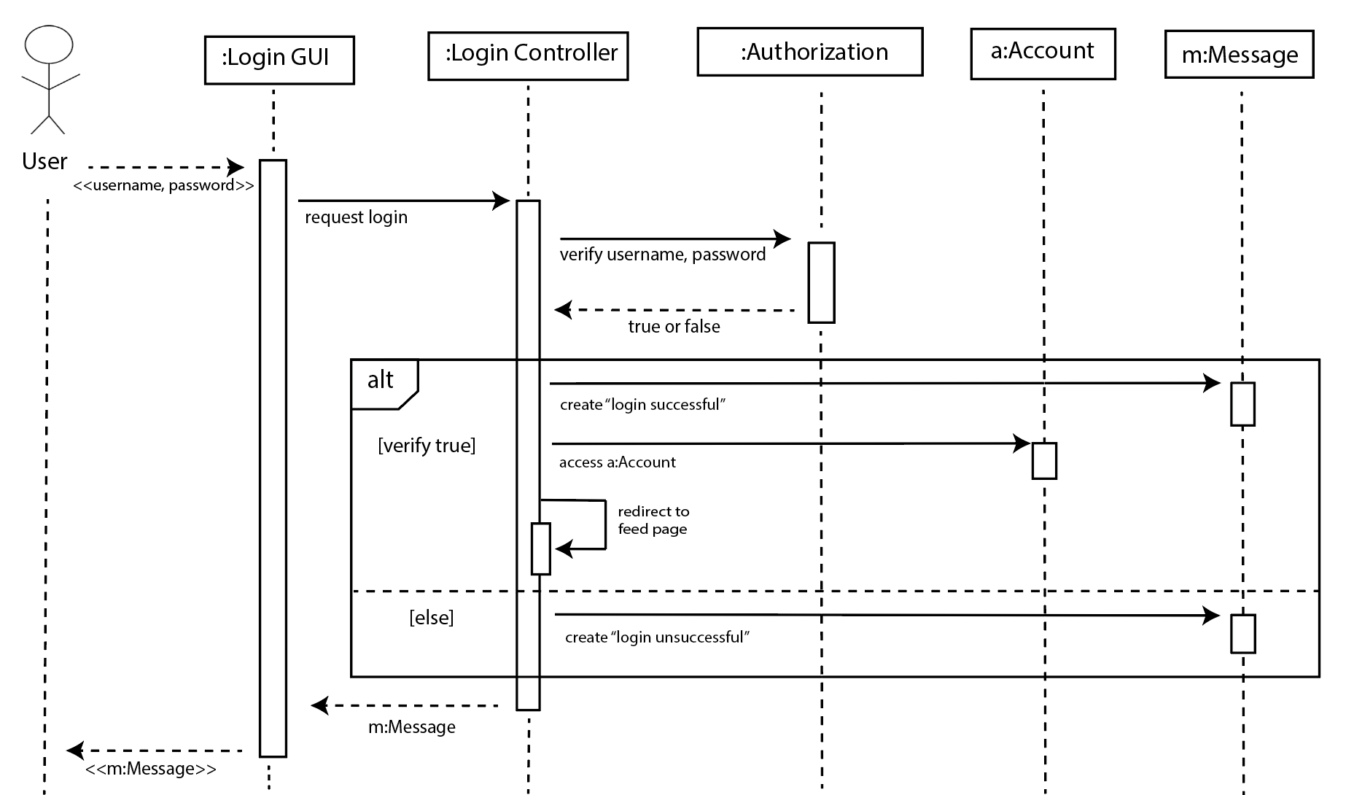

| # | Subject | Subject Action | Other Data/Objects | Object Acted Upon |
| --- | --- | --- | --- | --- |
| 3 | User | submits | username, password | Login GUI |
| 4.1 | Login GUI | requests | login for user | Login Controller |
| 4.2 | Login Controller | verifies | username, password | Authorization |
| 4.3 | Authorization | returns | true or false | Login Controller |
| 4.3 | If true is returned then |  |  |  |
| 4.3.1 | Login Controller | creates | “Login successful” | message |
| 4.3.2 | Login Controller | accesses |  | account |
| 4.3.3 | Login Controller | redirects | feed page link | Login Controller |
| 4.4 | Else |  |  |  |
| 4.4.1 | Login Controller | creates | “Login unsuccessful” | message |
| 4.5 | Login Controller | returns | message | Login GUI |
| 4.6 | Login GUI | displays | message | User |

*Register*

4. The system creates an account with the entered username and password.

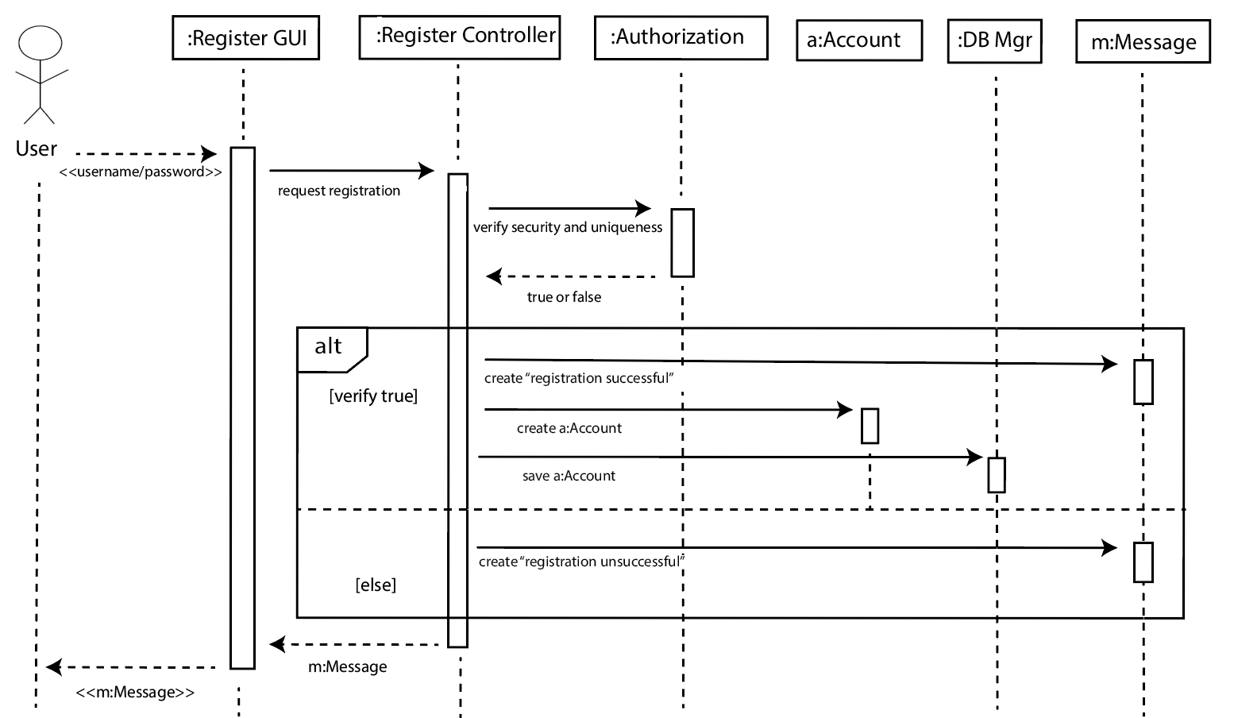

| # | Subject | Subject Action | Other Data/ Objects | Object Acted Upon |
| --- | --- | --- | --- | --- |
| 4.1 | User | submits | Username, password | Register GUI |
| 4.2 | Register GUI | sends | Username, password | DBMgr |
| 4.3 | DBMgr | verifies | security and uniqueness | Authorization |
| 4.4 | Authorization | returns | True or false | Register Controller |
| 4.4 | If true is returned then |  |  |  |
| 4.4.1 | Register Controller | creates | “Registration successful” | message |
| 4.4.2 | Register Controller | creates |  | account |
| 4.4.3 | Register Controller | saves | account | Database Manager |
| 4.4.4 | Register Controller | redirects | Login page link | Register Controller |
| 4.5 | else |  |  |  |
| 4.5.1 | Register Controller | creates | “Registration unsuccessful” | Register Controller |
| 4.6 | Register Controller | returns | message | Register GUI |
| 4.7 | Register GUI | displays | message | User |

*Publish Post*

4. The system creates a post based on the user’s submission of an image, caption, rating, and tag.

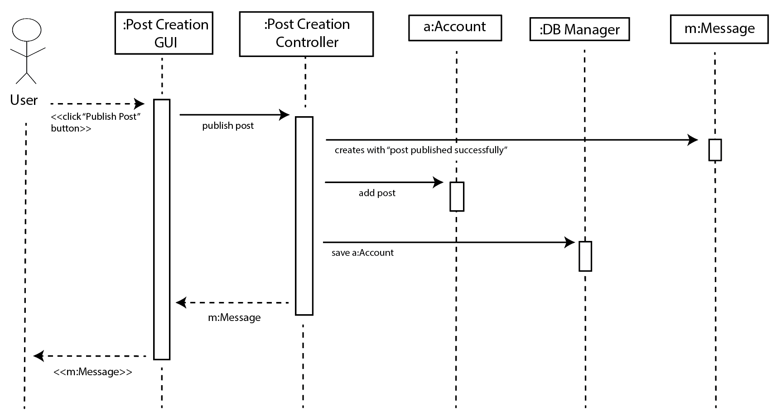

| # | Subject | Subject Action | Other Data/ Objects | Object Acted Upon |
| --- | --- | --- | --- | --- |
| 4.1 | User | clicks | “Publish Post” button | Post Creation GUI |
| 4.2 | Post Creation GUI | publishes | post | Post Creation Controller |
| 4.3 | Post Creation Controller | creates | “Post Published Successfully” | message |
| 4.4 | Post Creation Controller | adds | post | Account |
| 4.5 | Post Creation Controller | saves | Account | DB Manager |
| 4.6 | Post Creation Controller | returns | message | Post Creation GUI |
| 4.7 | Post Creation GUI | displays | message | User |

*Filter feed*

4. The system updates the feed to only show posts from the selected tags.

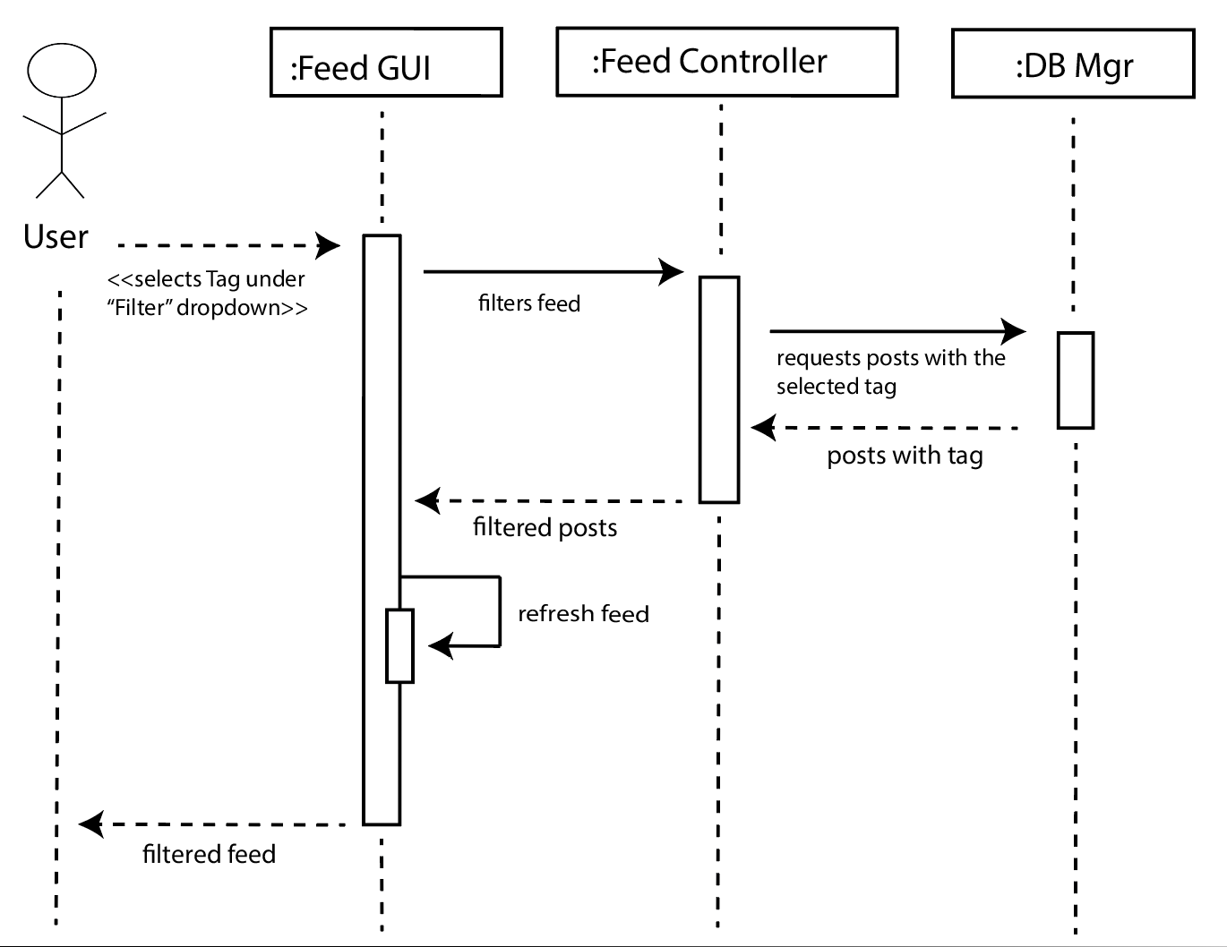

| # | Subject | Subject Action | Other Data/ Objects | Object Acted Upon |
| --- | --- | --- | --- | --- |
| 4.1 | User | Clicks | Tag button | Feed GUI |
| 4.2 | Feed GUI | filters | feed | Feed Controller |
| 4.3 | Feed Controller | requests | Posts with specified tag | Database Manager |
| 4.4 | Database Manager | returns | Posts with specified tag | Feed Controller |
| 4.5 | Feed Controller | returns | posts | Feed GUI |
| 4.6 | Feed Controller | refreshes |  | Feed GUI |
| 4.7 | Feed GUI | displays | Filtered feed | User |

*Like a Post*

2. The system registers the user’s like on the post, and displays a confirmation message.

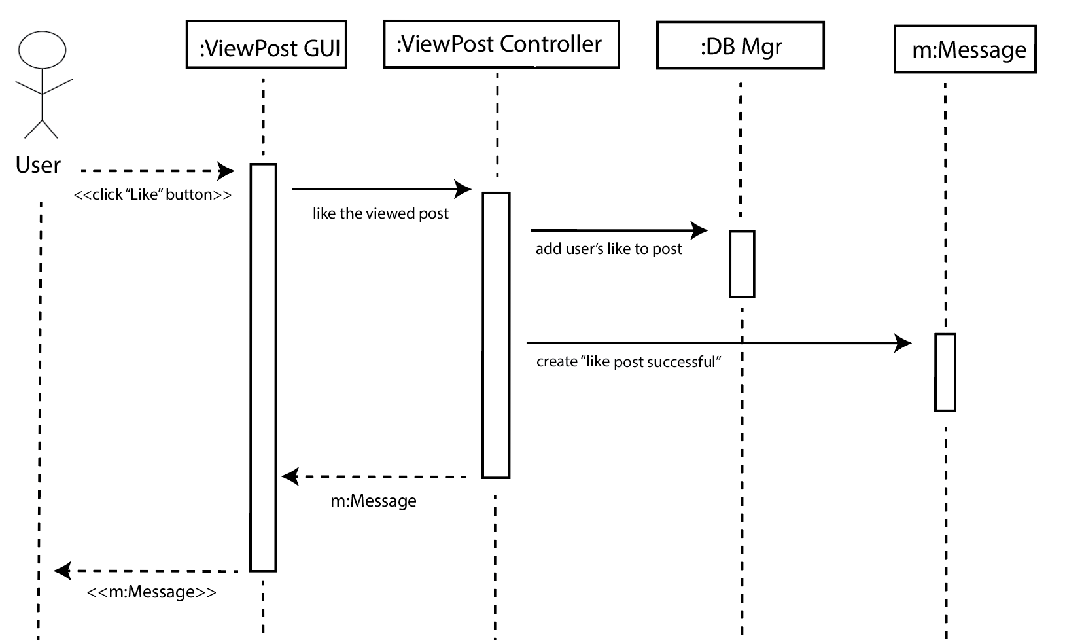

| # | Subject | Subject Action | Other Data/ Objects | Object Acted Upon |
| --- | --- | --- | --- | --- |
| 2.1 | User | clicks | Like button | Post GUI |
| 2.2 | Post GUI | likes | post | Post Controller |
| 2.3 | Post Controller | adds | like to post | Database Manager |
| 2.4 | Post Controller | creates | “Like post successful” | message |
| 2.5 | Post Controller | returns | message | Post GUI |
| 2.6 | Post GUI | displays | message | User |

*Comment on a Post*

8. The system updates the comment section to include the user’s new comment.

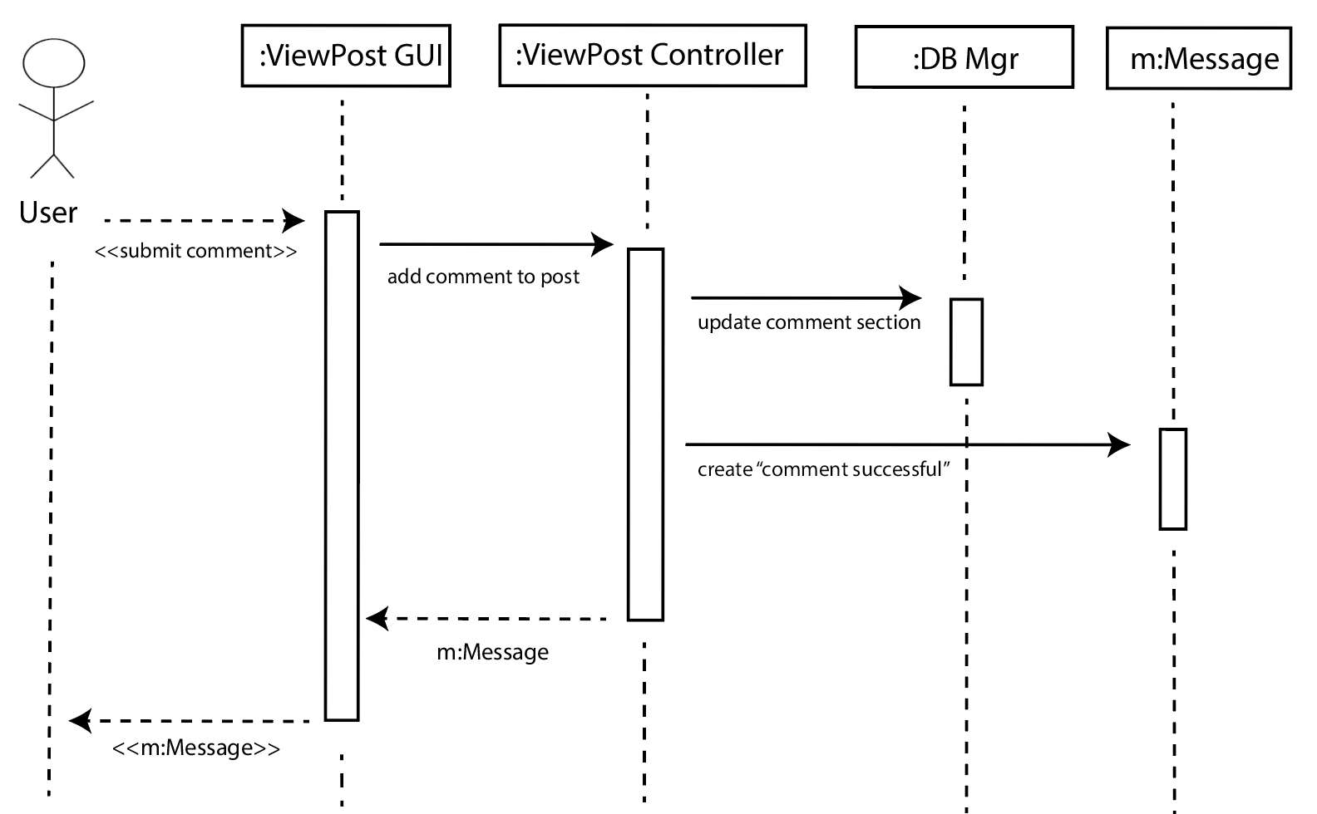

| # | Subject | Subject Action | Other Data/ Objects | Object Acted Upon |
| --- | --- | --- | --- | --- |
| 8.1 | User | submits | comment | Post Reaction GUI |
| 8.2 | Post Reaction GUI | requests | Add comment | Post Reaction Controller |
| 8.3 | Post Reaction Controller | updates | Comment feed | Database Manager |
| 8.4 | Database Manager | returns | Updated comment feed | Post Reaction Controller |
| 8.5 | Post Reaction Controller | creates | “Comment posted” | message |
| 8.6 | Post Reaction Controller | returns | message | Post Reaction GUI |
| 8.7 | Post Reaction GUI | displays | message | User |

*Follow*

4. The system adds the profile being viewed to the current user’s following list

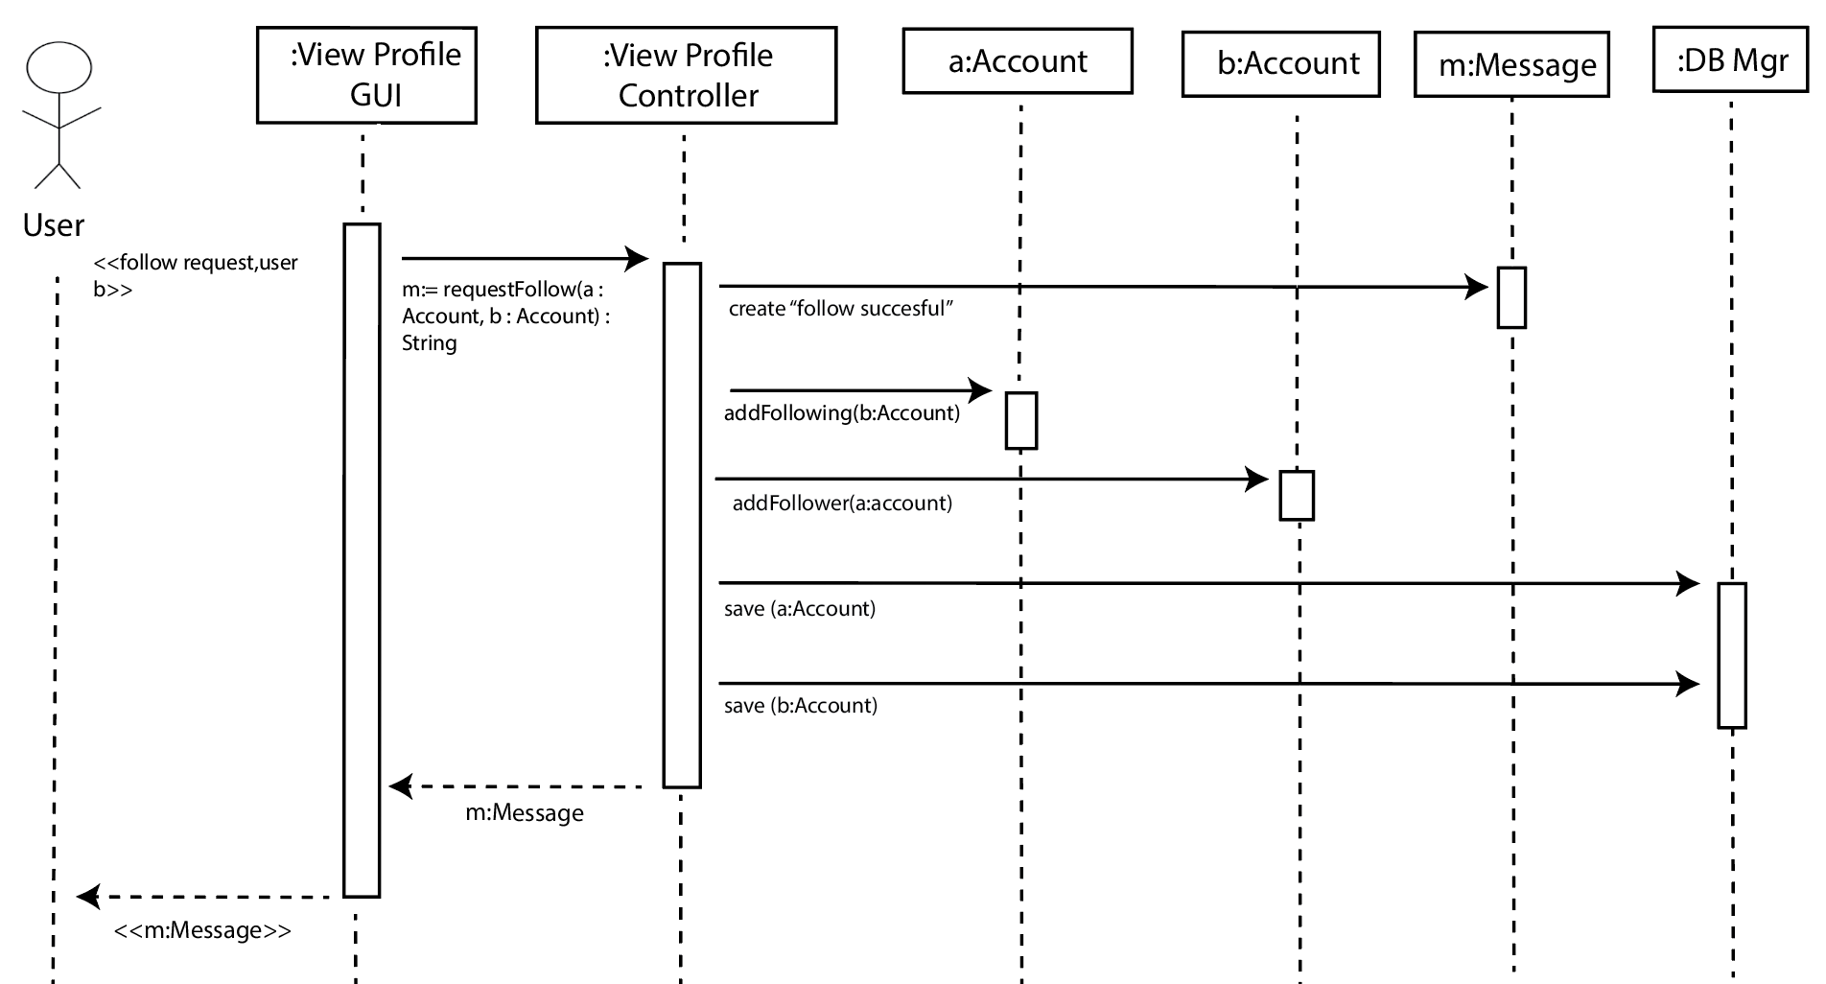

| # | Subject | Subject Action | Other Data/ Objects | Object Acted Upon |
| --- | --- | --- | --- | --- |
| 4.1 | User | clicks | Follow button | ViewProfile GUI |
| 4.2 | View Profile GUI | requests | user a to follow user b | ViewProfile Controller |
| 4.3 | ViewProfile Controller | creates | “Follow successful” | message |
| 4.4 | ViewProfile Controller | adds | b to following list | a:Account |
| 4.5 | ViewProfile Controller | adds | a to follower list | b:Account |
| 4.6 | ViewProfile Controller | saves | accounts a and b | Database Manager |
| 4.7 | ViewProfile Controller | returns | message | View Profile GUI |
| 4.8 | View Profile GUI | displays | message | User |

Design Sequence Diagrams and Steps

*Follow*

4. The system adds the profile being viewed to the current user’s following list

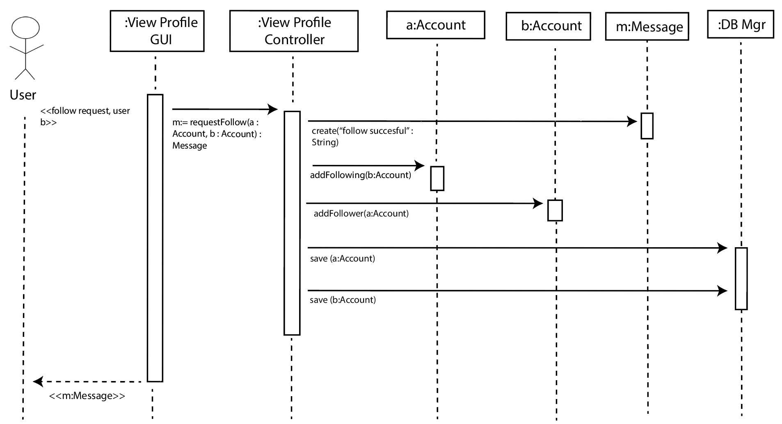

*Login*

4a. The system verifies the user’s input. If it’s correct, the system logs the user into the Poppin app and takes them to their feed.

4b. If it’s incorrect, the system displays an error message.

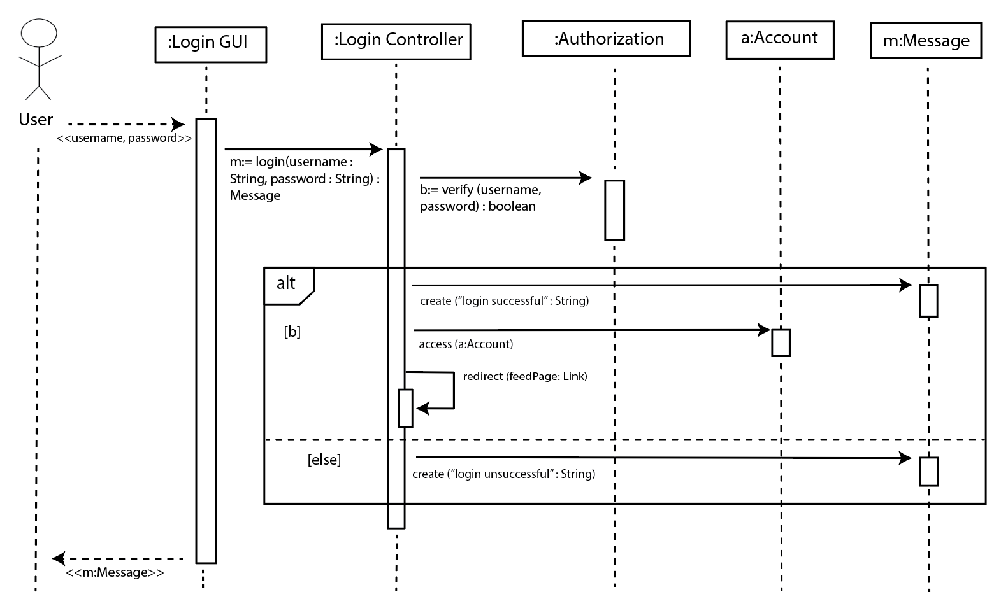

*Comment on a Post*

8. The system updates the comment section to include the user’s new comment.

